

**Secure Software Development**

Year 2 (2023/24), Semester 3

**SCHOOL OF INFOCOMM TECHNOLOGY**

Diploma in Cybersecurity & Digital Forensics

**Assignment**

**Secure Web Application**

**Duration:** Weeks 9 - 16

**Weightage:** 40%

**Individual/Team/Both:** Both

**Deadline: 6 August 2023, 11:59pm (Sunday)**

|  |  |
| --- | --- |
| **Group Name** | **Group 11** |
| **Student IDs** | **S10242282, S10243154, S10241971, S10242175** |
| **Student Names** | **Sherwyn, Keiran, Huang Wen, Ernest** |
| **Module Group** | **P03** |

Contents

3 Project Title: Shopping.com 4

4 Project Vision 4

5 Project Description 4

6 Project Features 4

6.1 Login, Registration and Authentication 4

6.2 Roles and Authorization 4

6.3 CRUD Database 4

6.4 Audit and Accountability 4

6.5 Miscellaneous Pages 4

6.5.1 Shopping Cart 4

6.5.2 Checkout 4

7 List of Members & Features Worked On 5

8 3-Tier Application Architecture 5

8.1 Presentation Tier 6

8.2 Application Tier 6

8.3 Data Storage Tier 7

8.4 Attributes of the Application: 7

8.4.1 Scalability 7

8.4.2 Modularity 7

8.4.3 Reusability 7

8.4.4 Security 7

8.4.5 Maintainability 7

9 Feature 1 (Login) 8

9.1 Secure Software Requirements 8

9.1.1 Use Case and Misuse Case Modelling 9

9.1.2 Data Labelling & Classification 12

9.2 Secure Software Design 13

9.2.1 Features related to Security Design 13

9.2.2 Attack surface evaluation (attack tree) 15

9.2.3 Threat Modelling 15

Secure Software Testing 40

10 Feature 2 (Roles/Authorization) 43

10.1 Secure Software Requirements 43

10.1.1 Brainstorming 44

10.1.2 Table of roles in Shopping.com 46

10.1.3 Use Case and Misuse Case Modelling 46

10.1.4 Data Labelling & Classification 48

10.1.5 Subject/Object Matrix 48

10.2 Secure Software Design 49

10.2.1 Features related to security design. 49

10.2.2 Attack Surface Evaluation 51

10.2.3 Threat Modelling 52

10.3 Secure Software Coding 55

10.3.1 Features related to Defence Coding Practice 55

10.3.2 Secure Software Process 56

10.4 Secure Software Testing 63

10.4.2 Security Conclusion of the Feature 74

11 Feature 3 (Auditing) 74

11.1 Secure Software Requirements 74

11.1.1 Use Case & Misuse Case Modelling 75

11.1.2 Data labelling & Classification 75

11.1.3 Subject/Object Matrix 76

11.2 Secure Software Design 77

11.2.1 Feature Related Security Design (Week 5 and 6) 77

11.2.2 Attack Surface Evaluation (Week 7) 77

11.2.3 Threat Modelling (Week 7) 77

11.2.4 STRIDE list 78

11.2.5 Attack tree 78

11.2.6 Average ranking 78

11.2.7 Control measures 79

11.3 Secure Software Coding (Week 11 and 12) 79

11.3.1 Feature Related Defensive Coding Practices 79

11.3.2 Secure Software Processes 79

11.4 Secure Software Testing (Week 13 and 15) 82

11.4.1 Test Strategy 82

11.4.2 Test Plan 82

11.4.3 Test Cases 83

12 Feature 4 (Shopping Cart) 84

12.1 Secure Software Requirements 85

12.1.1 Use Case & Misuse Case Modelling 85

12.1.2 Data Labelling & Classification 87

12.1.3 Subject/Object Matrix 87

12.2 Secure Software Design 88

12.2.1 Feature Related Security Design 88

12.2.2 Attack Surface Evaluation 88

12.2.3 Threat Modelling 89

12.3 Secure Software Coding 90

12.3.1 Feature Related Defensive Coding Practices 90

12.3.2 Secure Software Processes 90

12.4 Secure Software Testing (Week 13 and 15) 95

12.4.1 Test Strategy 95

12.4.2 Test Plan 95

12.4.3 Test Cases 95

13 Feature 5 (Checkout) 96

13.1 Secure Software Requirements 96

13.1.1 Use Case & Misuse Case Modelling 96

13.1.2 Data Labelling & Classification 97

13.1.3 Subject/Object Matrix 97

13.2 Secure Software Design 97

13.2.1 Feature Related Security Design 97

13.2.2 Attack Surface Evaluation 98

13.2.3 Threat Modelling 98

13.3 Secure Software Coding 99

13.3.1 Feature Related Defensive Coding Practices 99

13.3.2 Secure Software Processes 100

13.4 Secure Software Testing 103

13.4.1 Test Strategy 103

13.4.2 Test Plan 103

13.4.3 Test Cases 103

14 Conclusion 104

15 Reference 105

SSD Report

# Project Title: Shopping.com

The team was engaged in developing a secure web application for Shopping.com, an organization that aims to revolutionize online shopping by providing a seamless and user-friendly shopping experience. Hence, the theme of the application for this project is "Effortless Shopping".

# Project Vision

The project vision is to properly secure the web application using the knowledge we had gained during the Secure Software Development Course and apply these skills throughout the Secure Software Development Life Cycle (SSDLC). The target is to ensure that malicious attempts to access sensitive user information, disrupt services, or compromise the integrity of the platform are effectively thwarted. By incorporating robust security measures, we aim to provide Shopping.com's customers with a safe and trustworthy shopping experience, instilling confidence in the platform's reliability and protection of their personal data.

# Project Description

The objective of the web application is to offer a versatile platform for users to buy and sell products conveniently. Through Shopping.com's user-friendly interface, individuals can browse through an extensive catalogue of items from various sellers, ensuring a diverse and enriching shopping experience. Whether it is electronics, clothing, home decor, or any other category, the platform aims to cater to a wide range of interests and preferences.

For buyers, the platform provides detailed product descriptions, customer reviews, and ratings to assist in making informed purchasing decisions. The integrated shopping cart and secure payment gateway facilitate smooth and safe transactions, giving users peace of mind while shopping online.

On the other hand, Shopping.com empowers sellers by providing them with a dedicated space to list their products and reach a broader customer base. Sellers can manage their inventory and set prices.

# Project Features

Based on the business requirements, the web application consists of mainly four features to implement: authentication, authorization, auditing, a CRUD Database and Miscellaneous Pages.

## Login, Registration and Authentication

Users will be able to create an account by providing the necessary details such as email, name phone number and password during registration. The system will securely store user credentials and (support password encryption) for enhanced security. Upon successful registration, users can log in using their credentials to access personalized features and functionalities. Additionally, user can also use their google account to register.

## Roles and Authorization

To manage user access and permissions, the application will implement a role-based authorization system. Various user roles, such as users, staff, administrators, and owner, will be configured with appropriate authorization policies, as well as appropriately assign to users based on the responsibilities and authority within the job function to control access to resources, following the Principle of Least Privilege.

## CRUD Database

The web application will integrate a CRUD (Create, Read, Update, Delete) database to manage and store site content. It needs to be secured and available. The ability to read, write, update, and delete site data is based on the data type and user roles that it is assigned to.

## Audit and Accountability

Auditing feature will keep track of significant events and actions performed within the web application. This includes monitoring login attempts, user activity, changes to product listings, and any other critical system interactions. It can help to detect any suspicious actions by tracking what the user was doing at a given time, allowing administrators to act and have the information needed to predict the next course of action. Users will be deterred from doing anything suspicious or malicious to the website as their actions will be recorded and easily caught and punished. Having auditing, users are accountable for their actions and helps ensure the integrity of the web application.

## Miscellaneous Pages

### Shopping Cart

Users can add items from listings to their carts. A small cart view with the text "Your cart is empty" is generated on the listing index page. When an item is first added to the cart, the total cost, and the number of items in the cart are displayed, along with options to visit the cart index page and clear the cart.

Users can see a list of products added to the cart on the cart index page. The product name, quantity ordered, product price, and total cost (quantity * price) will be presented for each row. There are other buttons to increase and decrease the quantity, as well as one to remove the entire row from the cart.

Below the listing are two buttons, one of which clears the cart and the other of which takes the user to the checkout page.

### Checkout

The total amount and number of all products in the cart will be presented on the checkout page. Users can pay with PayPal, debit, or credit cards. If consumers want to pay using their cards, they must submit their card information as well as their billing address. Users who want to pay using PayPal must sign into their PayPal account, choose a PayPal payment option, and click the button that completes the purchase order.

After completing the transaction, depending on the order status, a success or error notice will appear, and users will be transferred to the homepage in three seconds. If an order is cancelled in the middle, a notification will show informing users that their order has been cancelled.

If users' orders were successful, the transaction will be audited, and the cart will be cleared.

PayPal Sandbox Account:

Email - sb-4r47ij26911900@personal.example.com

Password - Hc$c0'Uz

# List of Members & Features Worked On

|  |  |
| --- | --- |
| **Member** | **Features** |
| Ernest | Sign up, Login, Authentication |
| Huang Wen | Authorization |
| Keiran | CRUD Database, Auditing and Accountability |
| Sherwyn | Miscellaneous Pages |

# 3-Tier Application Architecture

In this phrase, an overview of the application architecture is carried out by diagramming the application and identifying the attributes of the application.

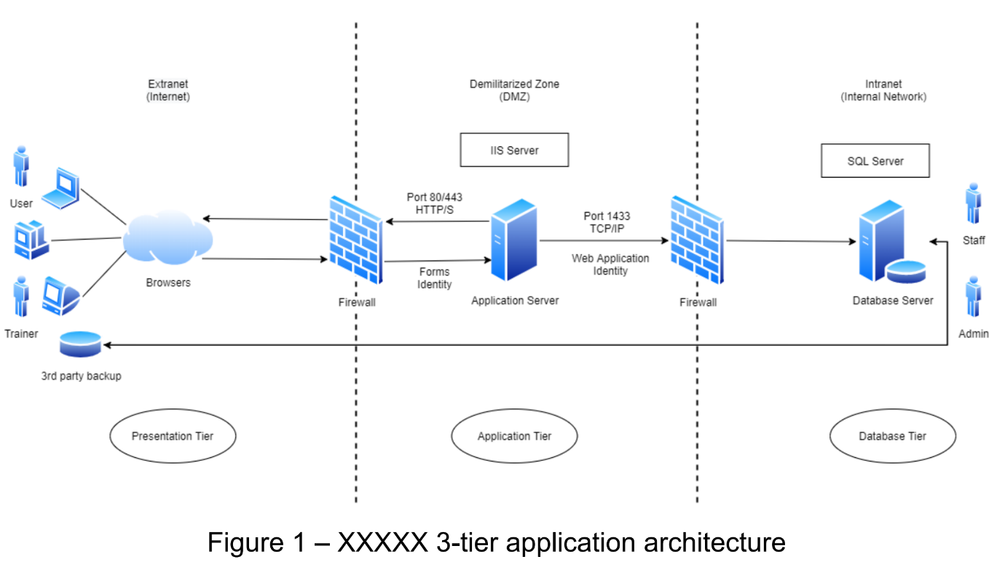

The software will be logically designed as a 3-Tier Application Architecture. This architecture is a modular client-server architecture that consists of a presentation tier, an application tier, and a data tier. The data tier stores information, the application tier handles logic, and the presentation tier is a graphical user interface (GUI) that communicates with the other two tiers. The three tiers are logical, not physical.

## Presentation Tier

Responsible for interacting with users through the user interface.

Utilizes web technologies (e.g., HTML, CSS, JavaScript) to create user-friendly web pages.

Handles user input and presentation of data to users.

Communicates with the middle tier to request data and process user actions.

## Application Tier

Contains the application's business logic and rules.

Processes user requests from the presentation layer.

Coordinates data retrieval and storage operations.

Performs necessary calculations and business workflows.

Acts as an intermediary between the presentation and data storage tiers.

## Data Storage Tier

Manages data storage and retrieval operations.

Interacts with databases or other data sources.

Provides a unified interface for data access.

Persists data and performs data-related operations (e.g., querying, inserting, updating, deleting).

## Attributes of the Application:

### Scalability

The 3-Tier Architecture allows for easier scalability as each tier can be scaled independently based on demand.

### Modularity

The clear separation of concerns in each tier promotes modularity, making it easier to develop, test, and maintain the application.

### Reusability

Components in each tier can be reused across multiple applications or user interfaces, increasing development efficiency.

### Security

The architecture enhances security by reducing the risk of data exposure and unauthorized access through the tiered structure.

### Maintainability

Changes and updates can be made more efficiently as developers can focus on specific layers without affecting the entire application.

Overall, the logical design of the software as a 3-Tier Application Architecture provides a structured and scalable foundation for the development of a secure and maintainable application. Diagramming the application's architecture will visually represent the relationships and interactions between these tiers, ensuring a clear overview of the system's structure and functionalities.

# Feature 1 (Login)

Authentication is crucial for security as it enables organizations to keep their networks secure by allowing only authenticated (users to access network resources. It ensures that individuals attempting to gain access to the network are authorized and have the necessary permissions to do so. By completing the authentication process successfully, users are granted access to specific applications, databases, files, or other resources based on their designated roles and privileges.)

(By focusing on robust authentication mechanisms, organizations can strengthen their network security posture, reduce the risk of unauthorized access or data breaches, and ensure that only authorized individuals can access and utilize network resources effectively.)

## Secure Software Requirements

In authentication, Forms authentication is most seen in online applications, (as it provides a straightforward and customizable way to authenticate users. Forms authentication is typically used in web applications where users submit their credentials through an HTML form.)

(Forms authentication is a widely used method for authenticating users in online applications. Its customizable login page, user credential verification, session management capabilities, role-based authorization, password encryption, integration with membership providers, support for custom authentication logic, and compatibility with cross-platform applications make it a popular choice for implementing authentication in web-based systems.) 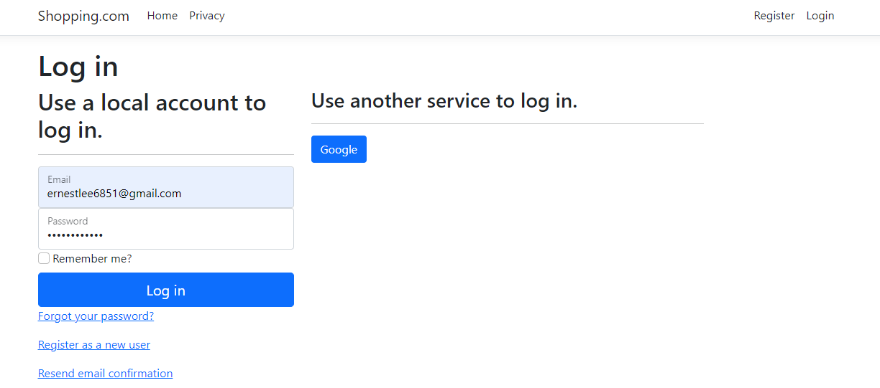

### Use Case and Misuse Case Modelling

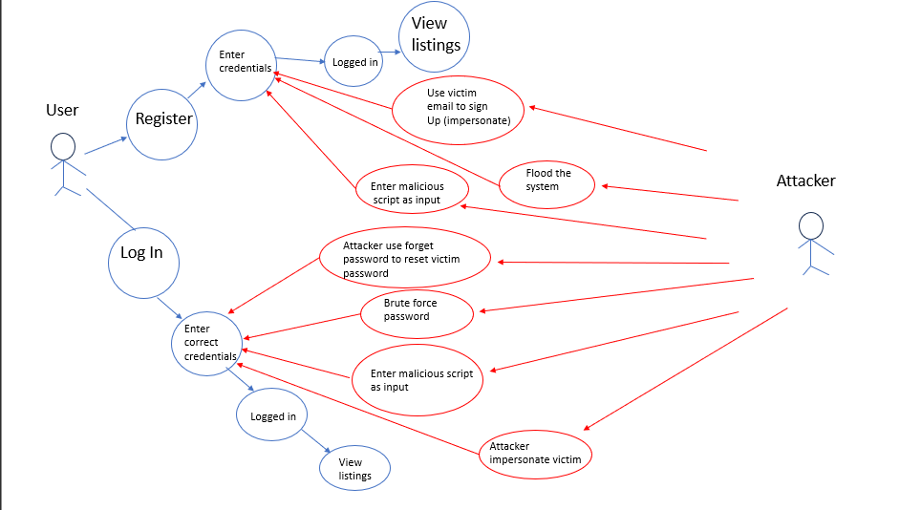

### Login

* Use Case
  + User is only able to log in after entering the correct username and password combination.
* Misuse Case
  + Attacker can brute force both username and password.
* Measures
  + Failed log in attempts should be logged, once there has been 3 failed login attempts, device should be temporarily locked in a period of time and not be able to attempt to log in.
  + 2 factor authentication can be implemented. Thus, even if the correct password and username combination is entered, the user still needs the 2-factor authentication code which would only be available on the actual user’s phone. These codes would be regenerated every 30 seconds to prevent brute-force attacks.
  + Password of users are validated to make sure they are alphanumeric, at least 5 characters long, contain 1 unique character and have both upper and lowercase letters, making it harder for attackers to brute force the password. ,
* Use Case
  + Username and password should be stored in a secure database to prevent attackers to gain unauthorized access to them.
* Misuses Case:
  + Attackers can use SQL injection attacks to gain unauthorized access to information in the database.
* Measures
  + User’s input should be validated to prevent attackers from exploiting special characters to gain unauthorized access to database.
  + All passwords stored in database should be hashed using an encryption algorithm which should be kept secret and password hash must all be individually unique. Thus, in the event attacker gains access to database, they will still not be able to view the password of the user and at the same time cannot unhash the password to view the actual password.
* Use Case
  + When user forgets password, a reset password email should be sent to the email associated to the user’s account to allow user to reset their password.
* Misuse Case
  + Attacker can get system to send reset password email of another user’s account to attacker’s email.
  + Attacker can change the password of other user’s account after accessing reset password link
* Measures
  + Reset password token can be generated for each specific user’s account whenever user forgets their password. Thus, if attacker attempts to enter the email of other account to try and change password, Thus, if user enters an account that is not theirs to reset password, the token would be invalid, resulting in user not being able to reset password.
  + Account password can only be reset if user confirms their email for the account. To do that, they would have to confirm their account through the email they get when they register for the account, or when they request for email verification email.

### Registration

* Used case
  + User provides all relevant information such as name, password and email address when registering for an account. System would then validate that email address entered is unique to prevent duplications of accounts under the same email address. Once all of user’s input passes through validation checks by the system, the account would be created, and account information would be stores in a secure encrypted database.
* Misuse case
  + Attacker uses brute force method to first generate many throw-away email addresses followed by generating many usernames and passwords. Attacker then attempts to flood the system by registering many accounts, causing a DOS attack, preventing people who legitimately want to register for an account from registering for one.
  + Attacker inputs scripts into user’s inputs and uses SQL injection attack to extract unauthorized information from the database.
* Measures:
  + ReCAPTCHAV3 is implemented as one of the factors needed to pass through before successfully registering for an account, this prevents bots from constantly creating new accounts as they would not be able to pass the ReCAPTCHA test. Furthermore, ReCAPTCHA V3 will not display image-based user questions to avoid user interaction. This makes it easier for user to use the website, making it more psychologically acceptable, causing users to have less complaints and are more likely to continue using the website.
  + All user’s inputs will be validated to restrict the abuse of special characters, preventing unauthorized access to database information.
* Used Case
  + User can use their own email account to register for a new account on the website.
* Misused Case
  + Attacker impersonates another user and uses their target’s email to sign in for an account.
* Measures
  + Email confirmation should be sent to alert user that their email is being used to register for an account, and if this was not them, they should be able to use the forget password function to reset the password of that account.

## Data Labelling & Classification

When user first register for an account, they would have to provide information such as email, name, phone number and password. The username for their account would be the email that they have entered. Password for user’s account would immediately be hashed and the hashed value would be stored inside the database, adding another layer of security in case attacker gains access to the database. Both email address and passwords are very important as email acts as the primary key while password gives user access to the account.

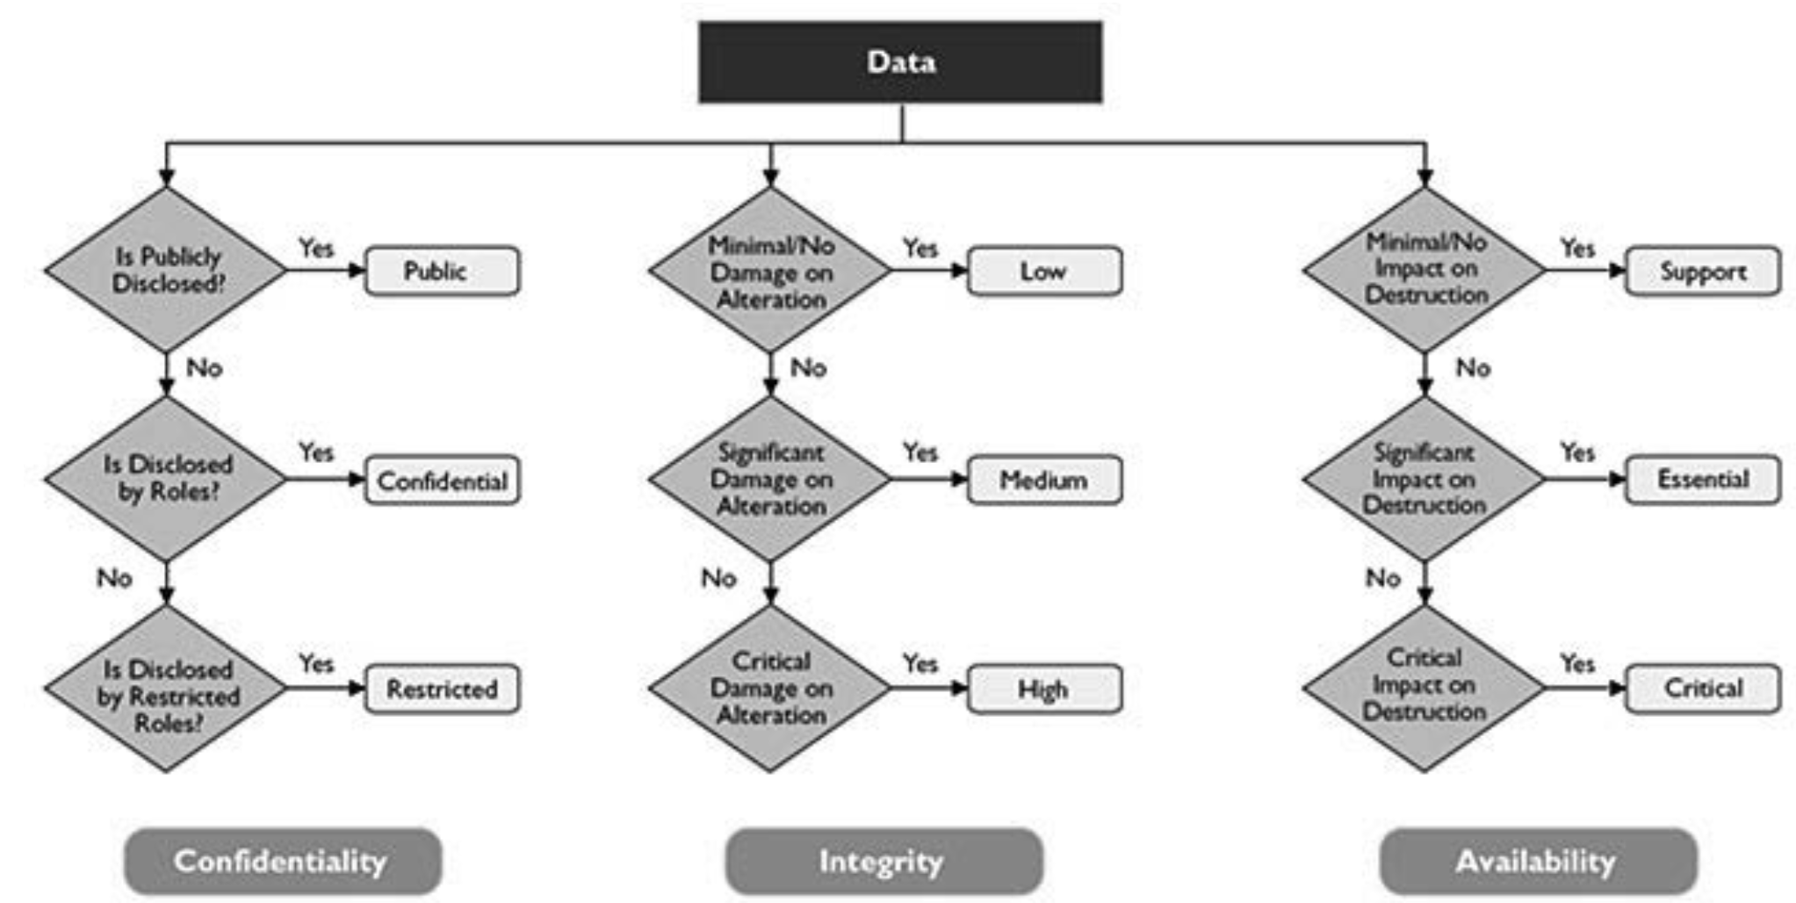

### List of data

|  |  |  |  |
| --- | --- | --- | --- |
| Data | Confidentiality | Integrity | Availability |
| Username | public | Low | Support |
| Email | public | high | critical |
| Password | Restricted | High | critical |
| Full name | Confidential | low | support |
| Phone number | Confidential | low | support |

## Secure Software Design

### Features related to Security Design

* Hashing
  + When user enters password and gets stored inside the database, the password would be immediately hashed, using an encryption algorithm and all hashes must be individually unique. Thus, even if attacker gets unauthorized access to database, they will not be able to see the password as it has been hashed and they will not be able to reverse the hash function.
* Multi-Factor Authentication
  + Users can configure 2 factor authentication when they have logged into the account. Once configured, every time the user logs in they would have to enter their credentials first followed by entering the code generated by the Microsoft authenticator app linked to their account. These codes would be regenerated every 30 seconds to prevent use of brute force attack.
* Secure Design principle
* Least Privilege
  + Users who have an account for the website are only able to have read access to the website. They will also be able to publish and edit their own listings but are not able to edit the listings of others.
* Separation of duties
  + Pen-testing of code will not be conducted by the coder themselves; it will be conducted by a code with a different role.
* Fail safe.
  + If user 3 failed attempts to log in to their account, they would be locked out for 30 minutes before they can try again.
* Economy of mechanism
  + ReCAPTCHA V3 is implemented instead of ReCAPTCHA V2 to help prevent denial of service attack if user were to generate bots to create multiple attacks. V3 is used instead of V2 as V3 does not involve human interaction but instead runs in the background. This makes it easier for user to create an account while still the website still has authentication of accounts being done. This makes it simple for users to create account while maintain high level of security.
* Psychological Acceptability
  + ReCAPTCHA V3 implemented to run in background to make user’s life easier instead of having to pass a test every time they try to sign in.
  + Google authenticator configured as another way user can use to sign up for an account, they simply just need to log in with their Gmail account icon order to sign up for an account.
* Leveraging Existing Components
  + Used third party email sender (SendGrid) as it has already been proven to work and is also secure.
  + Used Google ReCAPTCHA, a service that has already been configured by google to help track any suspicious activity on the website instead of tracking the activity ourselves.
  + Used Google authenticator, already been configured by google to make sign in easier for users.

### Attack surface evaluation (attack tree)

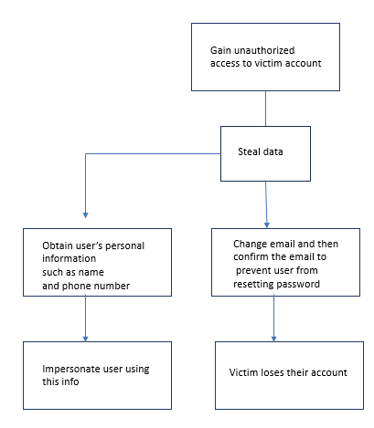

### Threat Modelling

Phase 1 - Model Application Architecture

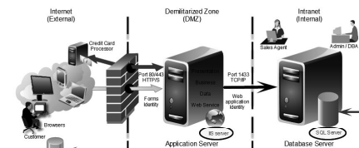

**Phase 2 -Identify Threats**

Trust boundary

* Internet (External) and Demilitarized zone (DMZ)
* DMZ and Internet (Internal)

Entry Points:

User’s inputs (logged out)

* + Register for account.
    - Email
    - Password
    - Confirm Password
    - Full Name
    - Phone Number
  + Log in
    - Email
    - Password
  + Forgot your password.
    - Email
  + Resend Email Verification
    - Email
* Logged in
  + Profile (Phone number)
  + Email (new email)
  + Password
    - Current password
    - New password
    - Confirm new password

Exit points:

* Search function for listing
* Logged in
  + Username (Profile)
  + Phone number (Profile)
  + Email (Manage Email)

Identify data flow.

* Anonymous user browser àCreate account àlistings page àadd to cart à checkout
* User log in à Listings page à add items to cart à view cart à checkout à Payment method page à pay using credentials à logout.

Mis-Actors

* Uneducated user
* External hacker

Determine potential and applicable threats.

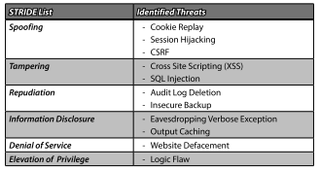

|  |  |
| --- | --- |
| Stride list | Identified threat |
| Spoofing | * CSRF * Cookie replay * Session Hijacking |
| Tampering | * XSS * SQL injection |
| Repudiation | * Audit log deletion |
| Information disclosure | * Eavesdropping verbose exception |
| Denial of service | * Website defacement * Multiple bots using throw away email to create account |
| Elevation of privilege | * Logic flaw |

**Phase 3 – Identify Prioritize and implement controls.**

Software faces several threats. Authentication bypass, impersonation, and session hijacking are just a few of the dangers. This section of threat modelling will address the threats identified from the previous sections and implement control measures based on their severity.

* + - * + STRIDE List

Based on the Use Case and Misuse Case, along with the identified attack surface areas addressed in the previous section, a STRIDE category threat list is used for categorizing the potential threats identified as depicted in Figure(image)

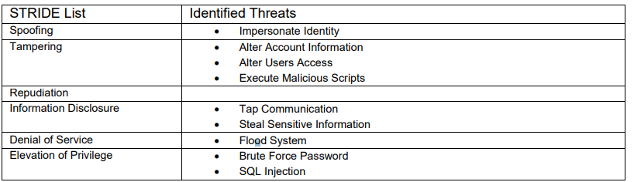

* + - * Attack Tree

Expanding on the STRIDE List earlier, an attack tree model allows for brainstorming of potential threats from the attacker’s perspective. This further strengthens the security of the software by identifying the attack path an attacker may take and implementing countermeasures to mitigate or prevent these attacks.

* + - * + Average Ranking

Following the identified threats, calculating the average of numeric values assigned to risk ranking categories is another approach for rating the threat’s danger shown in

|  |  |  |  |  |  |  |  |  |
| --- | --- | --- | --- | --- | --- | --- | --- | --- |
|  | Probability of Occurrence (P) | | | Impact (I) | | P | I | Risk |
| Threat | R | E | DI | D | A | (R+E+DI) | (D + A) | P x I |
| XSS | 2 | 2 | 3 | 3 | 3 | 7 | 6 | 42 |
| Sql Injection | 2 | 2 | 1 | 3 | 1 | 5 | 4 | 20 |
| Brute forcing | 1 | 1 | 2 | 2 | 2 | 4 | 4 | 16 |
| CSRF | 2 | 2 | 2 | 3 | 2 | 6 | 5 | 30 |
| DOS | 1 | 2 | 2 | 2 | 2 | 5 | 4 | 20 |
| Verbose expressions | 1 | 2 | 1 | 2 | 3 | 4 | 5 | 20 |

**Phase 4 Document and validate.**

|  |  |
| --- | --- |
| Threat (P x I rank) | Controls |
| XSS (42) | - Validate input using regular expressions  - Disallow script tag  - Disallow active scripting |
| SQL injection (20) | * Use parameterized queries. * Validate input regular expressions. |
| Verbose exception (20) | * Use non-verbose error message to handle errors |
| Brute Forcing (16) | * Do not allow weak passwords (Need alphanumeric, numbers and special characters) * 2 factor authentication * Google reCAPTCHA * Lockout function |
| CSRF (30) | * Razor pages implements unique session tokens whenever user uses the website * All inputs validates using regular expression or razor pages configured validation, preventing injection of malicious scripts. |
| Denial of service (20) | * ReCAPTCHA V3 implemented to monitor activity on the website, if it senses that there is a bot generating many accounts using throw away emails, it will prevent the accounts from being created |

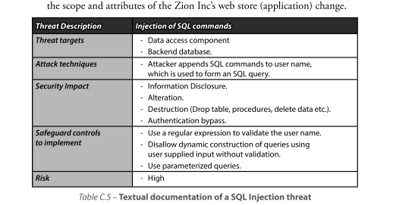

## Secure Software Coding

Input validation

|  |  |  |  |
| --- | --- | --- | --- |
| Input Validation | Validates | Description | Example |
| [RegularExpression(@"^[a-zA-Z0-9._%+-]+@[a-zA-Z0-9.-]+\.[a-zA-Z]{2,}$", ErrorMessage = "Invalid email address.")] | Email | Allows alphanumeric characters,  Cap and non-caps, allows special characters like ._%+-@ | User1@gmail.com |
| [Phone] | Phone number | Only contains numbers and optional hyphens(-) | 1234567890  123-456-789 |
| [RegularExpression("^[a-zA-Z0-9!@\\$]*$", ErrorMessage = "Entered Text contains Invalid characters")] | Password | Allows alphanumeric characters,  Cap and non-caps, allows special characters like !@$ | Erne123  abc@123 |
| [RegularExpression("^[a-zA-Z]*$", ErrorMessage = "Entered Text contains Invalid characters. Only letters are allowed.")] | Name | Only allow letters | Testing  testing |

Error handling

sign in

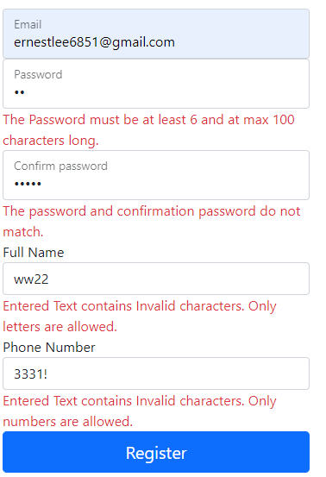

Email address not entered in correct format

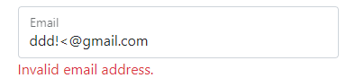

When log in password is wrong

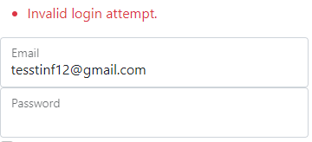

When current password is wrong

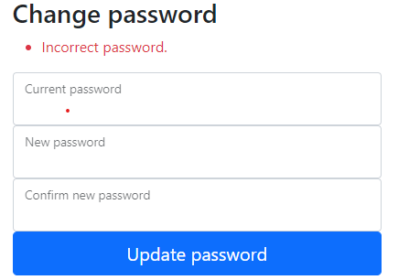

When user changes email to account already registered

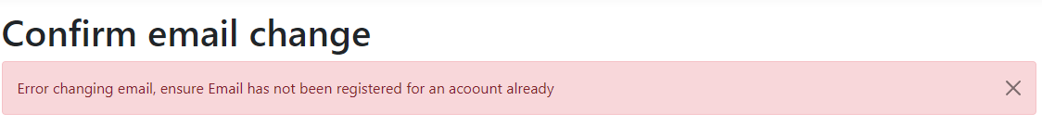

When user uses forget password and tries to reset password of other account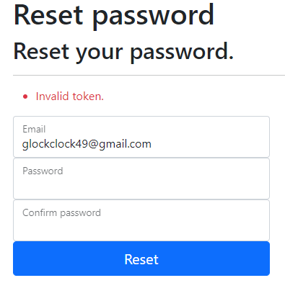

Exception Management

* All input fields are validated using regular expressions or configured validations by razor pages. Thus, input with the incorrect format would not even have an action result as they would be met with an error message as shown in Error handling.
* Furthermore, Model state would first have to be valid before calling an action.  
  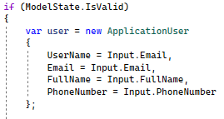

Else :



**3.2 Secure software processes**

-Versioning

Currently, we are using GitHub for versioning. We can pull the updated code from the repository and merge it with our code, before pushing it, ensuring everyone is editing on the newest version. We can also create a branch where it is an isolated environment that do not affect our master branch. It also allows us to track each of our updates and roll back if necessary.

**Code review**

Static code analysis

* Sending verification email after registering for an account

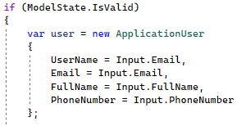

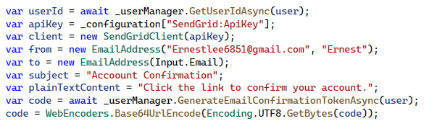

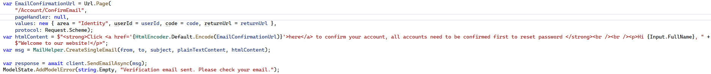

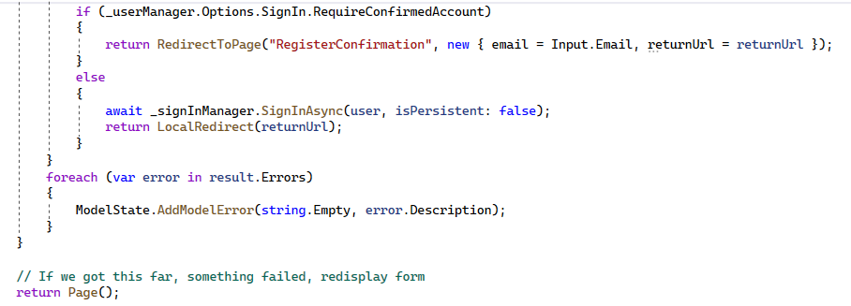

* Sending email when user forgets password.

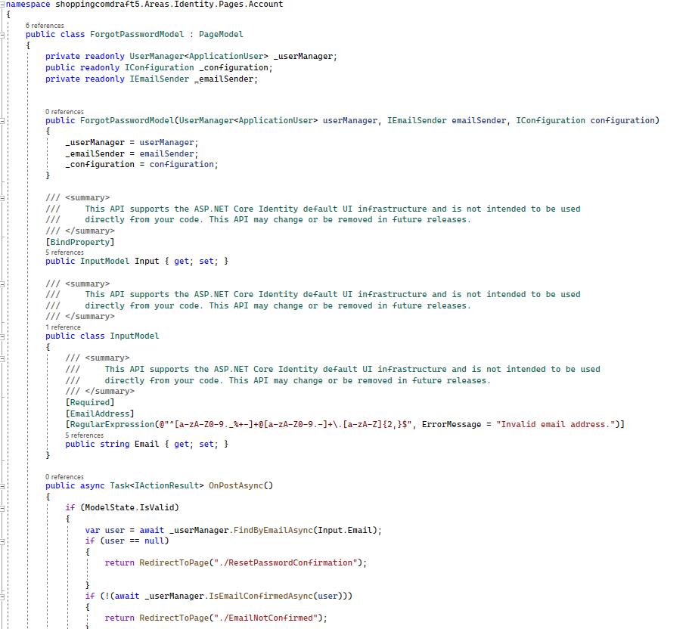

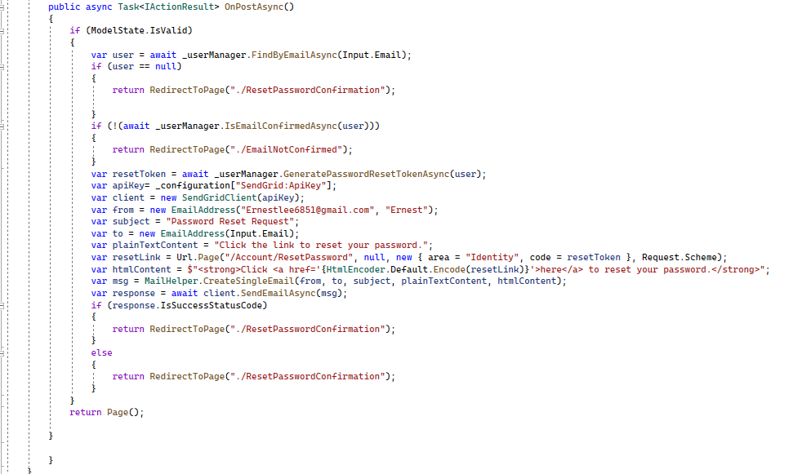

Redirected to reset password page.

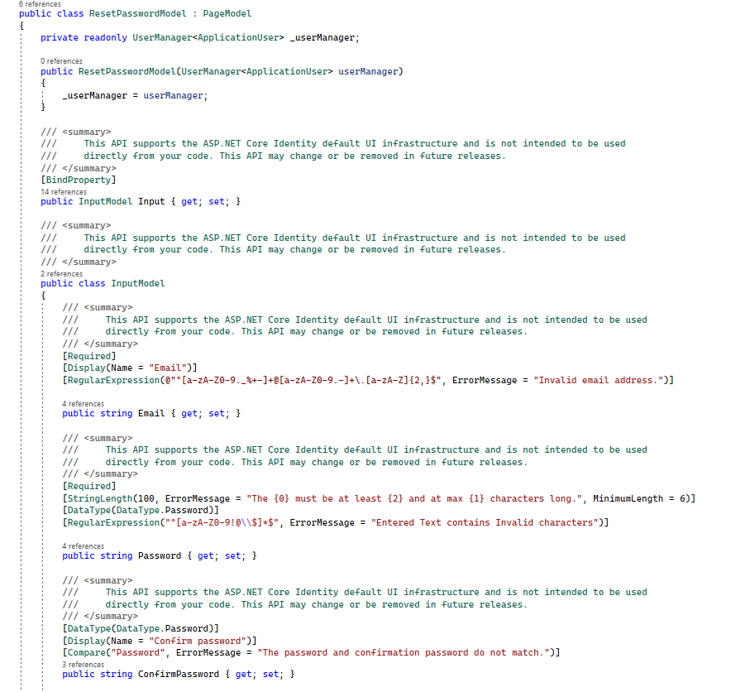

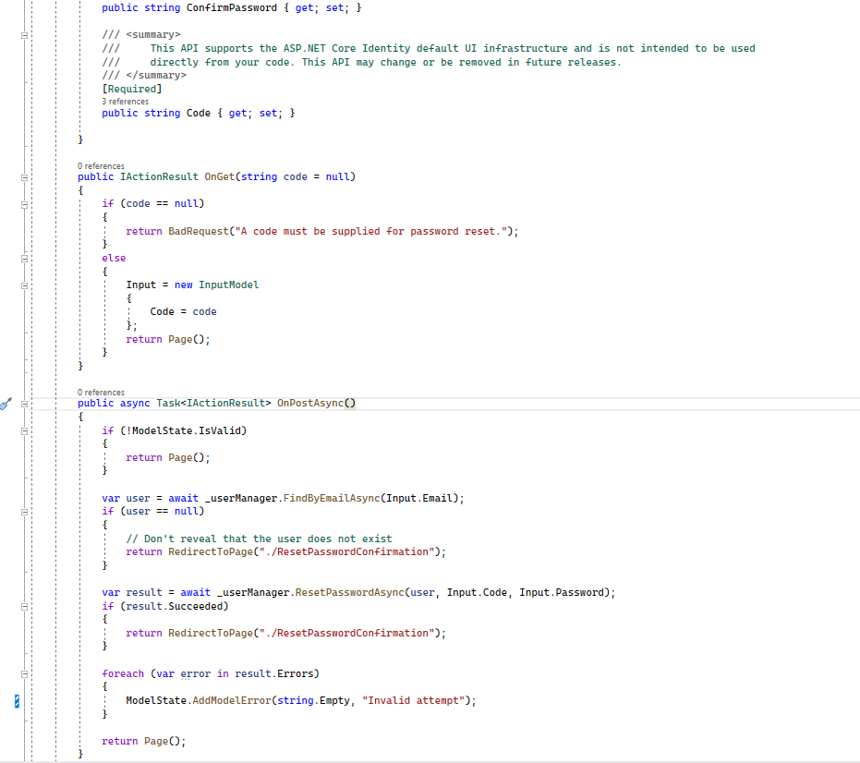

* Google reCAPTCHA V3 when registering

Register.cs

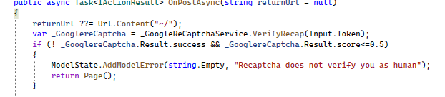

GoogleRecaptchaService.cs

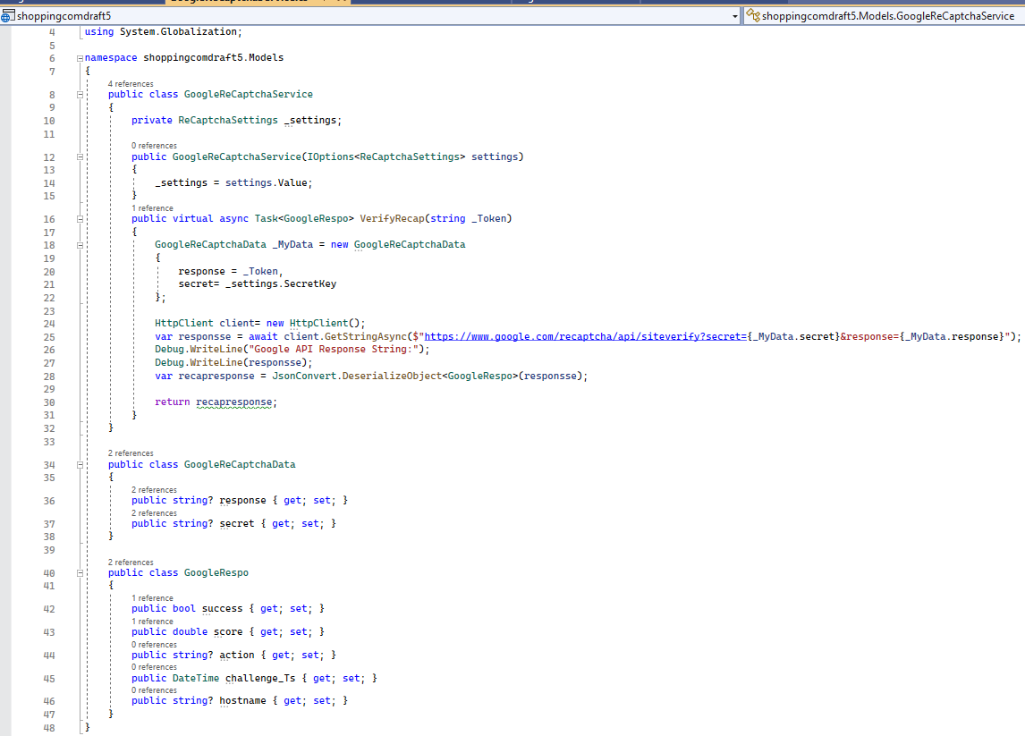

* Recaptchasettings.cs

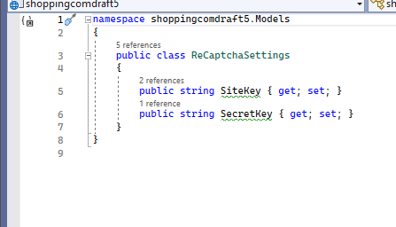

* Appsettings.json

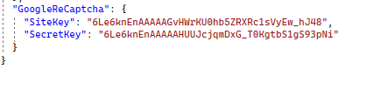

* Log in

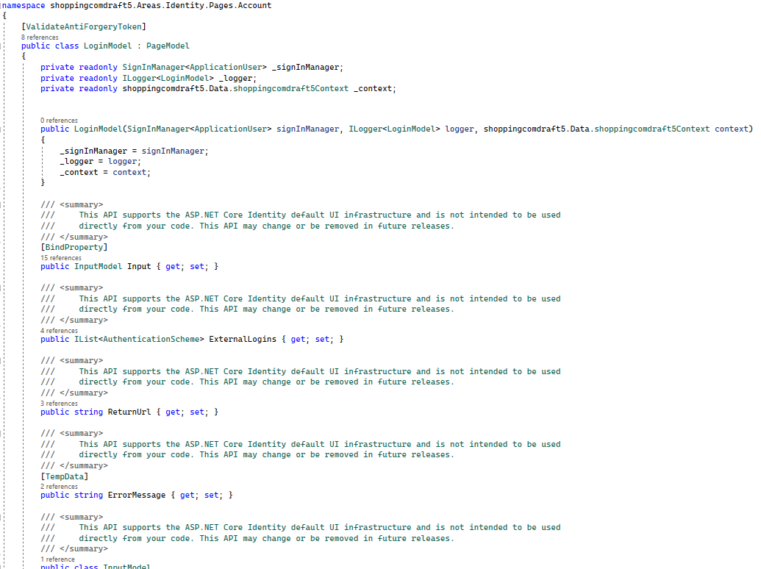

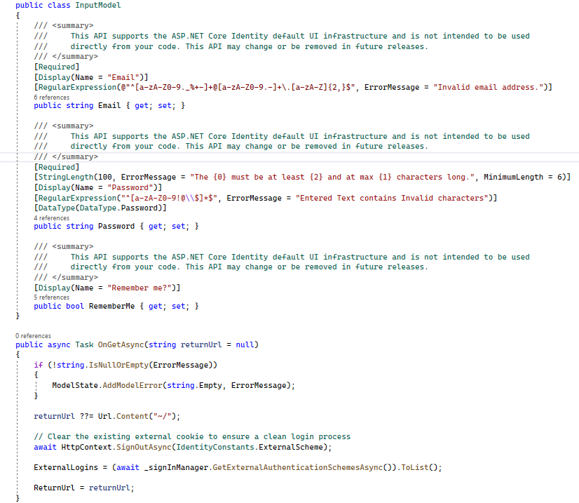

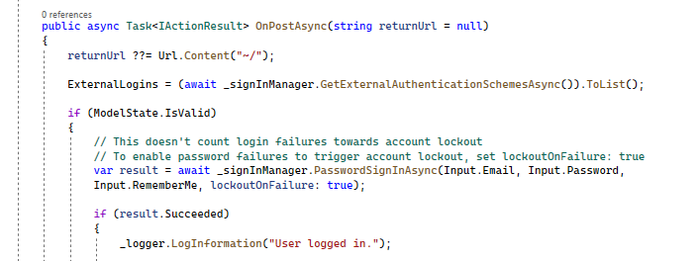

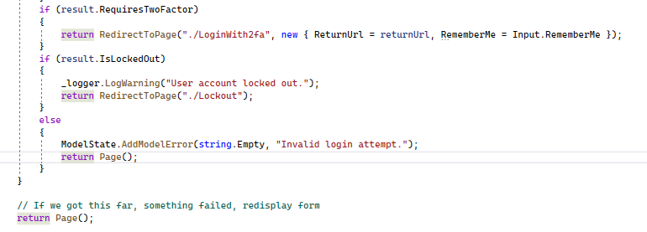

* Lockout

Program.cs

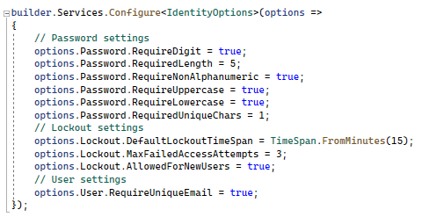

* Register
* Register.cs

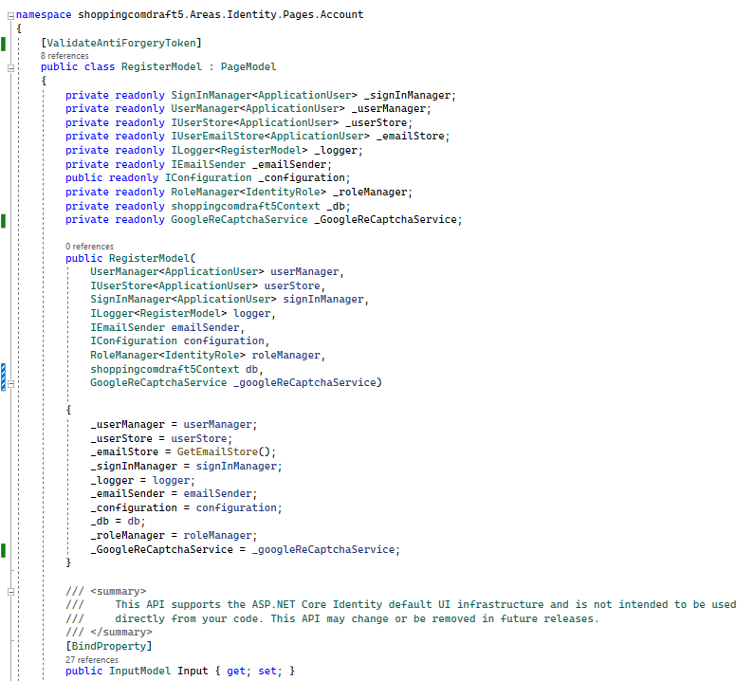

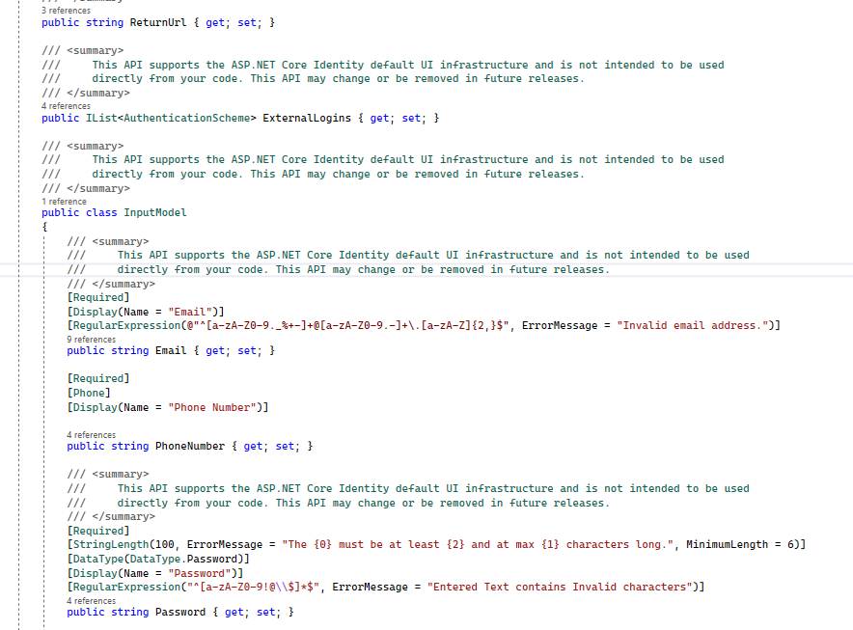

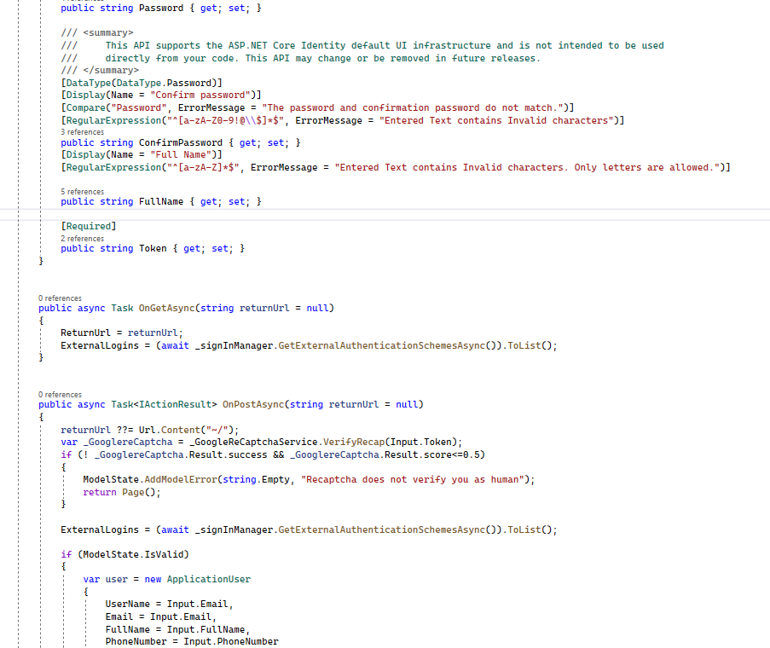

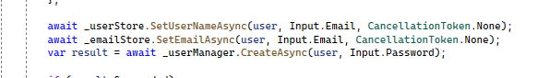

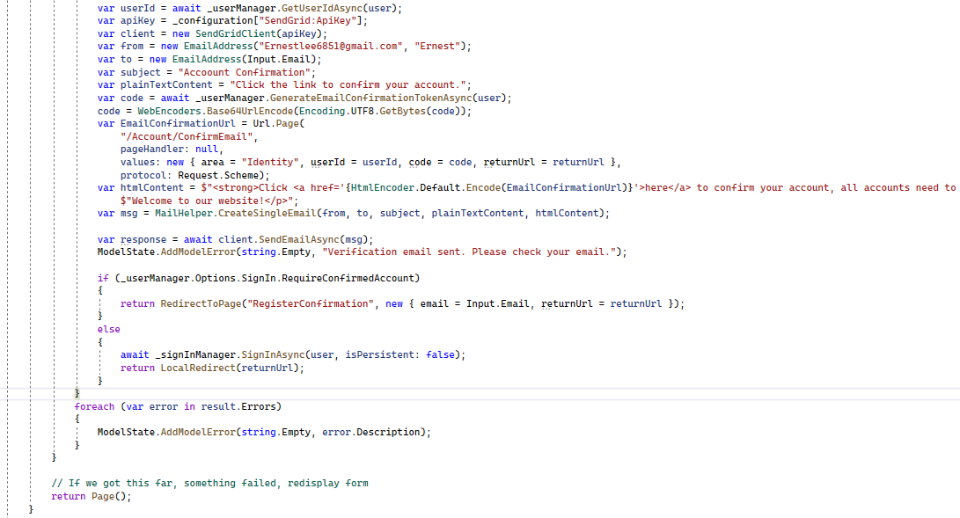

* Google authenticator

Program.cs

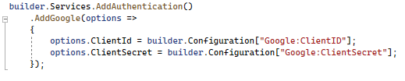

Secrets.json

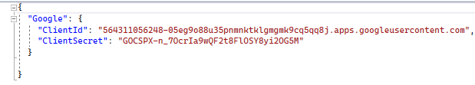

* 2 factor authentication

twofacto authentication.cs

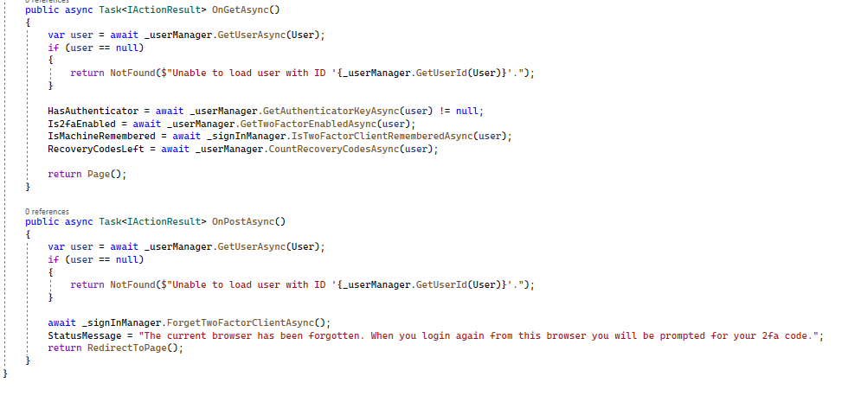

enableauthenticator.cs

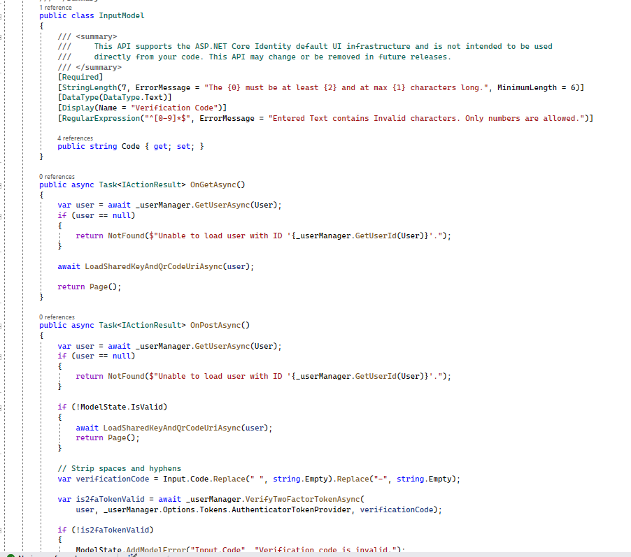

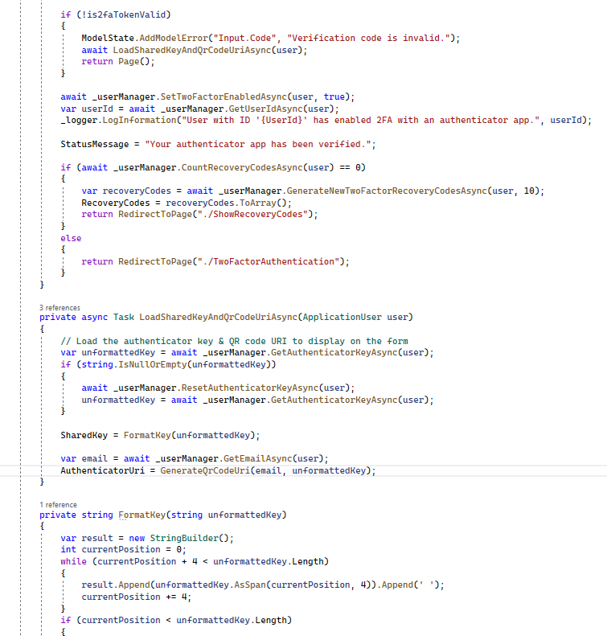



enableauthenticator.cshtml

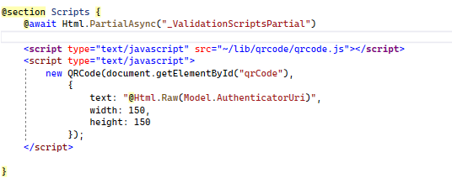

Loginwith2fa.cs

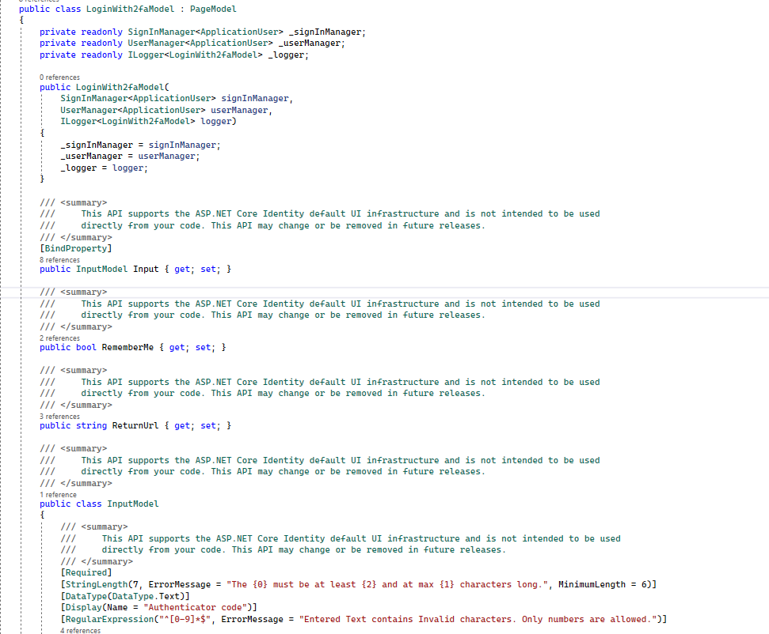

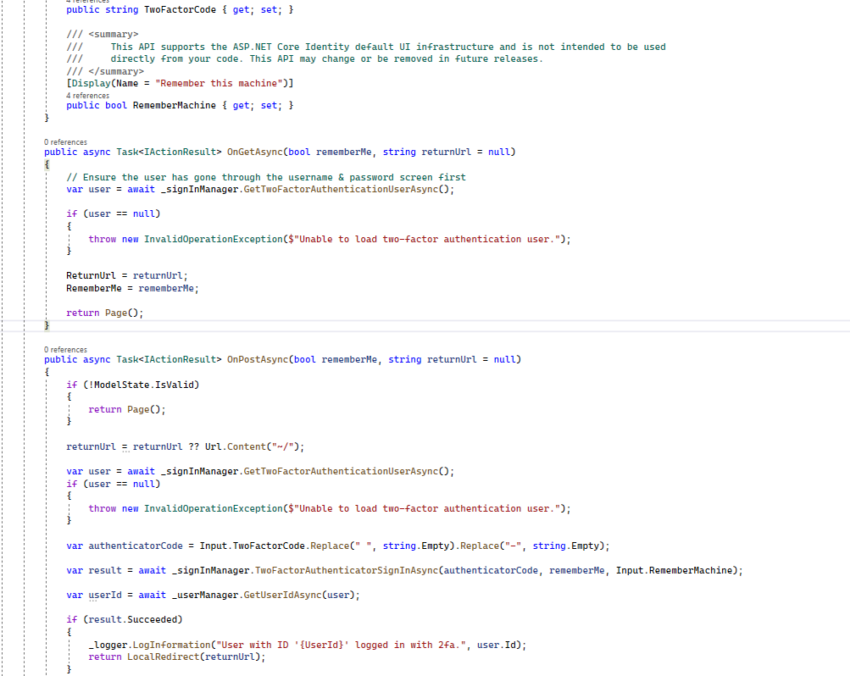

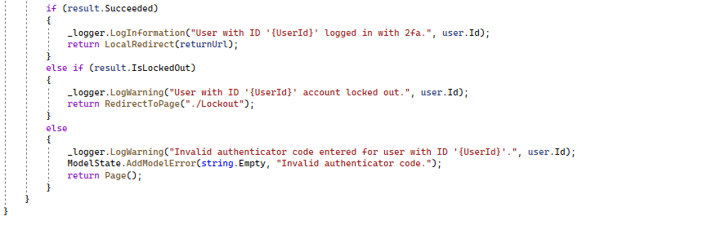

* Changing of email

Email.cs

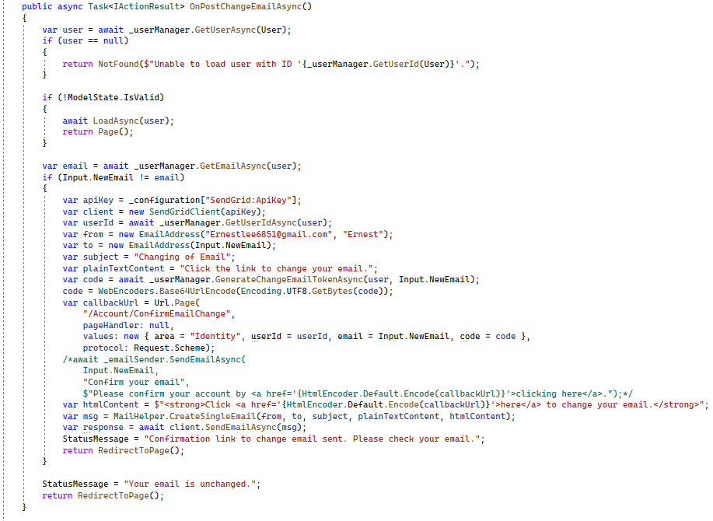ConfirmEmailchange.cs

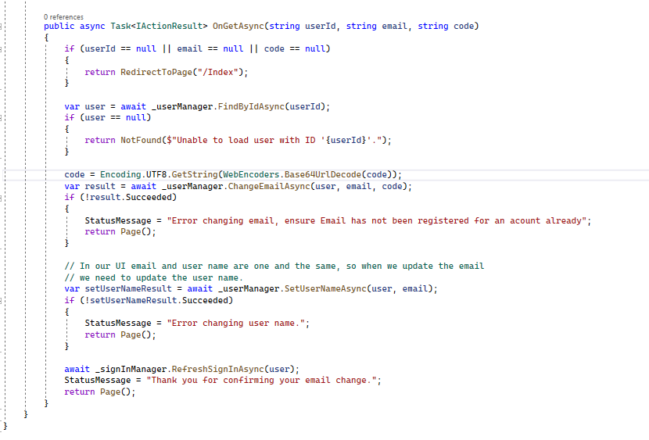

Dynamic code analysis

* Sending verification email after registering for an account

Verification Email

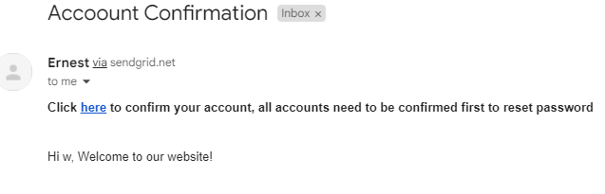

Clicking on hyperlink

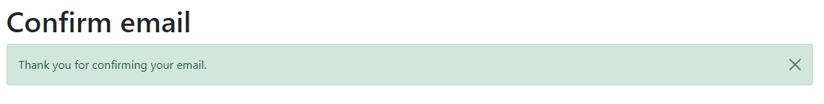

* Sending email when user forgets password.

Email sent

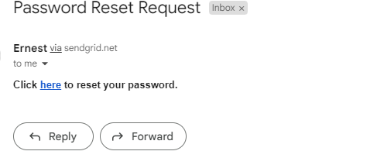

Clicking on hyperlink

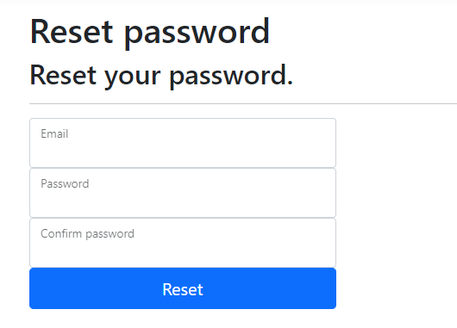

Successful change of password

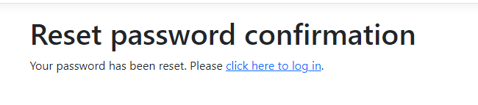

* Google ReCAPTCHA in register page

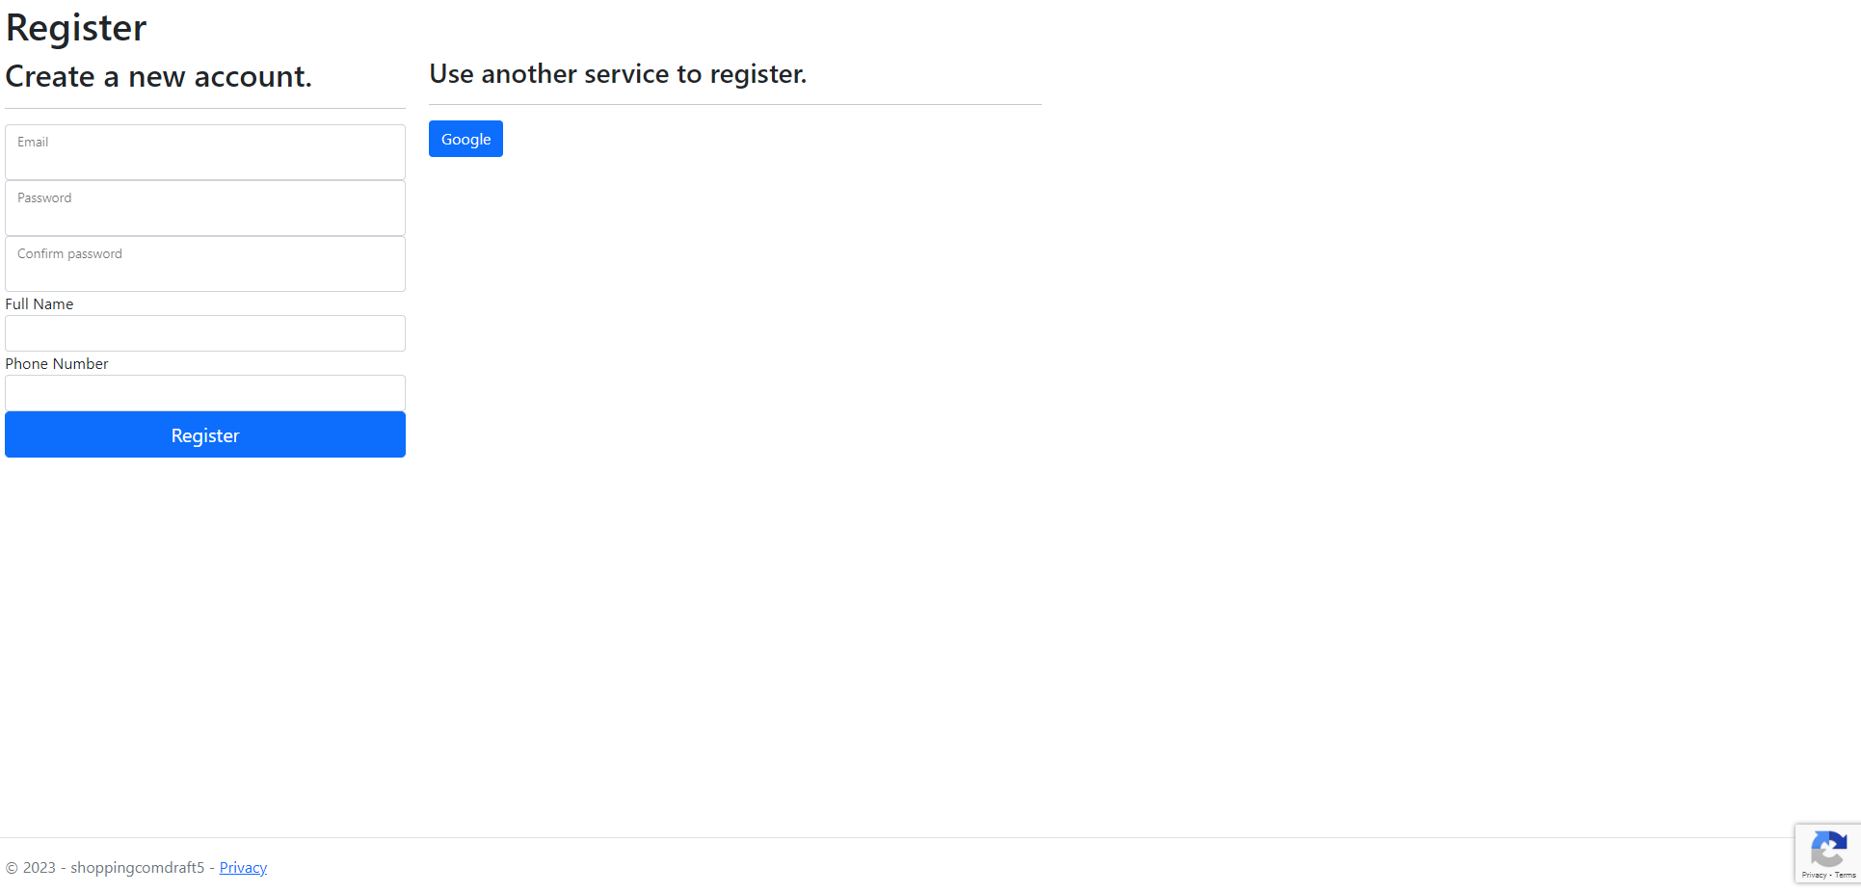

Google reCAPTCHA processing to test if request is successful.

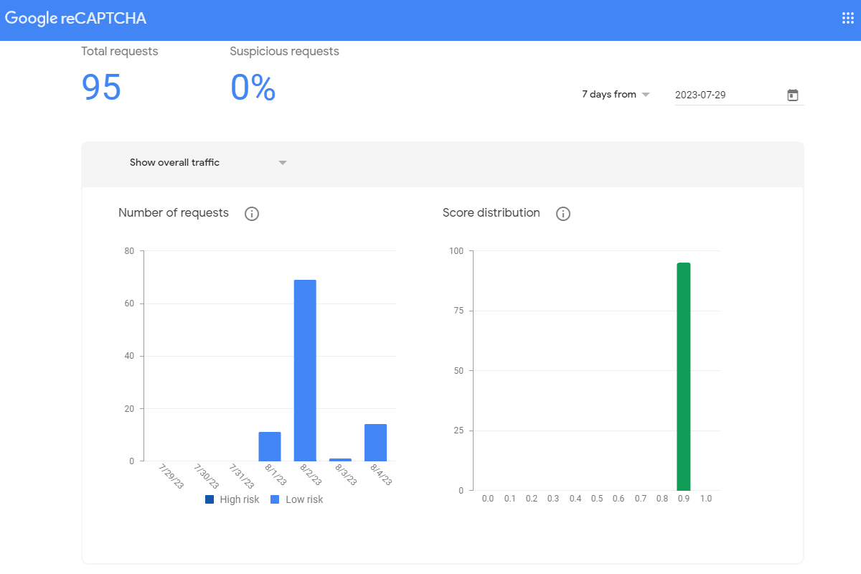

* Login



* Lockout

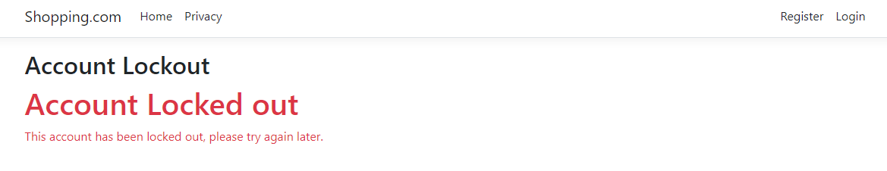

* Register

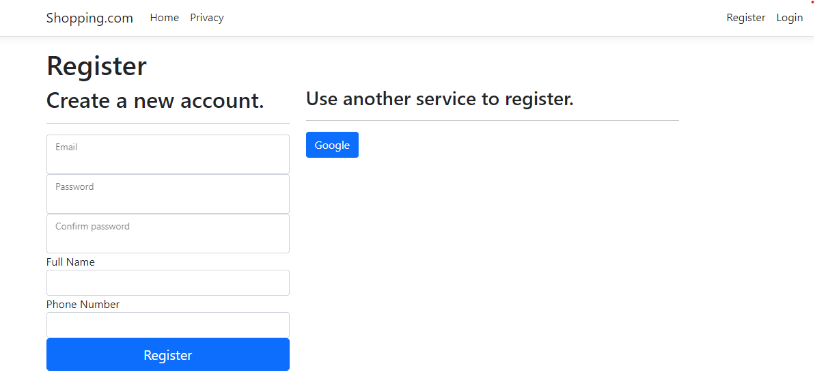

* 2factor authentication

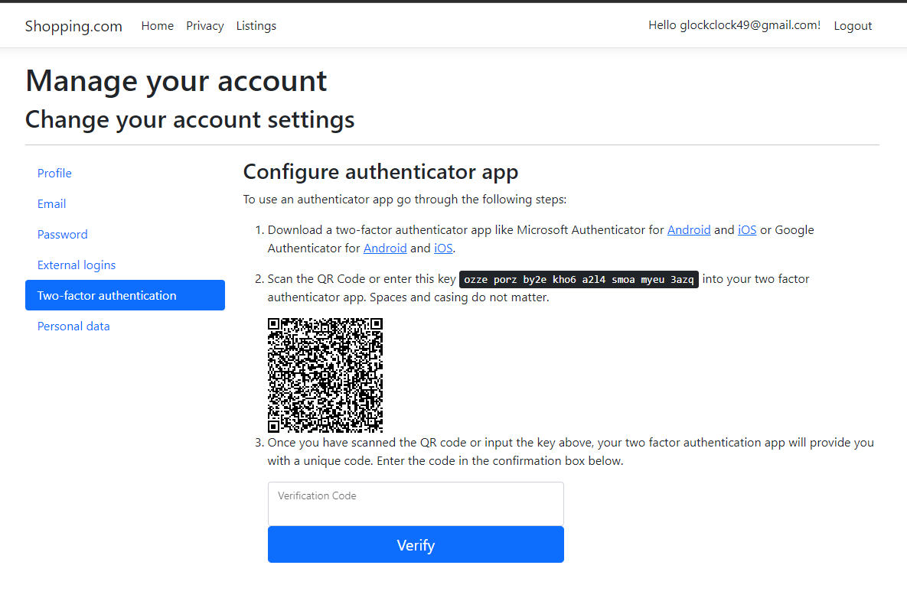

After scanning and entering code

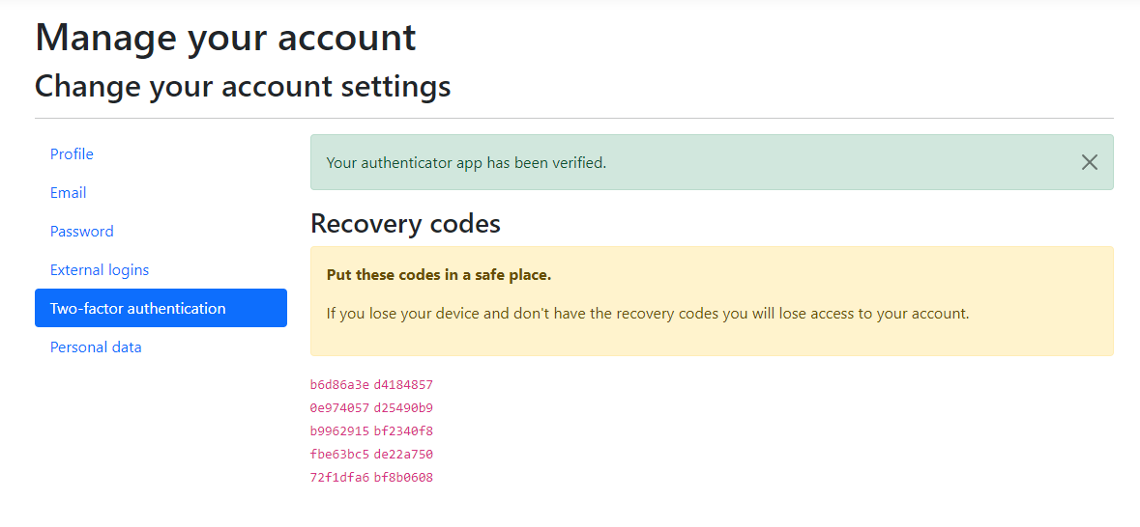

After entering credentials to log in’

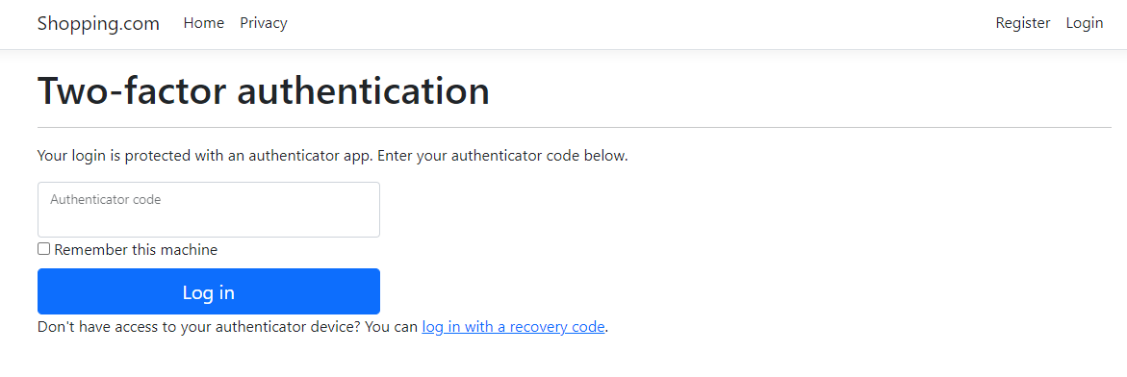

* Changing email

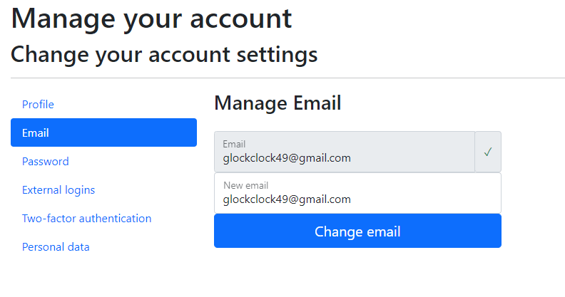

Email sent after pressing button.

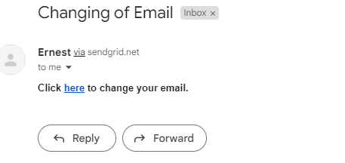

After clicking hyperlink

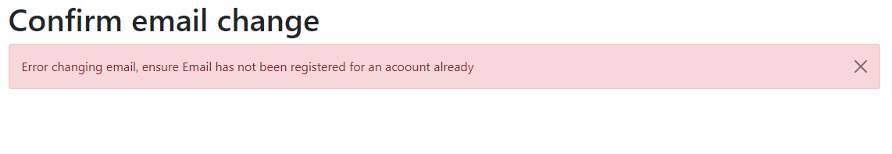

In the previous section, secure software requirements and secure software designs for the authentication feature were addressed to ensure the implementation of a robust and secure authentication mechanism. These measures include:2fa, GoogleRecaptcha,login,sign in ,email configurations

By incorporating these secure software requirements and designs into the authentication feature, the application can better withstand various security threats, protect user accounts and data, and ensure a secure user experience.

## Secure Software Testing

Test Strategy

A Test Strategy outlines the set of guidelines to be followed to achieve the test objective, test design, and how testing is to be executed during the Secure Software Development Cycle at a high level. Due to this high-level approach, (the Test Strategy does not delve into specific details of individual test cases or test scripts. Instead, it focuses on providing an overall framework and direction for testing activities throughout the Secure Software Development Cycle. The Test Strategy typically includes the following aspects:

The main testing method that has been used is logic testing, regression testing and integration testing. These methods work hand in hand to ensure the whole website is running smoothly and output Is as expected.

Test plan

* Focus of the test plan is to ensure that
  1. users are not able to change other user’s passwords.
  2. Each register request made, the appropriate information is stored and monitored by reCAPTCHA
* Testing methods used for
  1. When user first uses forget password function, user would enter email of their account to get the password reset email, they will then click on the hyperlink in the email which would redirect them to the reset password page, where they would then enter a different email to reset password of
  2. Break points will be used to track information stored I variables , to make sure that reCAPTCHA is receiving and returning information

Test cases

1. Email entered:

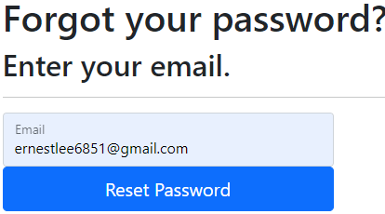

Different email used when resetting password.

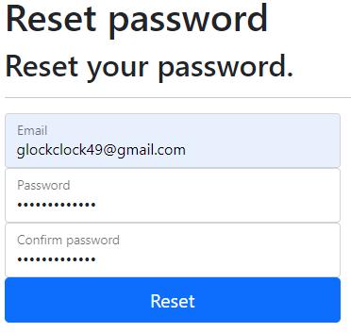

Error received.



1. Breakpoint set inside Register.cs

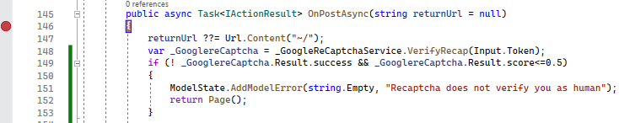

Step into this line to access google ReCAPTCHA file



Step over until this line is reached to view google response. Since there is a response, this means that it is working as expected

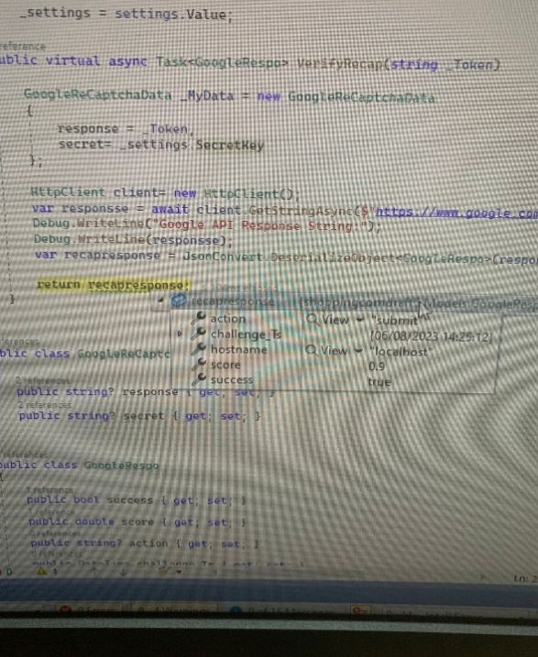

# Feature 2 (Roles/Authorization)

This Authorization feature is a basic and necessary implementation in any application, including the web application in this assignment for Shopping.com.

Authorization is the process of checking a subject’s rights and privileges before granting access to the objects that the subject requests. It plays a crucial role in ensuring the security and integrity of the application and its data. There will be only 4 different roles in the web application (Member, Staff, Administrator, and Owner).

## Secure Software Requirements

There are multiple Access Control Models that can achieve the Authorization requirement that includes Discretionary Access Control (DAC), Non-Discretionary Access Control (NDAC), Mandatory Access Control (MAC), Resource-Based Access Control and Role-Based Access Control (RBAC).

For this web application, we will be using Role-Based Access Control (RBAC). In an RBAC system, users are assigned specific roles, and each role has certain permissions or access rights associated with it. Permissions to operate on objects such as Create, Read, Update or Delete are also defined and determined based on responsibilities and authority (permissions) within the job function. By using RBAC, organizations can streamline access management, enhance security, and simplify the process of granting or revoking access to various parts of a system. Additionally, no user will be attached to more than 1 role, ensuring the principle of Least Privilege.

### Brainstorming

Brainstorming serves as a swift and informal approach to collect security requirements, primarily aimed at pinpointing initial security necessities. This technique facilitates the swift generation of ideas and fosters imaginative thinking. Hence, my team decided to brainstorm and conduct in-depth discussions to produce the roles and corresponding authorizations for the Shopping.com web application. This collaborative effort aimed to identify the various user roles that would best cater to the platform's primary objective while ensuring a secure and efficient user experience. By defining clear roles and their specific permissions, we could establish the requirements for each role and outline the functionalities that should be available in the application.

After thorough deliberation, we settled on four distinct roles for the application:

#### Member

The "Member" role encompasses buyers, who are the primary stakeholders of the platform. Upon registering on the web application, users will be assigned the "Member" role by default. As "Members," users can access and utilize various features, including browsing through an extensive product catalogue, adding items to their shopping carts, and proceeding with secure and hassle-free checkouts. Members play a crucial role in the success of the platform by engaging in transactions and contributing to its growth through their purchases. By default, every user gets a member role after registering.

#### Staff

The "Staff" role represents employees or team members responsible for managing product listings on the platform. Staff members are entrusted with essential responsibilities, including creating new product listings, updating existing product information to ensure accuracy and relevance, and deleting listings when necessary. Staff members' contributions are essential in maintaining an up-to-date and attractive product catalogue, thereby enhancing the overall user experience.

#### Administrator (Admin)

The "Administrator" role is dedicated to employees or team members responsible for overseeing the security and smooth operation of the web application. Administrators have the following key responsibilities: monitoring actions of Members, Staff, and Admins and Owners within the web application for any suspicious activities or policy violations, taking appropriate actions against Members who violate the terms and conditions of the platform, including removing roles from their "Member. Admins are the guardians of the platform's integrity and are responsible for ensuring a safe and secure environment for all users.

#### Owner

The "Owner" role holds the highest level of authority within the web application. Owners have ultimate responsibility for overseeing the entire platform and have the following responsibilities: assigning roles to Staff members, enabling them to manage product listings and perform administrative tasks, assigning roles to Admin members, responsible for monitoring the web application's security and adherence to policies and regulations, and accessing Audit logs to ensure that Staff and Admin members are acting in the company's best interest and not engaging in any harmful activities. When the Owner assigns Admin/Staff role to a user, their Member role will be removed from them to ensure abiding by the principle of Least Privilege.

#### Without any roles

Users who find themselves "Without Any Roles" are unable to access any web page on the platform. This situation occurs when the Owner or Admin removes roles from a Member, Staff, or Admin who violates the platform's terms and conditions or harms the company's interests.

Accidental removal of roles is reversible, and the Owner or Admin can re-assign the correct roles to affected users upon verification of any unintentional actions.

Everyone will only have one role assigned to them unless they are removed from the Member role. This is set to ensure that the web application abides by the principles of Least Privilege, providing each of them the permissions needed to complete their task.

### Table of roles in Shopping.com

Owner, Staff, Administrator and Member roles and their permitted actions.

|  |  |  |  |  |  |  |  |  |
| --- | --- | --- | --- | --- | --- | --- | --- | --- |
|  | Organisation permission | | | | | | | |
| Role | Create Listing | Read Listing | Update Listing | Delete listing | Purchase Listing | Assign/Delete Member role | Assign/Delete Staff/Admin role | Audit log |
| Owner |  |  |  |  |  | ✓ | ✓ | ✓ |
| Admin |  |  |  |  |  | ✓ |  | ✓ |
| Staff | ✓ | ✓ | ✓ | ✓ |  |  |  |  |
| Member |  | ✓ |  |  | ✓ |  |  |  |
| No role |  |  |  |  |  |  |  |  |

### Use Case and Misuse Case Modelling

For this web application, the owner’s email and password are seeded into the database in advance, so the owner can log in without having to register. On the other hand, every individual, including staff and admin, will be required to register. After registering, everyone will get a default member role. The owner needs to assign staff/admin roles to Shopping.com employees so that they can perform their job. These roles contain permission needed for employees to perform their job. There is a probability that the owner accidentally assigns a staff/admin role to the wrong user. In this case, the owner or the user should realise the error and the owner should reassign the correct roles to the user to allow the user to perform their job while abiding by the principle of Least Privilege.

If the user gains more permission than what is needed to perform their task such as having admin/staff roles and does not inform the owner, they can abuse their roles and permission by accessing data that is not supposed to be accessible to them, such as audit logs and other users’ personal data. If they get staff roles, they can create, edit, and remove listings, damaging the interest of Shopping.com. If they get Admin roles, they can remove users from their member roles so that users cannot access the website properly.

Attackers may have insider information on the roles and permission of different users in Shopping.com. They will try to attack those account that has Staff, Admin and Owner roles to get more permissions and privileges through attacks such as CSRF, SQL injection and Brute forcing. This may result in privilege escalation. The attacker can assign Staff/Admin roles to the wrong user, view Audit logs, edit listings information, or even delete listings. This will affect the confidentiality, integrity, and availability of the website.

Users of all roles hold the crucial responsibility of preserving confidentiality and integrity within the application. Users in the Owner role are accountable for ensuring the accuracy of assigned roles, adhering to the Least Privilege principle. On the other hand, non-Owner users are responsible for the roles assigned to them, promptly notifying the owner about any misassigned roles.

Below is a diagram of the use and misuse cases discussed above.

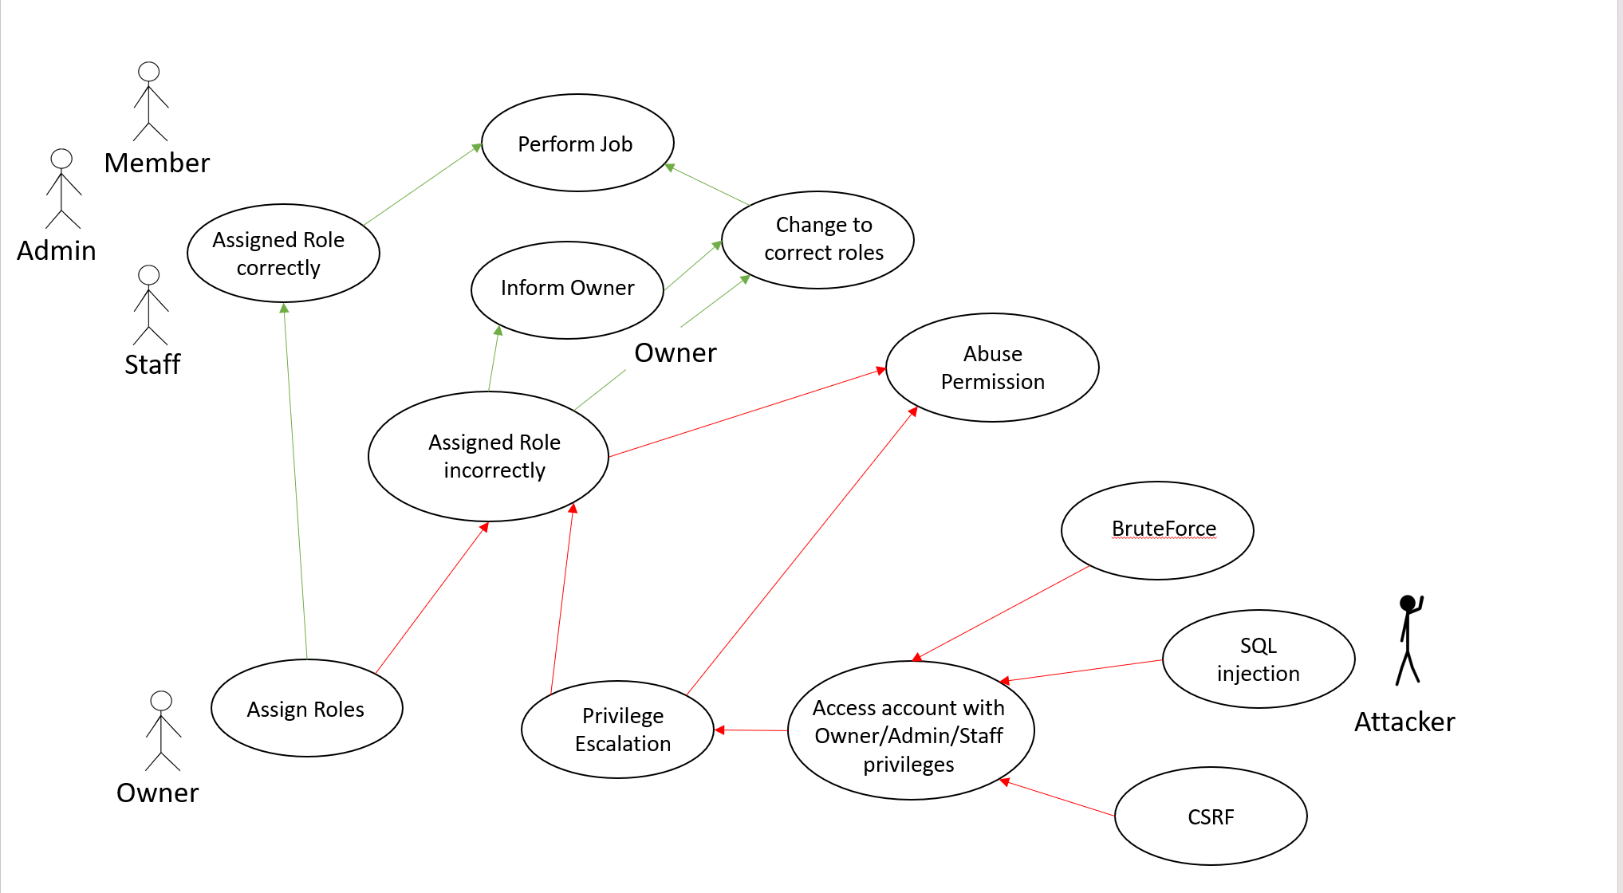

### Data Labelling & Classification

When assigning roles, the owner/admin will search for the user’s email address. The email address acts as a primary key that allows the owner/admin to search for individual users when assigning them roles.

When a user is promoted to admin, they can see the list of users with member roles. The owner can see everyone’s email and their corresponding roles.

The following table illustrates how sensitive the user’s data is, following the CIA triad using the classification chart below.

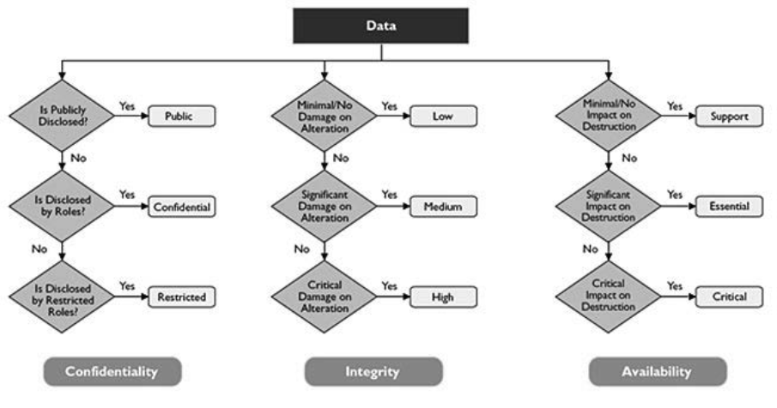

|  |  |  |  |
| --- | --- | --- | --- |
| Data | Confidentiality | Integrity | Availability |
| Email | Restricted | High | Essential |
| Role assigned | Restricted | High | Essential |

### Subject/Object Matrix

Roles represent subjects capable of executing actions within the system, while objects denote the resources subject actions are directed towards. It is crucial to comprehend the permissible actions each subject can take on objects, ensuring software security and appropriate access levels for subjects.

|  |  |  |  |  |  |  |  |  |
| --- | --- | --- | --- | --- | --- | --- | --- | --- |
|  | Organisation permission | | | | | | | |
| Role | Create Listing | Read Listing | Update Listing | Delete listing | Purchase Listing | Assign/Delete Member role | Assign/Delete Staff/Admin role | Audit log |
| Owner |  |  |  |  |  | ✓ | ✓ | ✓ |
| Admin |  |  |  |  |  | ✓ |  | ✓ |
| Staff | ✓ | ✓ | ✓ | ✓ |  |  |  |  |
| Member |  | ✓ |  |  | ✓ |  |  |  |
| No role |  |  |  |  |  |  |  |  |

The web application's roles have distinct access to specific pages and actions. By grasping the matrix of subjects and objects within the web page application, we can formulate a secure system that grants subjects precise resource access, avoiding unnecessary privileges or undue restrictions.

## Secure Software Design

After identifying possible vulnerabilities, it is time to design security features for the Roles/Authorization features. Usability should not be neglected when designing security features. However, should security come as an afterthought, it will take even longer and more complicated to implement the necessary features for the web application. Hence, there is a need for a balance and priority on both security and useability when designing features.

### Features related to security design.

When assigning roles to users, it is important for us to abide by the principles of Least Privilege and Separation of Duties. Ensuring that the roles and their authorised actions make sense can affect the overall useability of the application. Additionally, there should be a balance between security and useability.

#### Least Privilege

The least privilege principle helps to limit the attack surface of the web application. Only the necessary and minimum level of access rights (privileges) has been given to explicit users for them to complete their tasks. This will reduce the damage a user does, intentionally and unintentionally to the web application. In the case of our web application, it is most applicable to have control over members, listings, audit logs and assignment/removal of roles from users.

By default, all newly registered users will be assigned a member role by default, except for the owner, who has an owner role by default. The member role contains the least privilege out of the other roles. Users with member roles can only read listings, add listings to the cart and purchase the listings. This reduces the risk of the Owner accidentally giving users Admin/Staff roles with higher privileges than what they need as a buyer. It helps to contain the damage that can arise from an accidental or purposeful security breach by limiting the disclosure of sensitive information, such as auditing logs and prevents the users from editing listings or roles attached to users in the web application.

On the other hand, permissions assigned to other roles are ensured not to be outside of their assigned task. Such as Users with Admin and Owner roles. They are only able to read the audit log and are unable to edit it. This can prevent attackers that gained unauthorised access to accounts with Admin/Owner roles and edit the audit logs.

#### Economy of Mechanisms

A key challenge faced when implementing the security features is the trade-off between useability and security features that need to be implemented.

In the initial stages of development, the team considered allowing users to freely customize permissions within the organization. However, enabling extensive customization could lead to the creation of numerous permission combinations. This complexity might render the application challenging to navigate, causing confusion among users when deciding which role to assign to individuals. This confusion could potentially prompt users to generate new roles, exacerbating the situation and deviating from the principle of the Economy of Mechanisms.

Additionally, the potential for permission conflicts could arise, such as having the ability to delete listings, but not reading it. Implementing such an intricate access control system is not a straightforward endeavour and introduces the risk of expanding the attack surface or encountering unanticipated edge cases. This approach would raise concerns regarding security and usability, as some individuals might end up with excessive or inadequate permissions, thus violating the principles of Least Privilege and Separation of Duties, respectively. Moreover, there is a possibility of users misusing their access privileges, leading to data leaks or malicious attacks on the web server or application.

Therefore, it becomes crucial to carefully consider which permissions should be accessible to users and what combinations would be applicable to the majority, given that roles and their associated permissions will remain fixed. The naming of each role should also be user-friendly and comprehensible. All these considerations aim to streamline and simplify the process of assigning the appropriate roles to each user, ensuring a more intuitive and efficient workflow.

### Attack Surface Evaluation

The possible threat first needs to be identified, before thinking about the attack surface of the roles and authorisation feature.

Identifying Entry Points:

Entry points are points in the web application where users can input a string. Input is always to be encoded and every entry points are to be explicitly identified and secured. However, for the Roles and Authorization page where Owner/Admin assign and remove roles, there is a dropdown list where Admin/Owner can assign/remove roles from the user.

The entry point may be a risk if it is not implemented properly, Admin may make use of bugs in the dropdown list to assign himself an Owner role, allowing him to have an escalation of privileges and cause more damage to the web application.

Identifying Exit Points:

Exit points are information displayed in the system. Basically, the output is given by the web application after an action is performed. Exit points are also important and must be secured. The Roles and Authorization page only have an exit point. There is an exit point as it searches email and the corresponding roles and shows it to the Admin/Owner that is on the page.

The exit point may be a risk as it may leak important information such as emails that have Admin/Staff/Owner roles. Allowing Attackers to know which account to attack to gain escalation of privileges. Hence, it is important to protect this exit point to prevent data leakage.

### Threat Modelling

Based on the vulnerabilities outlined earlier, constructing an attack tree becomes possible. This approach offers a more holistic view of the vulnerabilities, aiding in the identification of potential and applicable threats. This comprehensive view contributes to enhancing the application's security and user confidence. Additionally, it facilitates the formulation of effective countermeasures for the identified vulnerabilities. The resulting attack tree serves as a valuable tool in achieving a robust and secure application, instilling a sense of safety among users.

#### Identify Threats

As previously mentioned, the drop-down list input is a prime target for potential cyberattacks, enabling attackers to exploit vulnerabilities. This situation poses a significant threat to the overall security of the application. Since an account with Owner/Admin role can access the Roles management pages, attackers can exploit vulnerabilities of the dropdown list to assign/remove any roles from any user in the web application. This could cause major consequences as wrong roles will be assigned to the wrong users and cause great harm to the web applications such as deleting all the listings on the website.

Attackers can also make use of the visible role assignment to target certain account that has Staff/Admin roles and find ways to gain entry to their accounts. Attackers can orchestrate Cross-Site Request Forgery (CSRF) attacks to obtain their session cookie to gain unauthorized access to the targeted account. If the attacker successfully gains access to the Owner account, they can attach their accomplice account with roles that have higher privileges in the web application, leading to a Privilege Escalation.

#### STRIDE List

Based on the Use Case and Misuse Case, along with the identified attack surface areas addressed in the previous section, a STRIDE category threat list is used for categorizing the potential threats identified as depicted in Figure(image)

|  |  |
| --- | --- |
| Goal | Identifies Threats |
| Spoofing | Impersonate Identity à Get access to account with Staff/Admin/Owner role. |
| Tempering | Modify roles permission.  Modify roles attached to the account |
| Repudiation | Modify Audit logs |
| Information Disclosed | Steal sensitive information.  Credential theft |
| Denial of Service | Flood attacks (E.g. UDP flood, HTTP flood)  Protocol attacks (e.g. ping of death) |
| Elevation of Privilege | Brute Force Password  Quid pro quo  SQL injection  Assign the wrong roles to the user  Bribery/Threatening  Phishing |

#### Attack Tree

Expanding on the STRIDE List earlier, an attack tree model allows for brainstorming of potential threats from the attacker’s perspective. This further strengthens the security of the software by identifying the attack path an attacker may take and implementing countermeasures to mitigate or prevent these attacks. The attack tree is shown below:

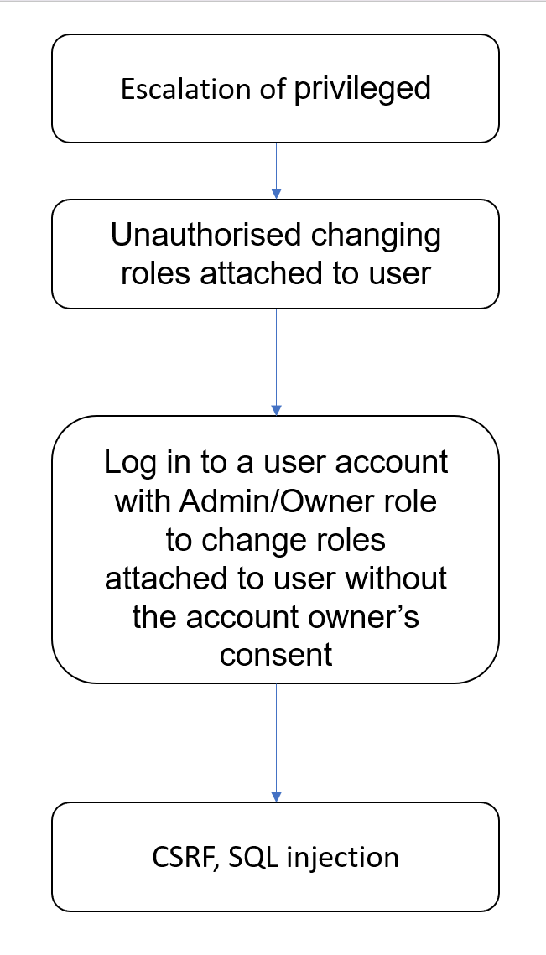

#### Average Ranking

Following the identified threats, calculating the average of numeric values assigned to risk ranking categories is another approach for rating the threat’s danger shown in below.

|  |  |  |  |  |  |  |
| --- | --- | --- | --- | --- | --- | --- |
| Threat | D | R | E | A | DI | Average Rank (D+R+E+A+DI)/5 |
| CSRF | 3 | 1 | 1 | 1 | 1 | 1.4 (Medium) |
| Quid Pro Quo | 2 | 3 | 3 | 2 | 3 | 2.6 (High) |
| Phishing | 2 | 3 | 3 | 2 | 3 | 2.6 (High) |
| Logic Flaws | 3 | 2 | 3 | 3 | 1 | 2.4 (High) |
| DDoS | 3 | 1 | 3 | 3 | 3 | 2.6(High) |
| XSS | 2 | 3 | 2 | 2 | 3 | 2.4 (High) |

#### Control Measures

After identifying the threats to the web application, it is time to identify control measures to mitigate the threats. The threats and their corresponding control measures will be documented in the table below:

|  |  |
| --- | --- |
| **Threats** | **Control Measures** |
| Quid Pro Quo / Phishing | Organisation-wide policies |
| Logic Flaws | Regular Security Assessments  Patch Management |
| CSRF | Use a unique session token |
| DDoS | Cooldown between API requests |
| XSS | Use dropdown list as input field |

Out of all the control measures mentioned in the table above, only some measures were implemented in the final application.

## Secure Software Coding

After identifying the potential threats and countermeasures of the web application, the implementation of security features can take place.

### Features related to Defence Coding Practice

When incorporating security features, it is important to consider the feature's functionality as well.

#### Using Drop down list as an input field

Using a dropdown list as input can help prevent Cross-Site Scripting (XSS) attacks. Unlike text fields or text areas where users can type their inputs freely, dropdown lists restrict users to selecting from available options. This prevents attackers from injecting scripts or harmful code since they have no opportunity to input arbitrary content.

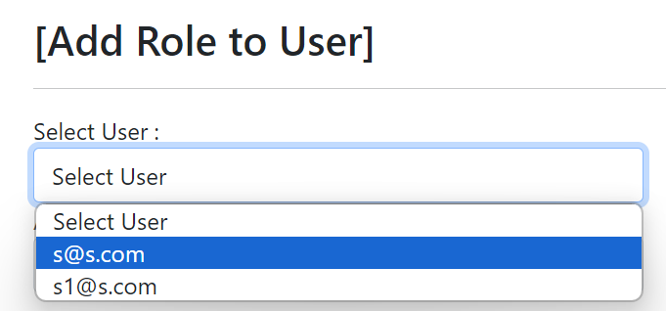  
User unable to type.

### Secure Software Process

During the coding process, specific practices can enhance the implementation by promoting security enhancements and aiding in the detection of vulnerabilities. This approach also contributes to refining software design and overall effectiveness.

#### Versioning

Versioning holds significant importance in the development process. When team members work on varying application versions, merging distinct codebases becomes challenging. In many cases, the different features of the application need to work together to function. This is especially true with the Roles/Authorisation feature, as it affects what actions users are permitted to perform. Failing to collaborate on the latest version containing updated permissions for each role can impact the application's confidentiality, integrity, and availability negatively. Additionally, versioning allows us to roll back to the previous version if necessary.

Currently, we are using GitHub for versioning. We can pull the updated code from the repository and merge it with our code, before pushing it, ensuring everyone is editing on the newest version. We can also create a branch where it is an isolated environment that do not affect our master branch. It also allows us to track each of our updates and roll back if necessary.

#### Code Analysis

The code responsible for Roles/Authorization undergoes a thorough evaluation to assess its quality and vulnerabilities. This examination aims to detect any potential bugs or exploitable points that attackers could exploit.

First, static code analysis will be performed on the feature’s code. This step serves two purposes: ensuring efficient code compilation and verifying the accuracy of authorizations assigned to each role. This analysis is a crucial starting point as user actions within the application are tightly controlled based on their role-based authorization.

Index.cshtml

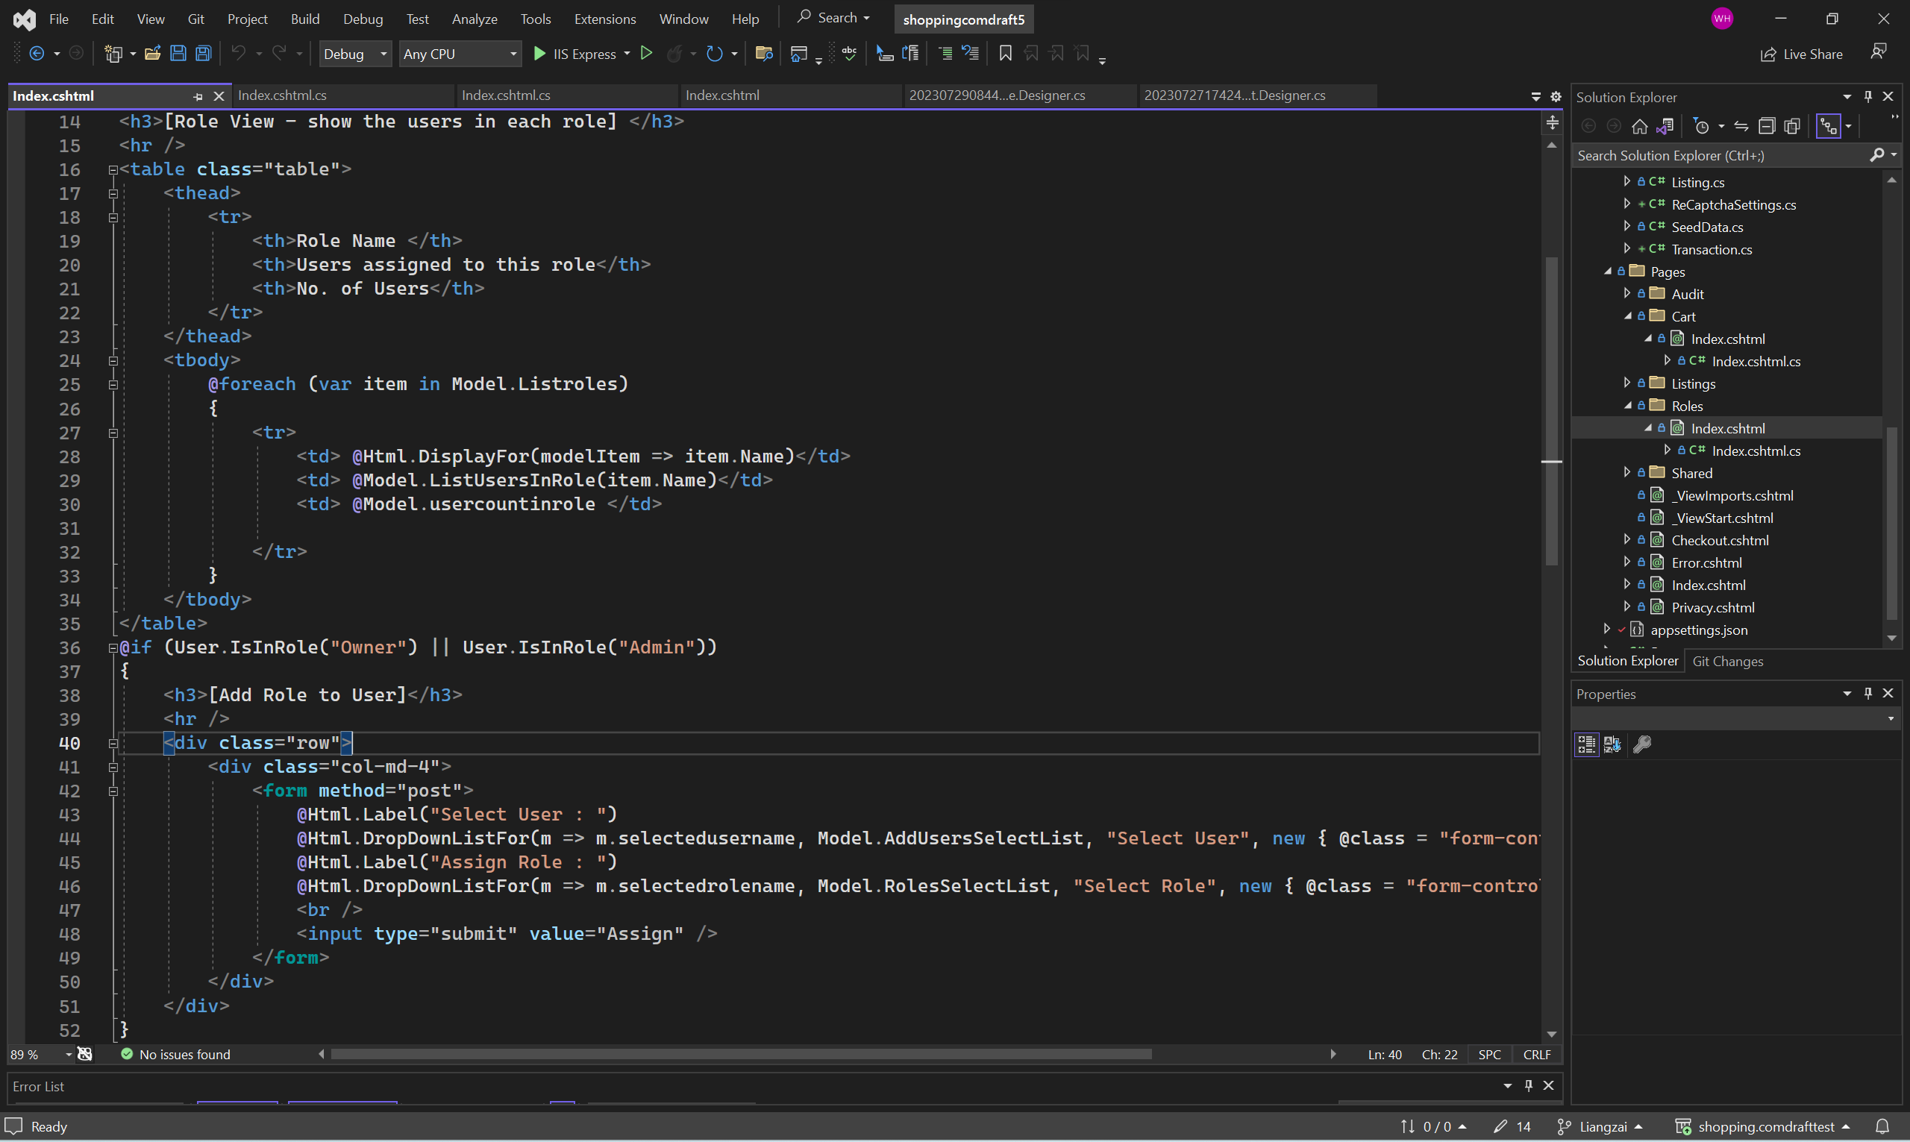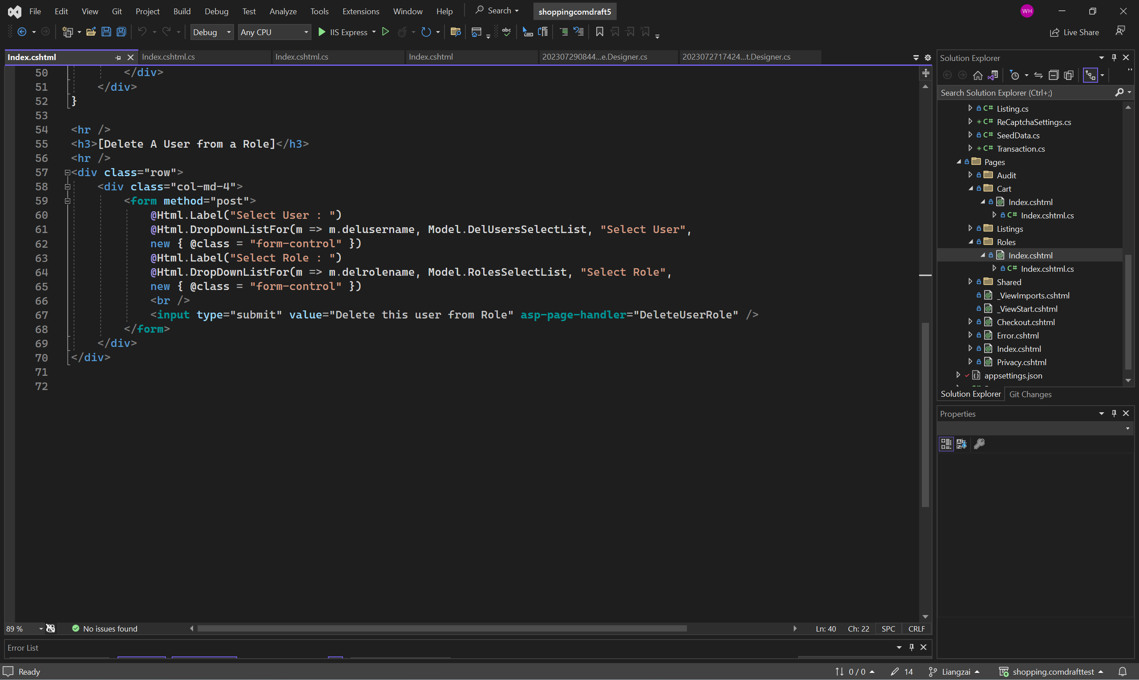

Index.cshtml.cs

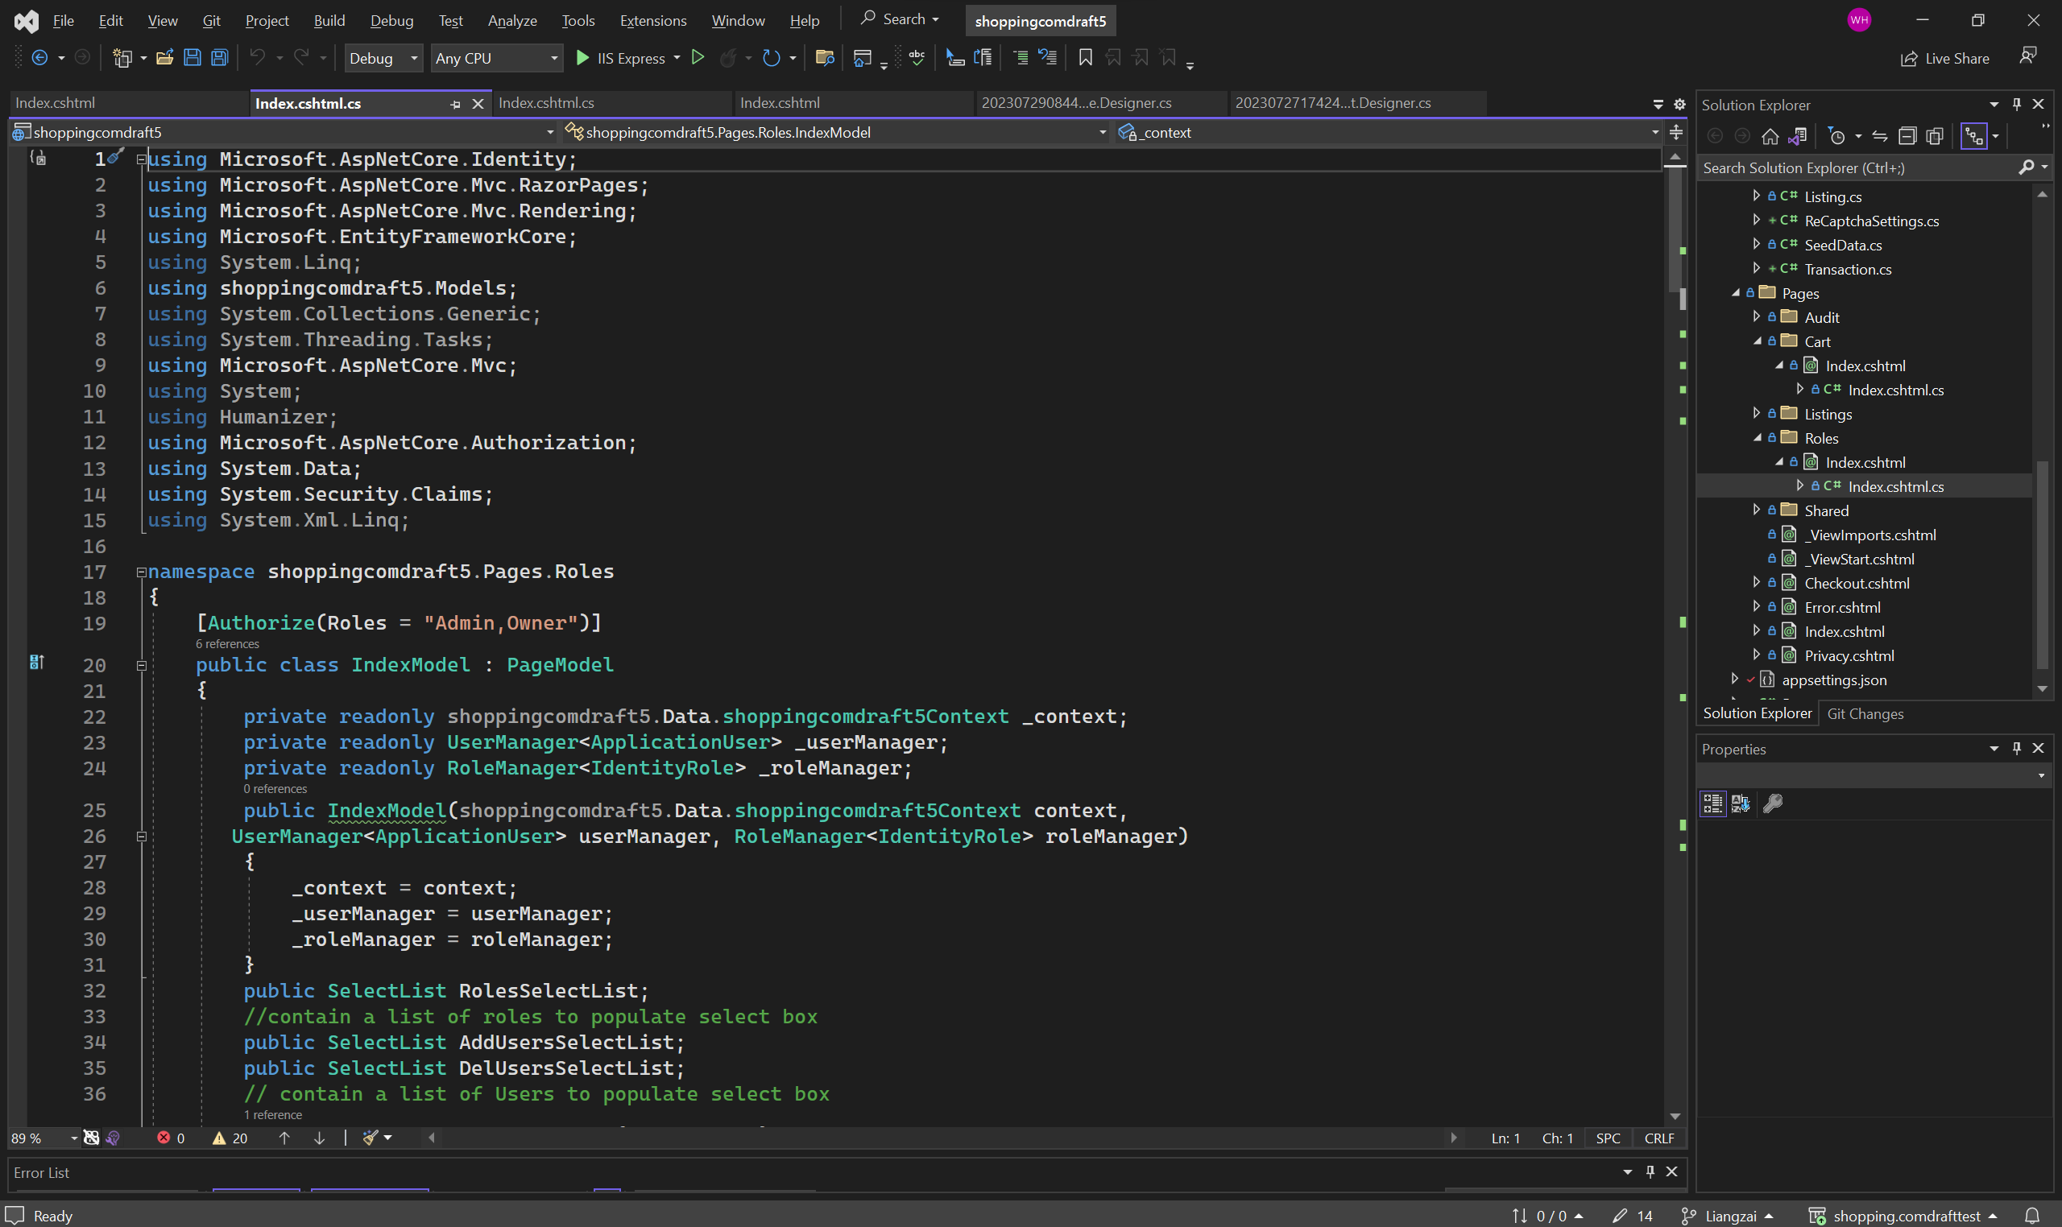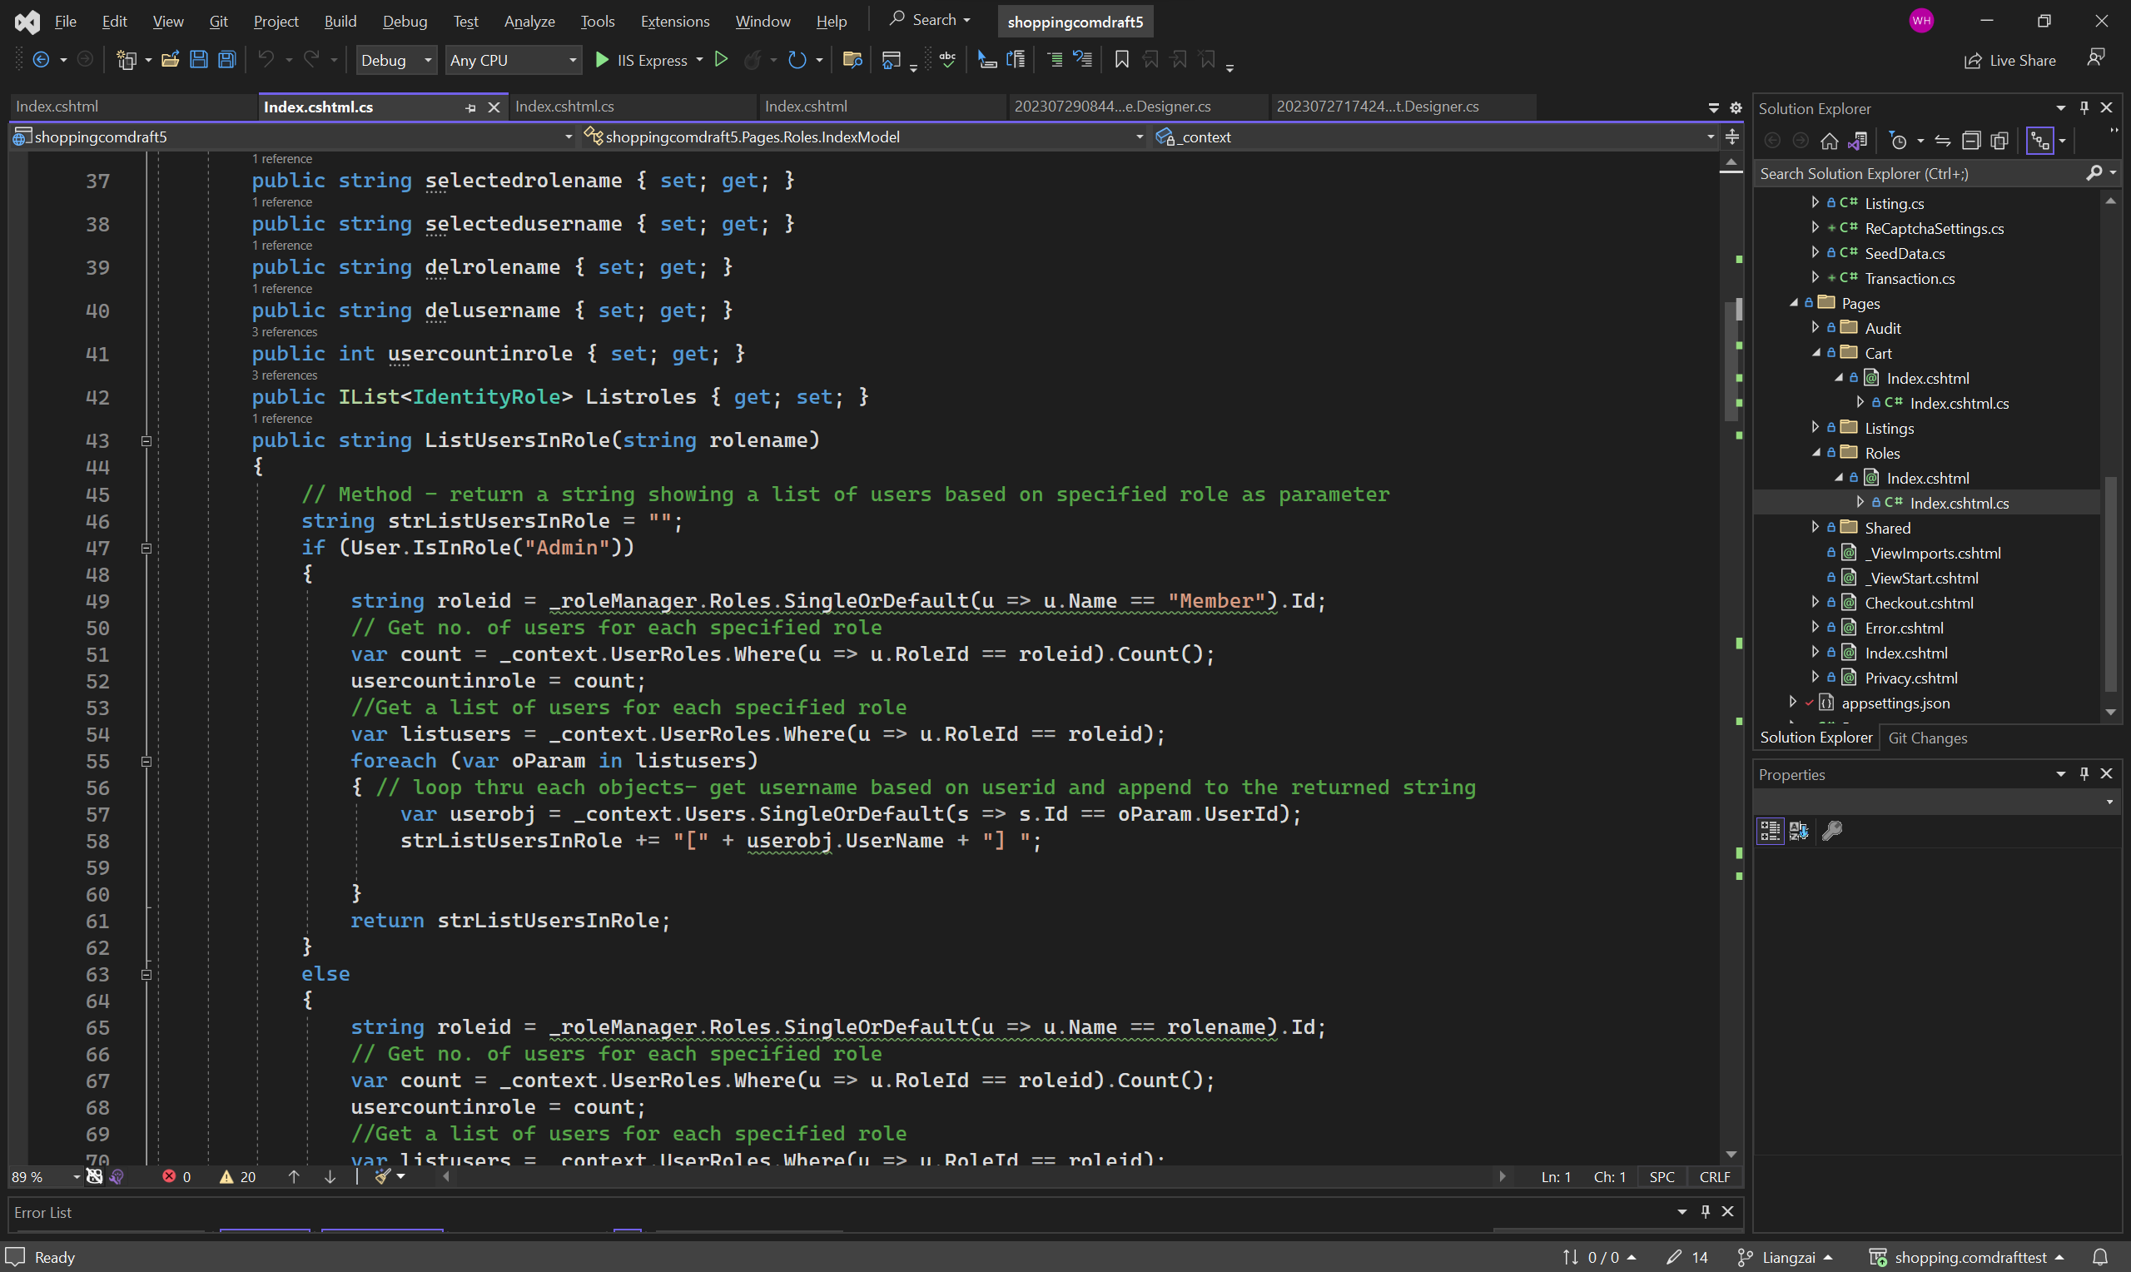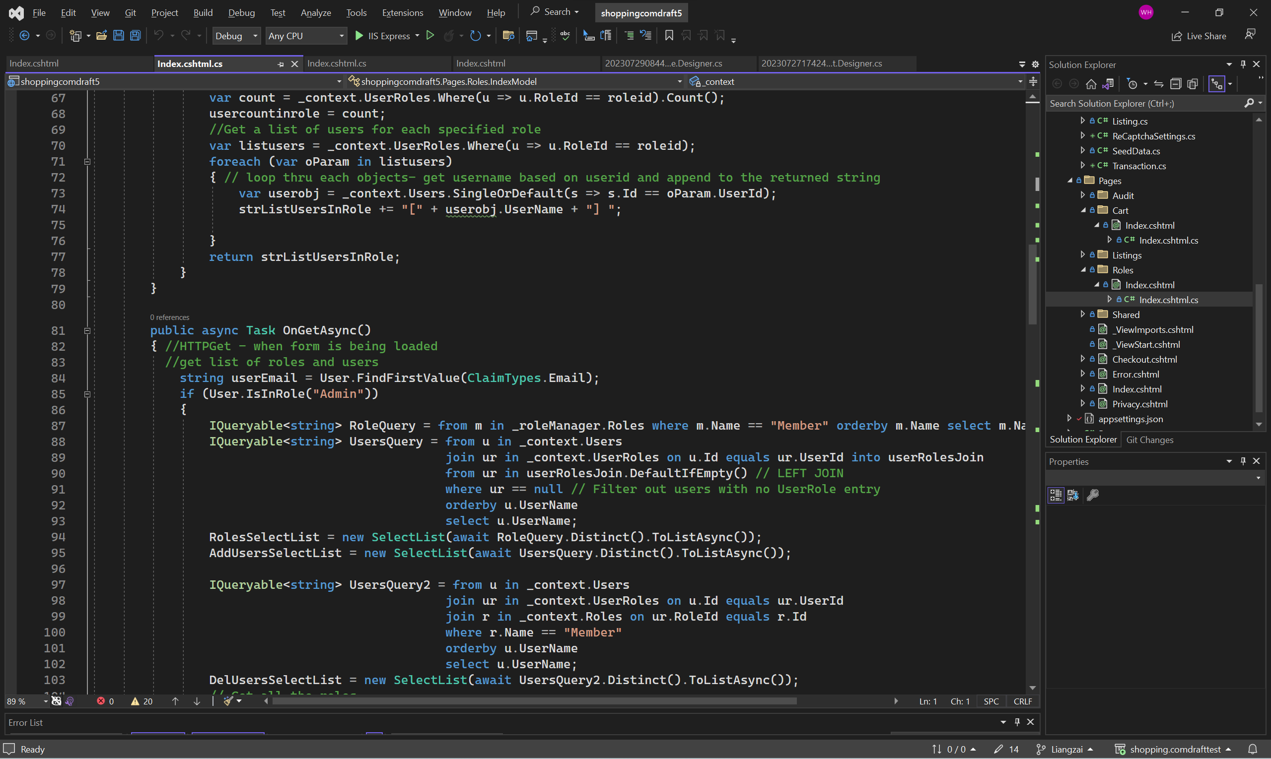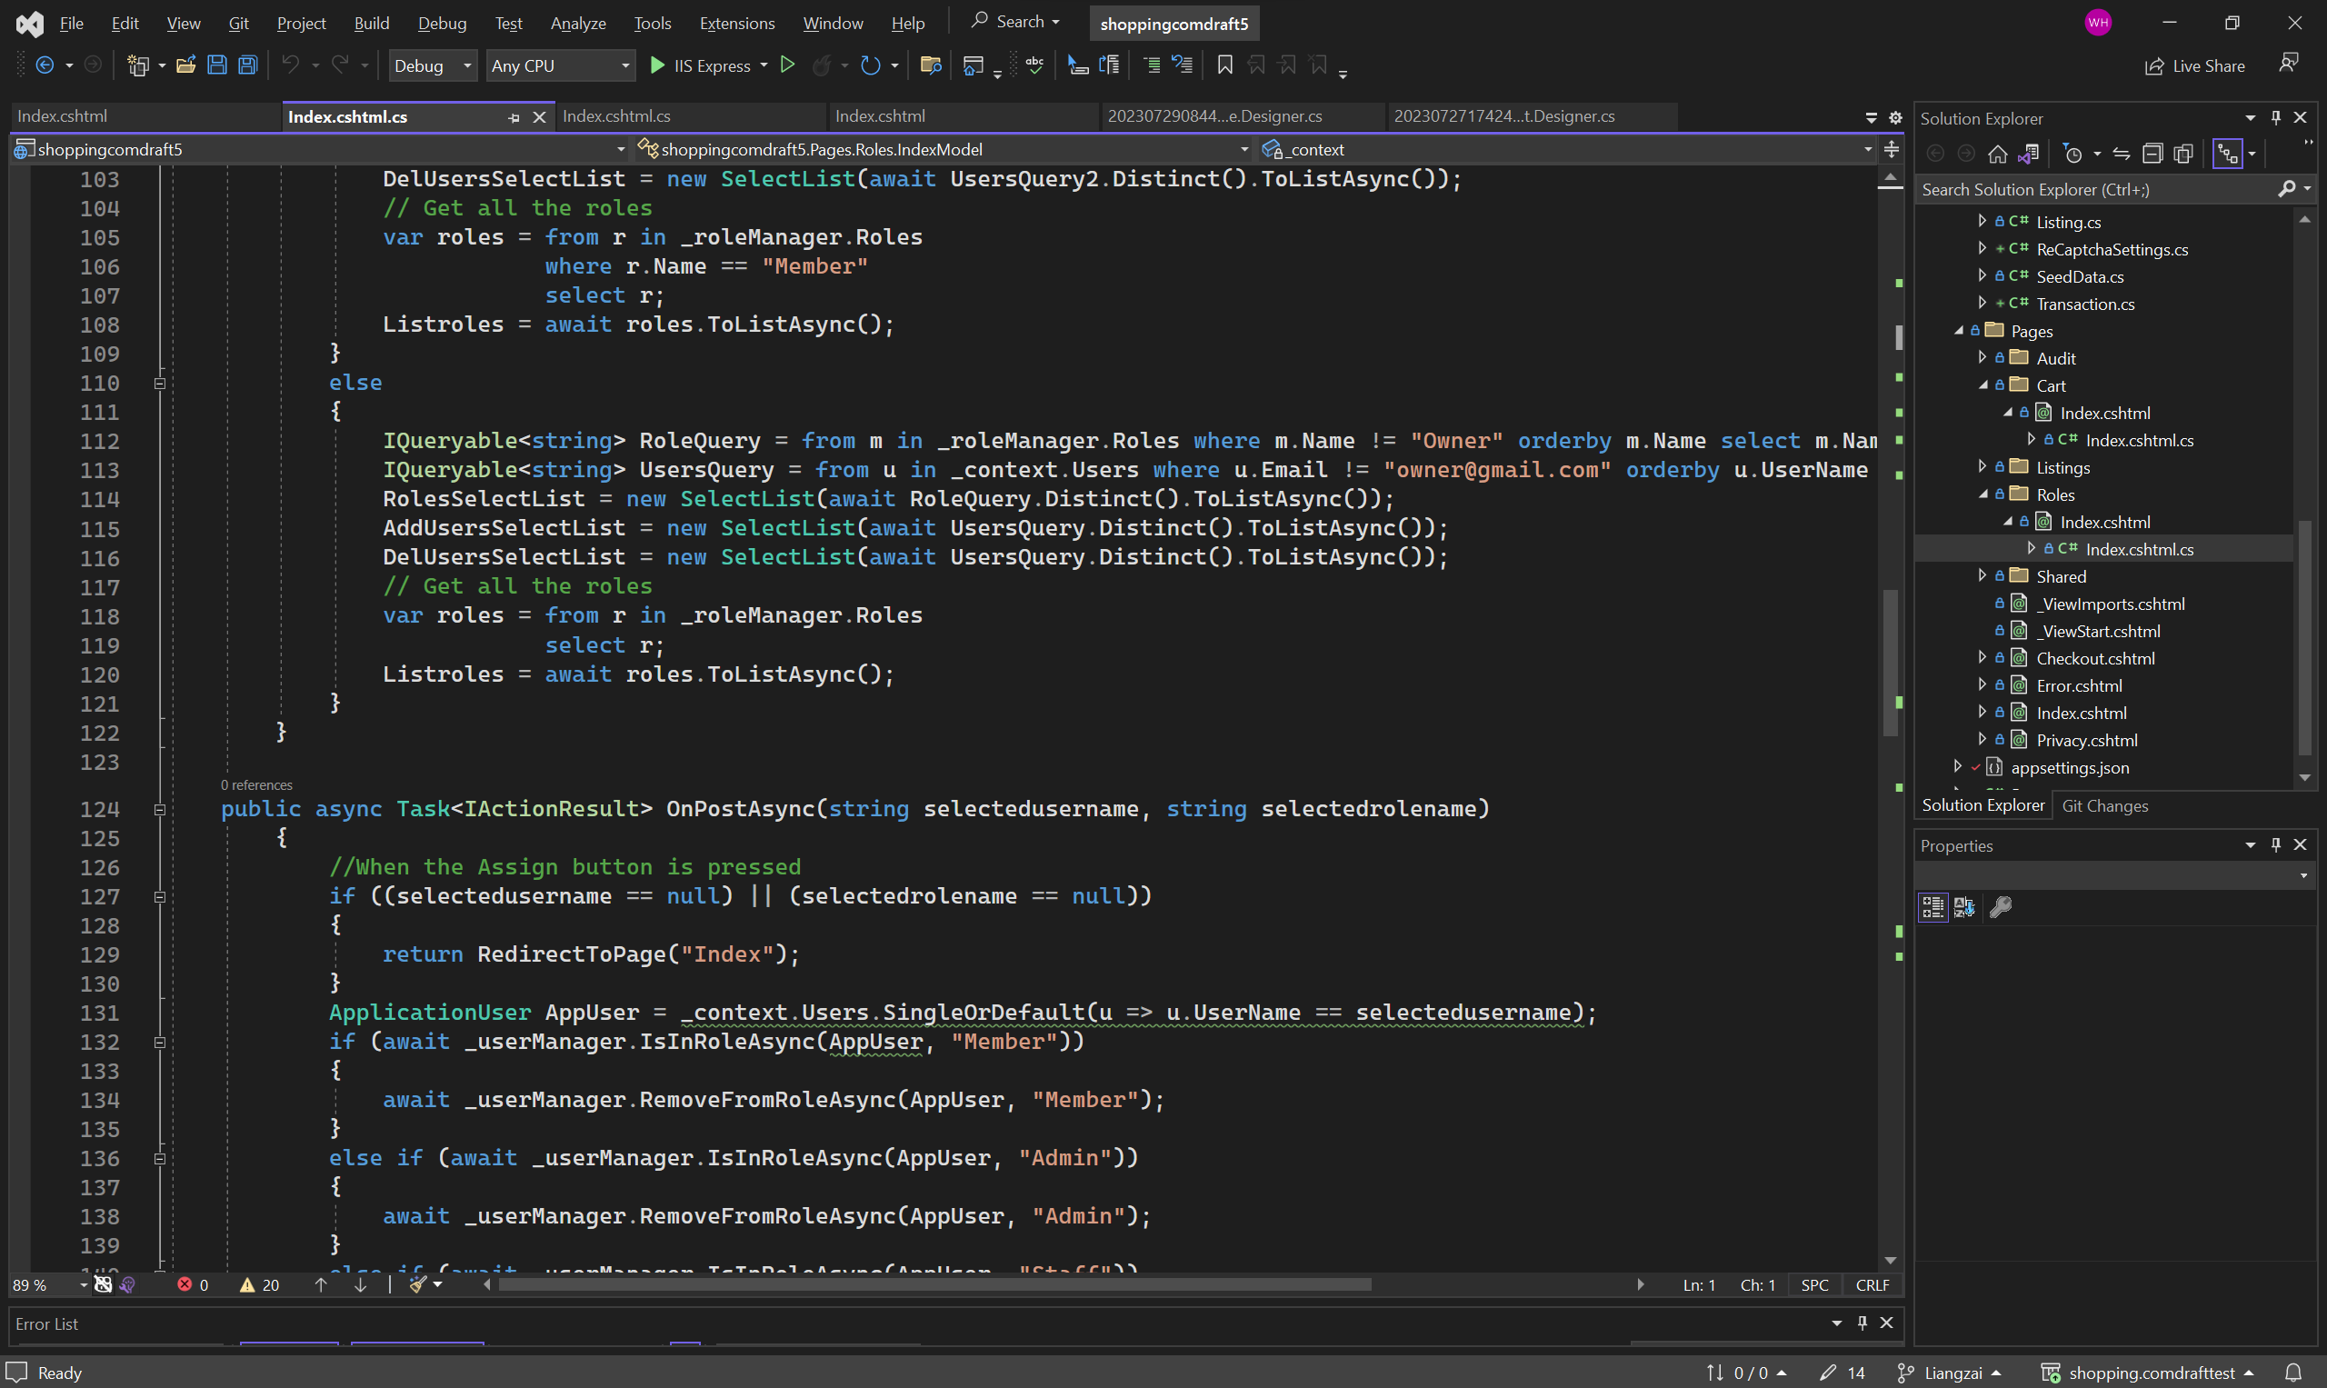

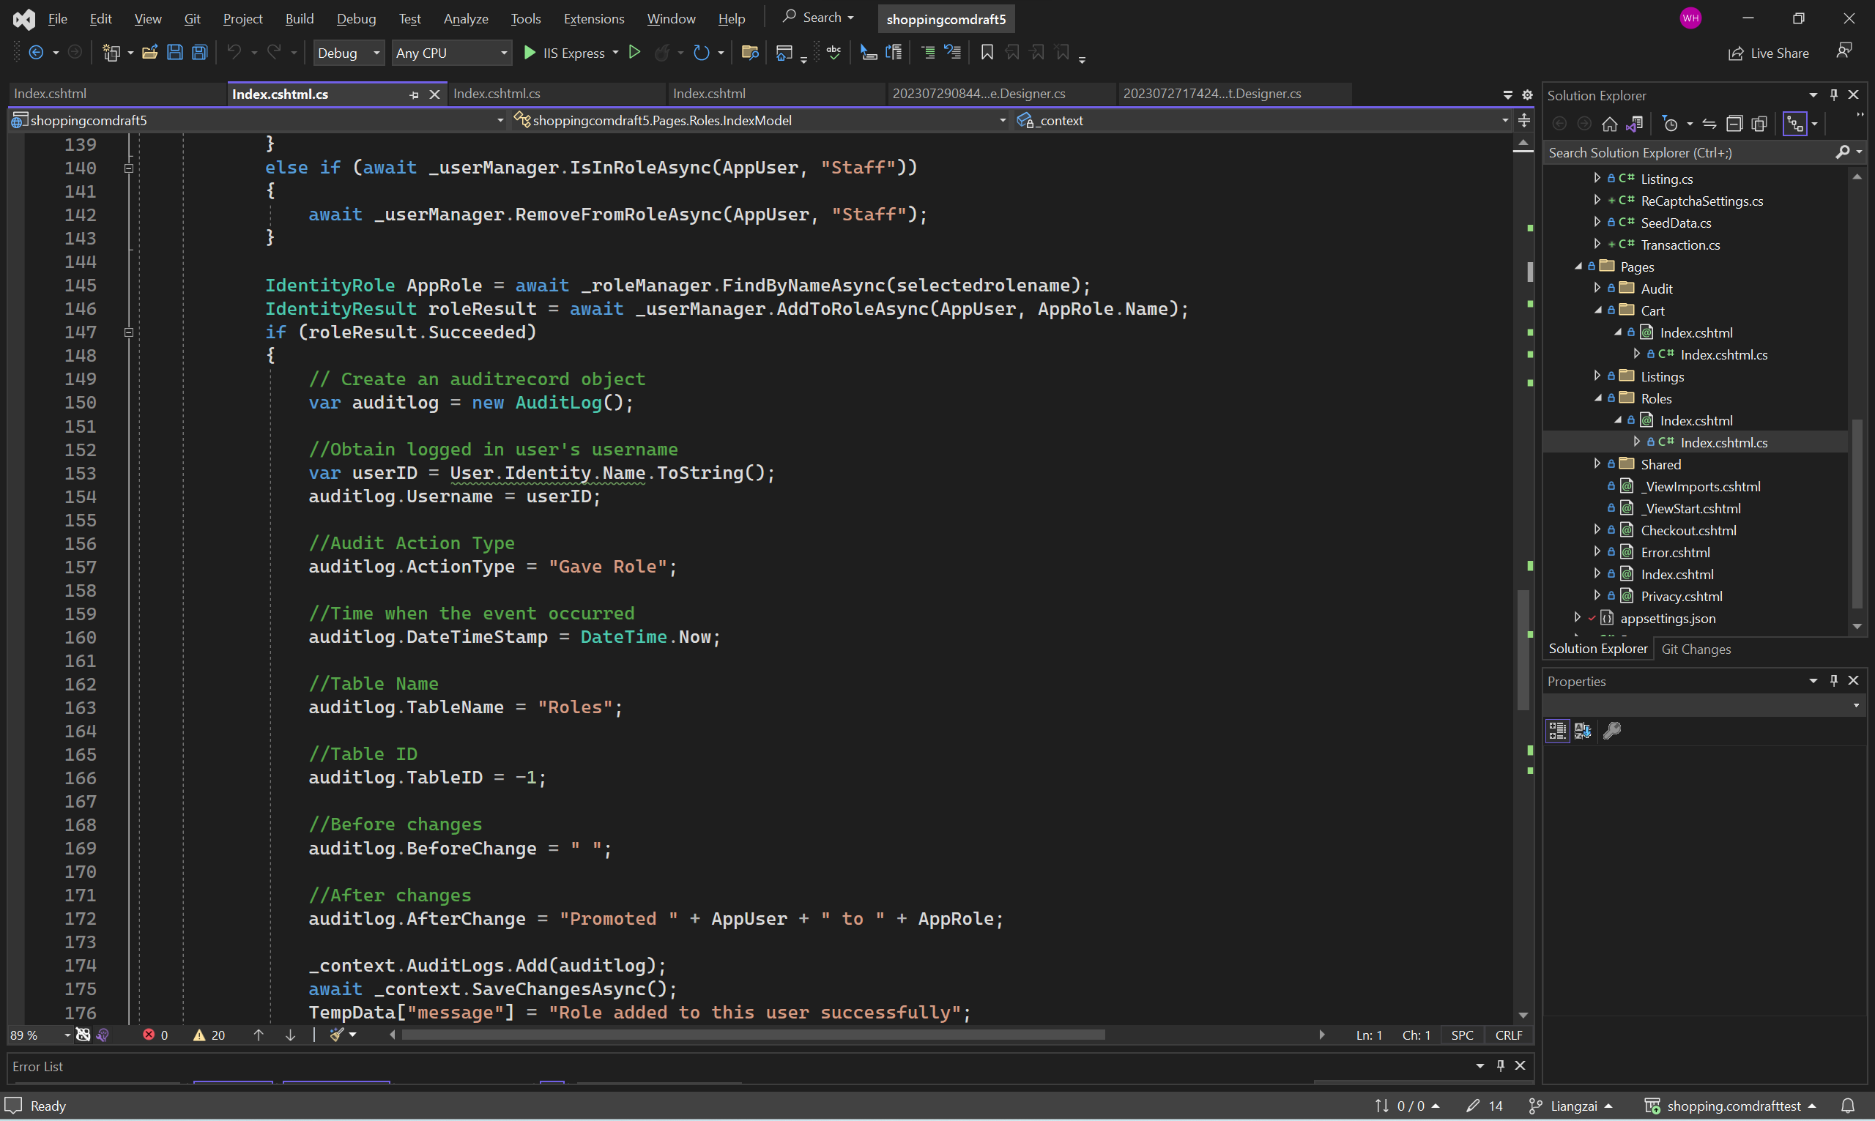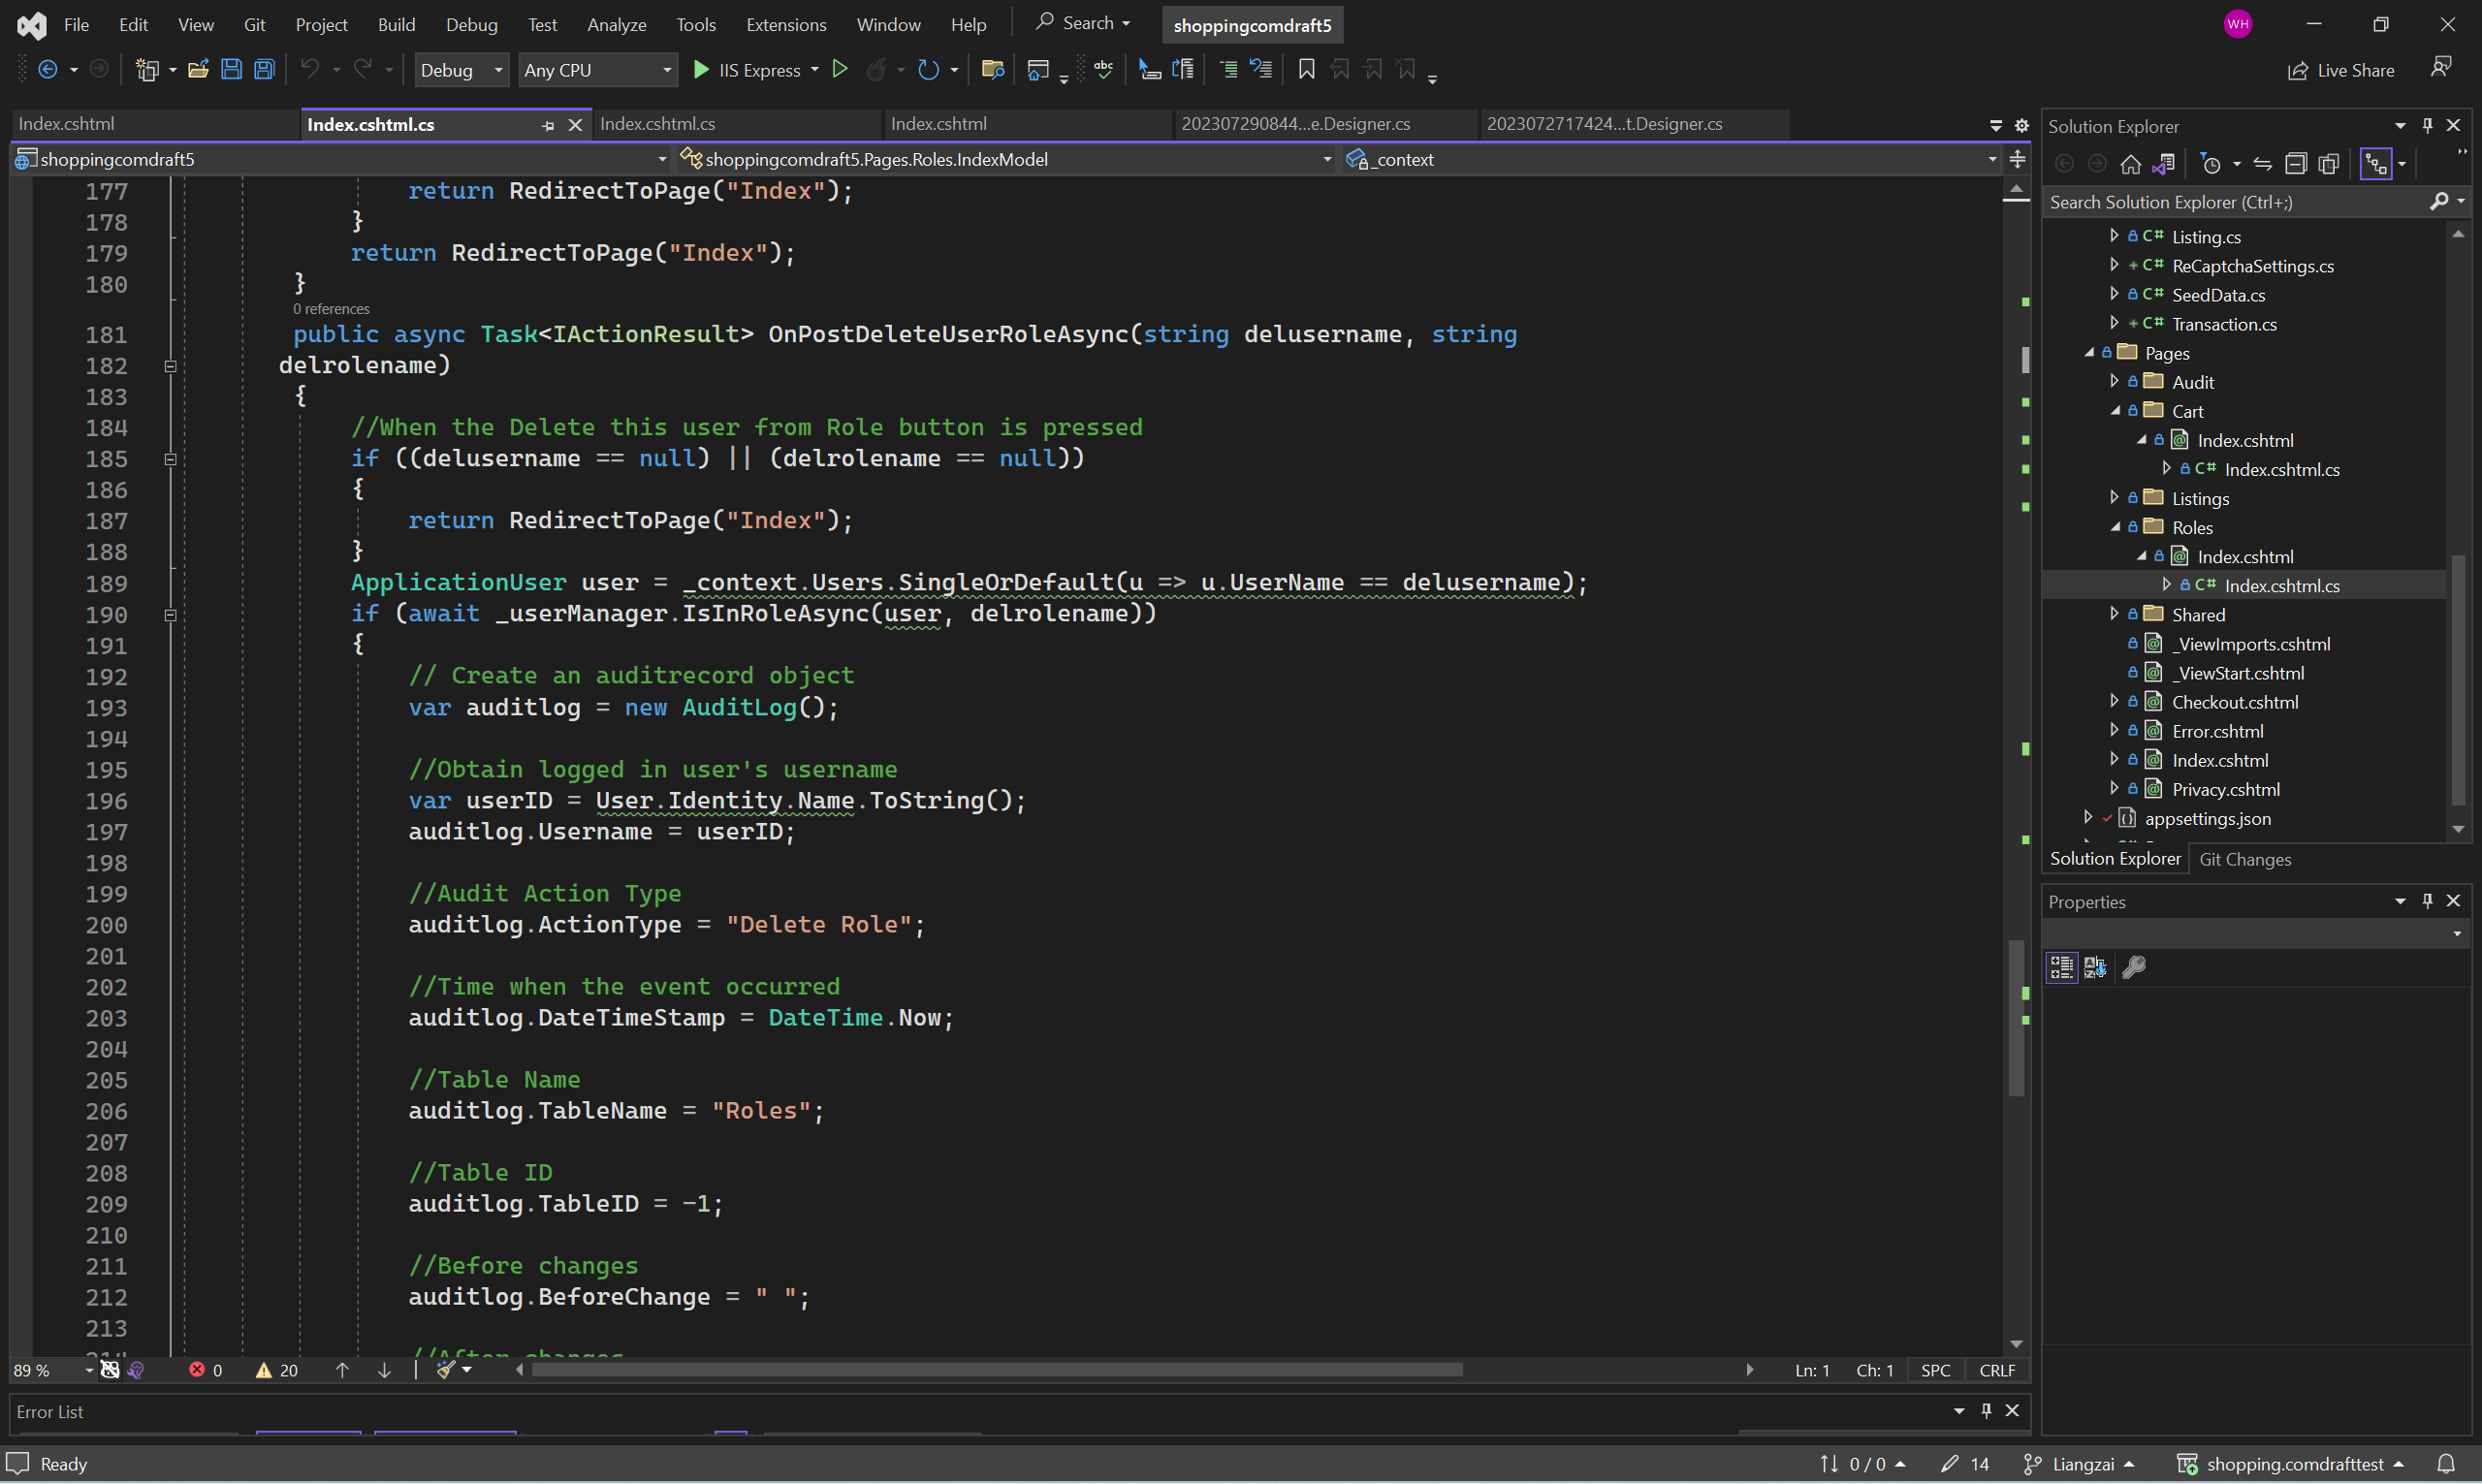

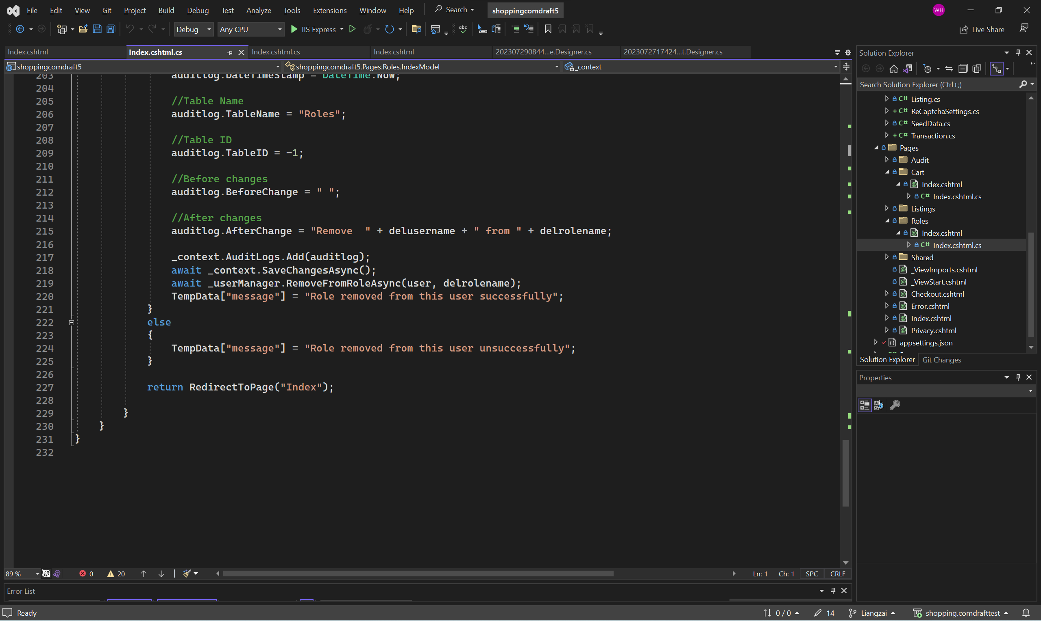

Authorize code for each page in the web application.

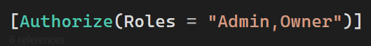

After ensuring that there are no visible vulnerabilities in the code, the application is run in the browser to ensure that the feature is working as it should be. Although no visible bugs were identified, the feature must work in conjunction with other features of the application. Hence, during the application launch, it becomes crucial to verify that the feature operates flawlessly. Interacting and using the application is the best way to check if the application is running smoothly, also known as dynamic code analysis.

Assigning roles for Owner account (Before)

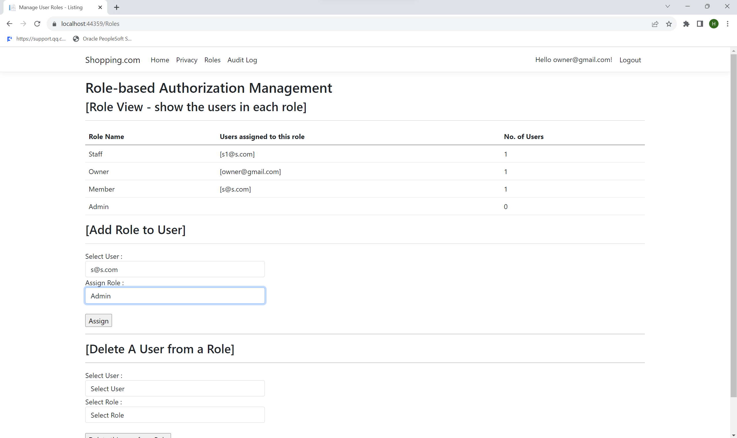

Assigning roles for Owner account (After)

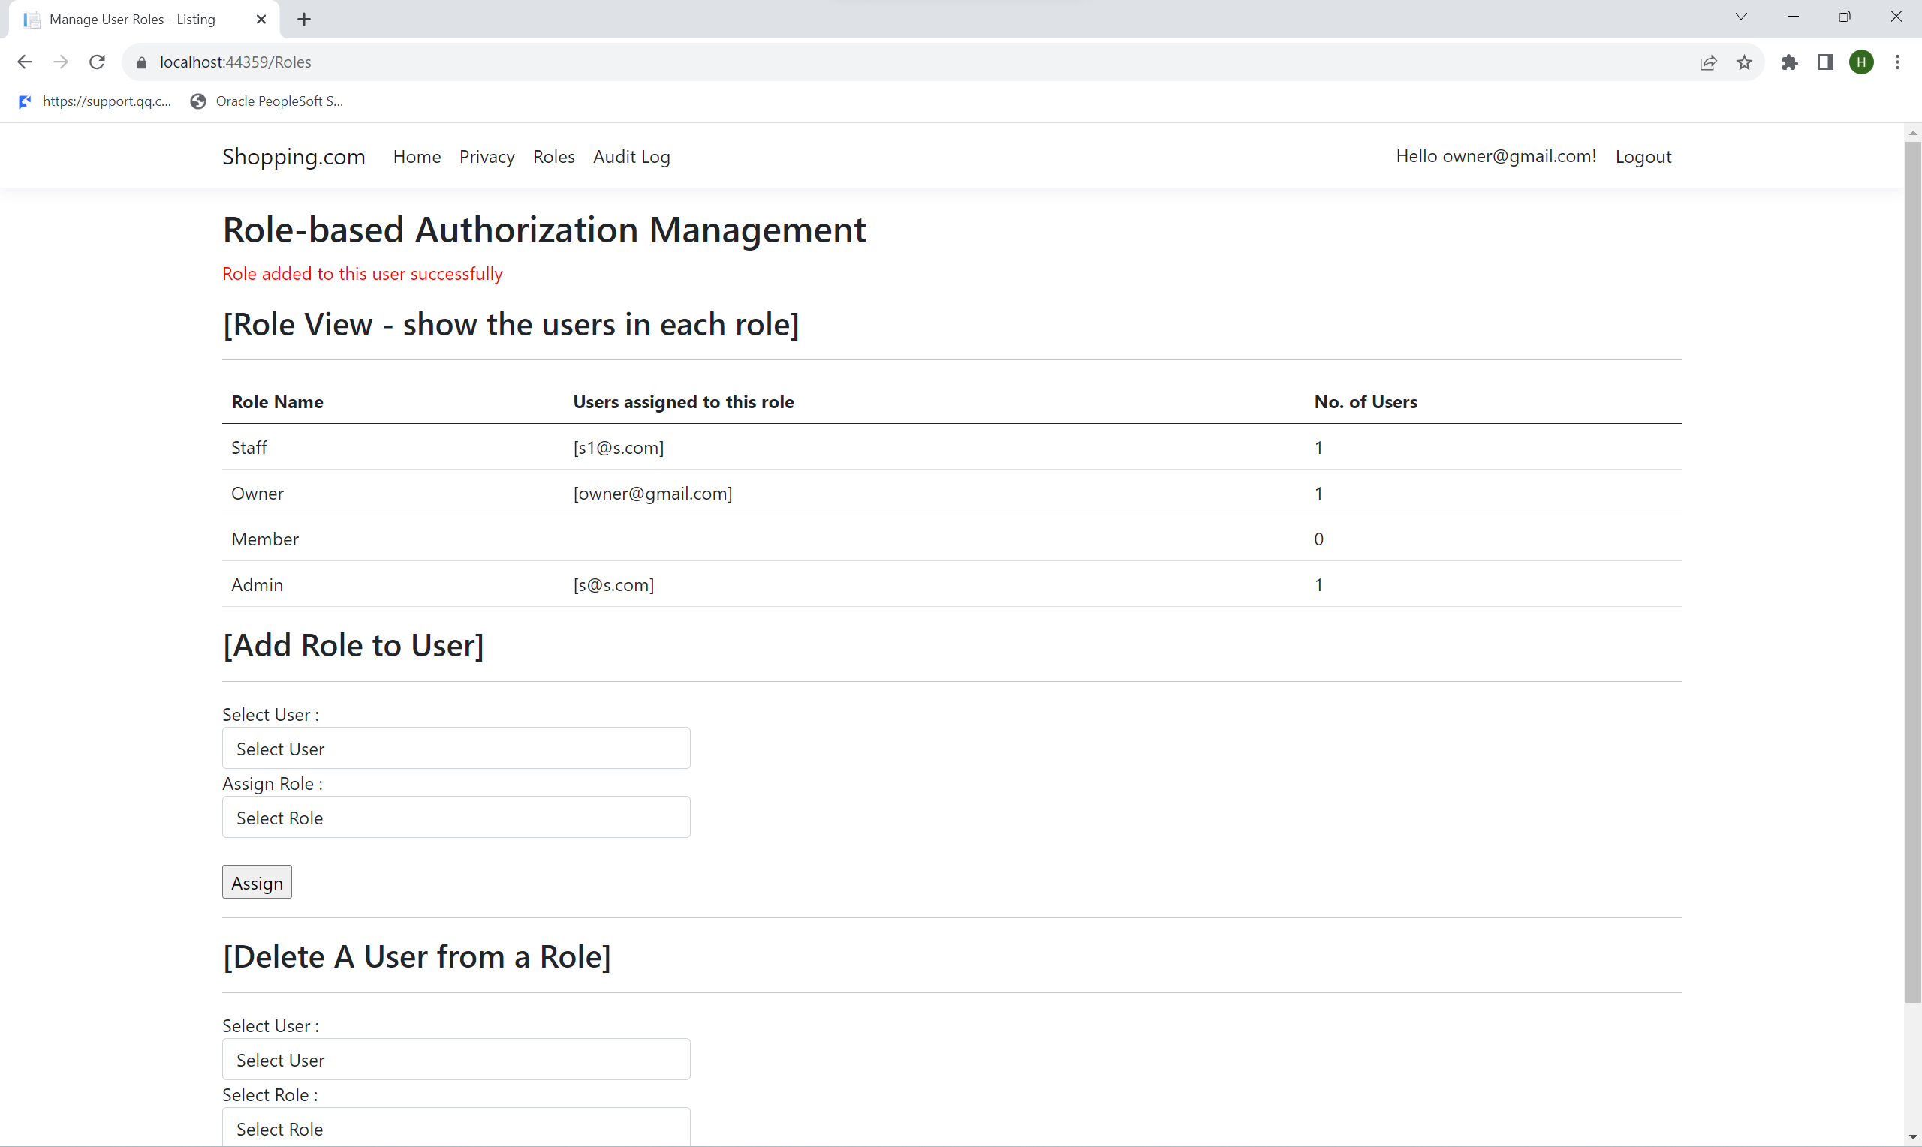

Assigning roles for Admin account (Before)

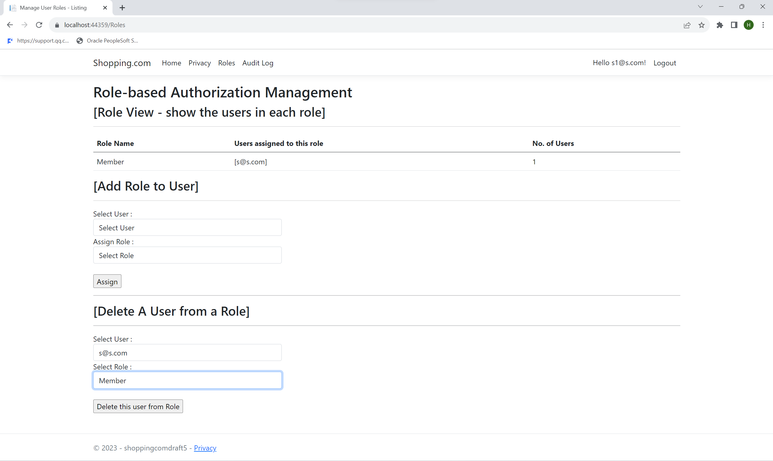

Assigning roles for Admin account (After)

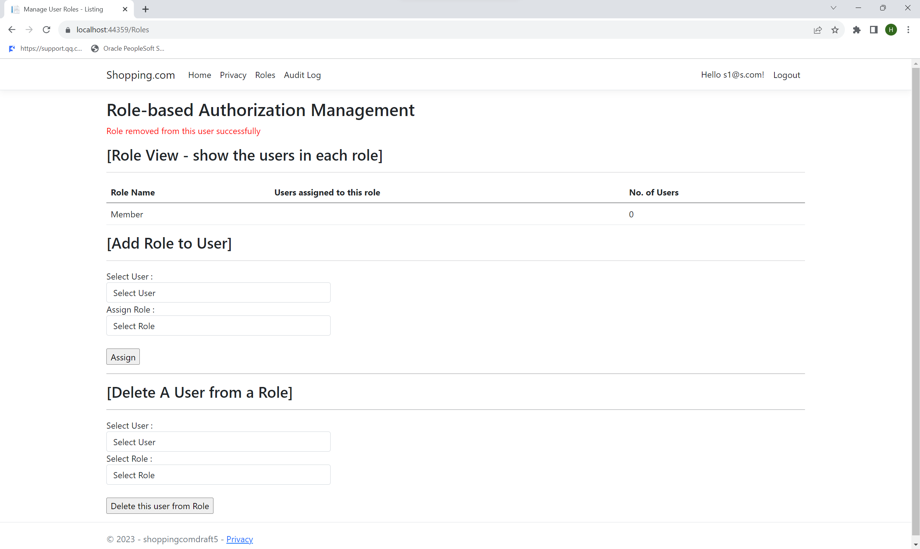

Since there are two roles that can assign/remove roles from the user, there are two different pages implemented for the two roles. Both pages were checked in dynamic code analysis. From the dynamic code analysis, it can be concluded that the web application is able to run smoothly.

#### Code/Peer Review

After doing code analysis, peers from other development teams and my groupmates tested Roles/Authorisation features by using an account with Owner/Admin roles and trying to assign/remove roles from users in the web application.

Assigning roles for Owner account (Before)

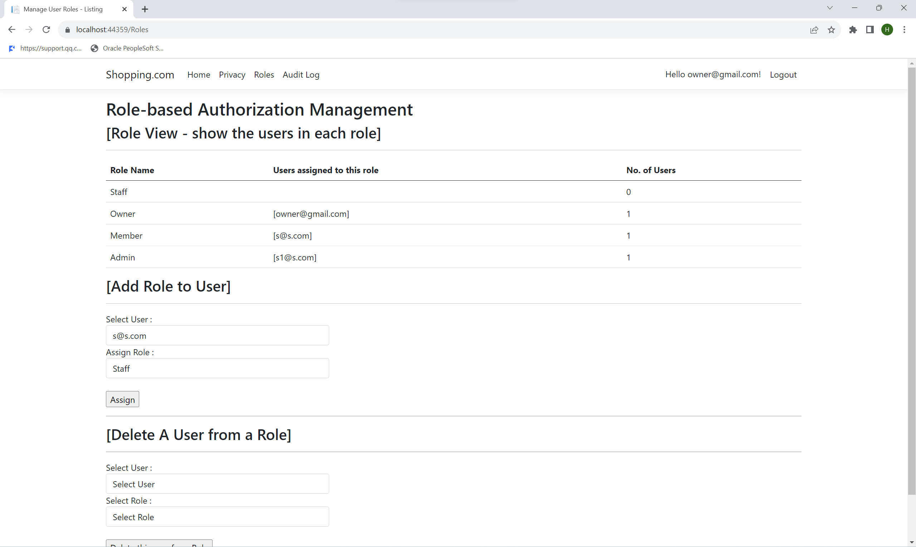

Assigning roles for Owner account (After)

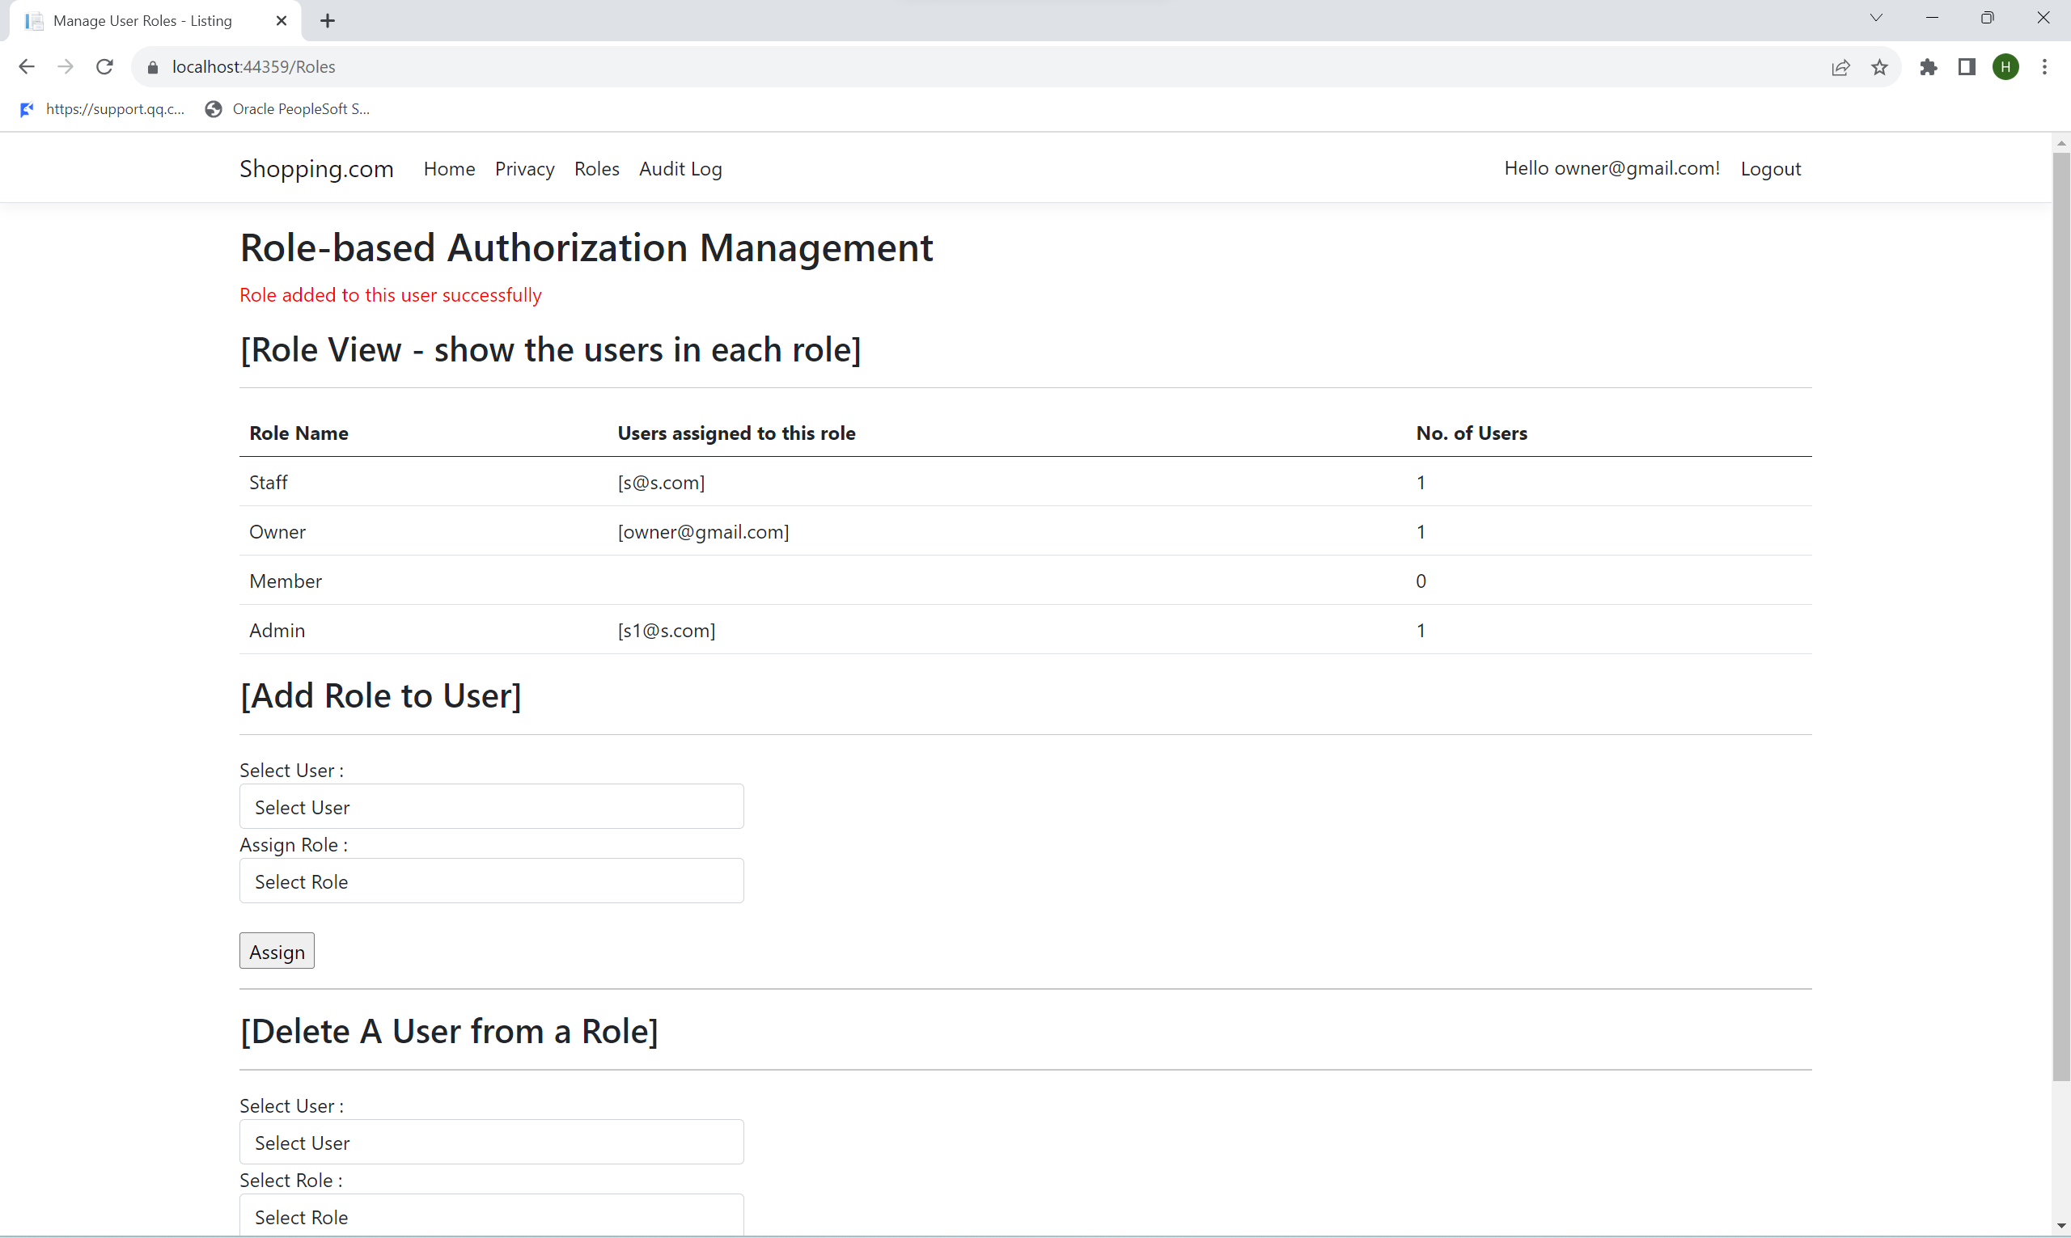

Removing roles for Owner account (Before)

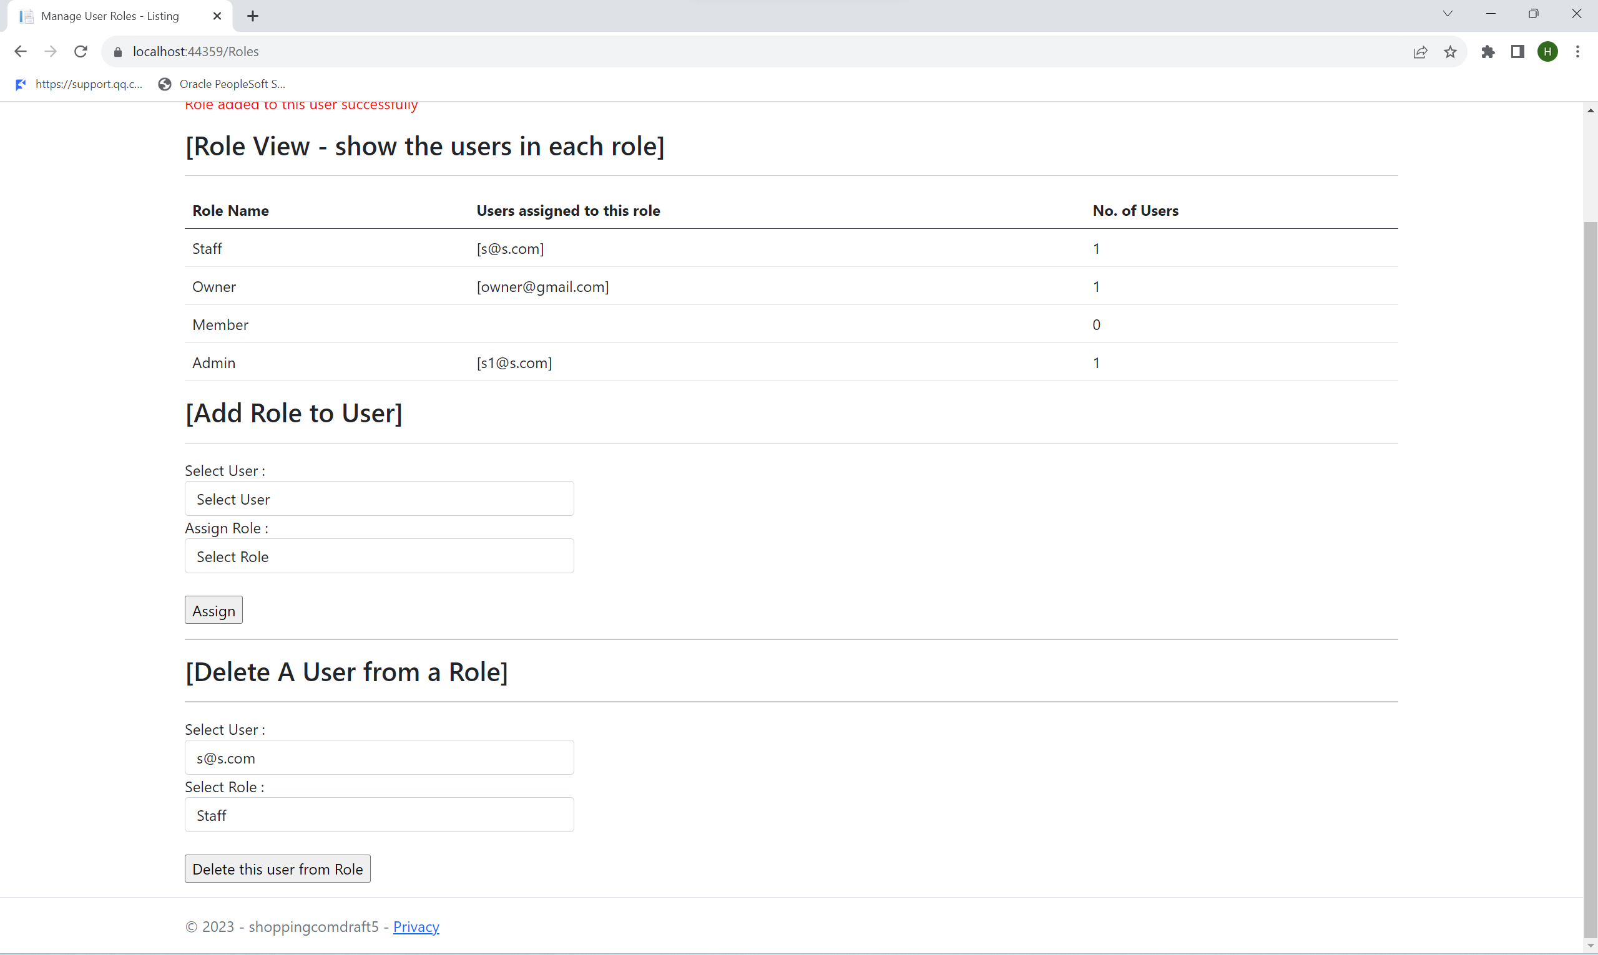

Removing roles for Owner account (After)

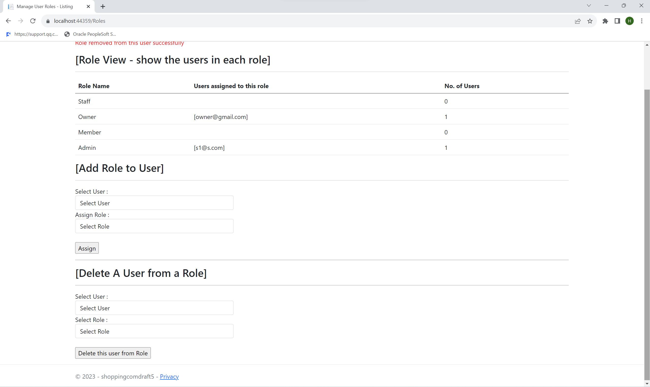

Removing member roles for Admin account (Before)

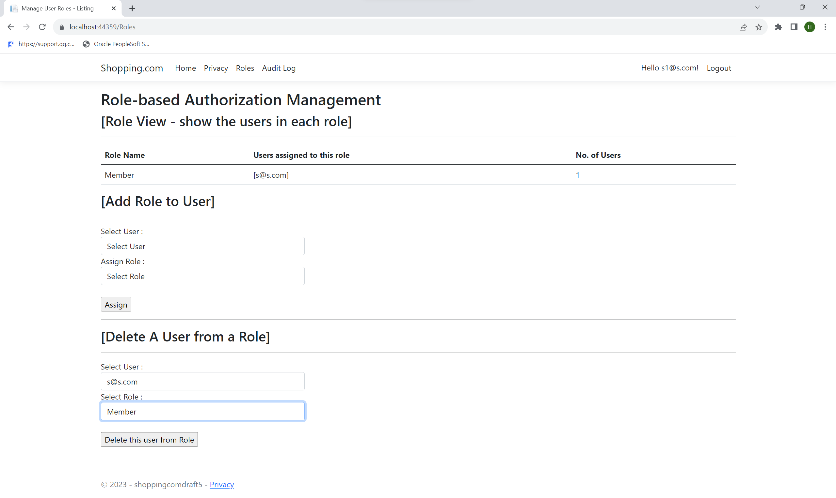

Removing member roles for Admin account (After)

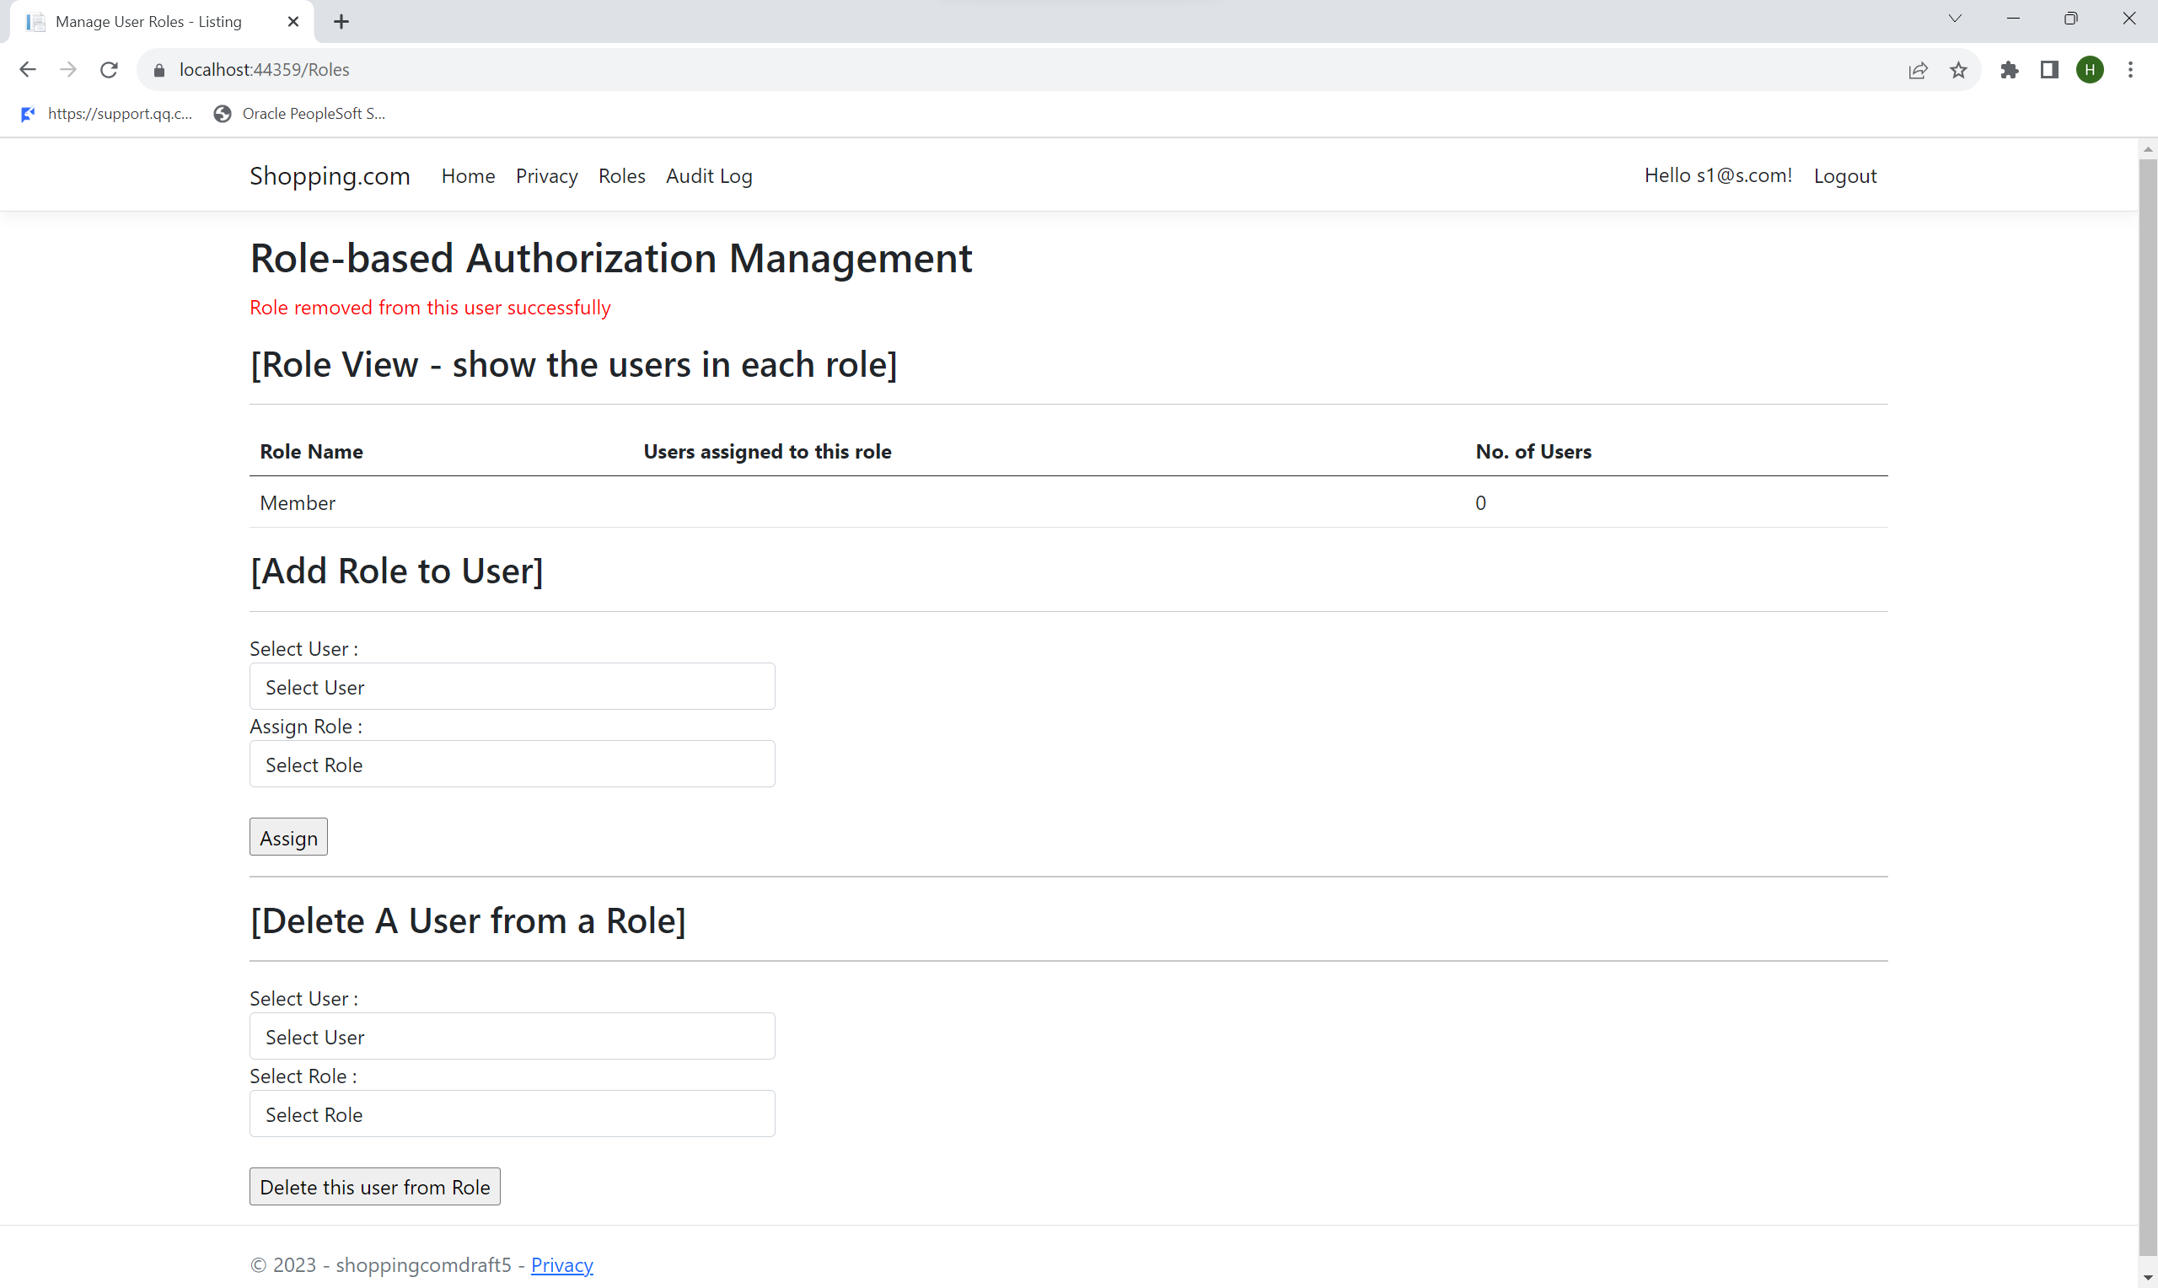

Assigning member roles for Admin account (Before)

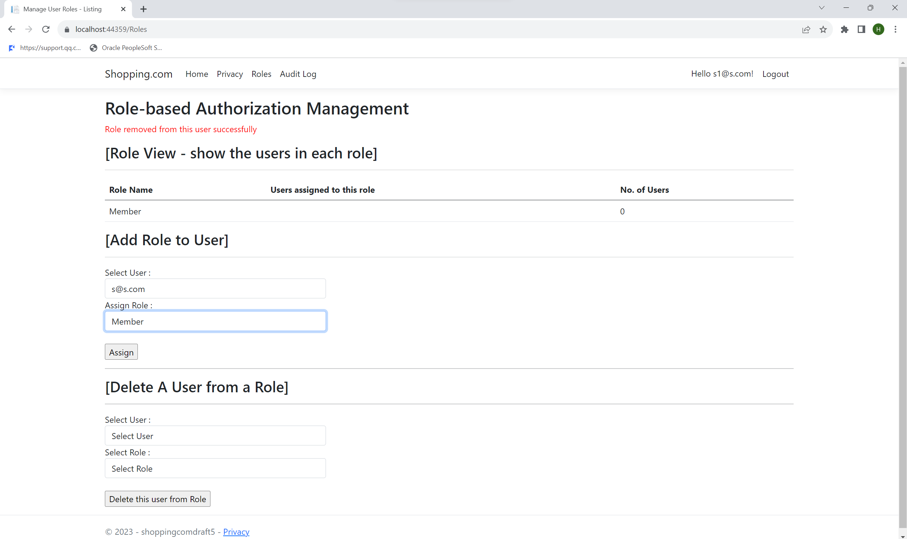

Assigning member roles for Admin account (After)

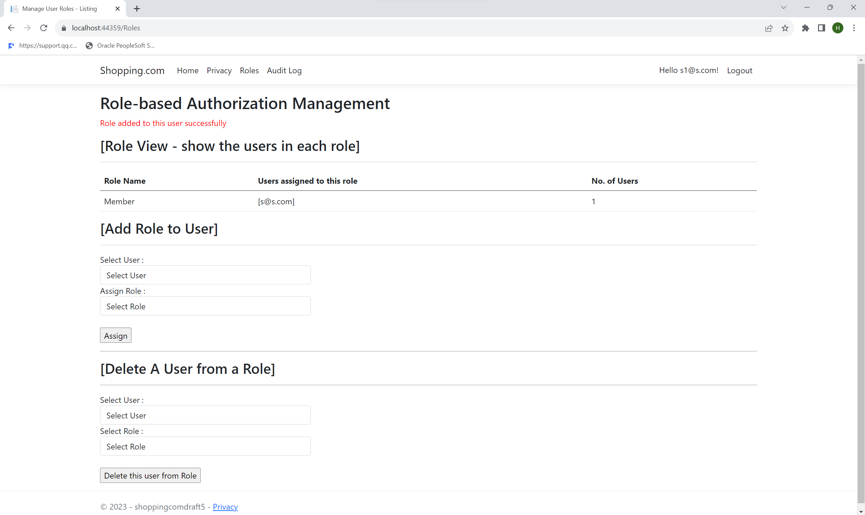

Restriction for account with no roles (email à s@s.com)

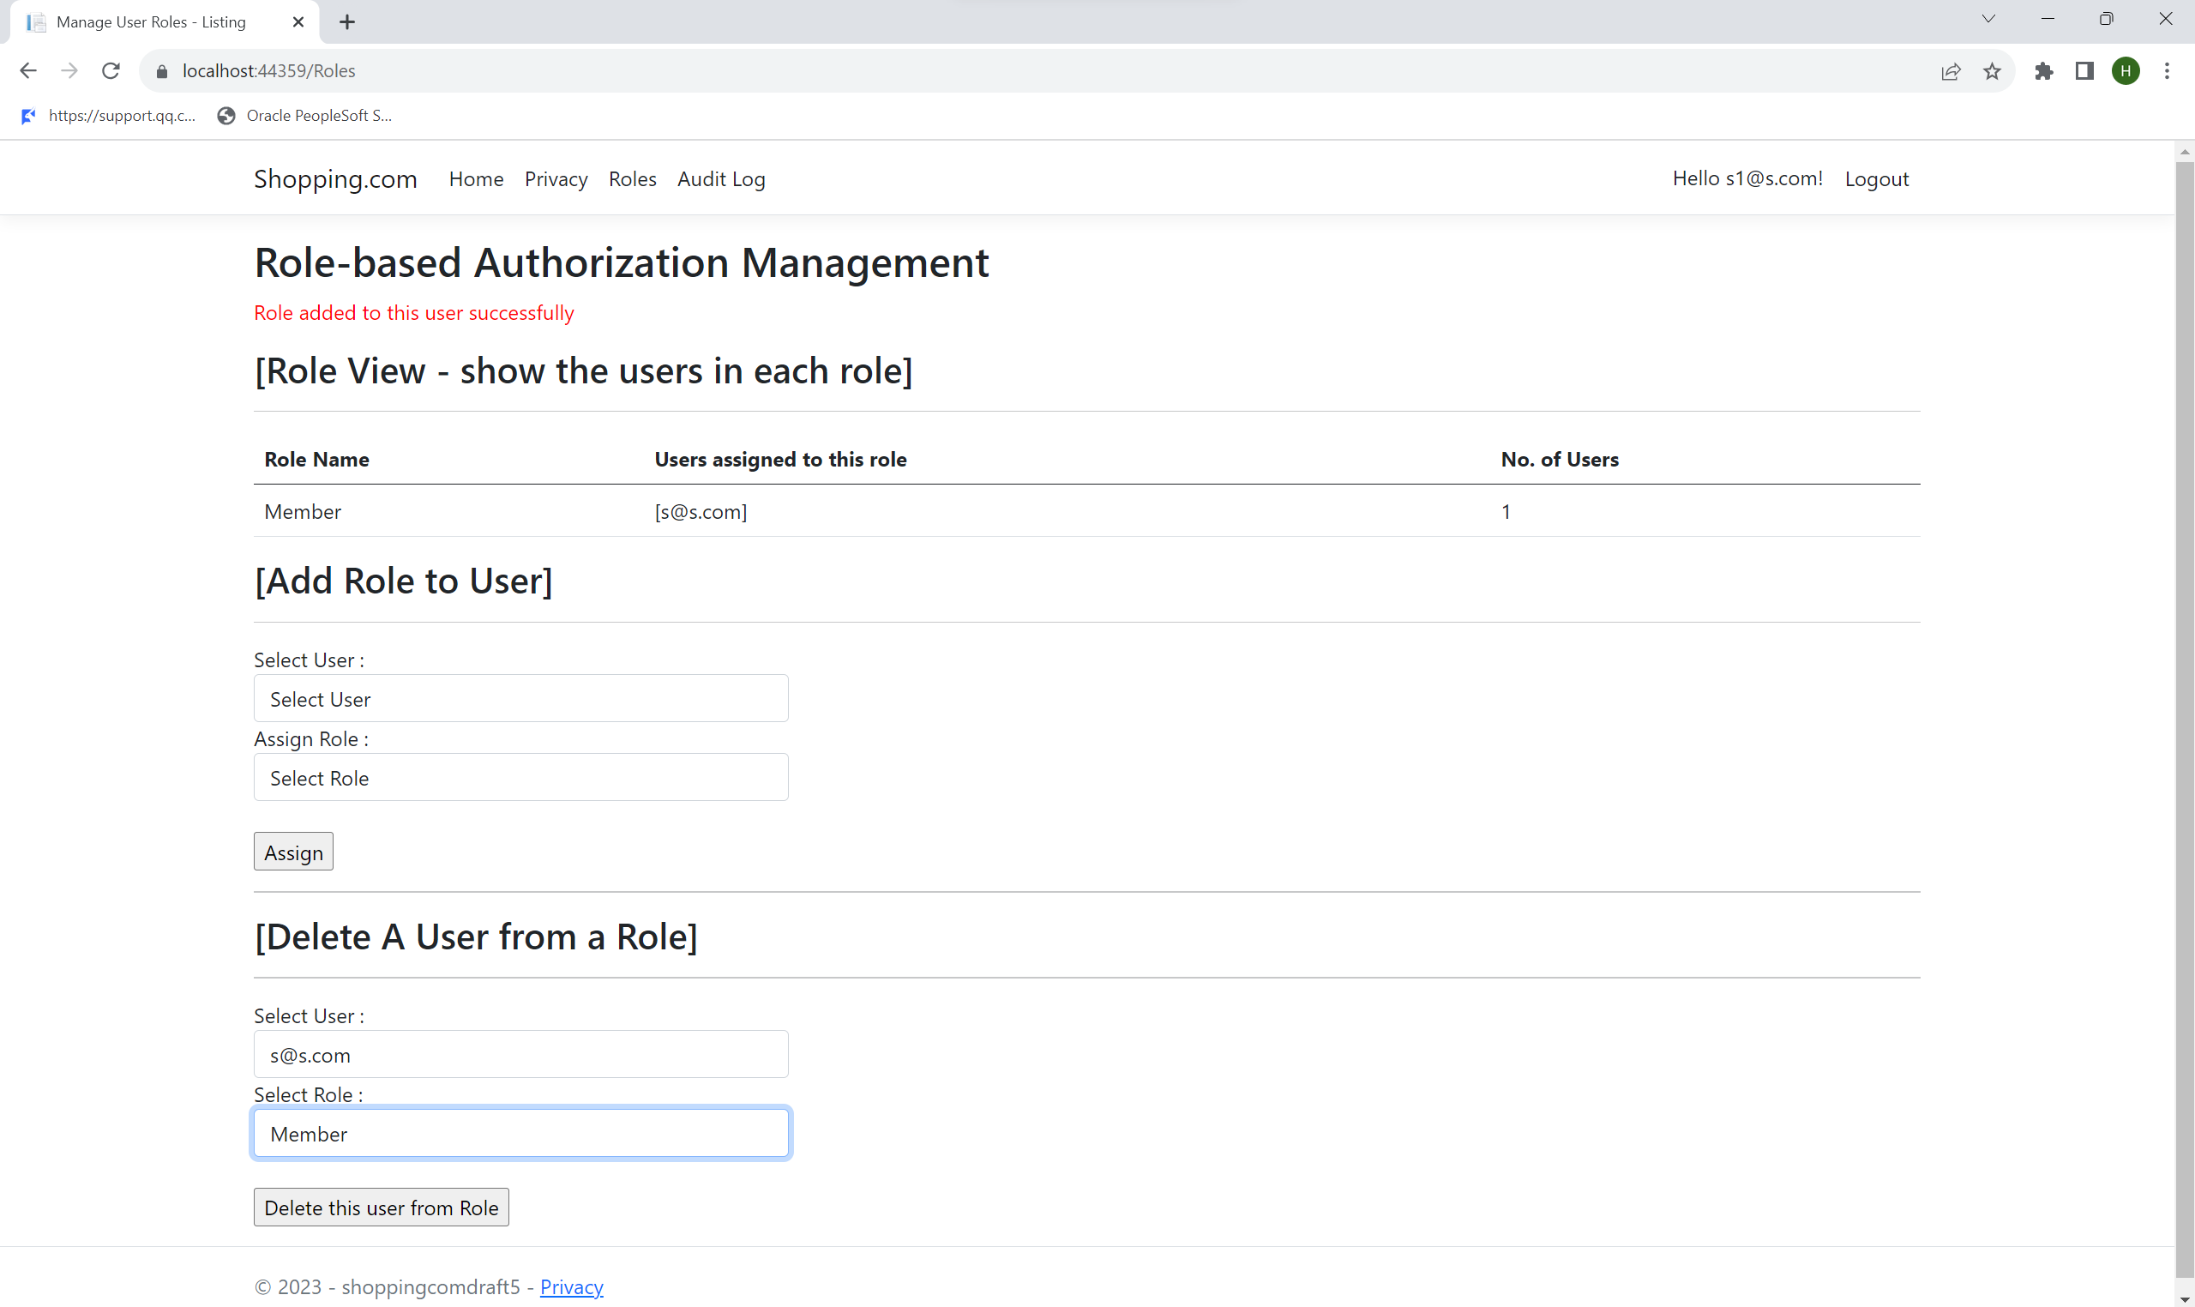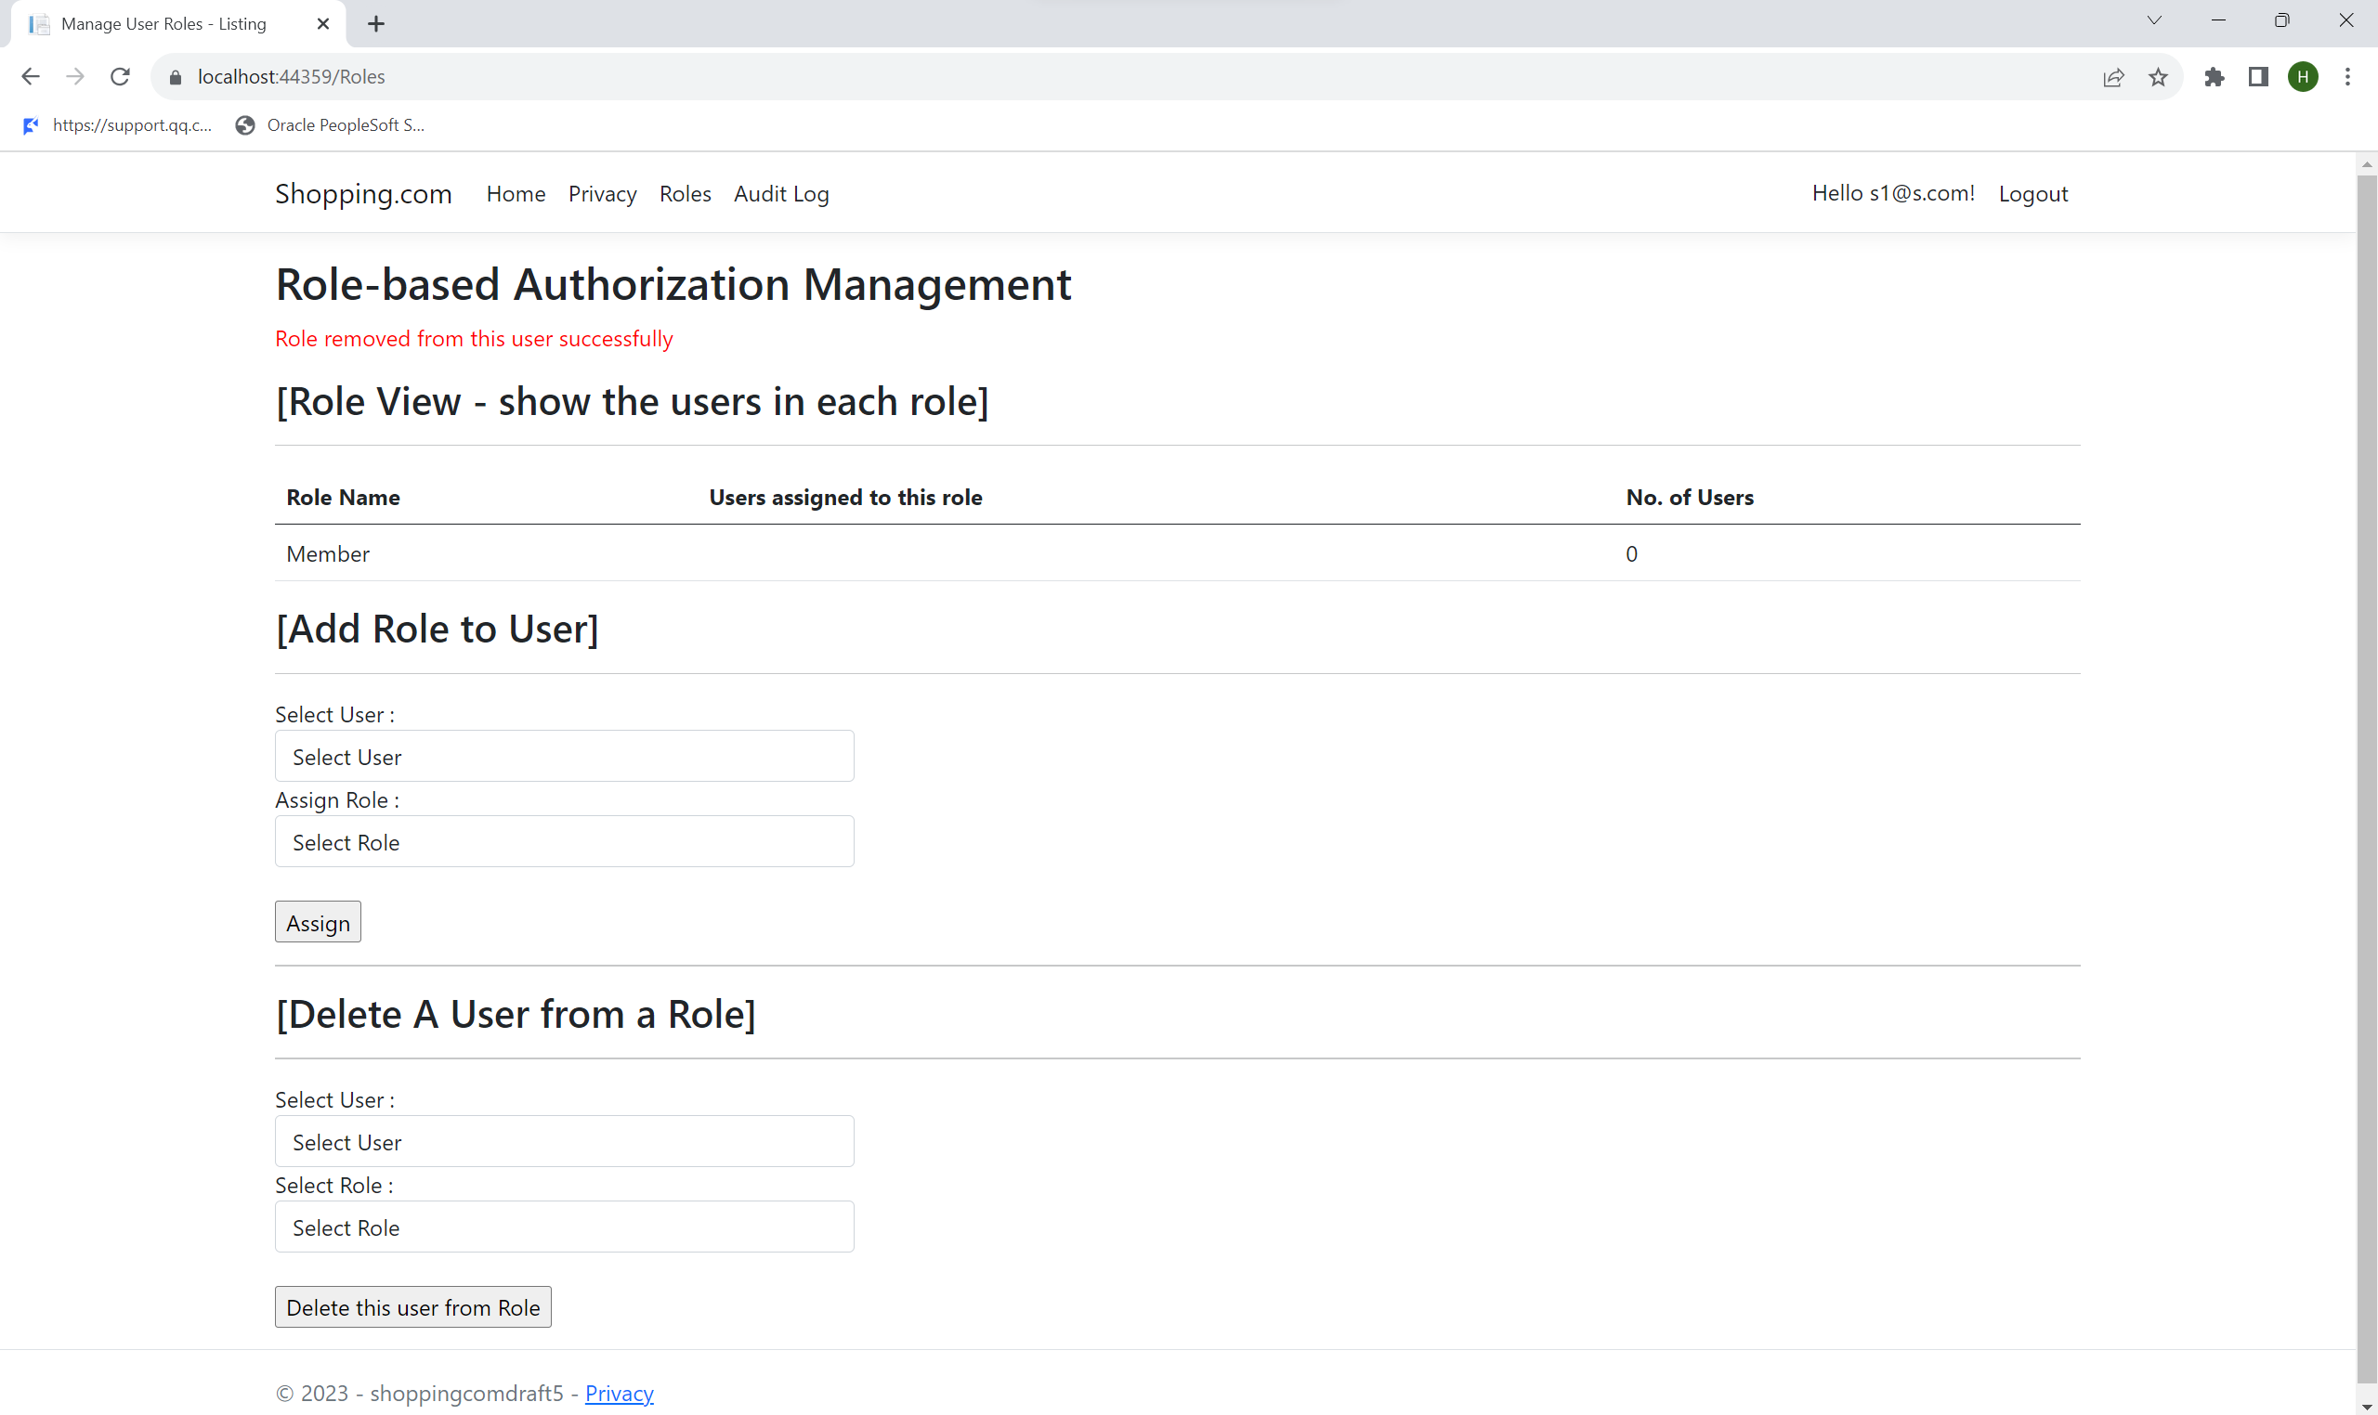

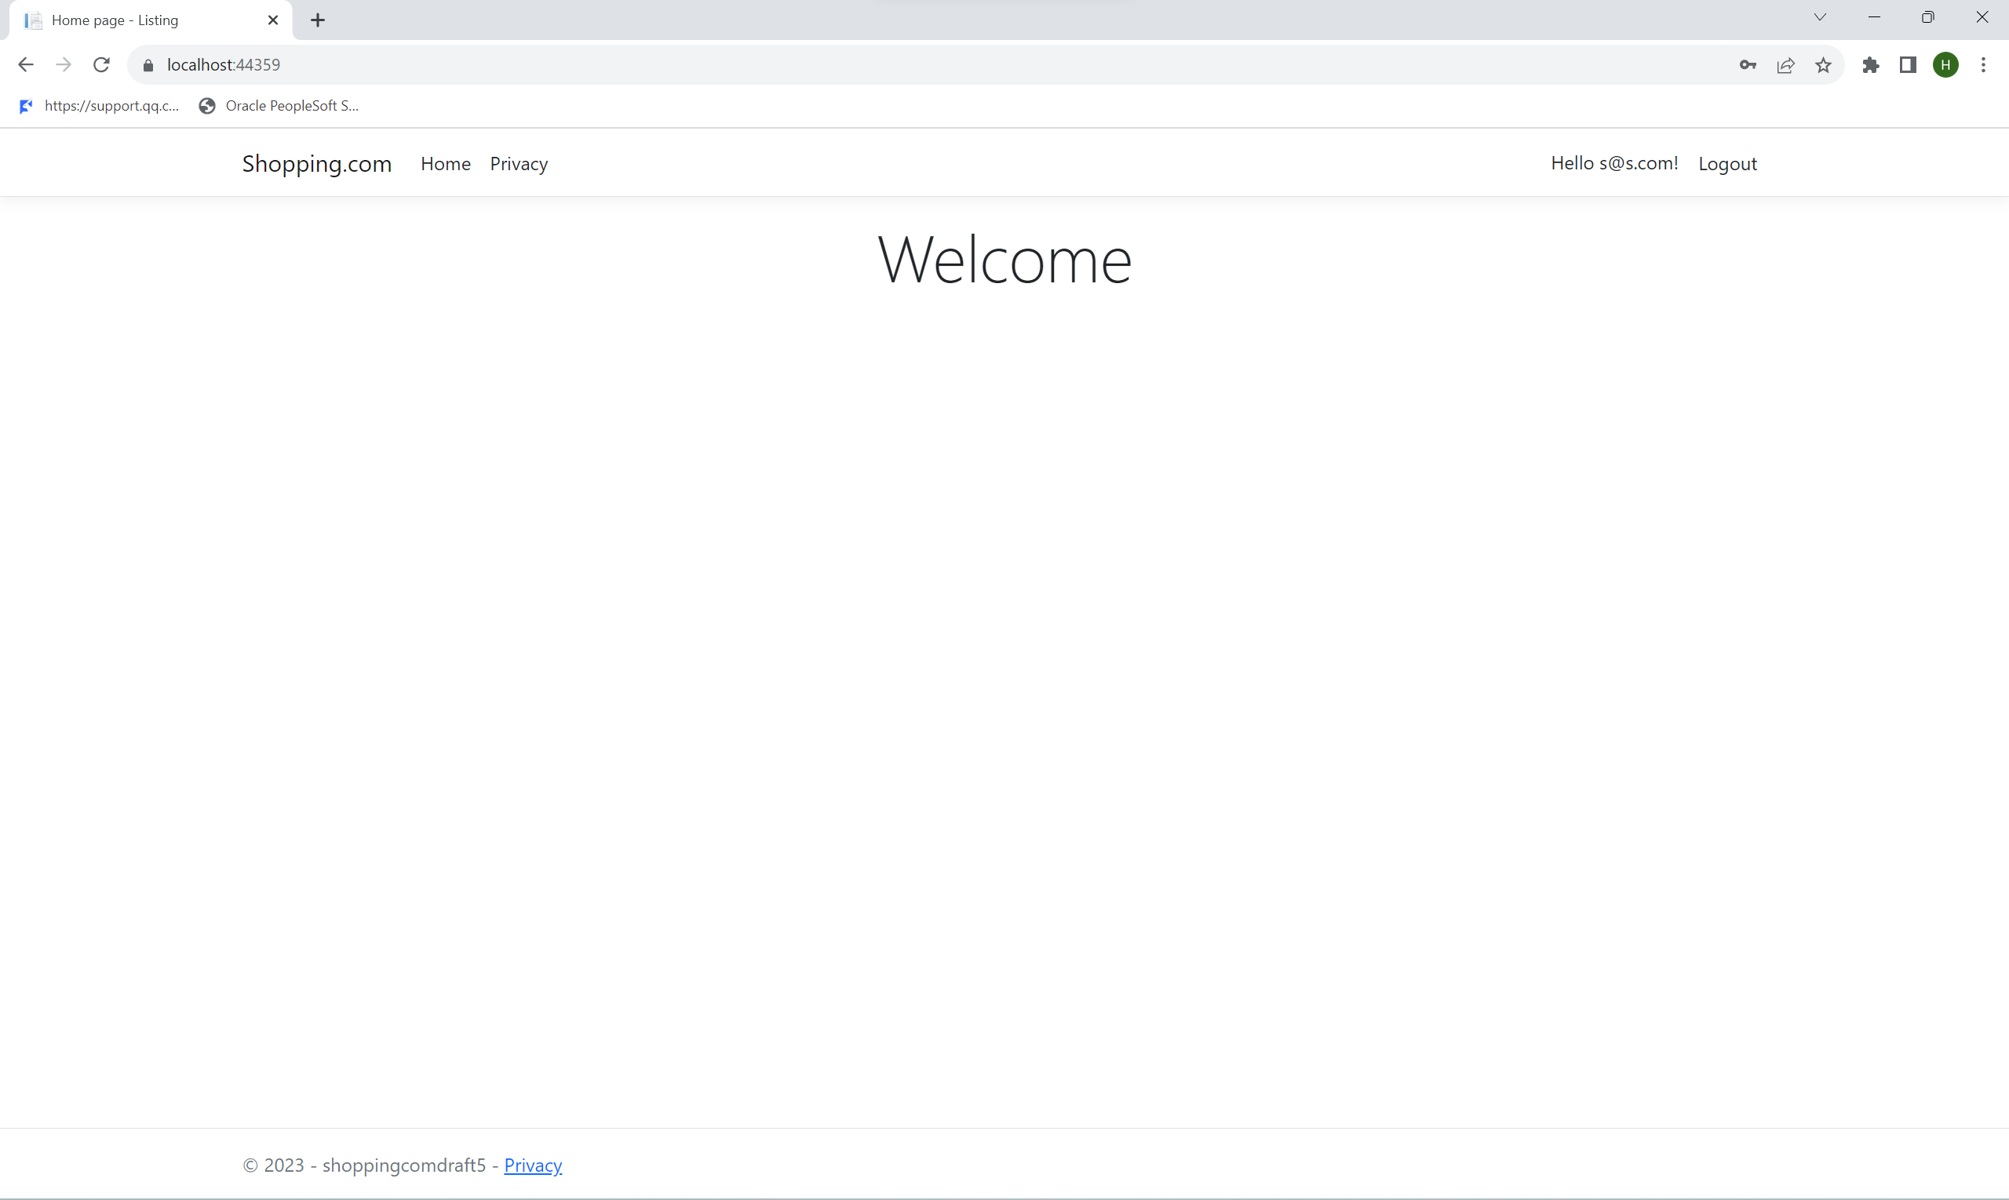

No listing buttons for user to press on.

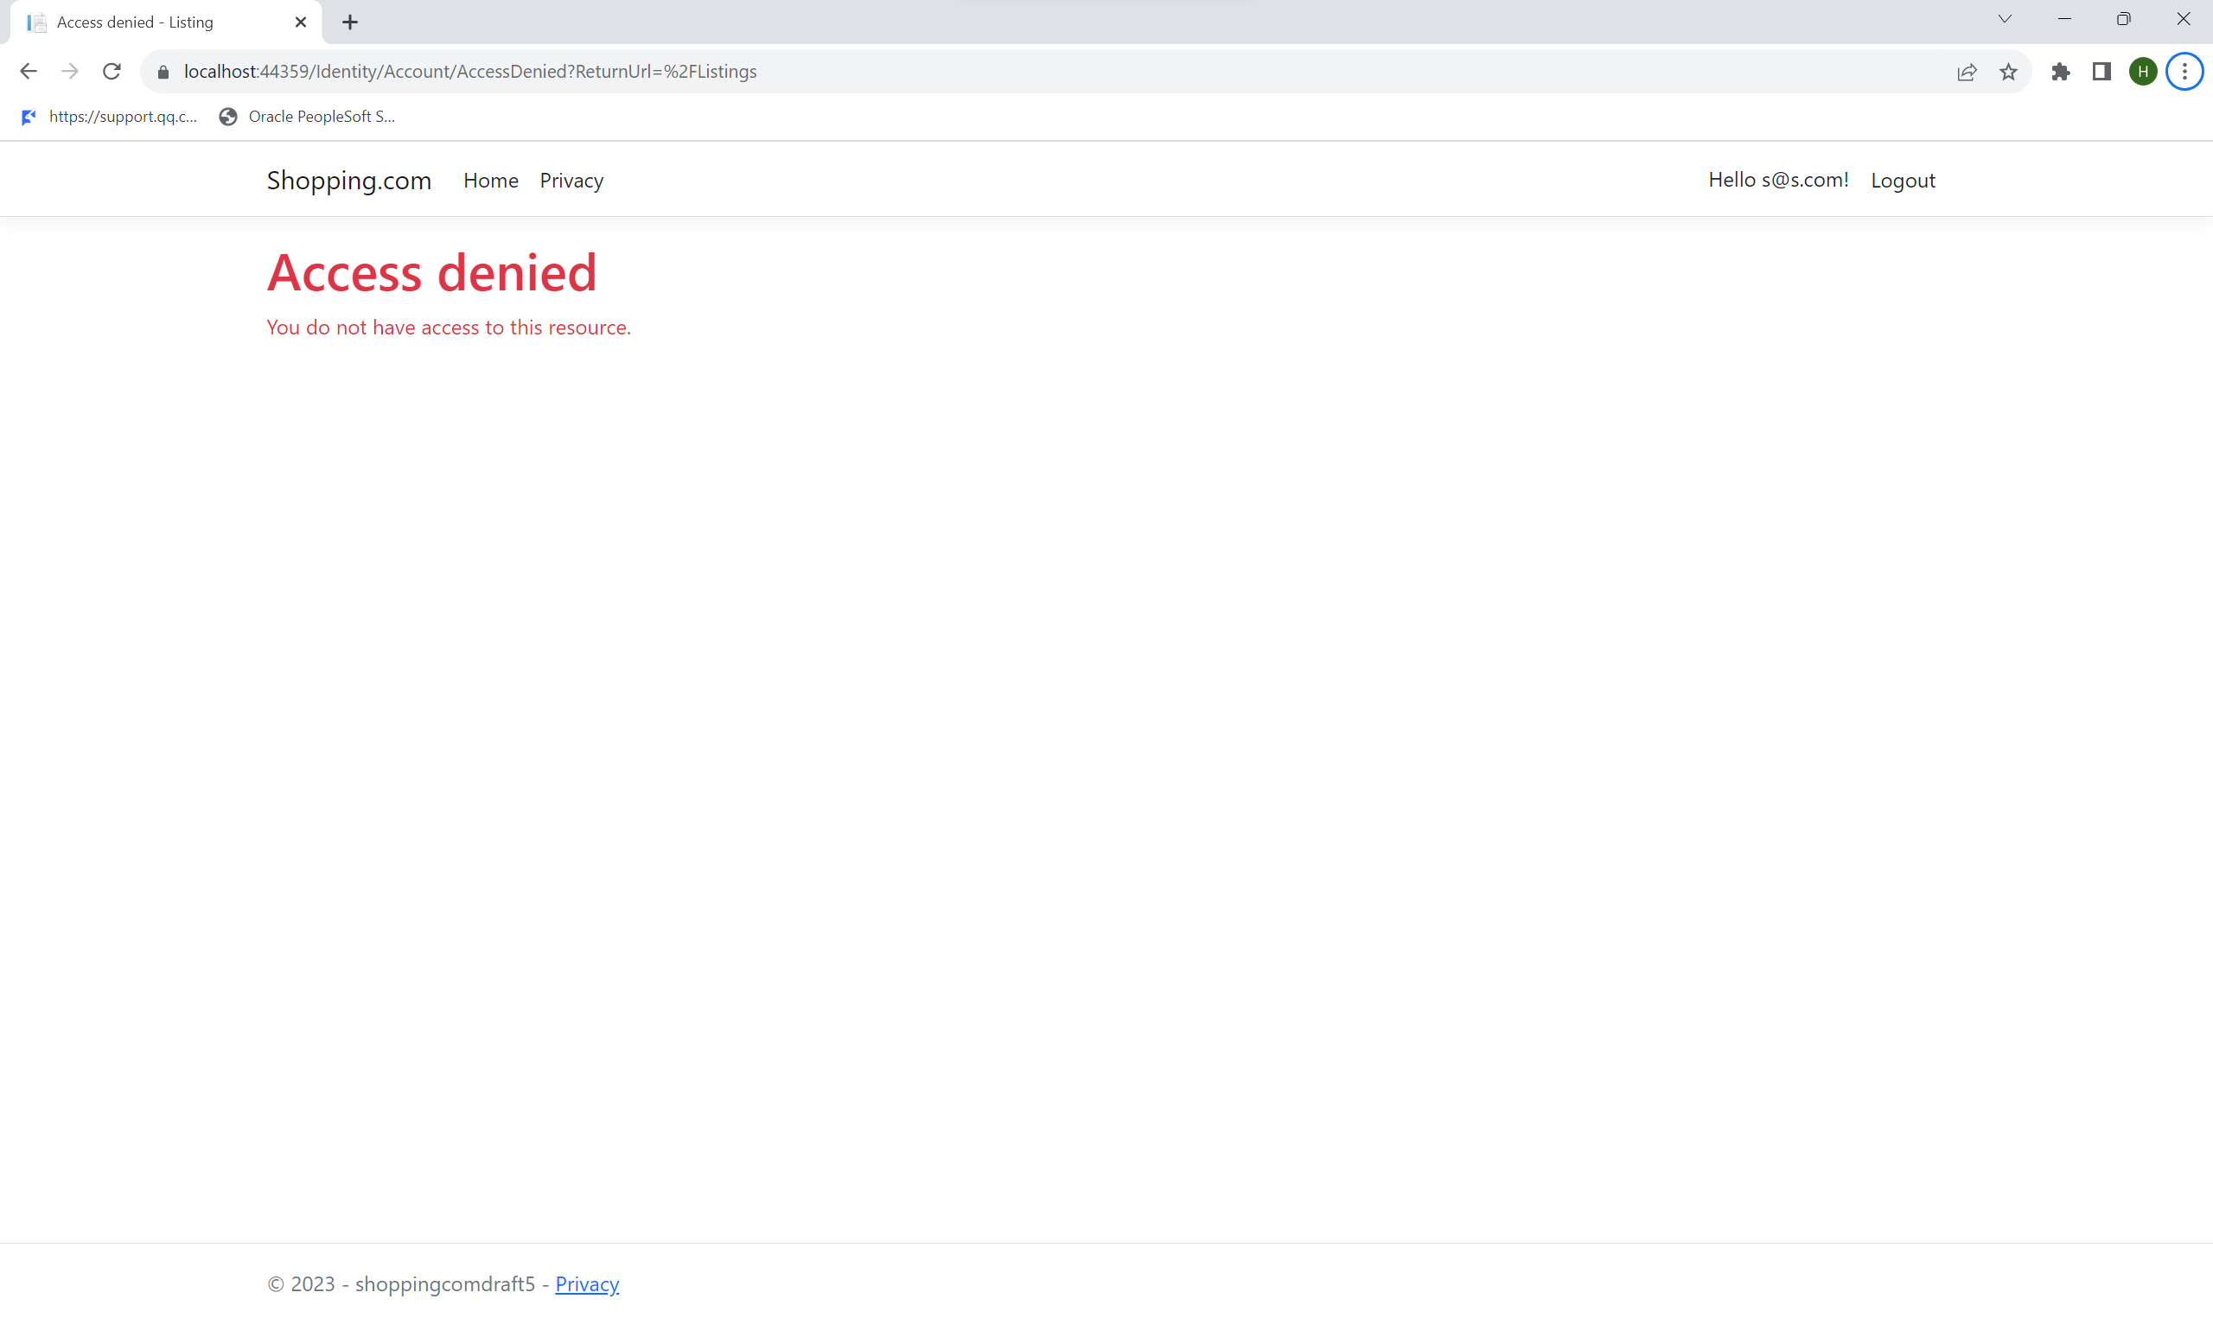

Unable to access the listings webpage through the link for accounts with no roles.

As seen from the screenshots above, the team members were able to assign/remove roles from users successfully in accounts that have Admin/Owner roles. Additionally, the authorisation of the roles is working.

## Secure Software Testing

Before releasing for production use, the secure web application underwent the secure software testing process that includes test strategy, test plan, and test cases. This is to test and uncover any vulnerabilities in the web application so that we can fix them before releasing them for production use.

#### Test Strategy

A Test Strategy outlines the set of guidelines to be followed to achieve the test objective, test design, and how testing is to be executed during the Secure Software Development Cycle at a high level. It identifies what needs to be tested, and what counts as a successful text. As mentioned previously in the “Identity Threats” section under the Roles/Authorization feature, the key entry point and exit point for potential vulnerabilities lie within the input field during the assignment or removal of roles from the user. This necessitates the execution of functional testing to evaluate the application's capacity to withstand potential attacks.

The primary testing approach chosen is logic testing, which would be the best for this feature authorisation of roles is the logic behind the application.

Authorisation for users in the web application comes in the form of assigning/ removing roles from users. Admins and Owners must be capable of selecting users and effectively assigning or removing roles from them. It is equally crucial that the role permissions associated with user accounts function as intended. This entails users being able to access specific pages and perform designated actions within the web application, strictly in accordance with the permissions granted by their roles. Conversely, users should be restricted from accessing certain pages or performing actions not authorized by their assigned roles.

As such, the main objective of the testing is to ensure roles assigned are permitting and limiting the correct actions.

#### Test Plan

The scope of the test plan will be ensuring the default assignment of member roles to newly registered users and trying out different roles.

For logic testing, the below are the possible conditions for a successful testing attempt:

|  |  |  |
| --- | --- | --- |
| **Feature** | **Condition 1** | **Attempt Pass/Fail** |
| Member Role assign to the user after registering | Newly Registered users have Member Role | Pass |
| Newly Registered user does not have a Member Role | Fail |
| Role authorisation - Member | Member can only purchase listings | Pass |
| Member cannot purchase listings | Fail |
| Role authorisation -Staff | Staff can create, read, update, and delete listings | Pass |
| Staff cannot create, read, update, or delete listings | Fail |
| Role authorisation - Administrator | Administrators can assign or remove member roles from users. | Pass |
| Administrators cannot assign or remove member roles from users. | Fail |
| Role authorisation - Owner | Owner role can assign or remove Staff/Admin/Member role from users. | Pass |
| Owner role cannot assign or remove Staff/Admin/Member role from users. | Fail |

#### Test Case

First, the ability to assign Member roles to newly registered users. After the user register, their email should appear in the roles pages with the member roles attached to them.

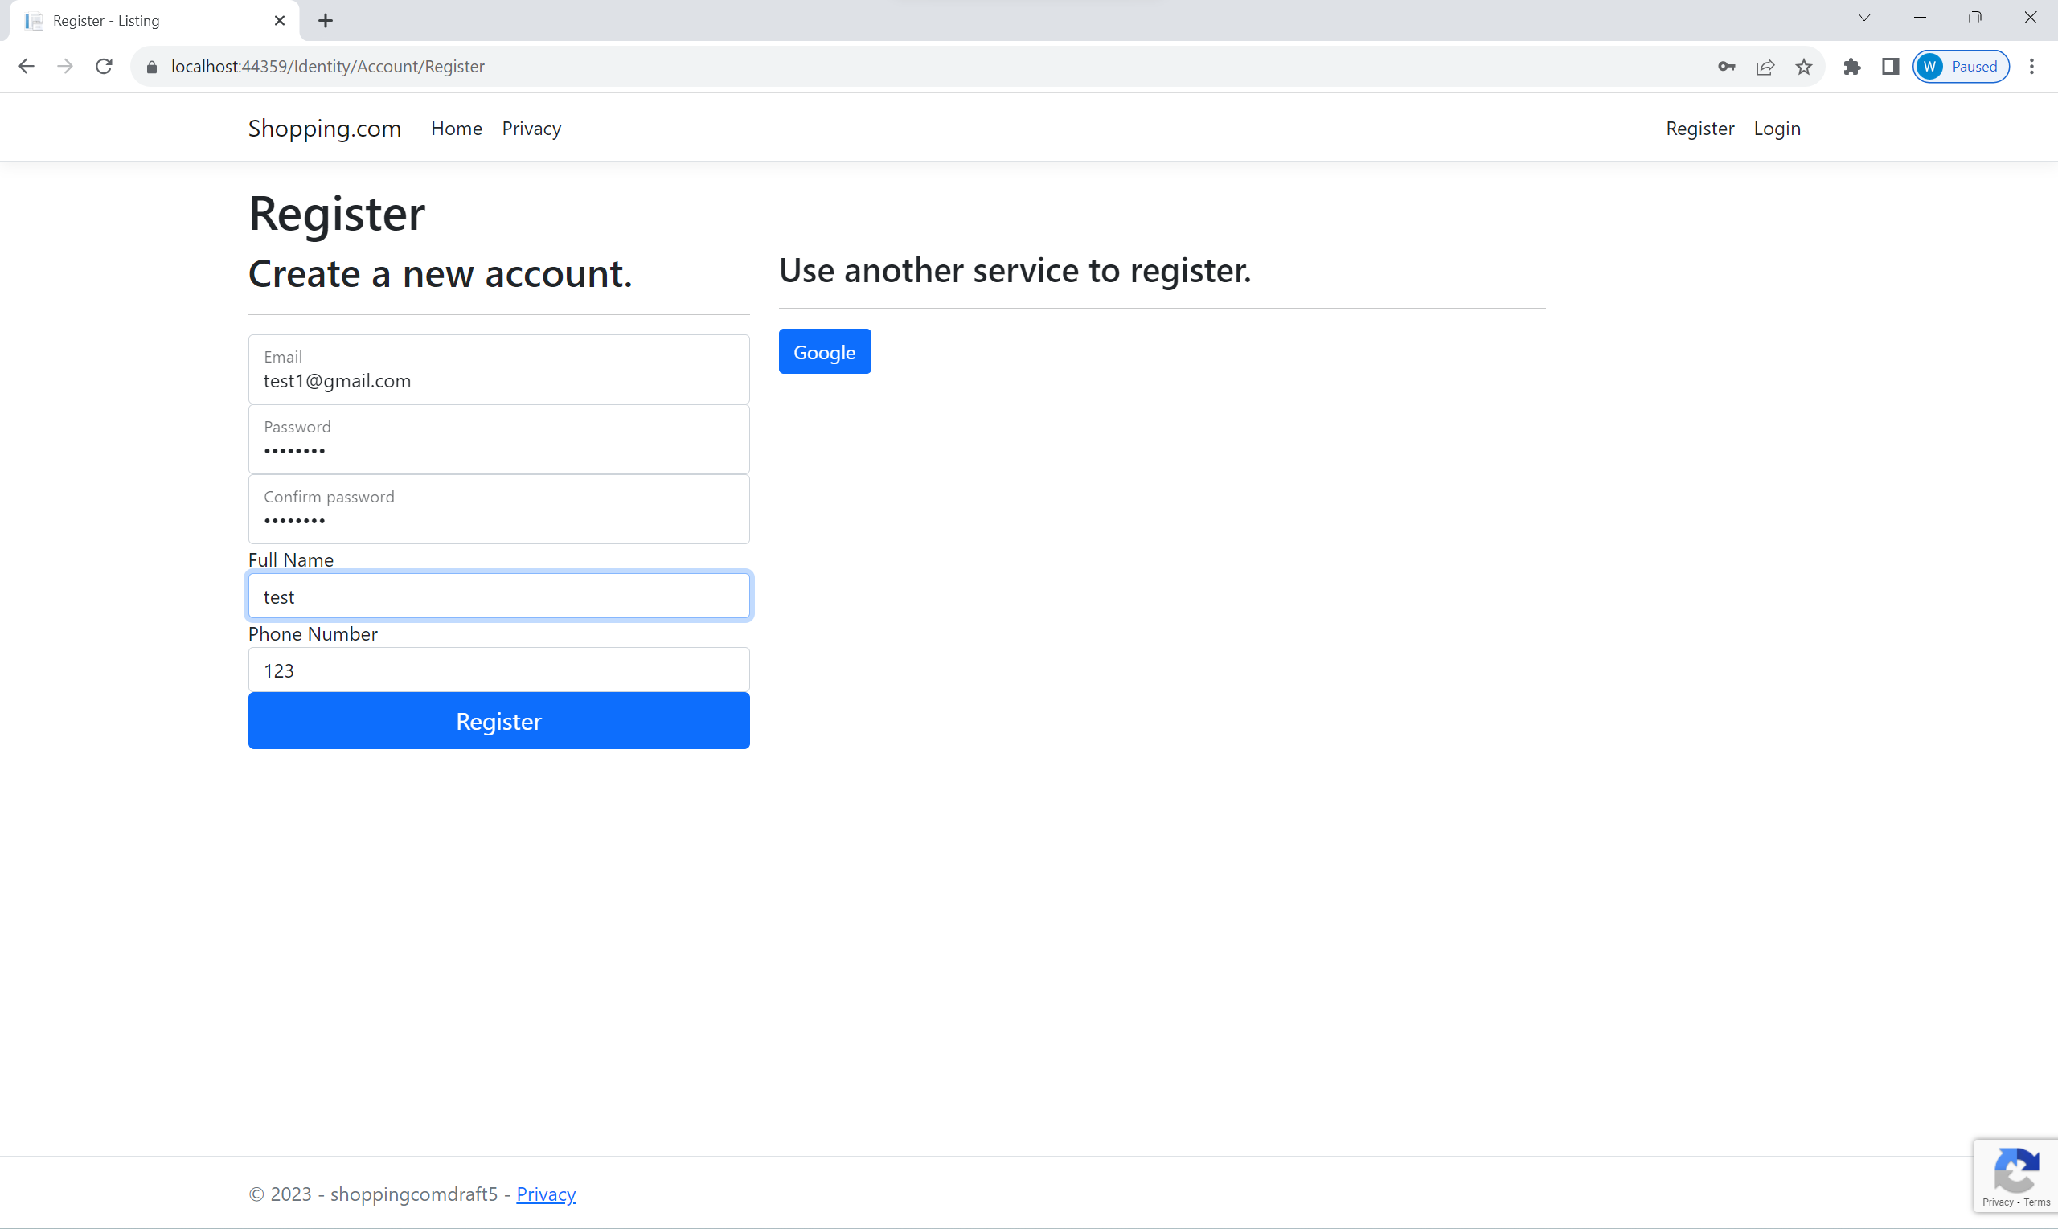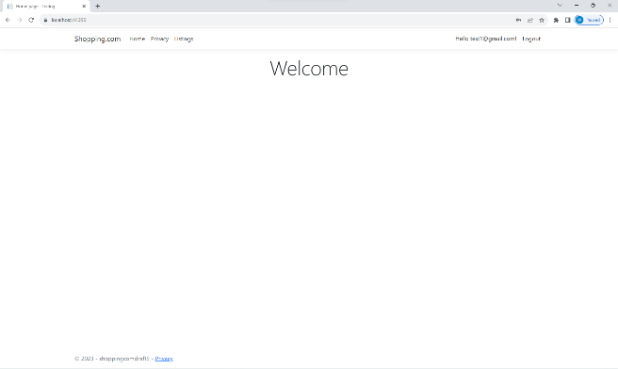

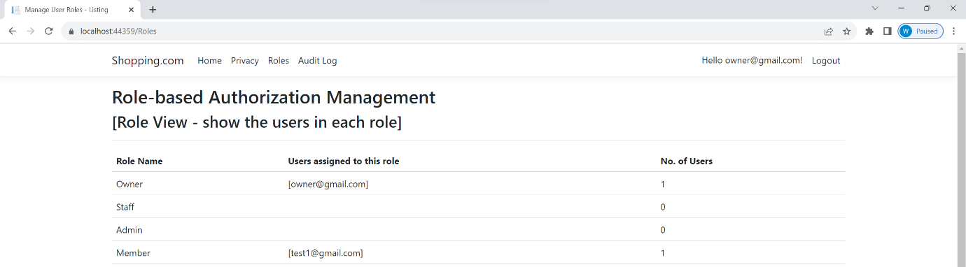

As we can see from the above pictures, after a new user with the email [test1@gmail.com](mailto:test1@gmail.com) registers, the owner can see that the member roles are attached to the user.

The authorisation of each role needs to be tested as well. The Member role will be tested first. As a member of the web application, the user is only permitted to purchase listings.



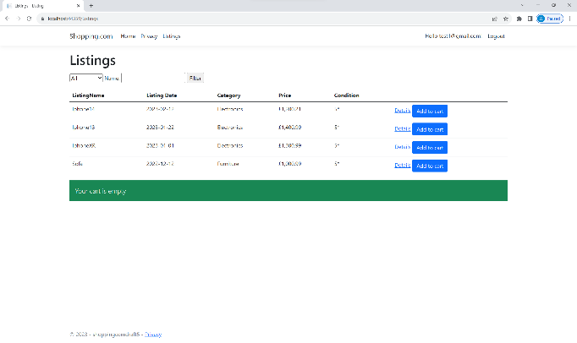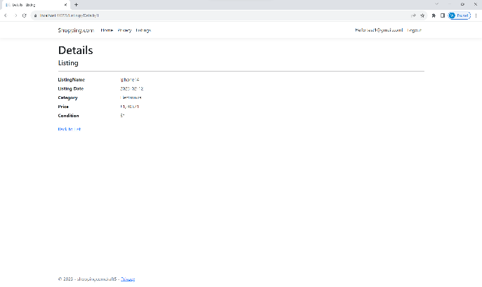

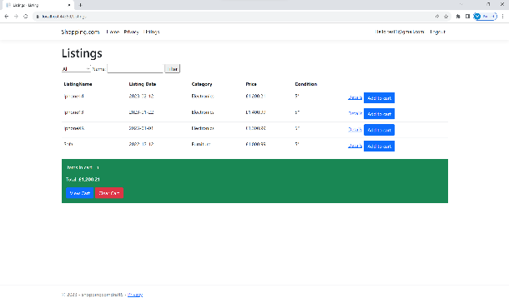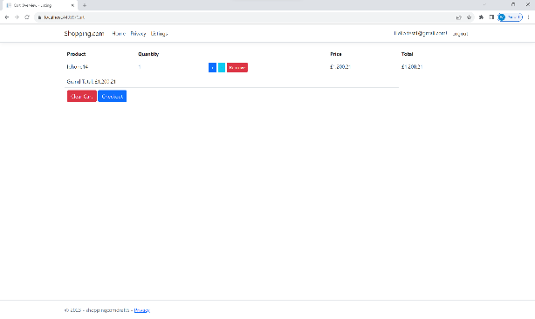

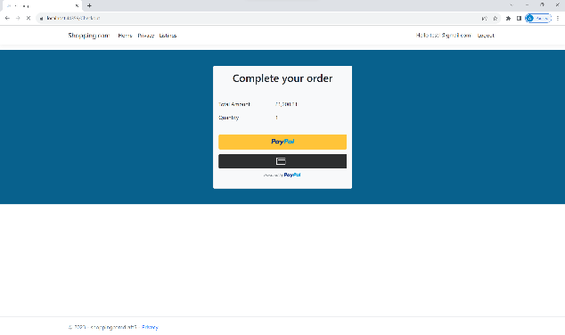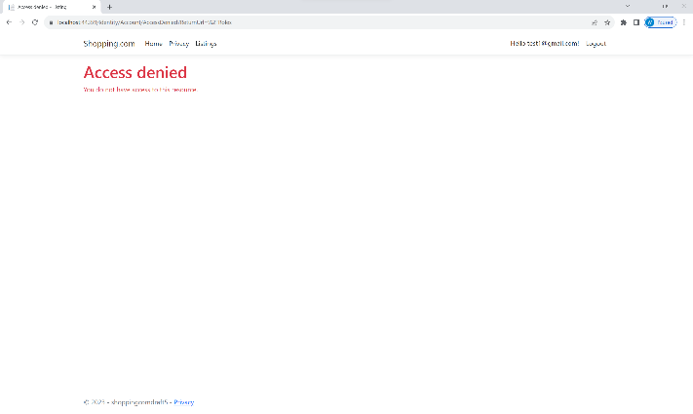

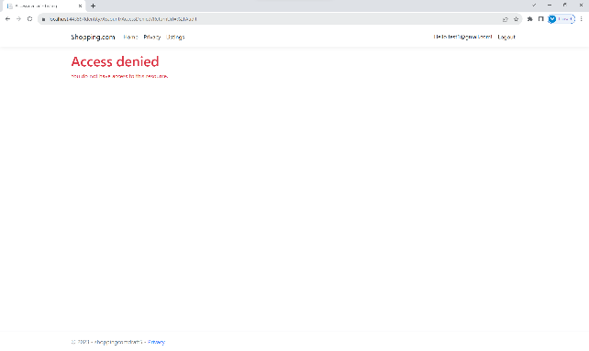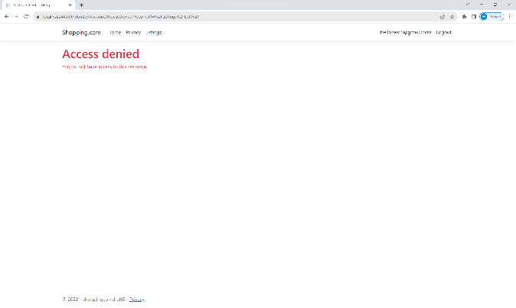

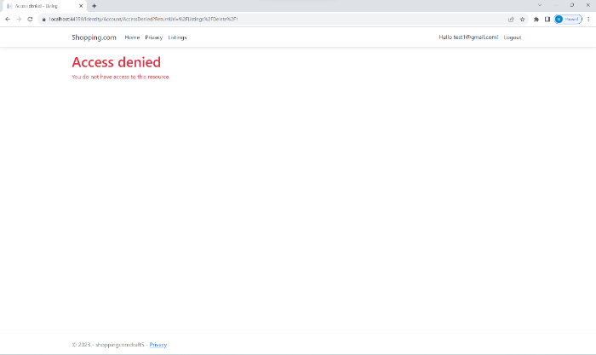

As we can see from the above screenshots, we can see that test account [test1@gmail.com](mailto:test1@gmail.com) with a member role is able to purchase listings. However, the account is unable to create, update or delete listings. It is also unable to access roles management and audit logs pages. When the accounts try to access the authorized pages, the access denied page will be shown instead.

Next, we will be testing Staff roles, which only have permission to create, read, update, and delete listings. We will be assigning [test1@gmail.com](mailto:test1@gmail.com) with a Staff role.

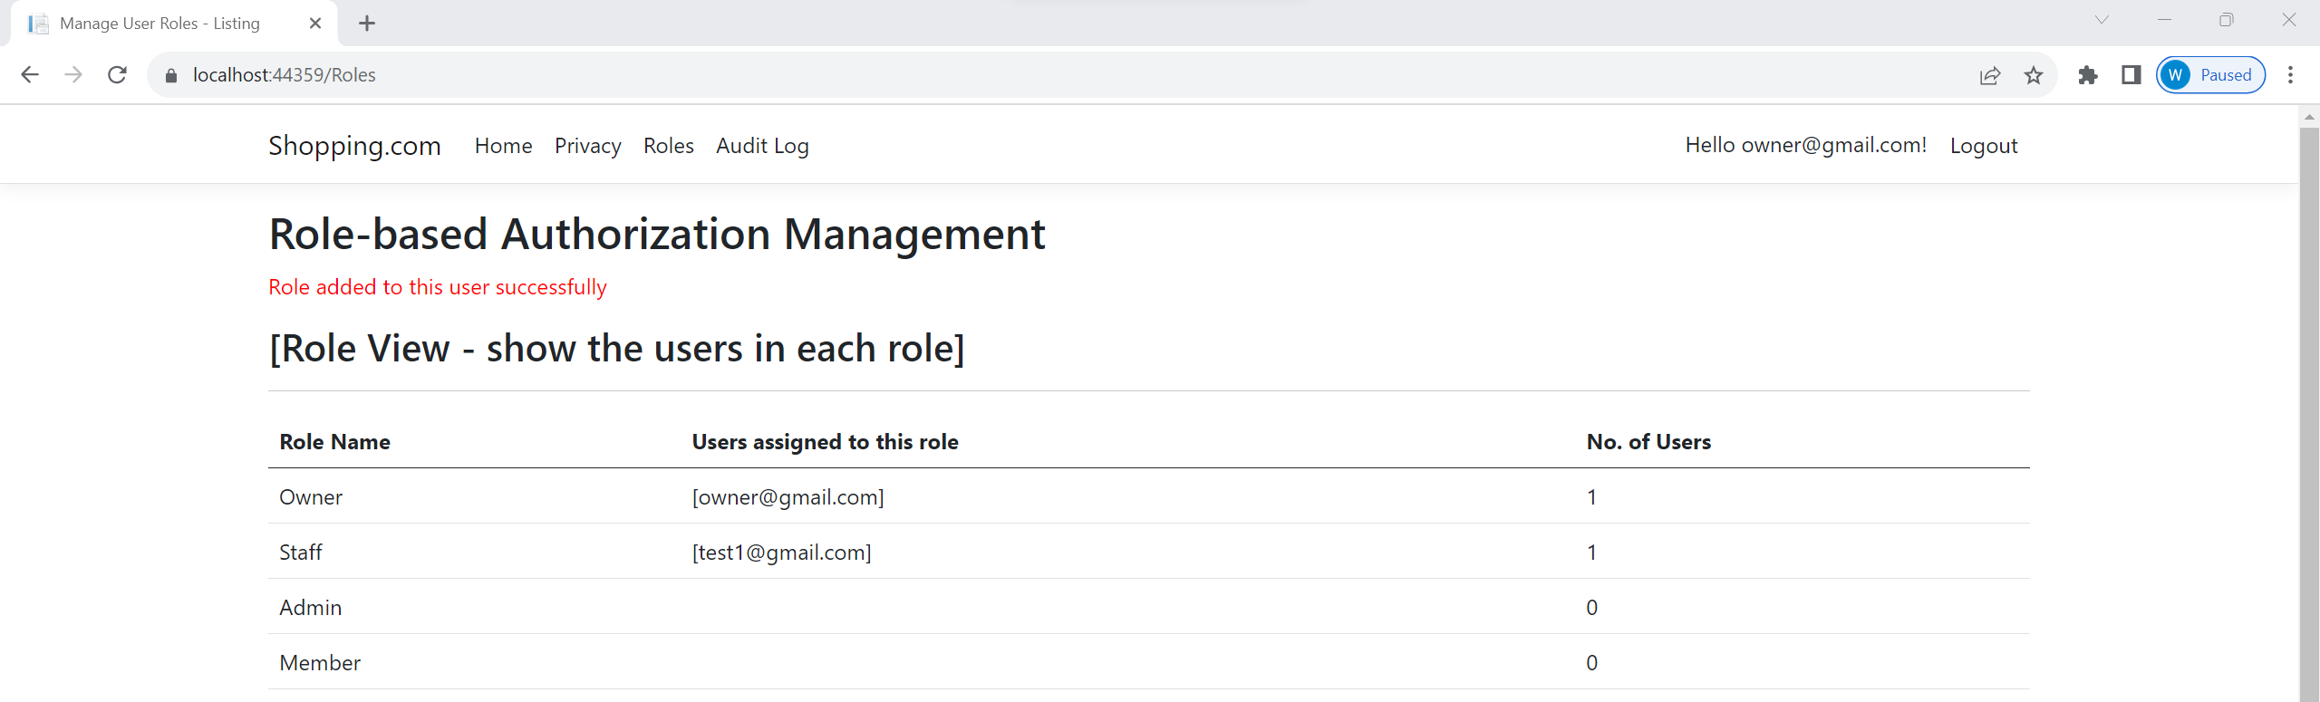

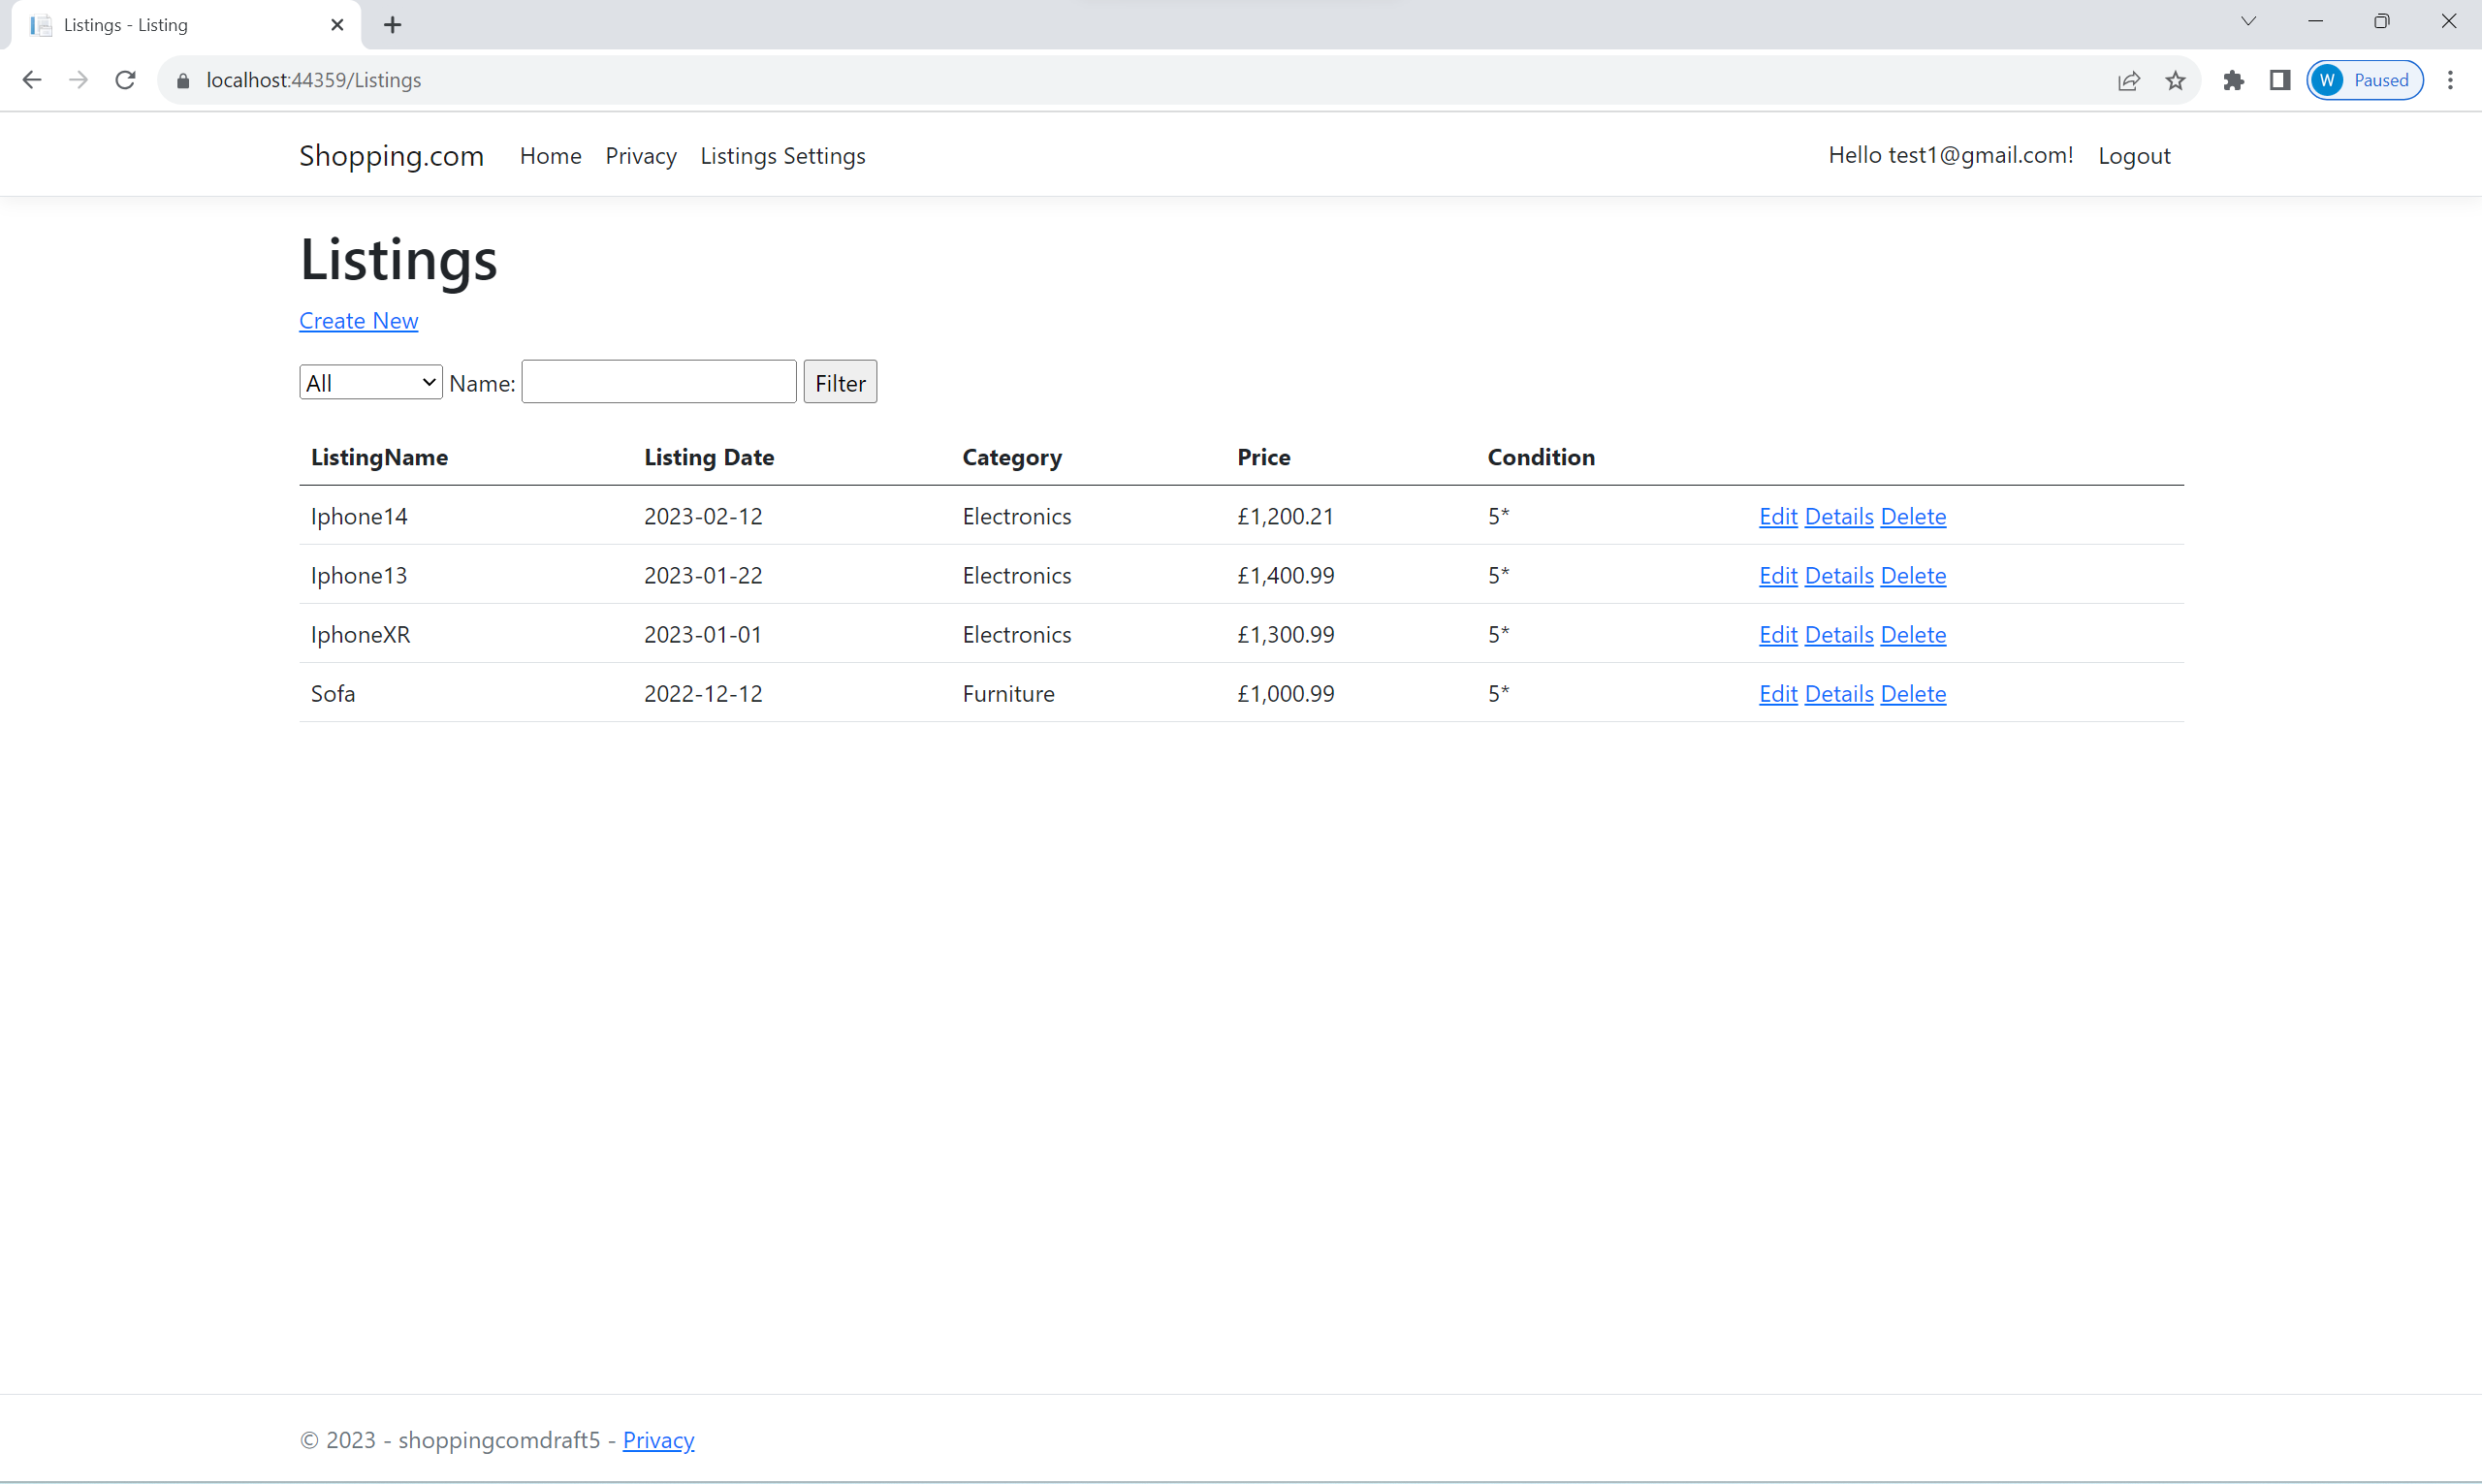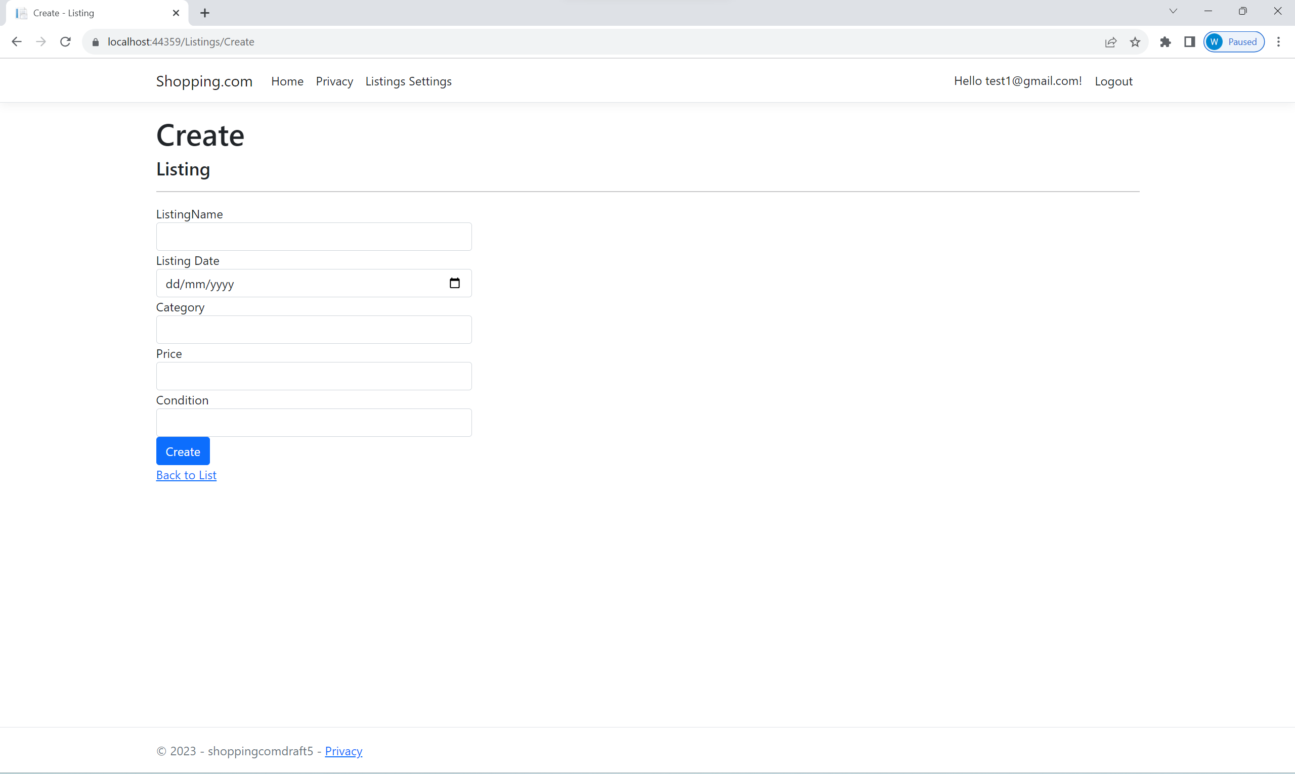

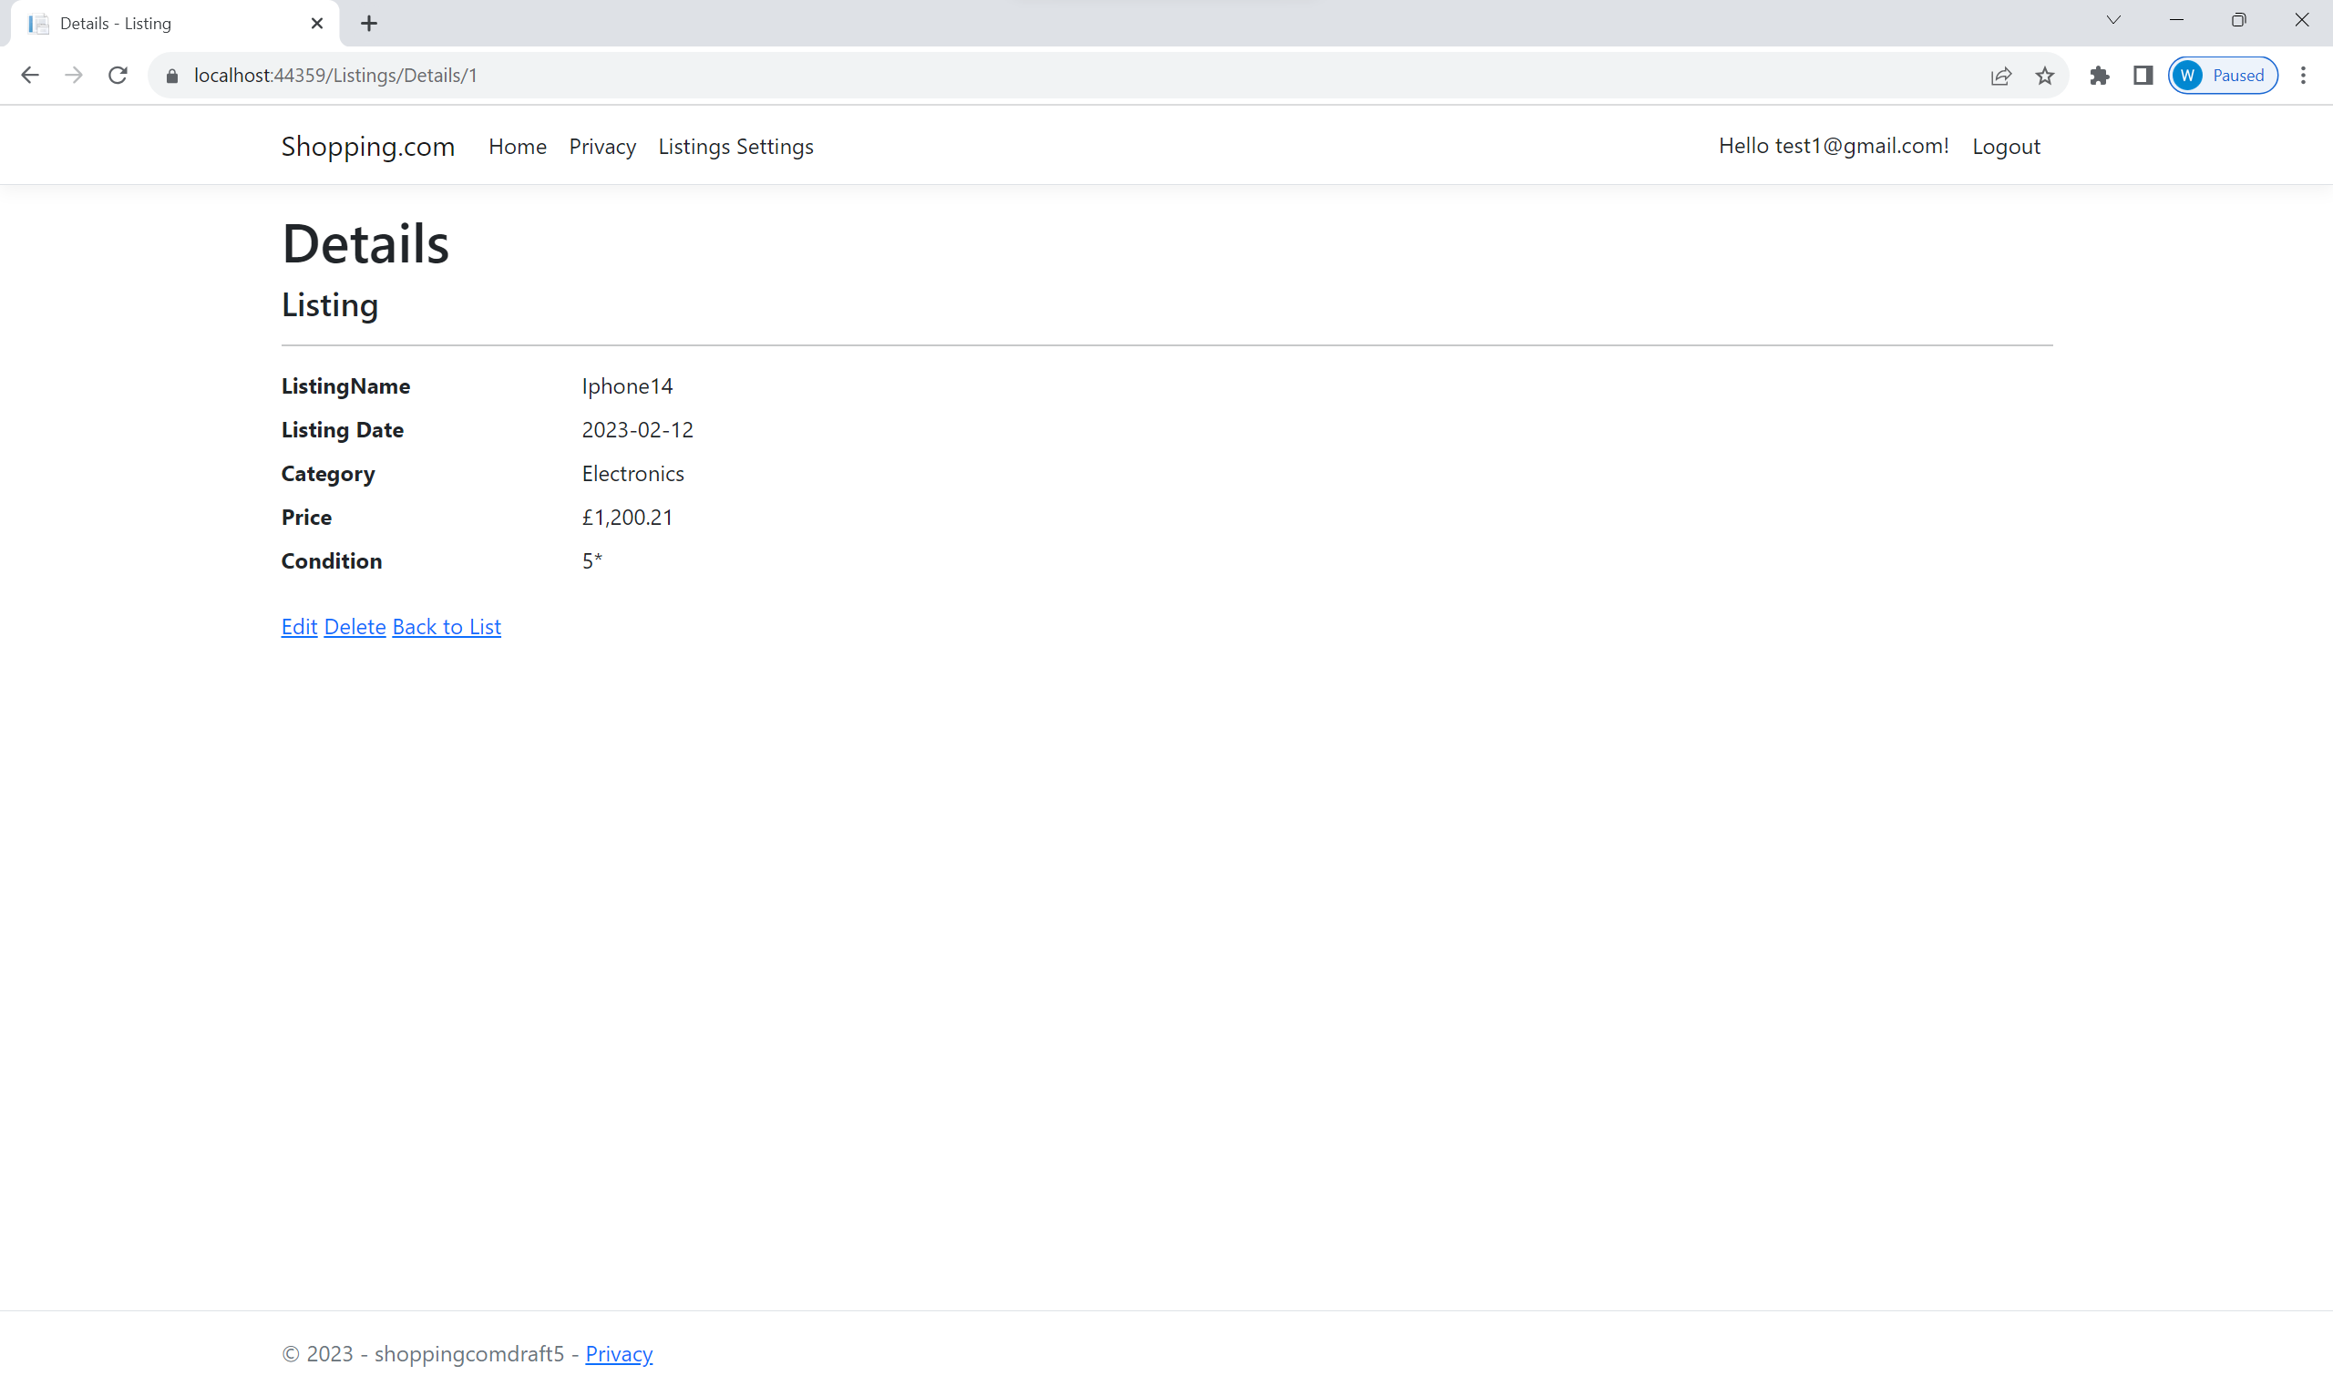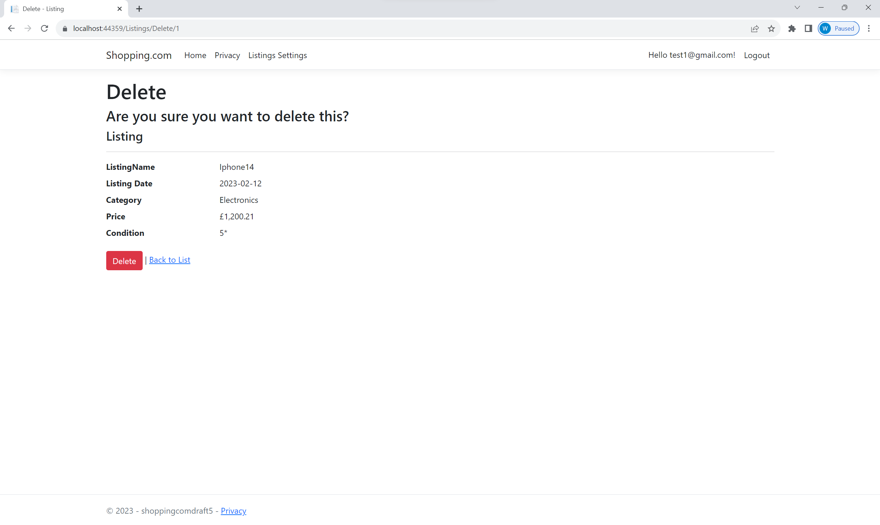

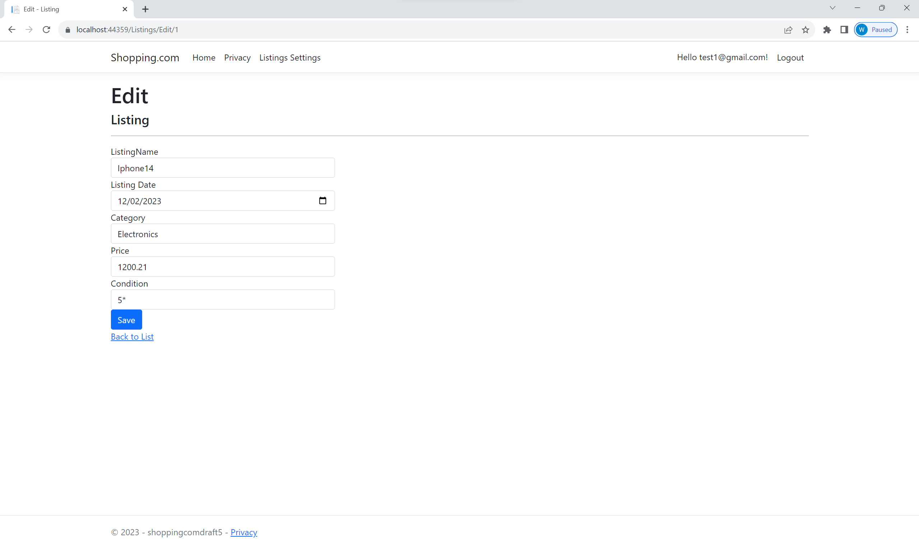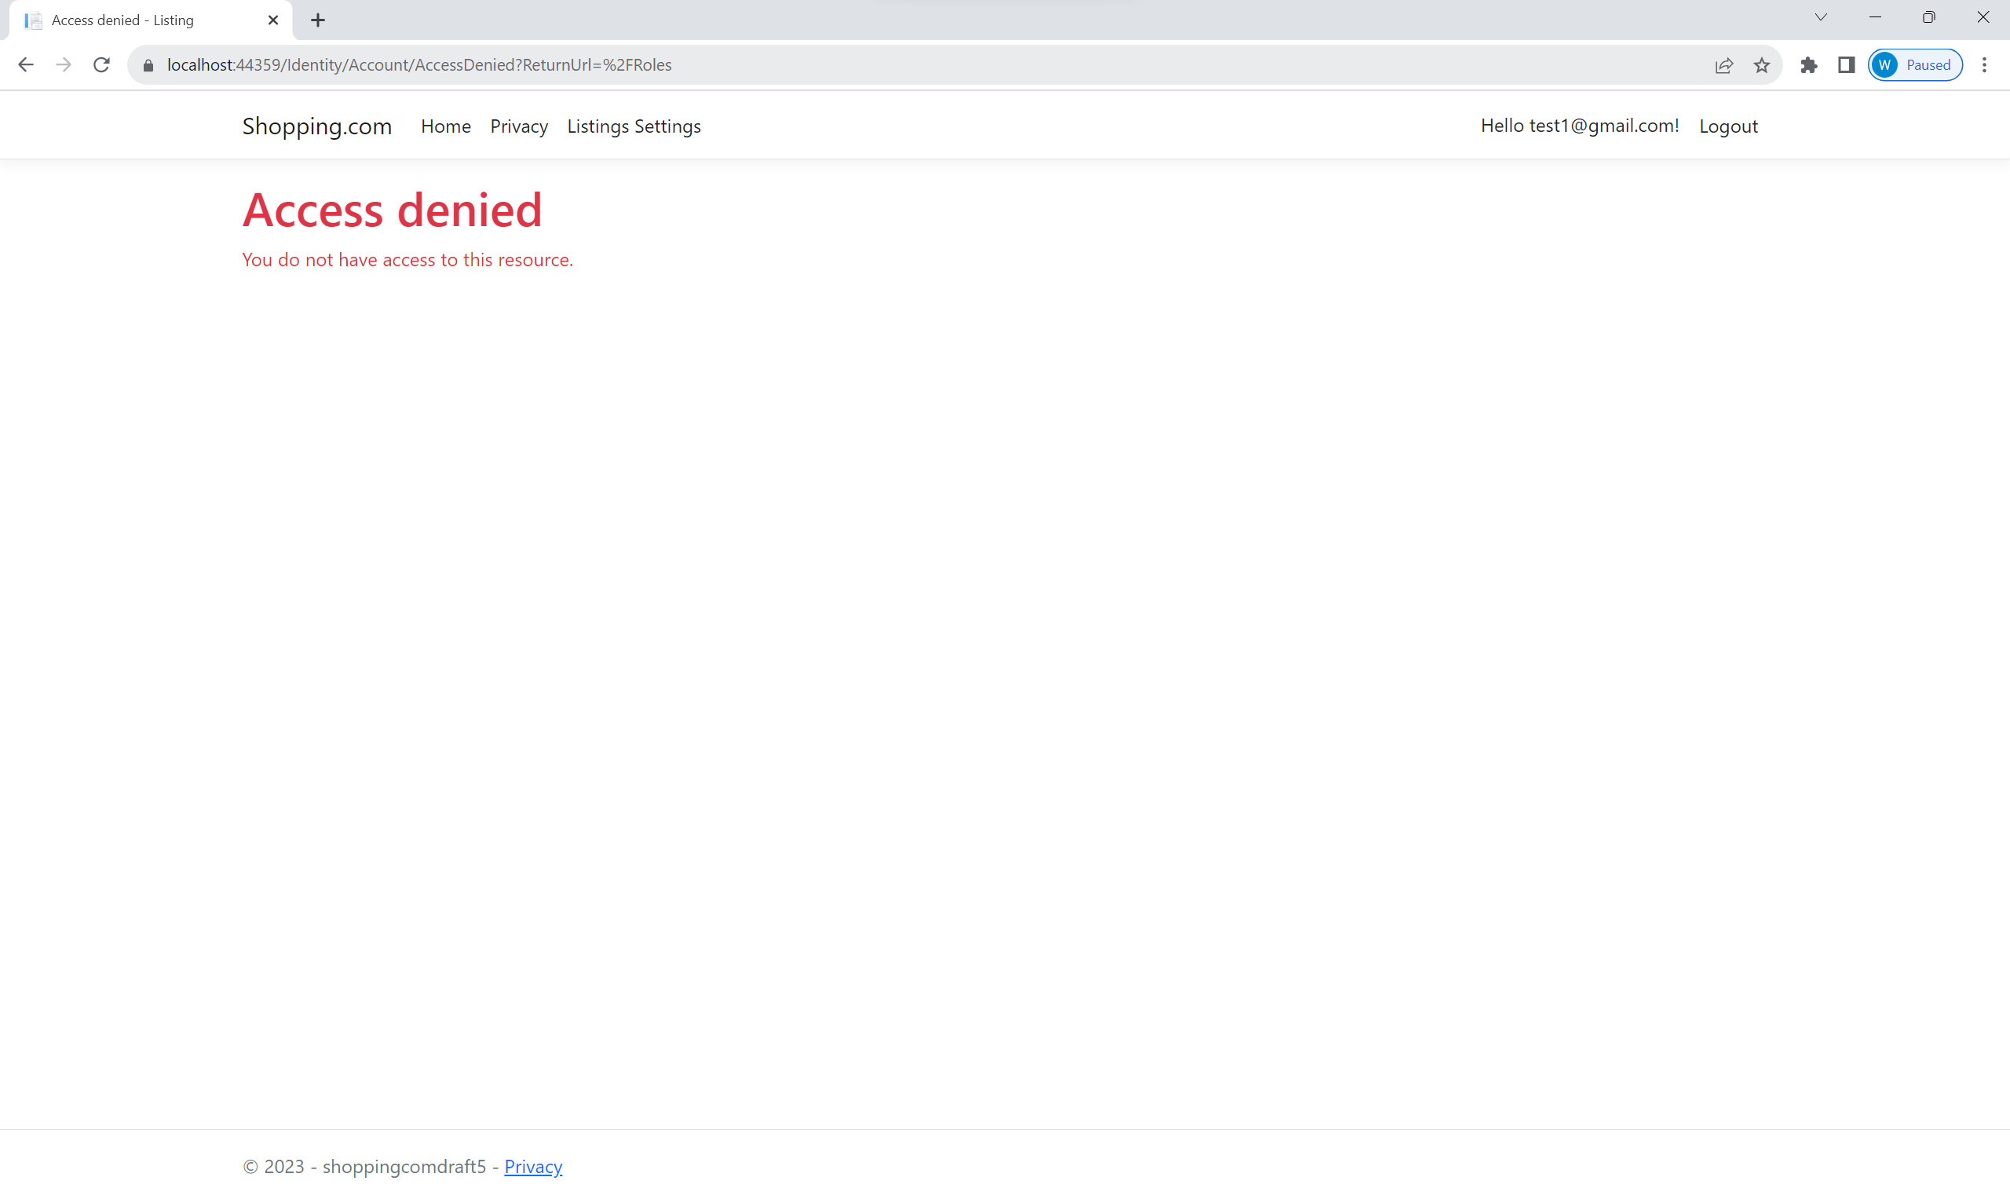

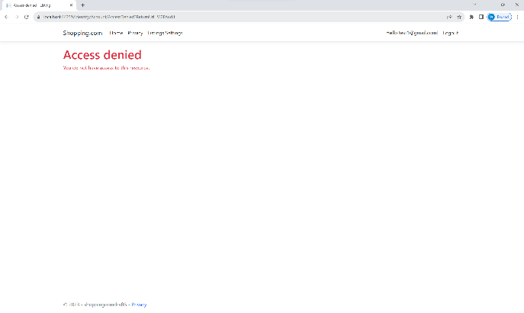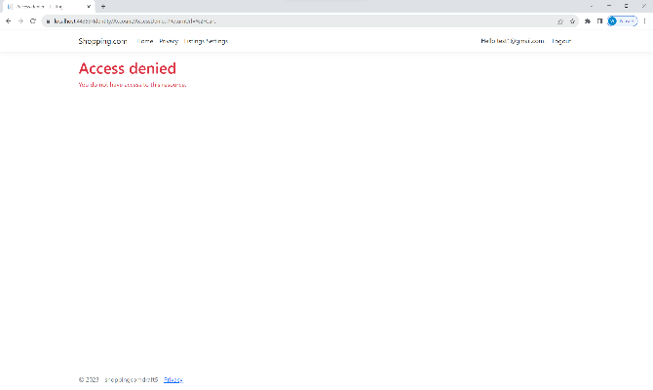

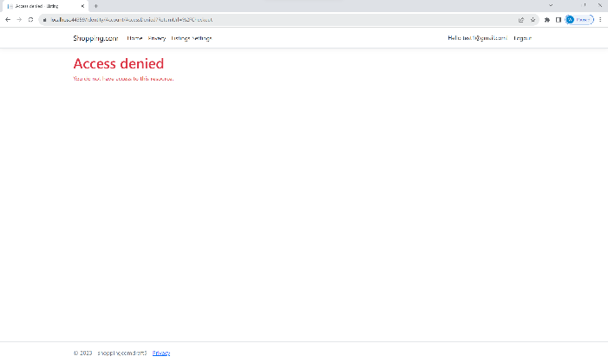

As we can see from the above screenshots, we can see that the test account [test1@gmail.com](mailto:test1@gmail.com) with a staff role is able to create, read, update, and delete listings. However, the account is unable to purchase listings. It is also unable to access roles management and audit logs pages. Any attempt by the account to access these unauthorized pages results in an access denied notification.

Next, we will be testing Admin roles, which only have permission to assign and remove member roles from users and view audit logs. We will be assigning [test1@gmail.com](mailto:test1@gmail.com) with an Admin role.

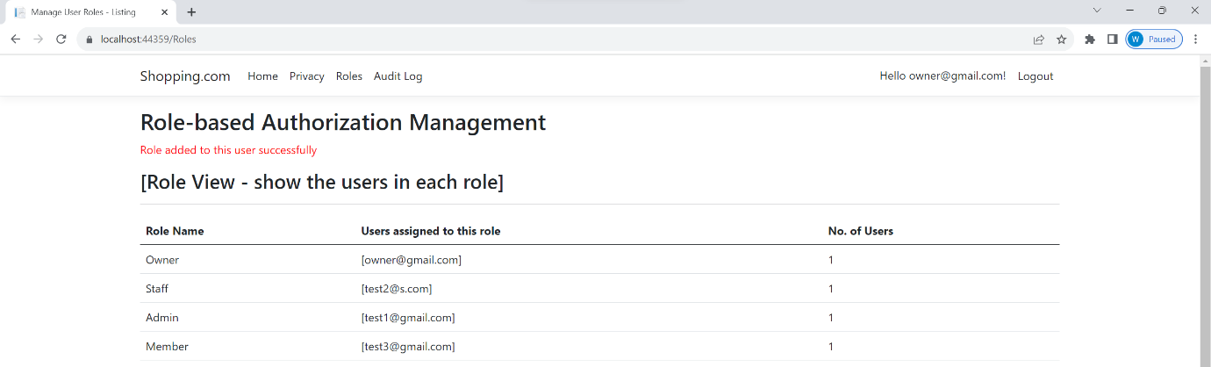

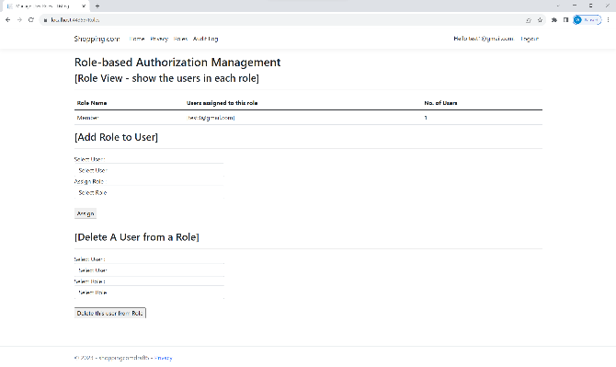 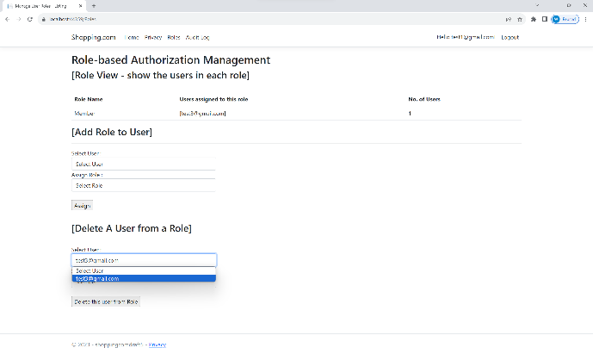

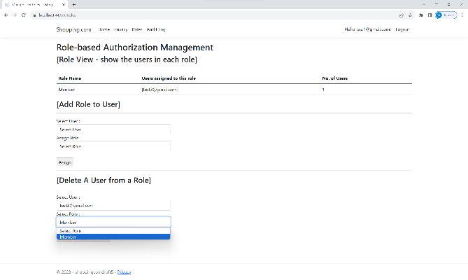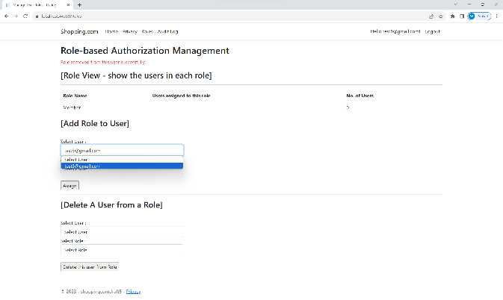

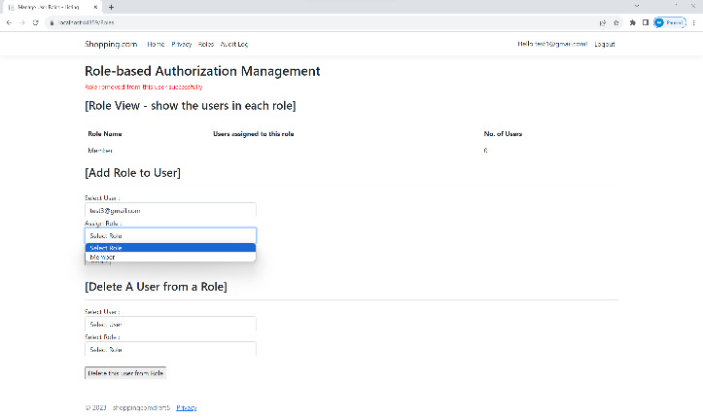 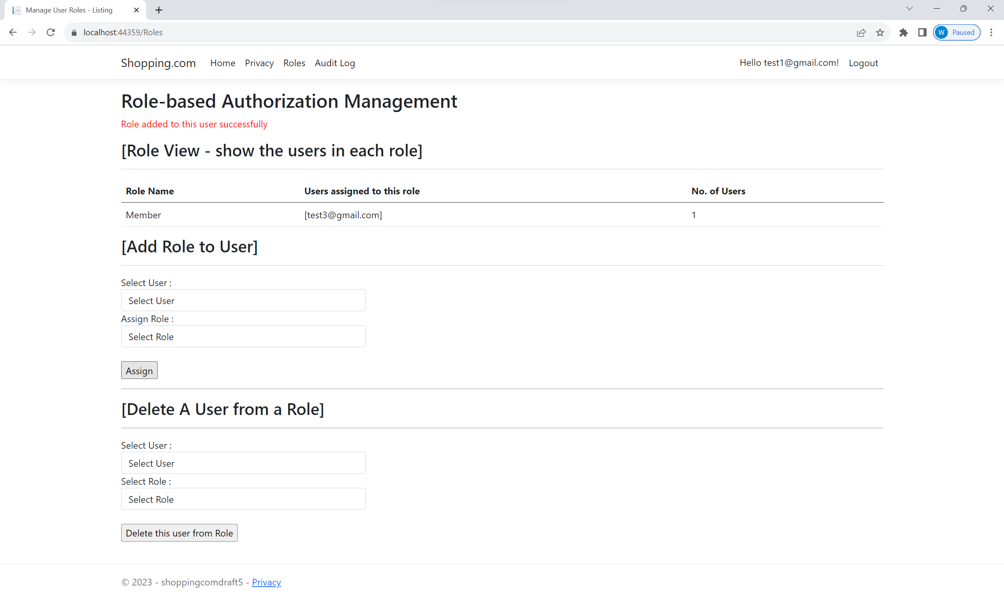

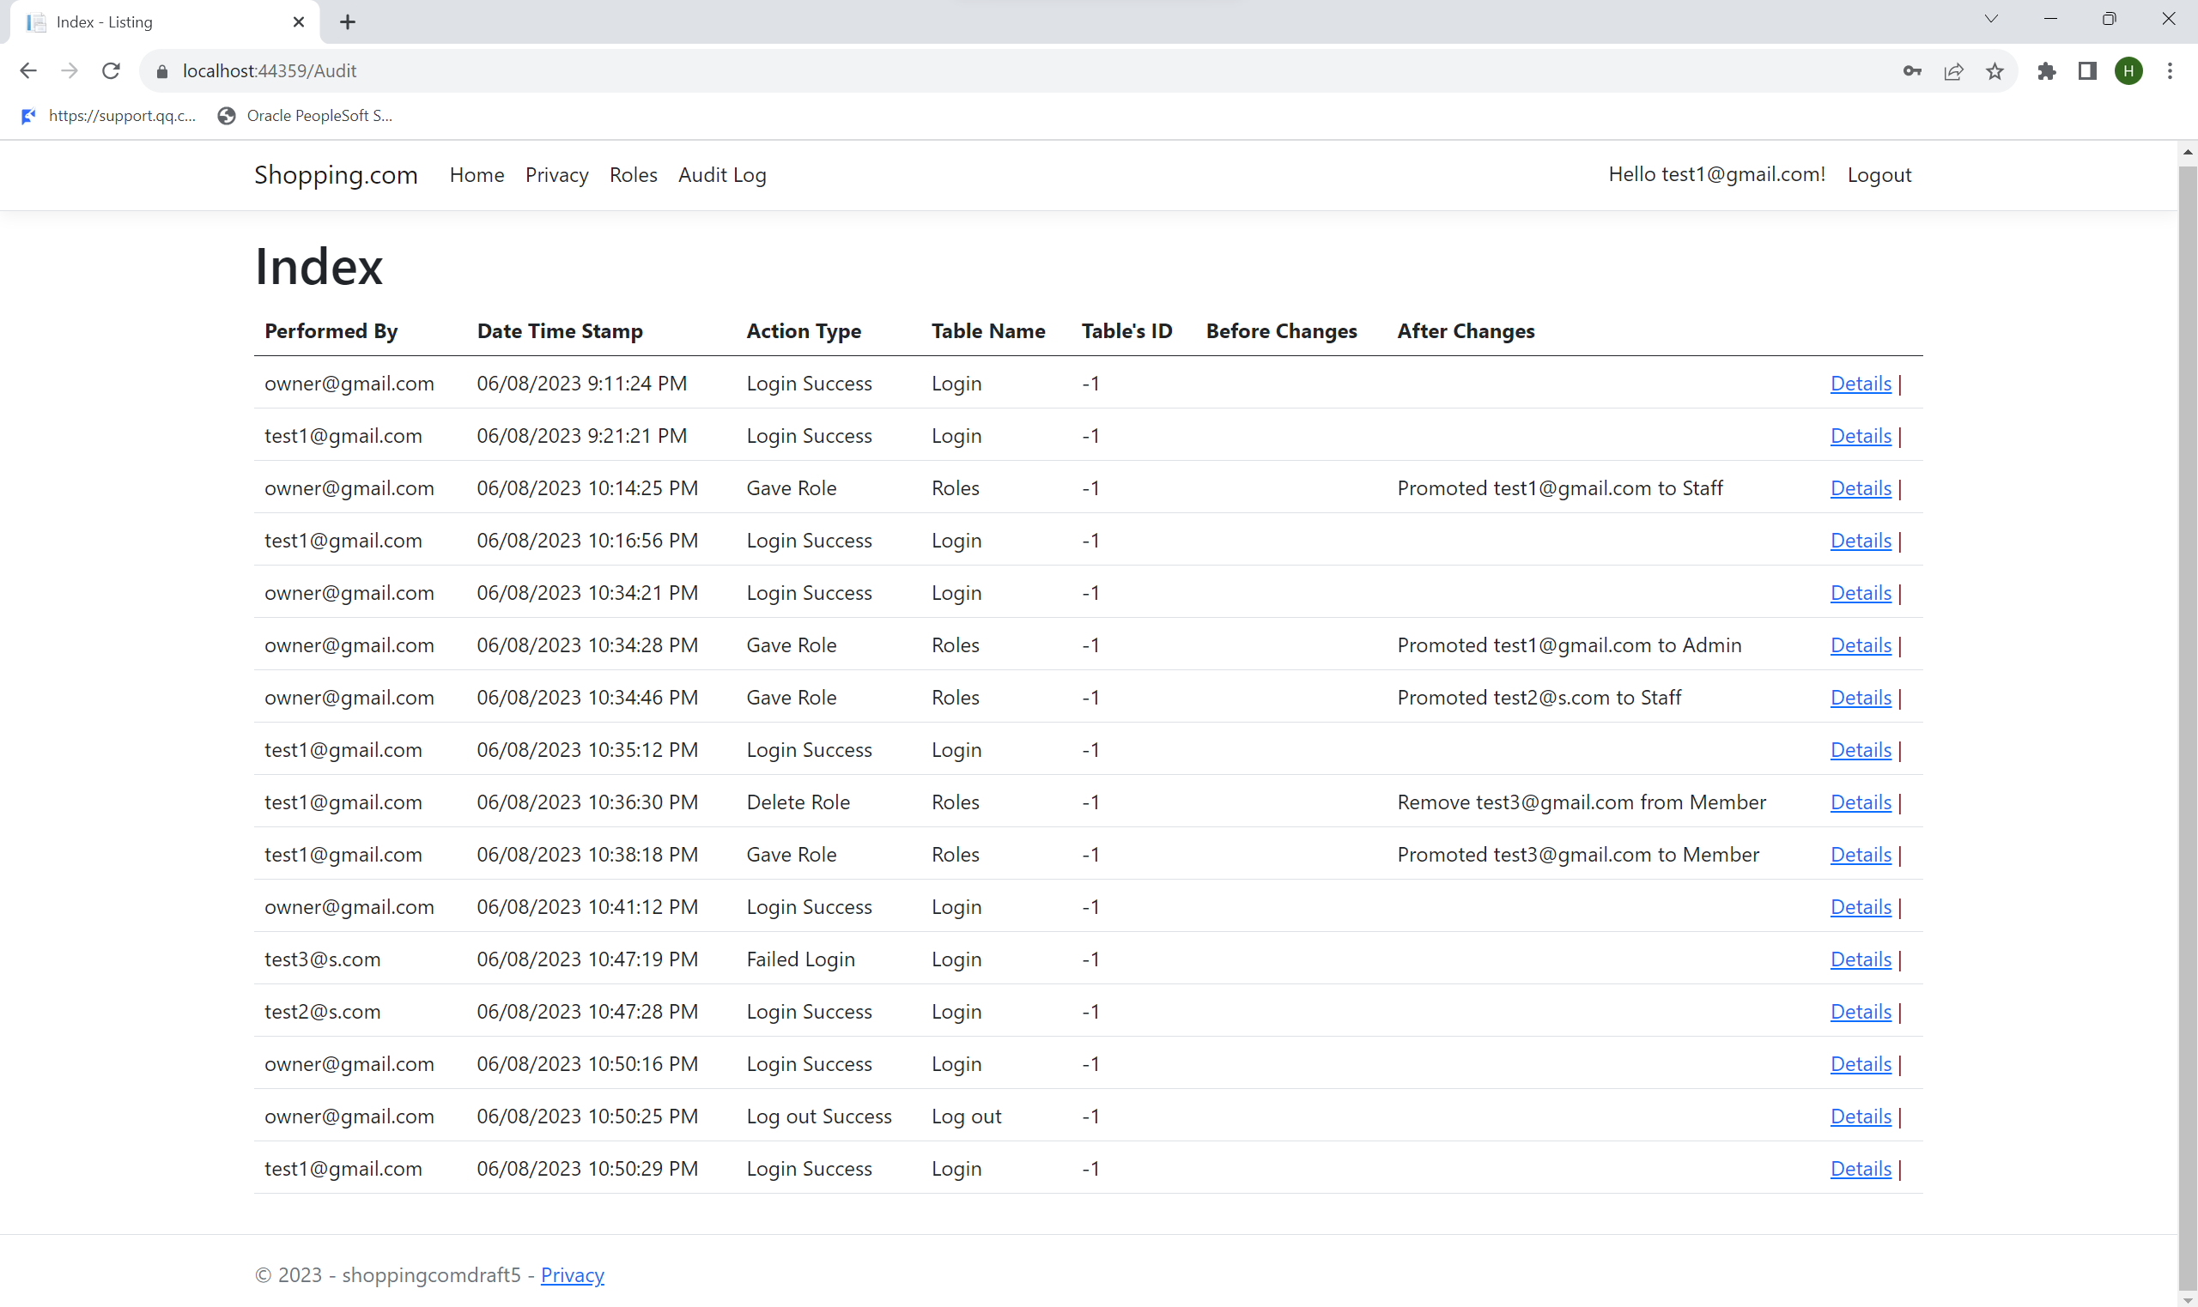 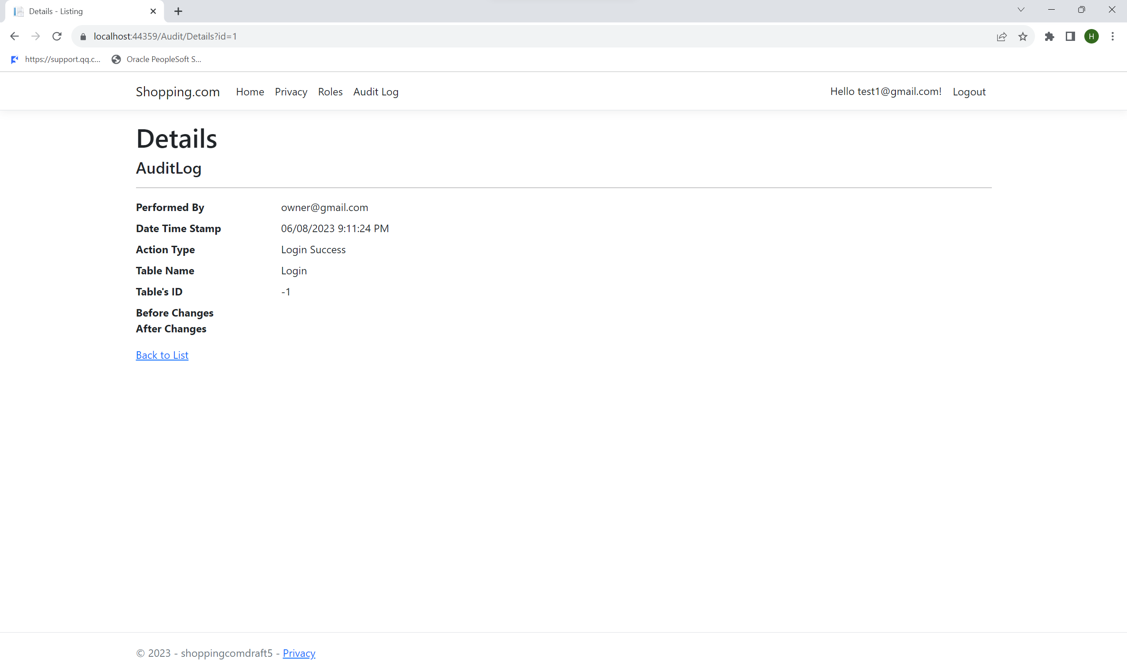

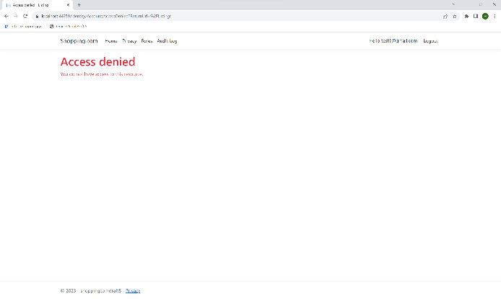 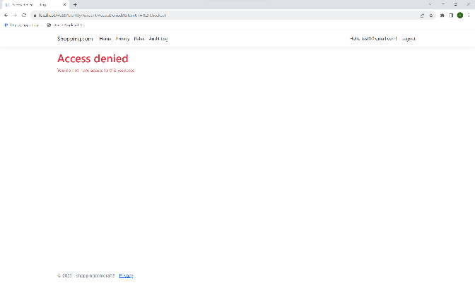

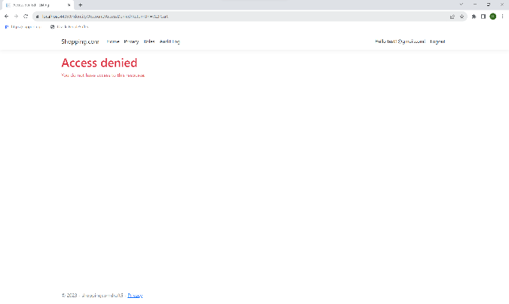

As we can see from the above screenshots, we can see that the test account [test1@gmail.com](mailto:test1@gmail.com) with an admin role is able to assign or remove member roles from users. Admin can only see those accounts with member roles, preventing email leakage for accounts with Staff/Owner and other Admin roles. However, Admin cannot select accounts that have Admin/Owner/Staff roles to assign or remove roles, thereby preventing Admin from giving escalation of privilege to another user. Notably, the Admin cannot select his own account to prevent an unauthorised escalation of privileges. The selection of roles is restricted to members only. It can also access Audit logs. However, the account is unable to purchase listings. It is also unable to create, read, update, and delete listings. Furthermore, any attempt by the account to access these unauthorized pages results in an access denied notification.

Next, we will be testing Owner roles, which only have permission to assign and remove Admin/Staff/Member roles from users and view/delete audit logs. We will be using [owner@gmail.com](mailto:owner@gmail.com) with owner roles.

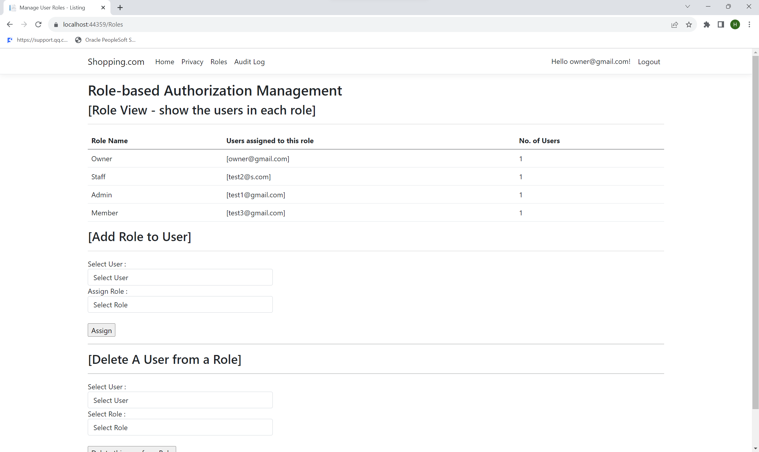 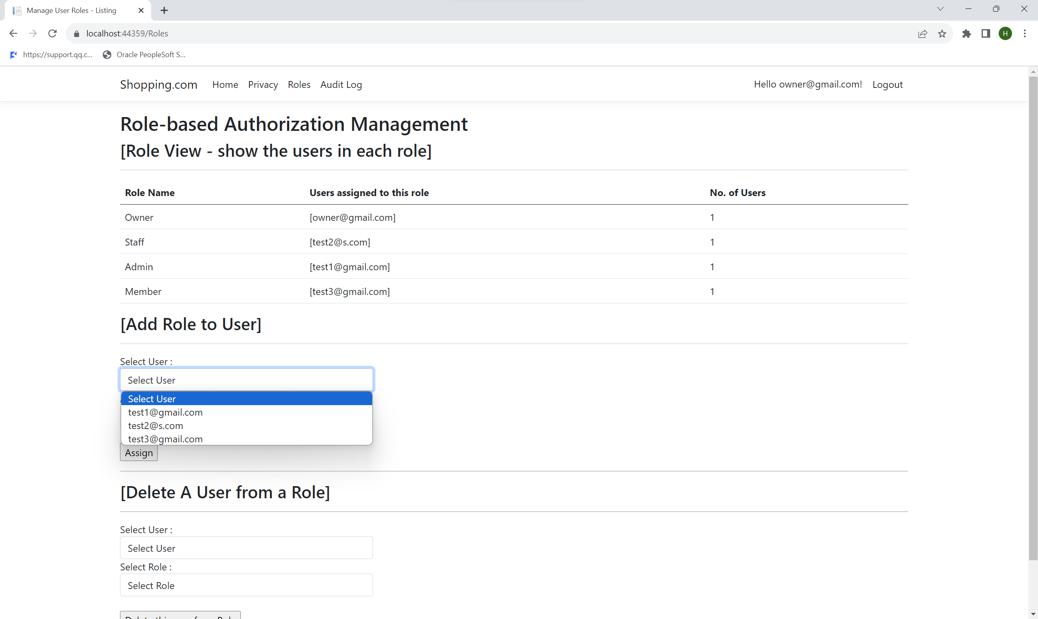

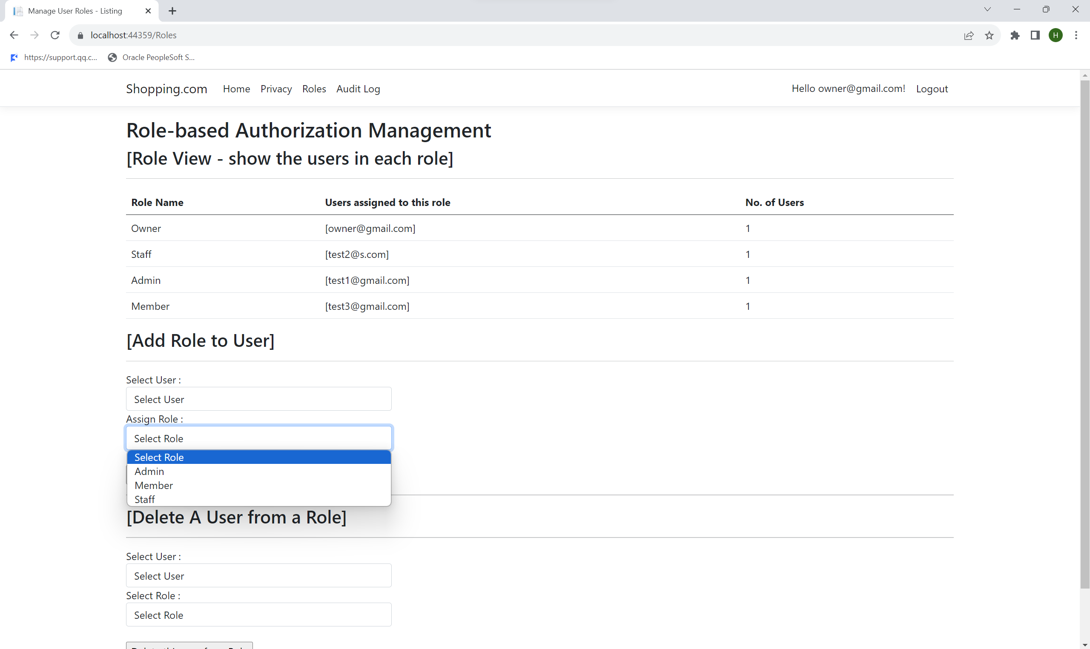 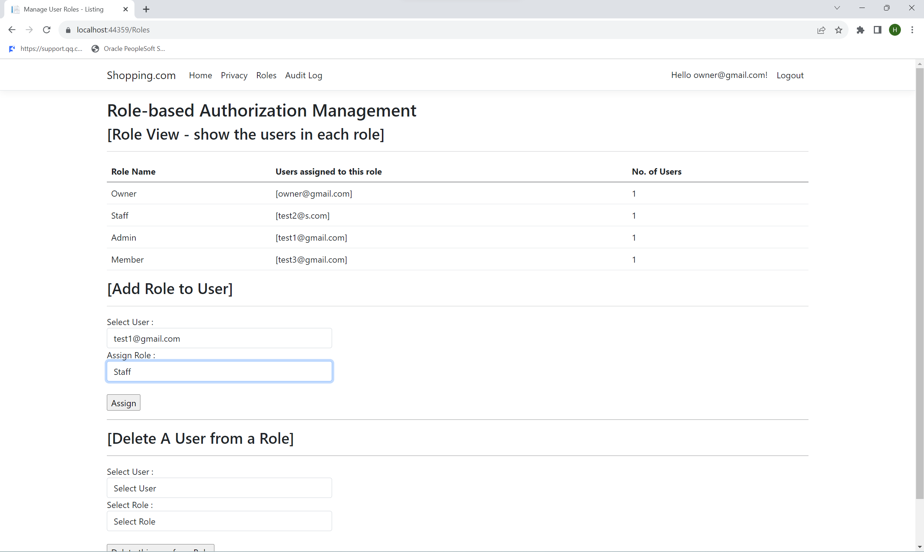

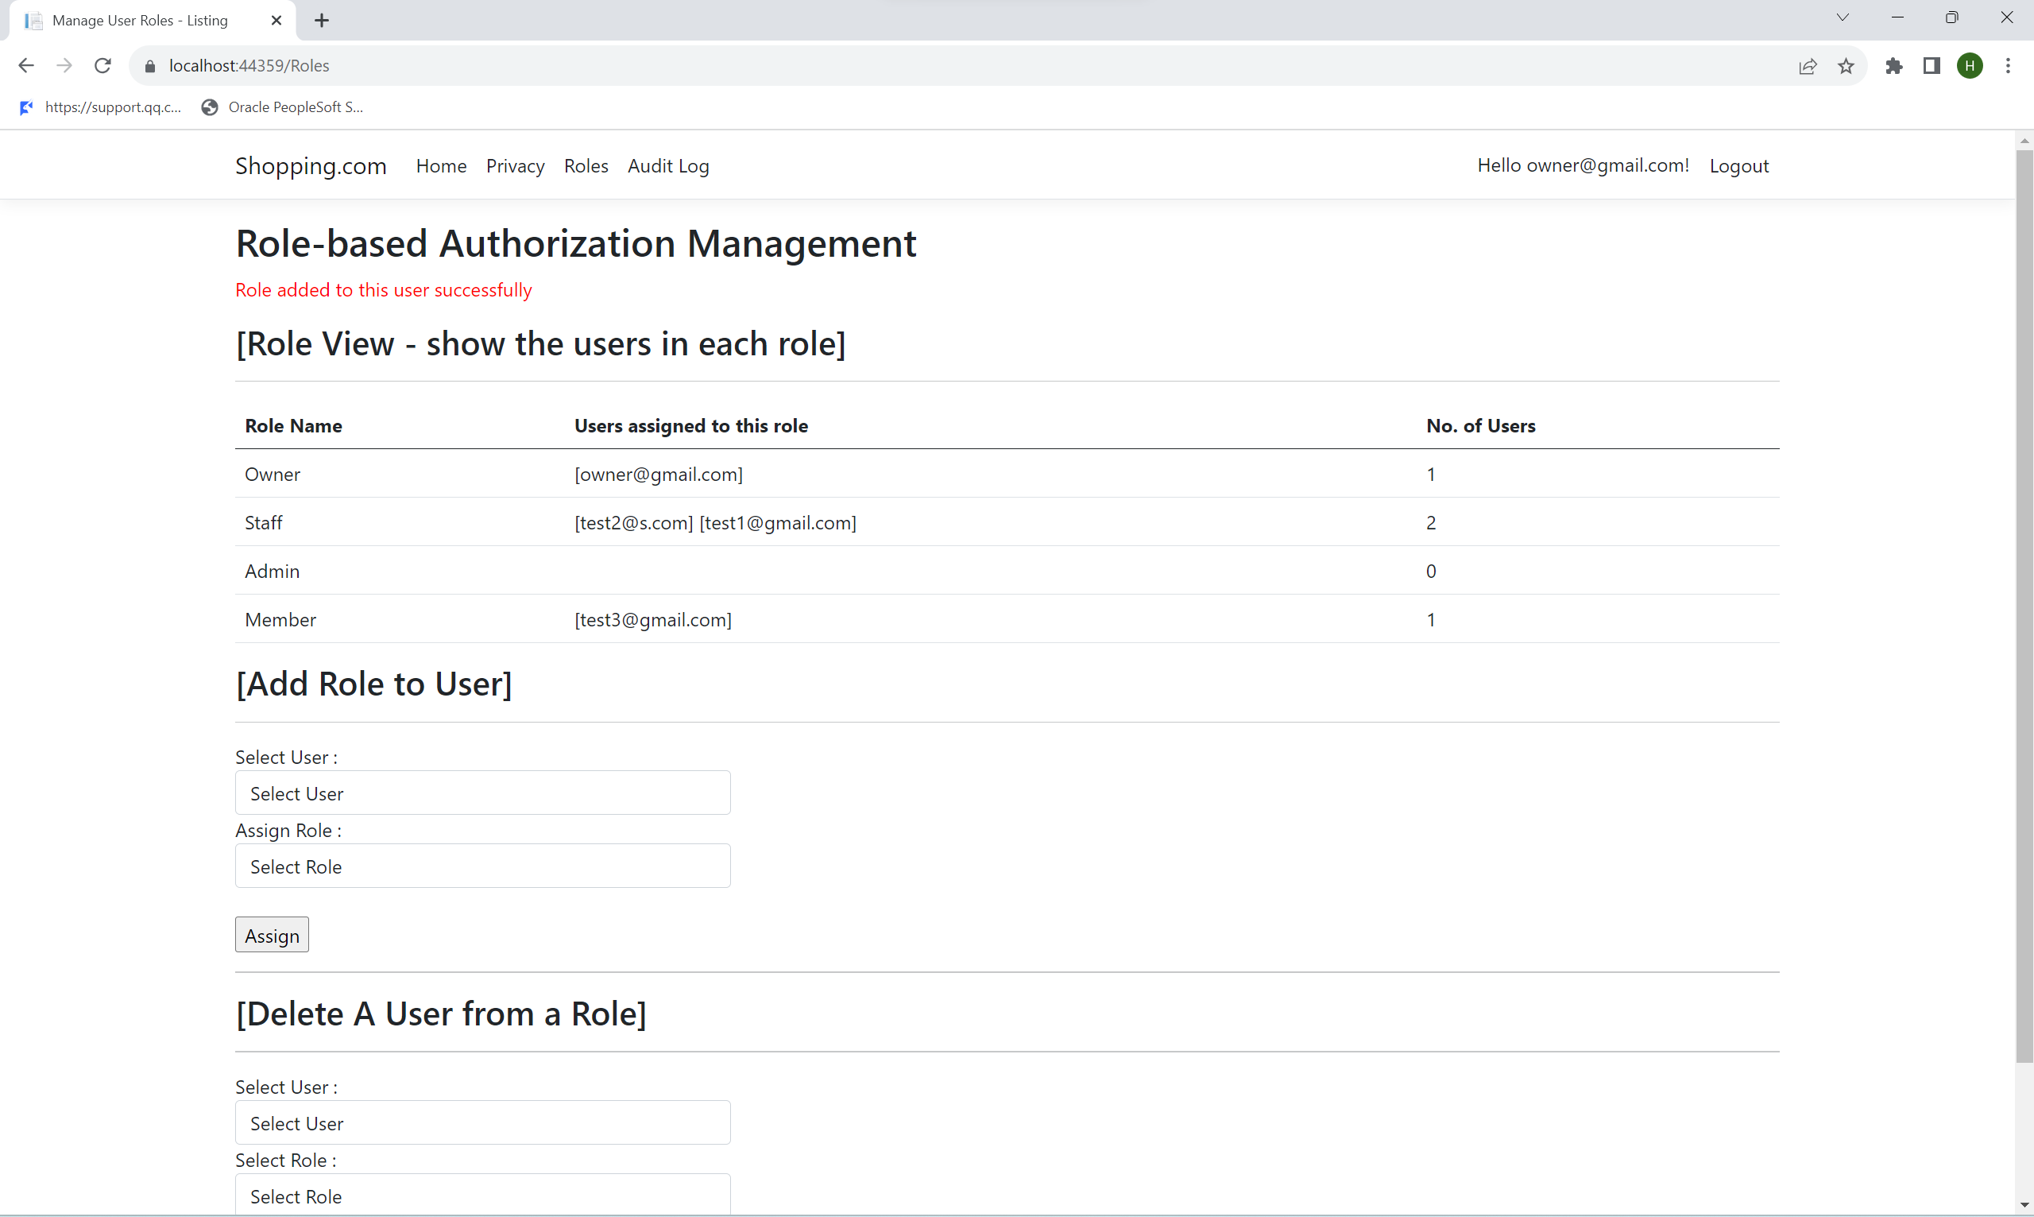 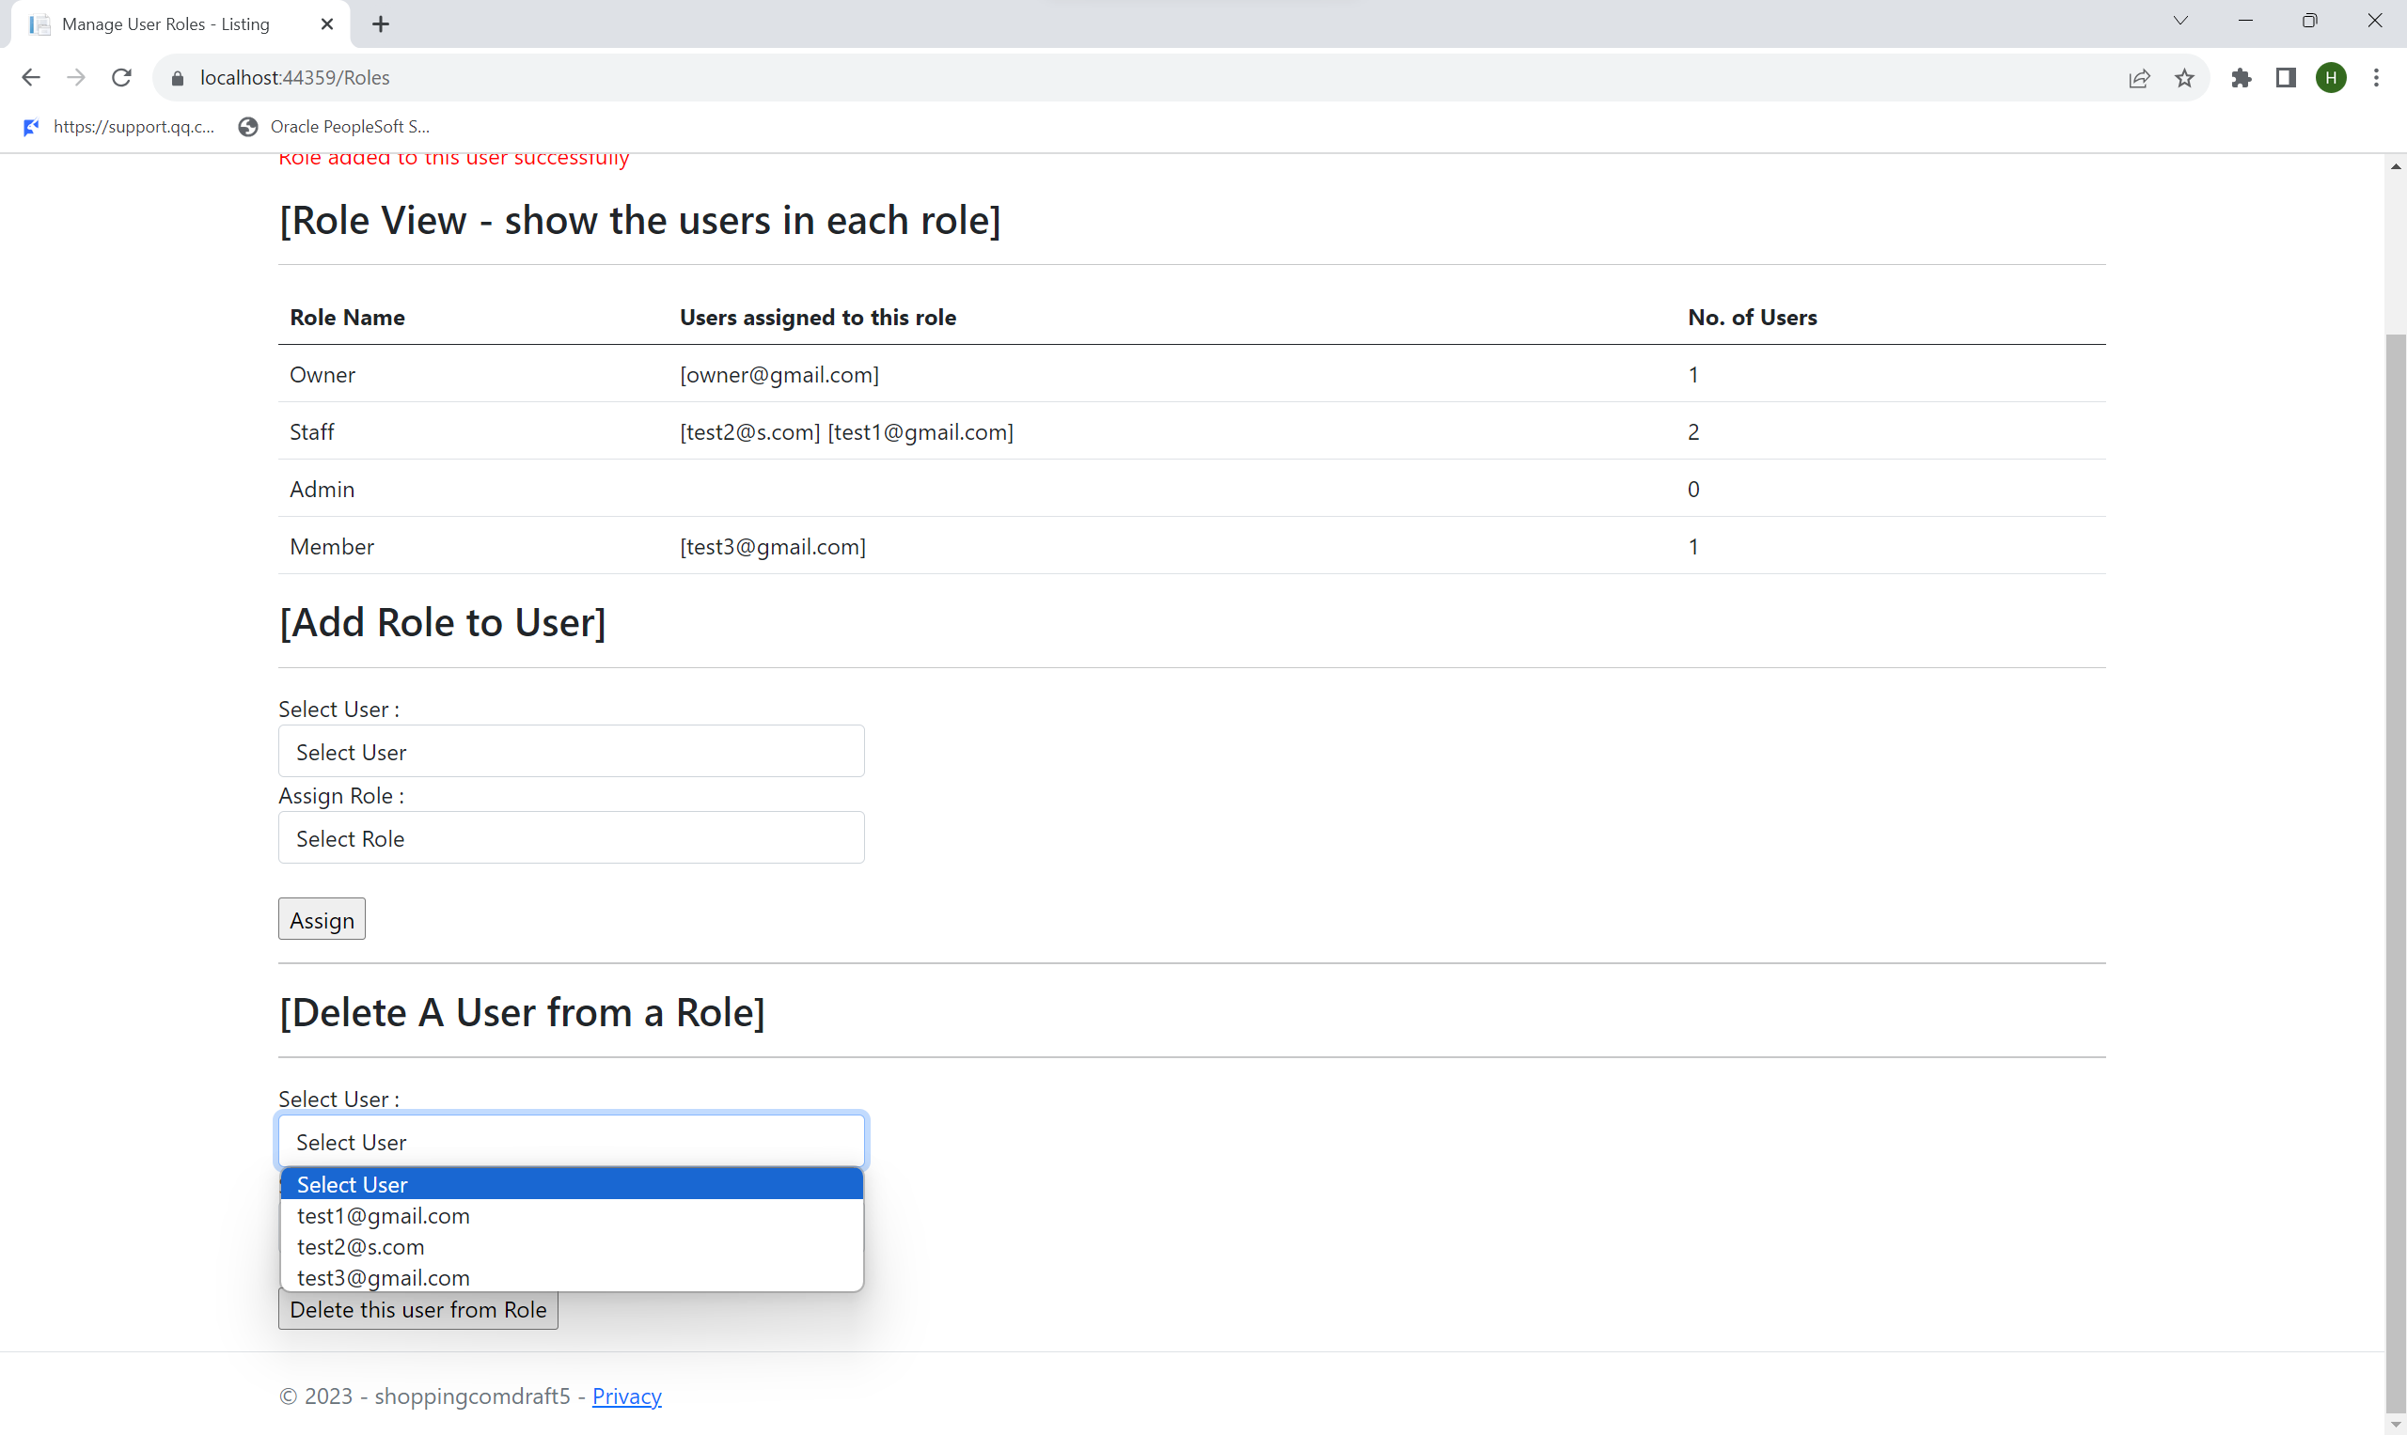

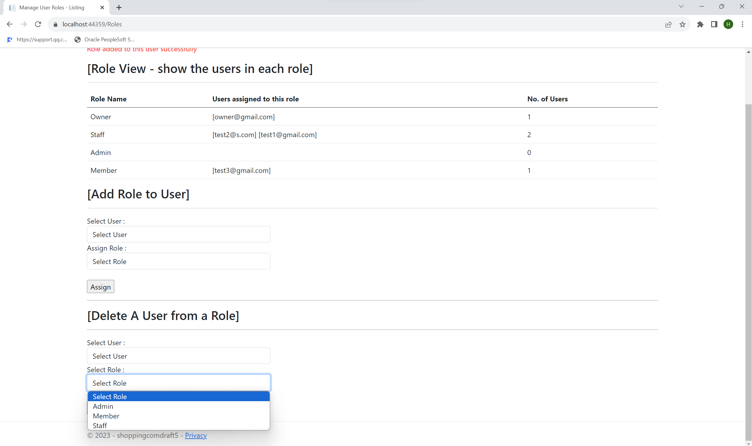 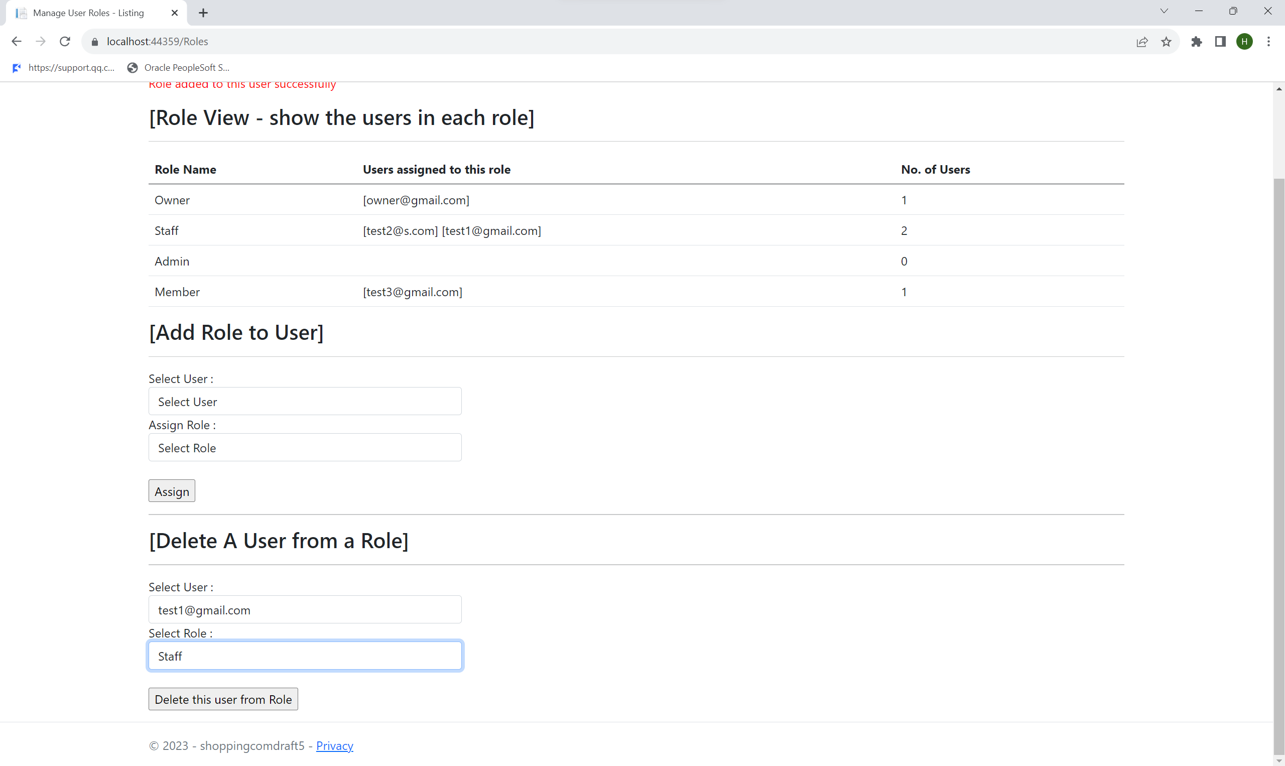

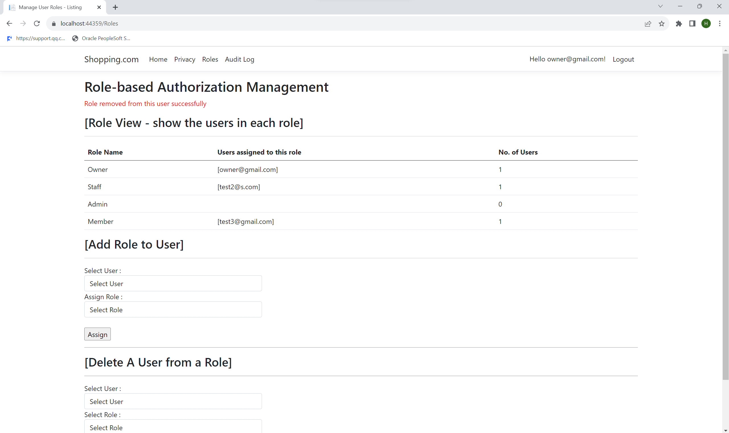 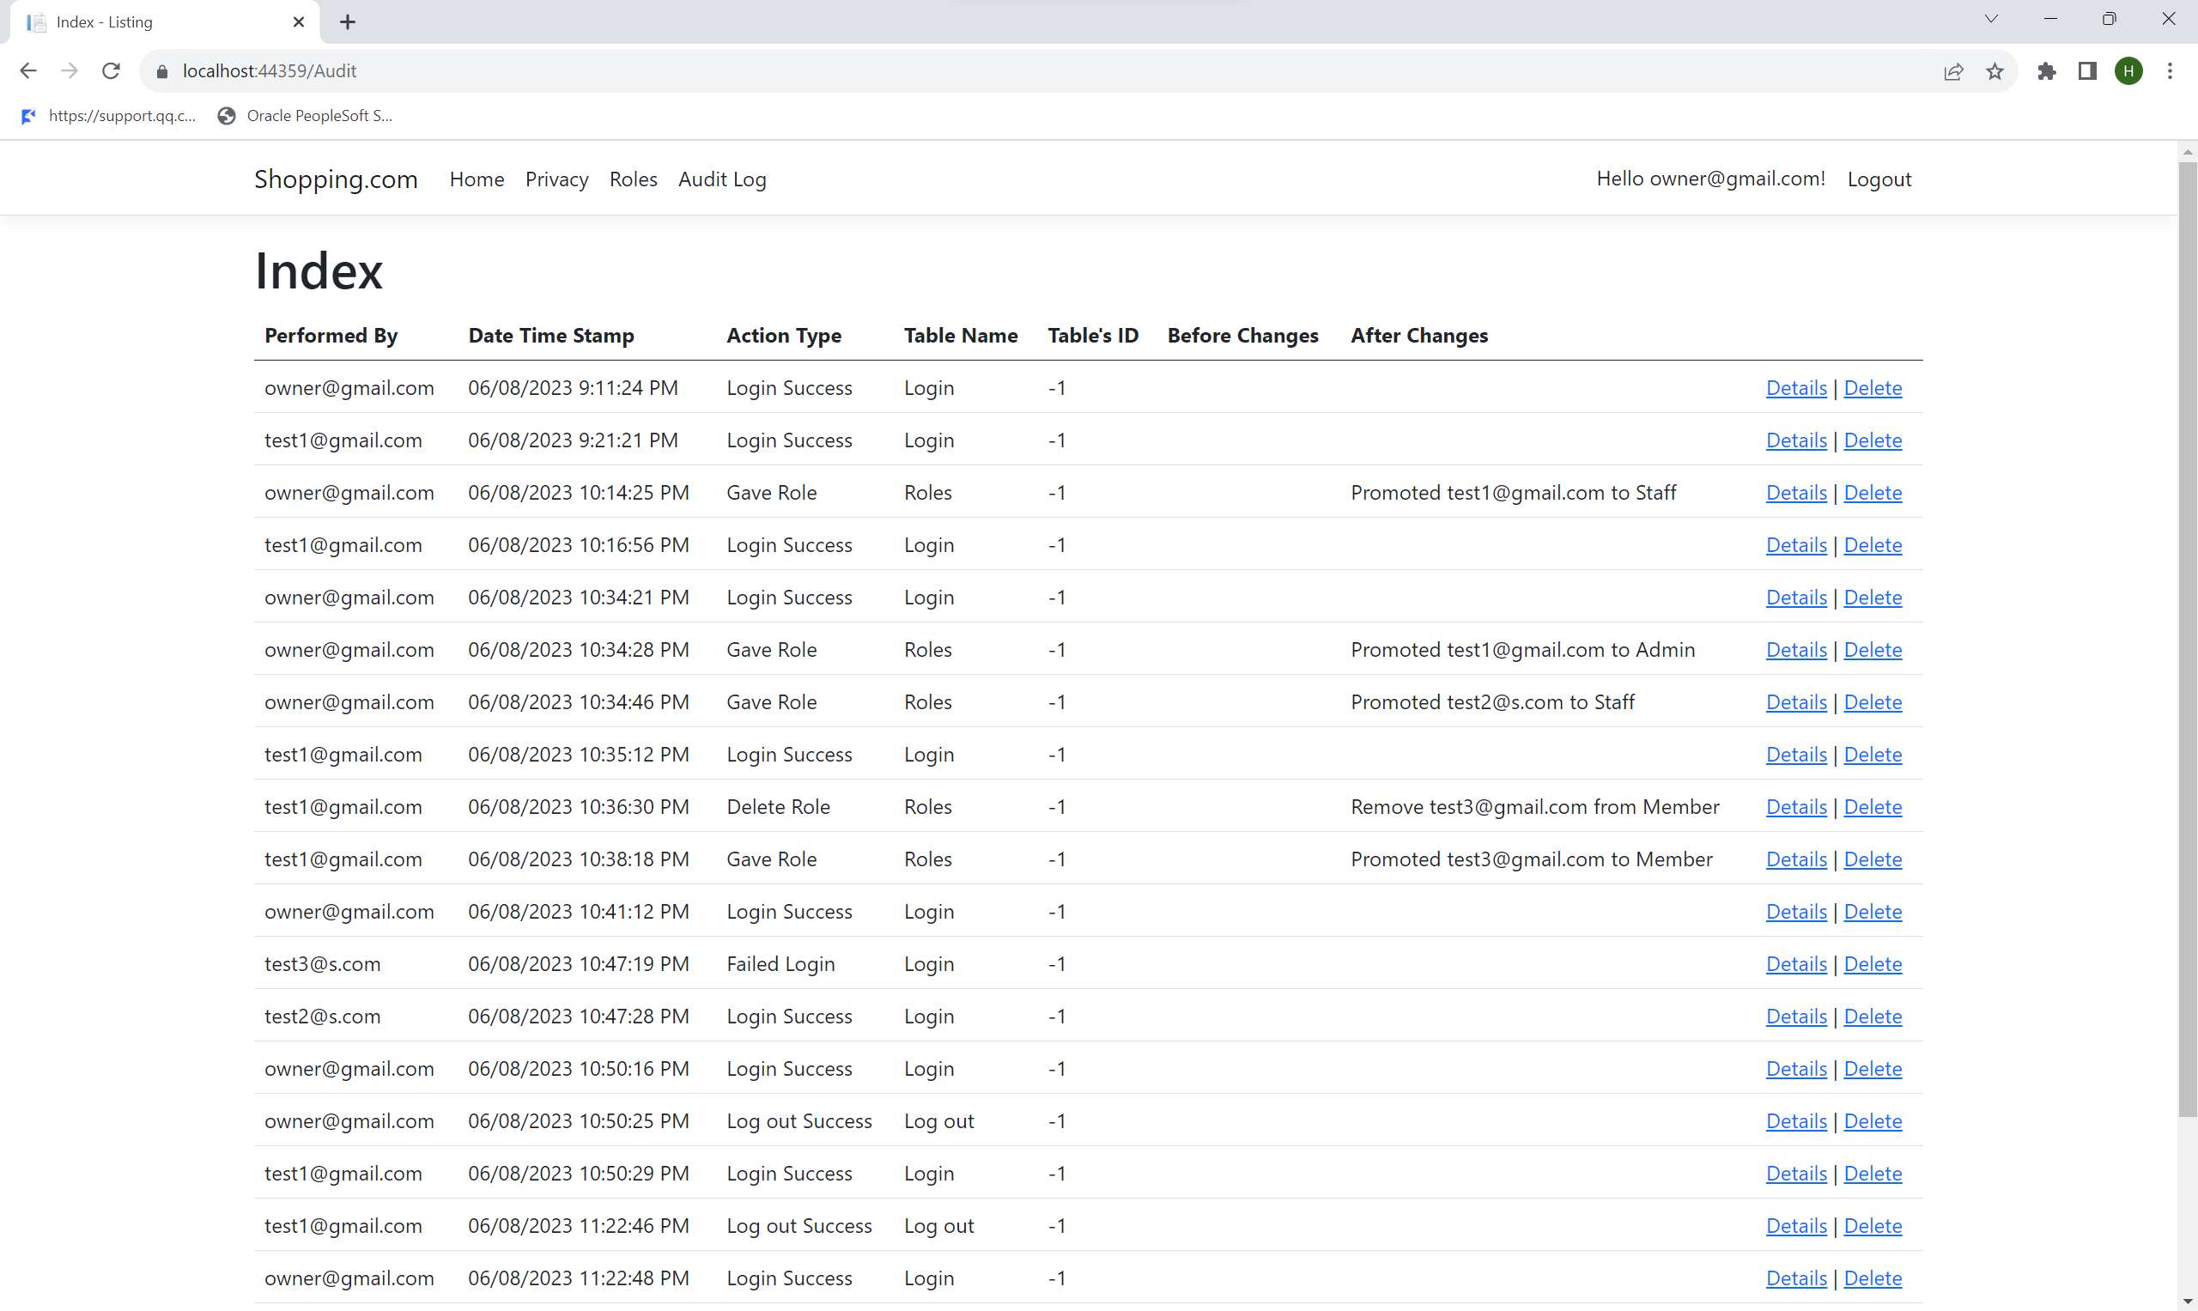

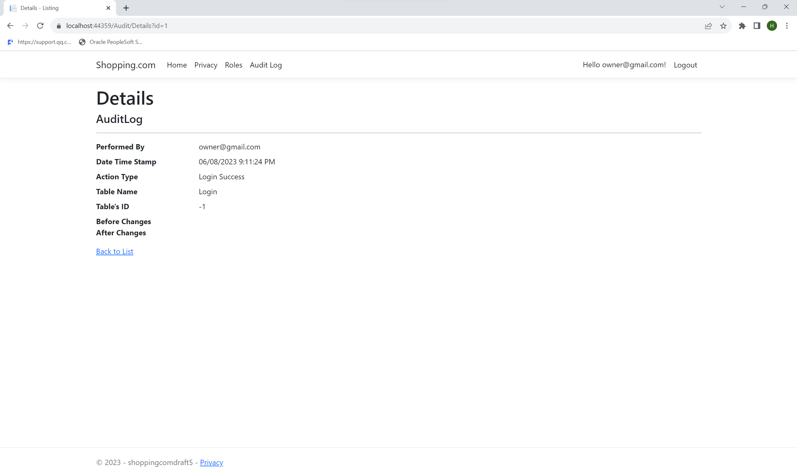 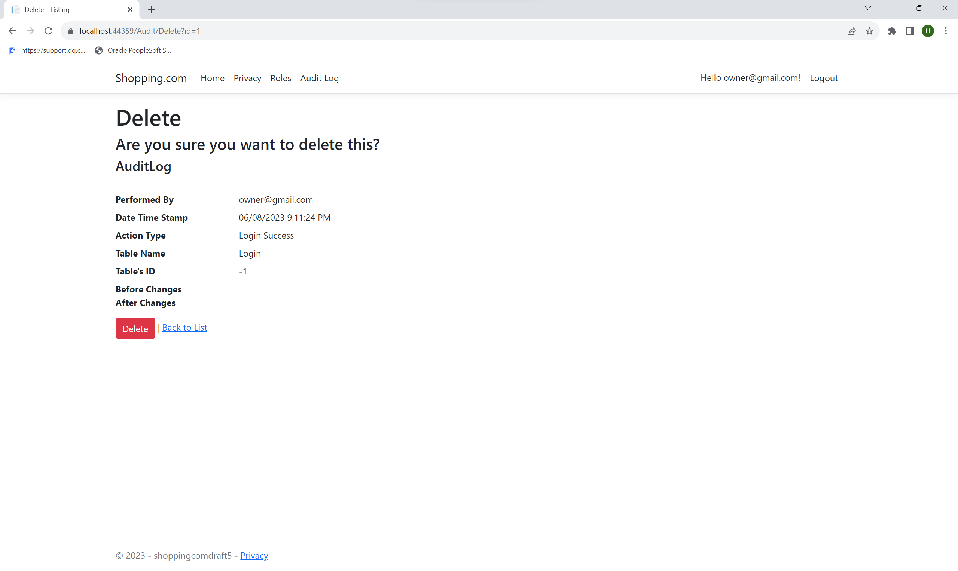

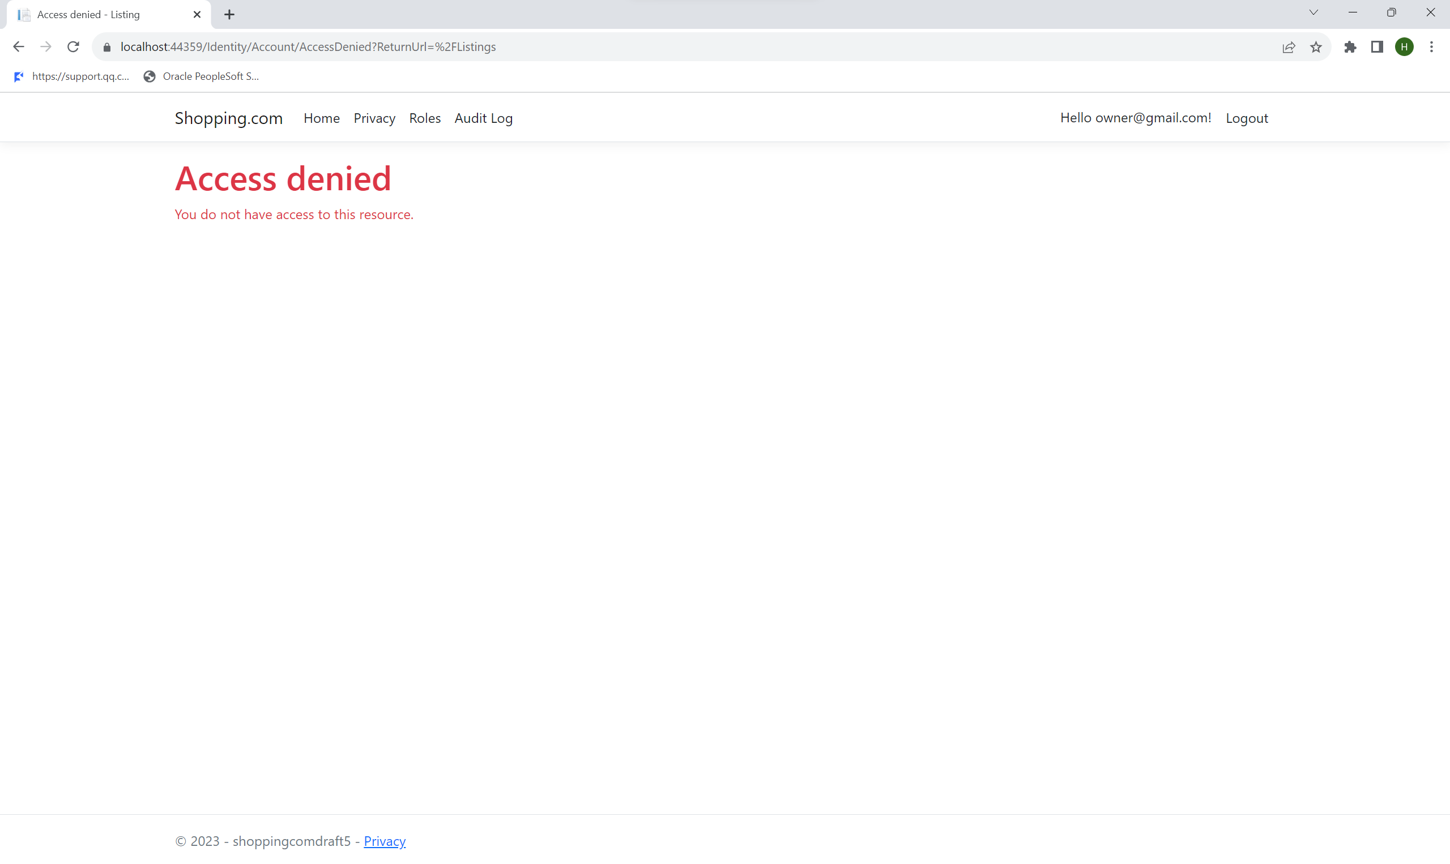 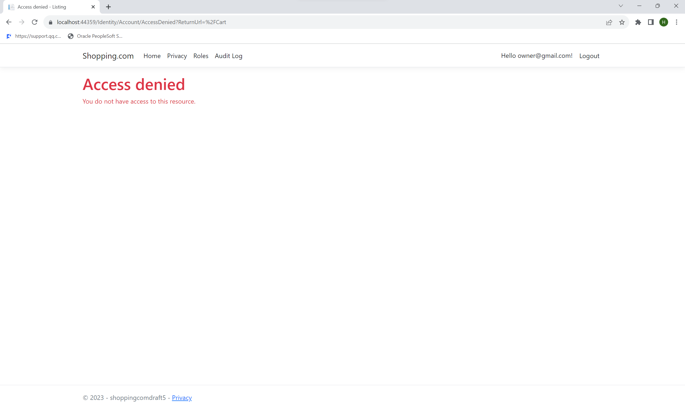

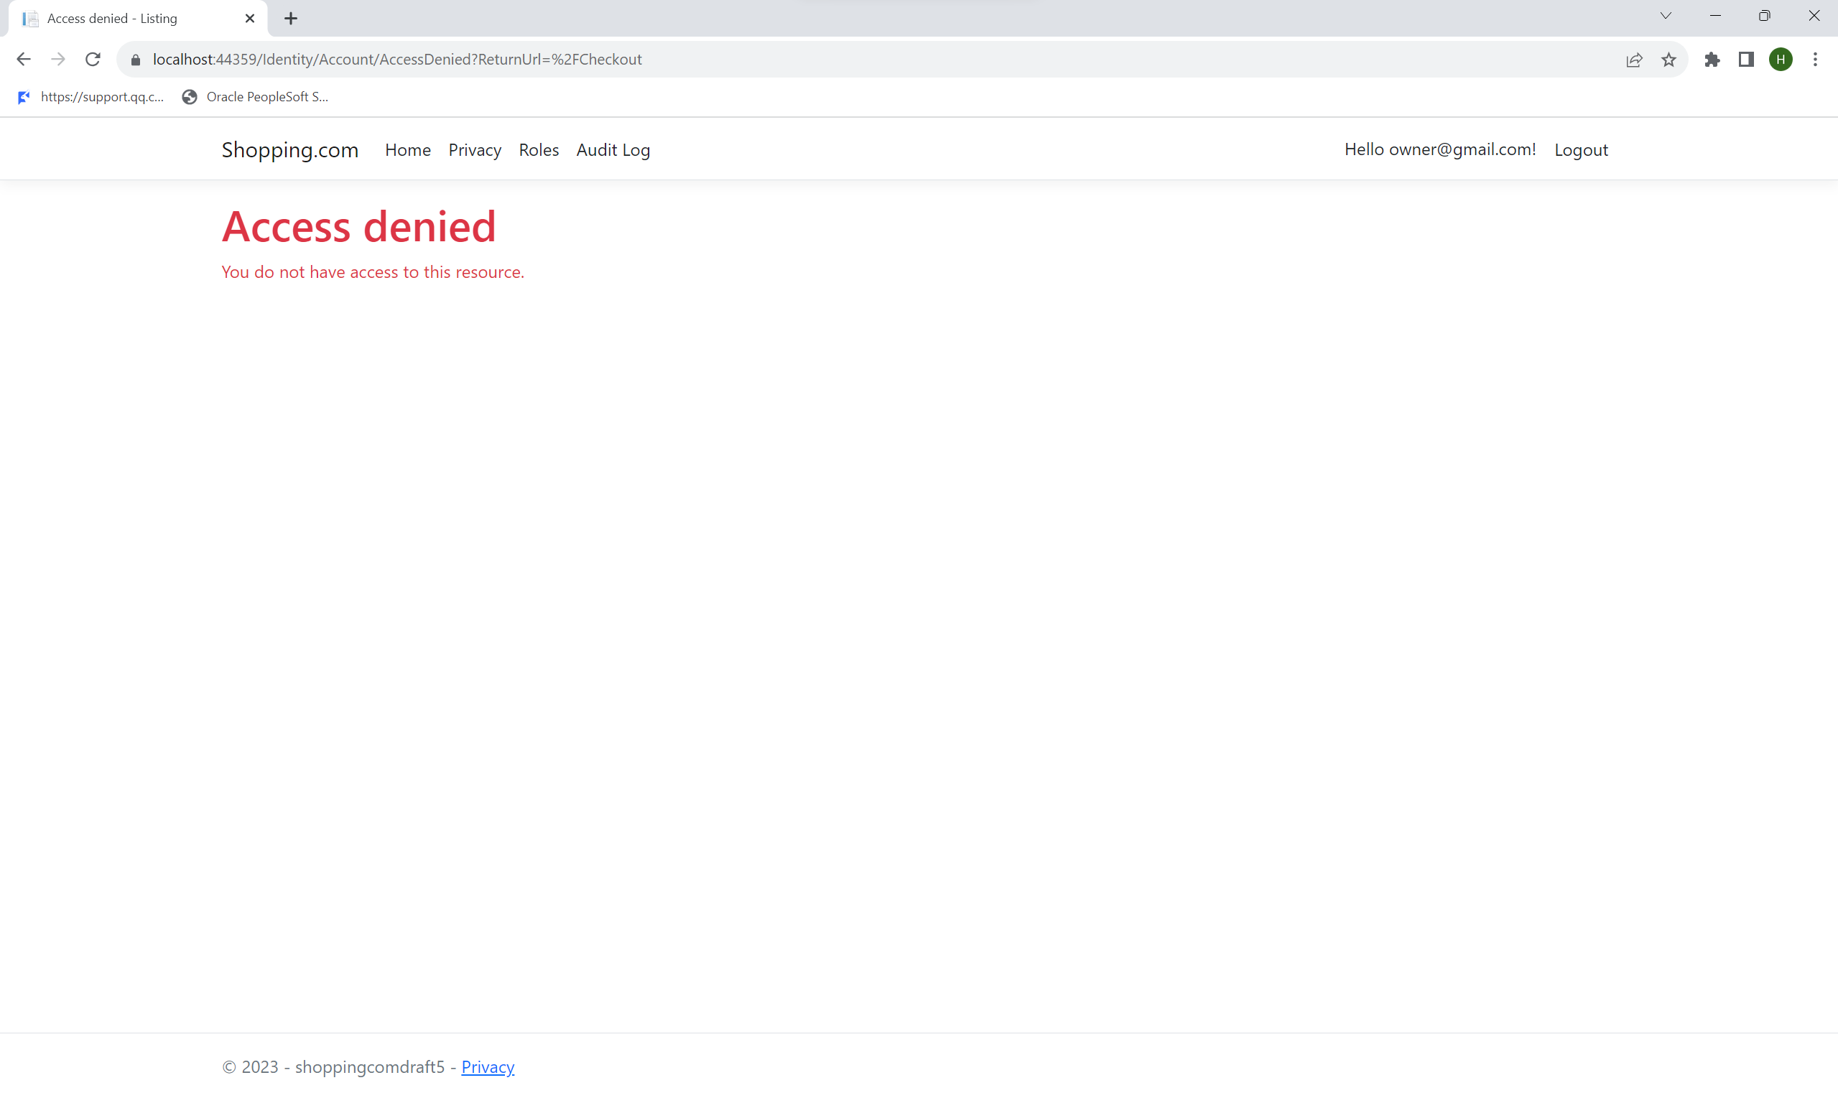

As we can see from the above screenshots, we can see that [owner@gmail.com](mailto:owner@gmail.com) with an owner role is able to assign or remove Admin/Staff/Member roles from users. However, the Owner cannot select his own account to assign or remove roles, thereby preventing the Owner from removing owner role from his account. It can also access and delete Audit logs. However, the account is unable to purchase listings. It is also unable create, read, update, and delete listings. Furthermore, any attempt by the account to access these unauthorized pages results in an access denied notification.

### Security Conclusion of the Feature

Overall, the Roles/Authorisation feature is one of the most important security requirements. If the security measure is not in place or does not work properly, there would be no way to control the damage caused by malicious attackers, who would have full permission to change the organisation and its contents freely. This would make the application unusable to users who want to purchase listings.

# Feature 3 (Auditing)

Auditing is an important feature for Shopping.com web application as it provides security and accountability by tracking and recording each user’s action that they take while on the website. Some of these actions include logging in and out, creating, editing, or deleting listings and role assignments. Audit trails can provide a detailed history of who did it, where it happened, when it happened and what has changed. This promotes accountability for the website as every action is recorded no matter who you are, and this also promotes security as it allows software developers to easily identify when suspicious activities such as fraudulent activities or security breaches are taking place.

## Secure Software Requirements

In order to meet the accountability requirements, our team have developed an audit log for the Shopping.com web application. The audit log can help software developers detect when an unauthorized user makes changes or when an authorized user makes unauthorized changes which are cases of violation of integrity. The audit log records down information such as the user who performs the action (Who), The action that was performed (What), The item on which the action was performed on (Where) and the date time stamp of which the action was performed (When).

### Use Case & Misuse Case Modelling

A use case and misuse case modelling can help elicit functional requirement by capturing how the user interacts with the system and the expected behaviour of the system in response. Furthermore, it allows software developers to get a clear representation of the software and security requirements and goals that it should achieve. By creating a use case and misuse case model for the audit log in the Shopping.com web application, I would be able to understand how the audit log would be used by the users and how attackers might attack the use cases with the misuse cases.

Use case and misuse case model:

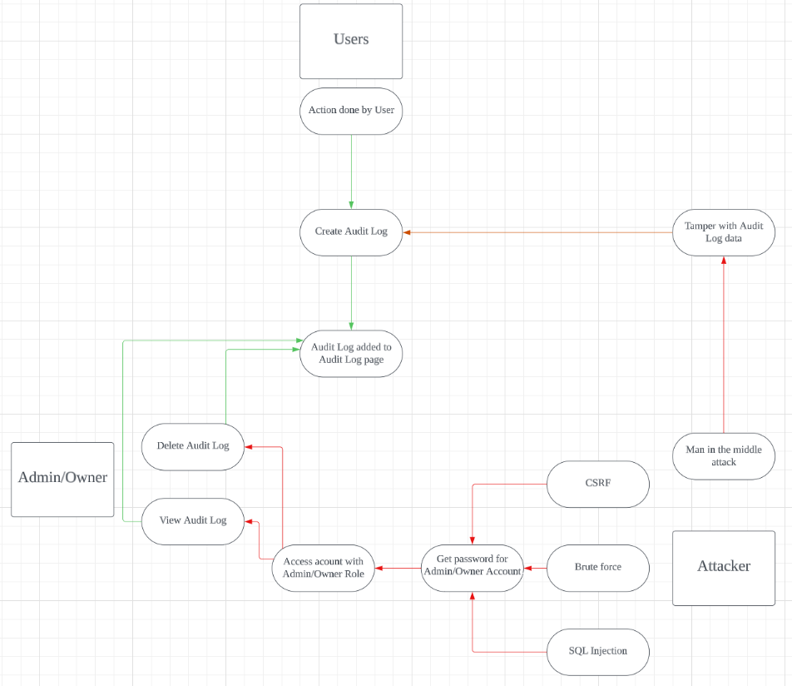

### Data labelling & Classification

Audit data and information on the Shopping.com website is important as it allows the administrators and owners to understand what users are doing and if any of them are carrying out any malicious acts. It is crucial that the data in the audit log are not altered or release to the public as it contains sensitive information about the user, system, and database which attackers can take advantage of. Hence, we would need to appropriately label and classify these data.

The data that are involved in auditing are as follows:

|  |  |
| --- | --- |
| Data | Information |
| Username | Username of user that performed the action |
| Action Type | What the user has done (Login/Logout, Create, Edit, Delete, listings, Assign/Remove roles) |
| Data Time Stamp | The date and time of when the action was performed by the user |
| Table Name | The name of the affected item (e.g Listing, Role) |
| Table ID | The ID of the affected item if present (e.g Listing) |
| Item before changes | Listing information/User role information before the user updates the item |
| Item after changes | Listing information/User role information after the user updates the item |

Data labelling and classification:

|  |  |  |  |
| --- | --- | --- | --- |
| Data | Confidentiality | Integrity | Availability |
| Username | public | High | Essential |
| Action Type | Confidential | Medium | Support |
| Date Time Stamp | public | Medium | Support |
| Table Name | Confidential | Medium | support |
| Table ID | Restricted | High | Essential |
| Item before changes | Restricted | High | Essential |
| Item after changes | Restricted | High | Essential |

### Subject/Object Matrix

Only users with admin and owner roles have access to view the audit log and only owners have the rights to delete audit records as users with lower ranking roles such as member or staff might have malicious intent on modifying or deleting the audit log to frame others or deny that they did the malicious act. Admins and Owners have the responsibility to ensure that the audit log is not tampered with and is only used when necessary.

|  |  |  |  |  |  |
| --- | --- | --- | --- | --- | --- |
|  | Subject | | | | |
| Object | No Roles | Member | Staff | Admin | Owner |
| View Audit Log | ❌ | ❌ | ❌ | ✔️ | ✔️ |
| Delete Audit Record | ❌ | ❌ | ❌ | ❌ | ✔️ |

## Secure Software Design

Secure Software Design can help minimize the time needed to fix identified security issues and assure the stakeholders trust by proving that the software is reliable, resilient, and recoverable. It also allows reduced redesigning of the software in the future.

### Feature Related Security Design (Week 5 and 6)

* Separation of duties - Users with either Admin or Owner roles are able to view the details on the Audit Log page. However, only Owners are able to delete Audit Logs. Hence, if an Admin realises that there is a need to delete any Audit Records, he will have to discuss with users with the owner role in order to have the Audit Record deleted.

### Attack Surface Evaluation (Week 7)

As Audit Records are meant to monitor every step taken by each user in the Shopping.com web application, users should not be able to manually create a new Audit Record or edit any existing ones. This significantly reduces the attack surface on the Audit Log pages.

### Threat Modelling (Week 7)

Threat modelling is important for developing a hack-resilient software as it allows the software development team an attacker’s point of view on how they would attack the system by pointing out entry points (Items that take in user input) and exit points (Items that display information from the system/database) that attackers can exploit. By implementing measures to seal these points, the developers can ensure that the attackers cannot make use of these vulnerabilities to launch an attack on the web application.

In the case of Audit Log page in the Shopping.com web application, there are no inputs available as users are not able to create new Audit Logs or Edit existing Audit Logs. Hence, there are no entry points on the page.

As for the exit points, the details page of the Audit Log displays the information of the Audit which is stored in the database and can be used as an exit point.

### STRIDE list

Based on the use case and misuse case, along with the attack surface area addressed in the previous section, a STRIDE threat list can be created which can categorize potential threats identified.

STRIDE list:

|  |  |
| --- | --- |
| STRIDE List | Identified Threats |
| Spoofing | * Impersonating admin/owner |
| Tampering | * Man In the Middle attack, change Audit Log data while in transit |
| Repudiation | * Deleting audit Log |
| Information Disclosure | * Unauthorized viewing and disclosing of Audit Log by accessing admin/owner accounts |
| Denial of Service | * Overwhelm Audit Log system with fake Audit Logs. |
| Elevation of privileges | * None |

### Attack tree

Attack trees are great for visualising how an attacker will potentially attack the software by giving scenarios that the attacker might follow to achieve his goal. By creating an attack tree for an Audit Log, I would be able to pinpoint on possible vulnerabilities in for the Audit Log and patch them up before publishing the code.

Attack tree diagram:

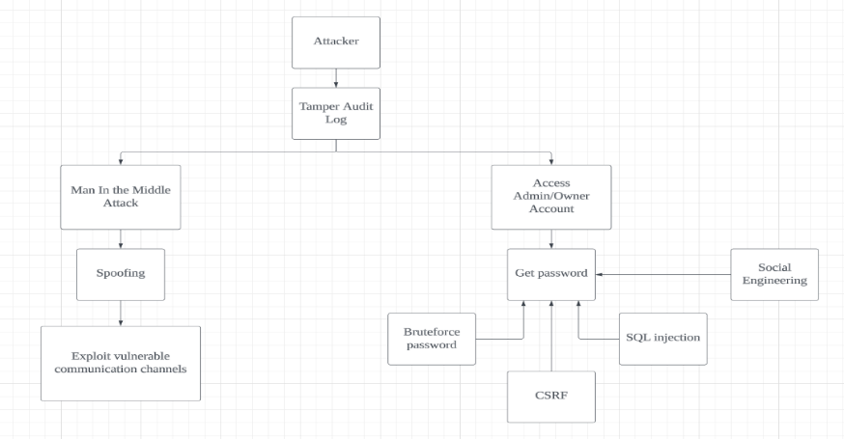

### Average ranking

|  |  |  |  |  |  |  |
| --- | --- | --- | --- | --- | --- | --- |
| Threat | D | R | E | A | DI | Average Ranking  (D+R+E+A+DI)/5 |
| Audit Log Deletion | 1 | 1 | 2 | 1 | 4 | 1.8 (Low) |
| Man In the Middle Attack | 1 | 3 | 4 | 1 | 4 | 2.6 (High) |

### Control measures

Audit Log Deletion – Only Owners are able to delete Audit Logs.

Man in the middle attack – Use a secure channel for transmitting items to database.

## Secure Software Coding (Week 11 and 12)

### Feature Related Defensive Coding Practices

Session Management - Each user has a specific session that cannot be replicated or used by others

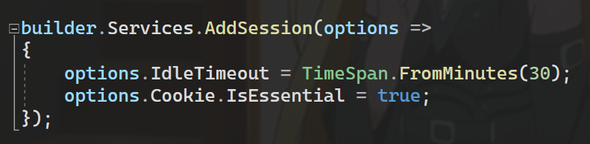

### Secure Software Processes

In addition to writing secure code, we as software developers have to conduct secure software processes during the implementation phase such that we can assure the security of the Shopping.com web application.

#### Versioning

Versioning of software allows me and my development team to work with the correct version of code and rollback to a previous version if necessary. This reduced the incidence of regenerative bugs which saved us lots of time as we would not need to regularly fix the old bugs in the update code. Hence, we decided to use GitHub for version control as it is easy for me and my team members to use and understand. In contrast get the latest version of the code, one simply needs to pull the latest changes from GitHub. On the other hand, in order to provide others with the latest code, one would simply push their latest version to GitHub. This makes it easier for my team and I to work on the code simultaneously. As for rollbacks in case of any errors such as data lost, our team decided to save a copy of our own updated version when we are done coding, pushing the code, and save their own updated code on their devices

#### Code Analysis

Code analysis is the process of inspecting the code for to assess the quality and identify any vulnerability that could be exploited in the code. There are 2 ways to analyse the code, static analysis, and dynamic analysis. Static analysis is the inspection of code without executing it and the benefits of it are that errors and vulnerabilities can be detected early and be fixed before deployment. On the other hand, dynamic analysis is the inspection of code when it is being executed. For me, I have utilized both static analysis and dynamic analysis while analysing my code.

Static analysis – I first checked through my code carefully for any errors and had found none.

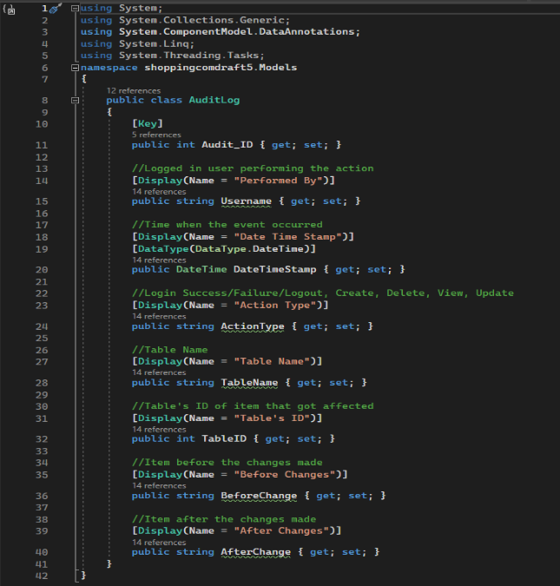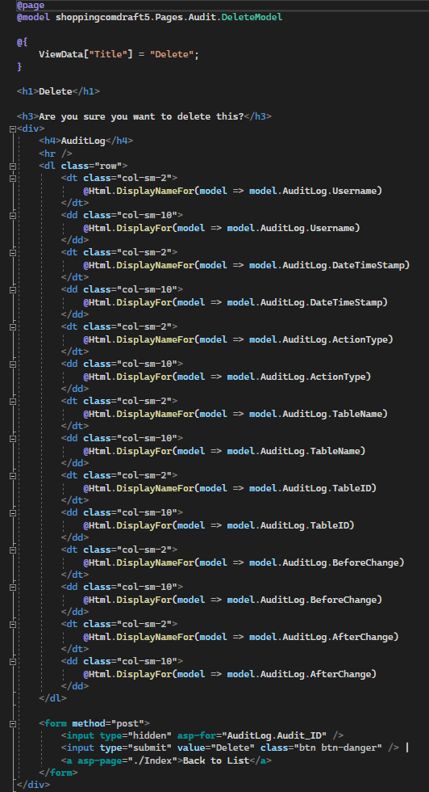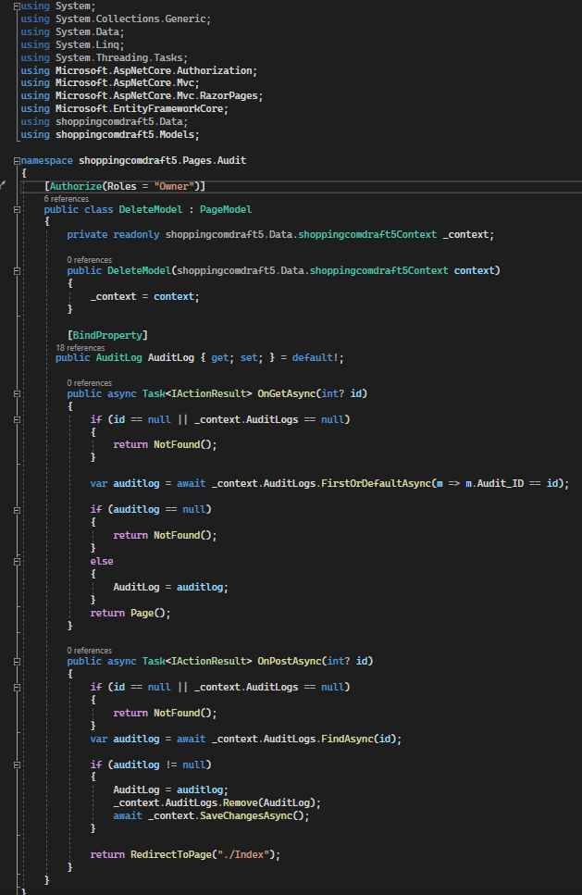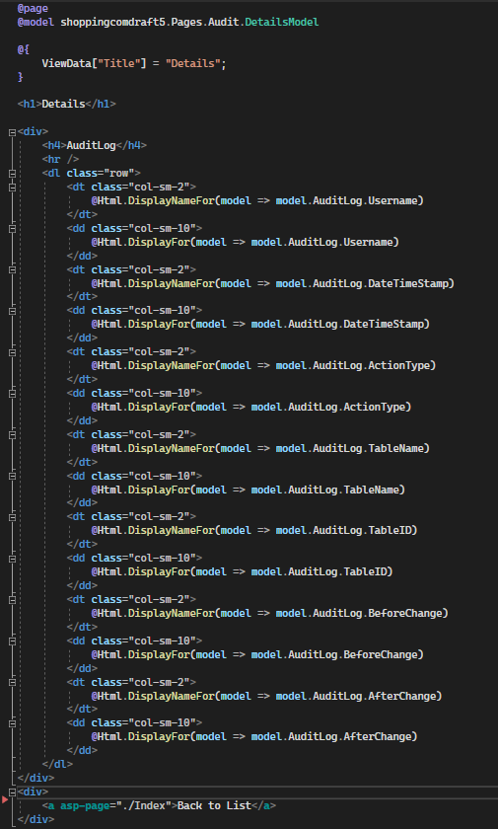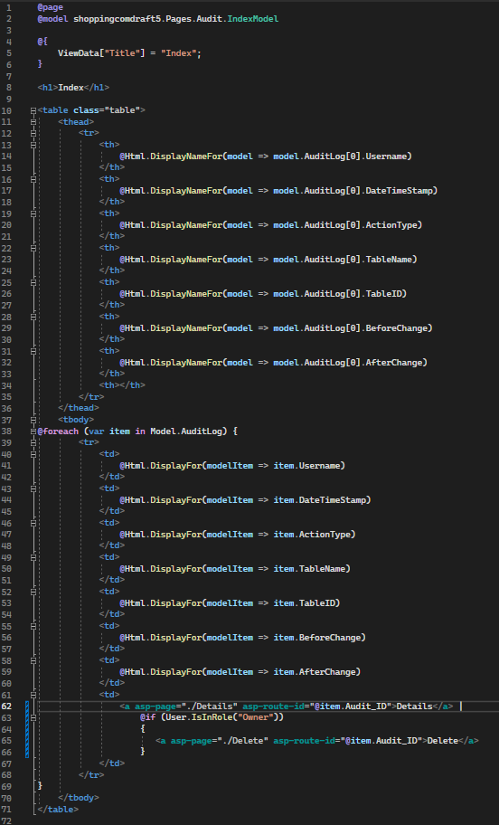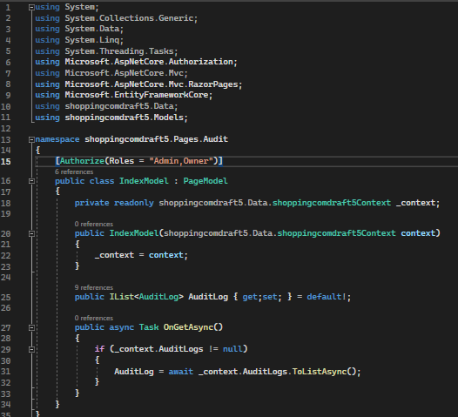

Dynamic analysis – After ensuring that the code has no errors, I ran the program and checked if the audit feature was working as intended. I was able to create an audit after login in, updating listing and managing roles without any issues.

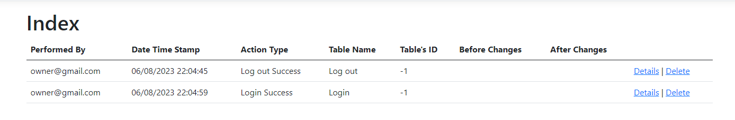

When user logs in/logs out



When Admin/Owner update roles

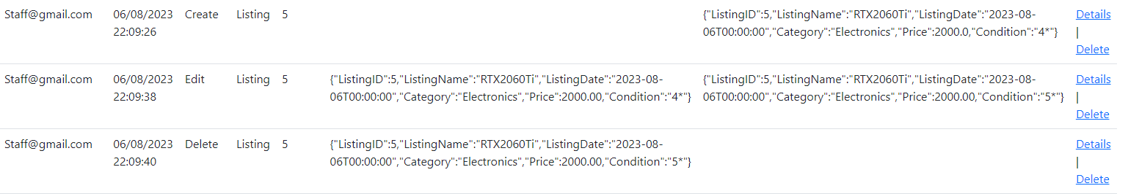

When Staff Create/Edit/Delete listings

#### Code/Peer Review

Code/Peer review is when peers from the development team comes to review the code. It can be performed using tools or manually with the goal of finding out syntax errors and vulnerabilities in the code which can impact performance and security of the Shopping.com web application. My peers would run the website and test the logic of the Audit Log pages and checked if it were running fine with no errors. After some testing, it was determined that the code was safe.

## Secure Software Testing (Week 13 and 15)

Before Shopping.com was ready to be pushed out to the public, it had to undergo software security testing which included test strategies, test plan and test case. This is to find any missing bugs that I or my team members have missed out.

### Test Strategy

A test strategy outlines the set of guides to be followed to achieve the test objective and how it would be tested. The goal at the end would be that the actions such as Login/Logout, Create, Edit, Delete Listing and Assigning/Removing roles from user would update the Audit Log and only allow users with correct roles to view or delete the Audit Log.

### Test Plan

A test plan is the approach on how the test would be done in a systematic way. Below is the test plan for the Audit Log Pages.

Feature

* User Logs in/Logs out of Shopping.com
* Staff Creates a new Listing
* Staff Edits a listing
* Staff Deletes a listing
* Admin/Owner give Role to user
* Admin/Owner remove Role from user

Condition

* Is an Audit Log created for each of the feature?

Feature

* Users with Member role tries to access Audit index/details page
* Users with Staff role tries to access Audit index/details page
* Users with Admin role tries to access Audit index/details page
* Users with Owner role tries to access Audit index/details page
* Users with Member role tries to access Audit delete page
* Users with Staff role tries to access Audit delete page
* Users with Admin role tries to access Audit delete page
* Users with Owner role tries to access Audit delete page

Condition

* Does the user successfully access the page?

### Test Cases

When an Audit is created, there should be a fix format of the user’s username, the date and time stamp, the action type, the table’s name, the table’s ID (if non will display –1), item before the change and item after the change (If there are no changes before and after such as when a user logs in, there will be nothing displayed.

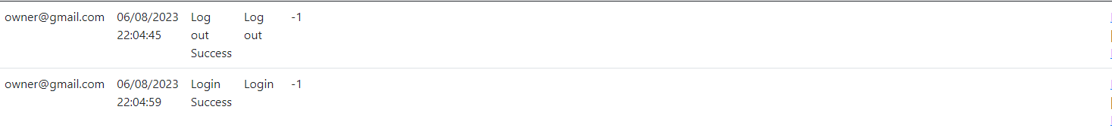

As seen from above, nothing will be displayed in the before and after changes for audit logs with log in and log out. In addition, since there is no table ID, the displayed table ID is –1.





As seen from the images above, the audit will only show items after change if there were nothing before the item was changed. Likewise, the audit will only show items before change if there is nothing after item has been changed.

When user with Member or Staff role try to access Audit index and details page, they would be met with an access deny page telling them that they do not have access to the page. Same goes for users with Member, Staff or Admin roles trying to access the Audit Delete page.

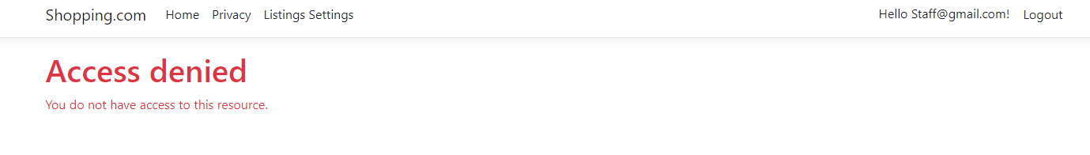

# Feature 4 (Shopping Cart)

A shopping cart is a feature that allows customers to save products they intend to order into a cart that they can later use to checkout. It is an essential component of a shopping website that allows visitors to purchase things with ease.

## Secure Software Requirements

Shopping cart is a simple and straightforward idea that does not allow user inputs other than a few buttons enabling the user to interact with the cart; as a result, the attack surface for shopping cart has already been greatly reduced and is relatively secure. All that remains is to determine which exploits remain and how to mitigate them, which data to restrict, and the authority for each role. With this in mind, I will investigate the secure software requirements utilising use case and misuse case modelling, data labelling and classification, and a subject/object matrix.

### Use Case & Misuse Case Modelling

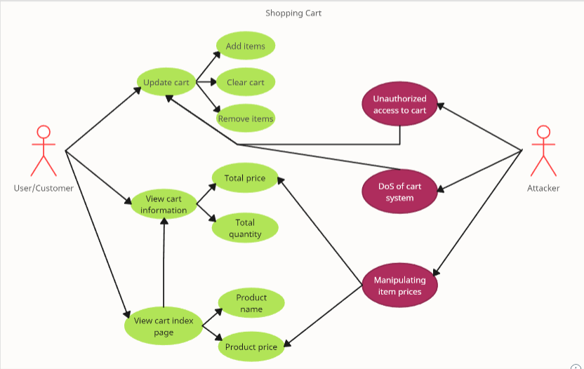

Mitigation for unauthorized access to cart:

* **User Authentication**

Configure a user authentication system to guarantee that only approved users have access to their own carts. Strong authentication mechanisms include passwords, multi-factor authentication (MFA), and single sign-on (SSO).

* **Session Management**

Manage user sessions properly and ensure that a user can only access their own cart after logging in. Session tokens with appropriate expiration times should be used, and session data should be kept securely.

* **Access Control**

Use role-based access control (RBAC) to limit access to the cart functionality. Users should only be able to view and modify their own carts based on their responsibilities and permissions.

Mitigation for DoS of cart system:

* **Rate Control**

Use rate limiting strategies to limit the number of requests made by a single IP address or user in a given time period. This prevents a single user from overloading the system.

* **Resource Sizing**

Use load balancing and auto-scaling technologies to ensure that the system can handle more traffic during peak hours. This aids in weight distribution and eliminates the chance of a single point of failure.

* **Anomaly Detection**

Use anomaly detection and monitoring to identify unusual patterns of behaviour that could indicate a DoS attack. Set up automatic alerts and response techniques to counteract such attacks.

Mitigation for manipulation of item prices:

* **Server-Side Price Verification**

Rather than relying solely on client-side data, conduct price verification and calculations on the server. Calculate the total cost using the server's database's current pricing.

* **Immutable Pricing**

To avoid unauthorised price changes, use immutable pricing records or a secure pricing solution. Any pricing adjustments should be documented and tracked.

* **Input Validation**

To prevent injection attacks, strict input validation should be implemented on both the client and server sides. Validate and sanitise input to ensure that it is free of potentially harmful code.

### Data Labelling & Classification

|  |  |  |  |
| --- | --- | --- | --- |
| Data | Confidentiality | Integrity | Availability |
| ListingId | Confidential | Medium | Critical |
| ListingName | public | Medium | Critical |
| Quantity | public | Medium | Essential |
| Price | public | Medium | Critical |
| Total | public | Medium | Essential |

### Subject/Object Matrix

|  |  |  |  |  |
| --- | --- | --- | --- | --- |
|  | Product Data | User Data | Cart Data | Session Data |
| Guest | N/A | N/A | N/A | N/A |
| User | View | View | Edit | N/A |
| Admin | Edit | Edit | Edit | View |

**Access Legend:**

N/A – No permission.

View – Permission to read the data.

Edit – Ability to modify the data.

**Roles:**  
Guest – Represents an unregistered user.

User – Represents a registered user.

Admin – Represent an administrative role.

**Object Descriptions:**

Product Data – Information about the products available for purchase.

User Data – Information about the users of the application.

Cart Data – Information about the contents of a user's cart.

Session Data – Information related to user sessions and interactions.

## Secure Software Design

### Feature Related Security Design

**Least Privilege:**

Users can only browse product details and cannot change anything that could cause the shopping cart to crash.

**Separation of Duties:**

The shopping cart is implemented independently of the listings. As a result, if something went wrong with the listings' coding, the shopping cart code would be fine.

**Defense in Depth:**

Only app-authenticated users have access to the shopping cart. Its code also employs if-else and try-catch expressions to ensure that operations are not halted due to an error and to perform proper error handling.

**Open Design:**

Even if someone were to review the shopping cart's codes, it would have no effect on the software's security because no critical data is hardcoded into the codes.

**Psychological Acceptability:**

The shopping cart offers a straightforward and user-friendly user interface, with each choice identified and colour coded accordingly. For example, the buttons for options that delete objects are red to draw attention to and discourage the user's activities. To encourage users, the buttons for options that add items are green.

### Attack Surface Evaluation

**Entry Points:**

There is no entry point because the only means to interact with the cart is via buttons, and there are no input fields for attackers to exploit to change the functionality of the buttons.

**Exit Points:**

Checkout index page

* Attack Tree

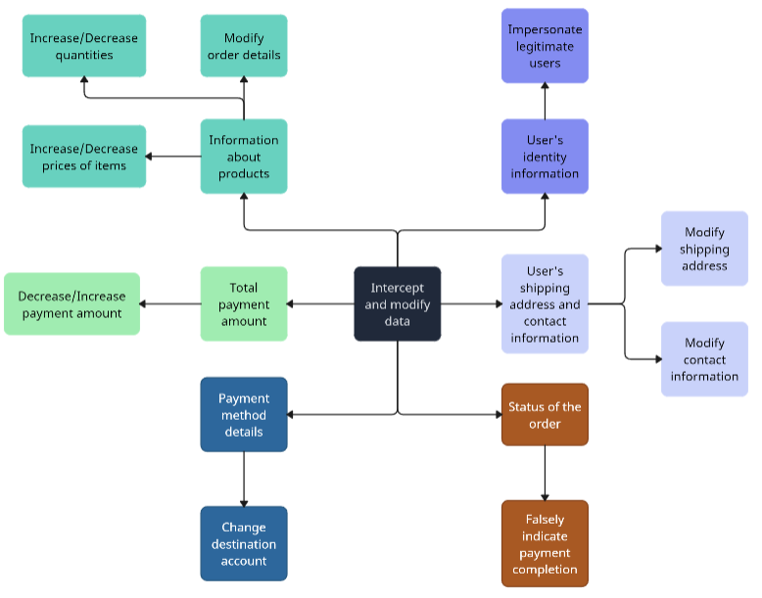

* STRIDE

|  |  |
| --- | --- |
| Attacks | Identified Threats |
| * Impersonate legitimate users | * Cookie Replay |
| * Modify order details * Increase/Decrease quantities * Increase/Decrease prices of items * Decrease/Increase payment amount * Change destination account * Falsely indicate payment completion * Modify contact information * Modify shipping address | * XSS |

### Threat Modelling

**Using the P x I ranking method:**

|  |  |  |  |  |  |  |  |  |
| --- | --- | --- | --- | --- | --- | --- | --- | --- |
|  | Probability of Occurrence (P) | | | Impact (I) | | P | I | Risk |
| Threat | R | E | DI | D | A | (R+E+DI) | (D + A) | P x I |
| XSS | 3 | 3 | 3 | 3 | 3 | 9 | 6 | 54 |
| Cookie Replay | 2 | 2 | 2 | 3 | 1 | 6 | 4 | 24 |

**Document and Validate:**

|  |  |
| --- | --- |
| Threat (P x I rank) | Controls |
| XSS (54) | Encode output; Validate request; Validate input; Disallow script tags; Disable active scripting |
| Cookie Replay (24) | Cookieless authentication; Encrypt cookies to avoid tampering |

## Secure Software Coding

### Feature Related Defensive Coding Practices

**Error Handling and Exception Management:**

Throughout the implementation of the shopping cart, I utilised many if-else and try-catch lines to ensure that if the operational criteria are not met, the else or catch statements prohibit the display of verbose error messages. This also aids in the detection and management of exceptions.

### Secure Software Processes

#### Versioning

When we wanted to save the current state of the file, we zipped it up and sent it to our chatgroup with the proper naming convention to separate the versions. In addition, we utilise GitHub to keep track of our versions by uploading the new code to a new branch each time.

#### Code Analysis

**Static code analysis:**

* CartController.cs

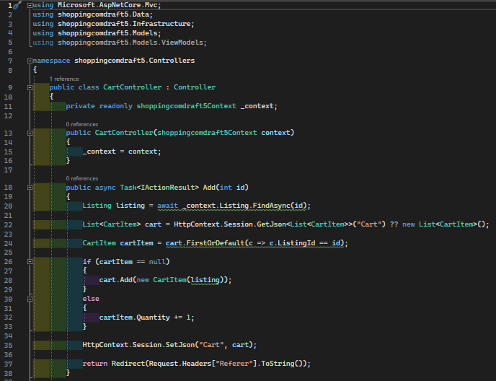

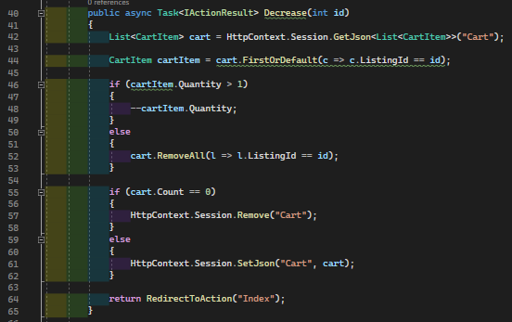

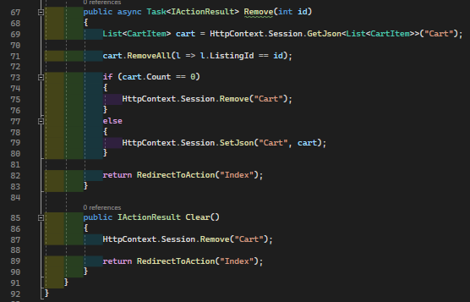

The purpose of the cart controller is to control the interactions users can have with the cart, such as Add, Decrease, Remove, and Clear.

* SmallCartViewComponent.cs

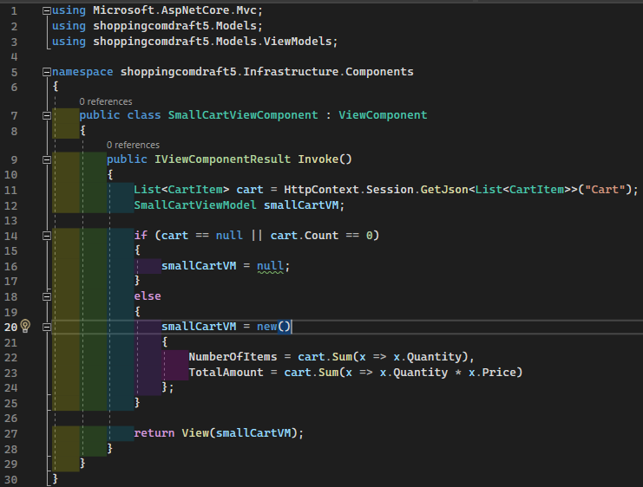

The purpose of this code is to generate the view of the small cart. This cannot be done using the razor pages format because small cart is not an actual page by itself, it is more of an add-on in listings index page.

* SessionExtensions.cs

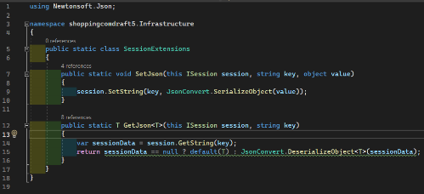

This code allows me to pass user’s cart information around different pages.

* CartViewModel.cs

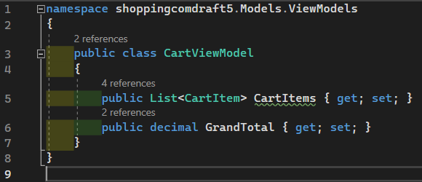

This stores the objects that will be needed to create the cart index page.

* SmallCartViewModel.cs

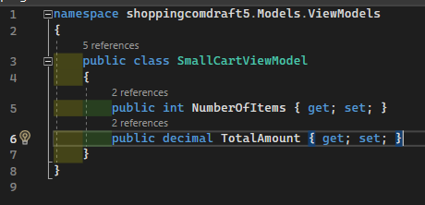

This stores the objects that will be needed to create the small cart view.

* CartItem.cs

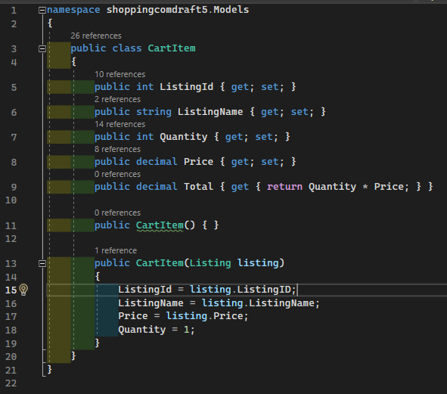

This stores the information of products inside the cart alongside a few information generated for the cart.

* Cart/Index.cshtml

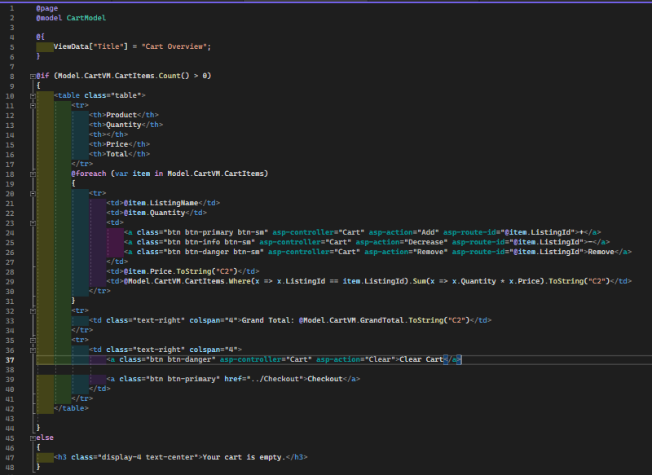

This creates the cart index page.

* Cart/Index.cshtml.cs

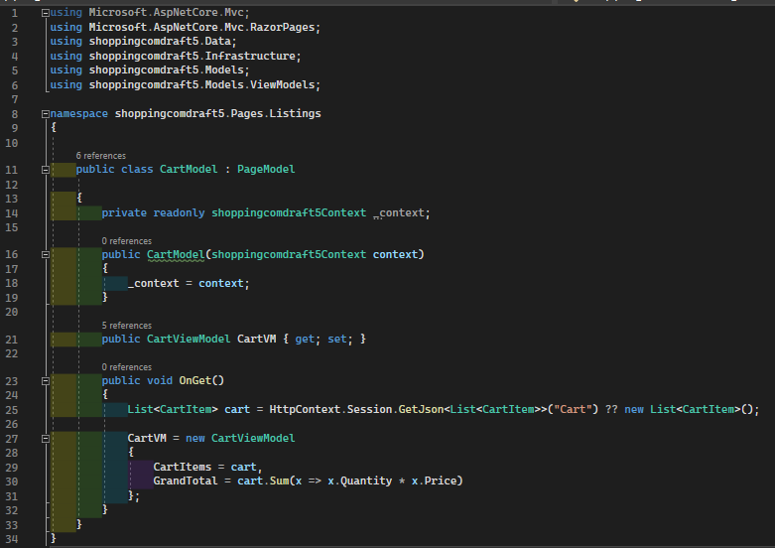

This loads the data needed for the cart index page.

* SmallCart/Default.cshtml

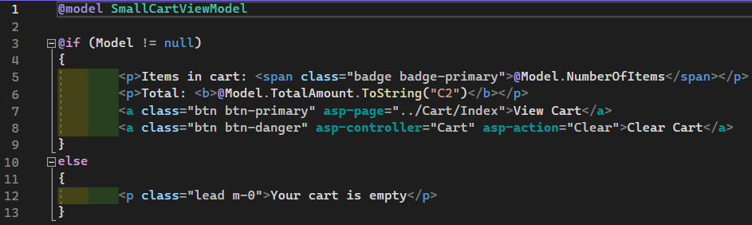

This creates the small cart view.

**Dynamic code analysis:**



Empty cart has been generated.

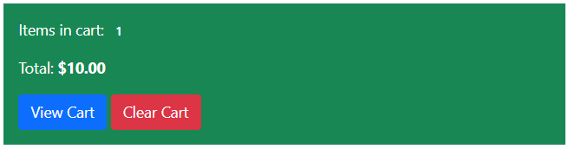

Adding a single item.

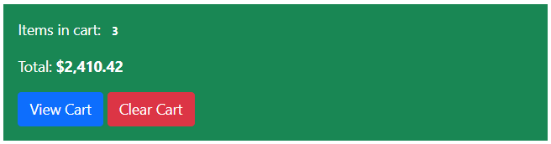

Adding multiple items.

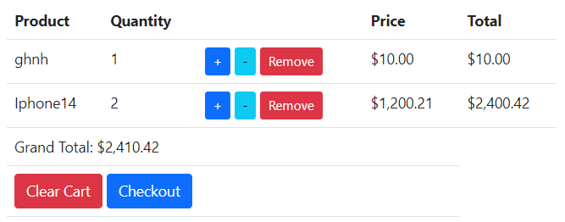

Accessing cart index page.

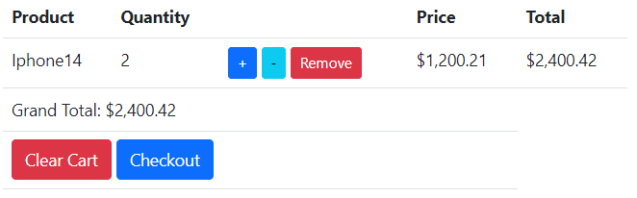

Removed item.

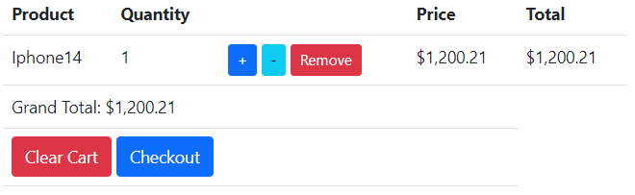

Decreased quantity of an item.

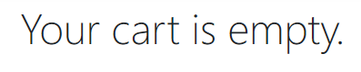

Cart is cleared.

#### Code/Peer Review

My teammates double-checked my code for flaws and pen tested my features to see if there were any vulnerabilities that might be exploited.

## Secure Software Testing (Week 13 and 15)

### Test Strategy

During the secure software testing phase, our objective is to ensure that the shopping cart feature functions correctly, securely, and meets the criteria. To validate the feature's behaviour, security, and robustness, we will use a combination of automated and manual testing methodologies.

### Test Plan

Functional Testing:

* Test adding items to the cart.
* Test increasing and decreasing item quantities.
* Test removing items from the cart.
* Test clearing the cart.
* Test interactions with the small cart view.

Security Testing:

* Test for session management vulnerabilities.

### Test Cases

Functional Testing:

* Test adding items to the cart.
  + Steps: Click the "Add to cart" button.
  + Expected Result: The item should be added to the cart.
* Test increasing and decreasing item quantities.
  + Click the "+" and “-“ buttons
  + Expected Result: The quantity should increase/decrease.
* Test removing items from the cart.
  + Click the “Remove” button
  + Expected Result: The item should be removed from the cart.
* Test clearing the cart.
  + Click the “Clear Cart” button
  + Expected Result: The cart should be empty.
* Test interactions with the small cart view.
  + Click on the buttons on the small cart view
  + Expected Result: They should work.

Security Testing:

* Test for session management vulnerabilities.
  + Steps:
    1. Add items to cart
    2. Logout and log back in using
    3. Check if the cart retains the items
  + Expected Result: The cart should be empty.

# Feature 5 (Checkout)

## Secure Software Requirements

### Use Case & Misuse Case Modelling

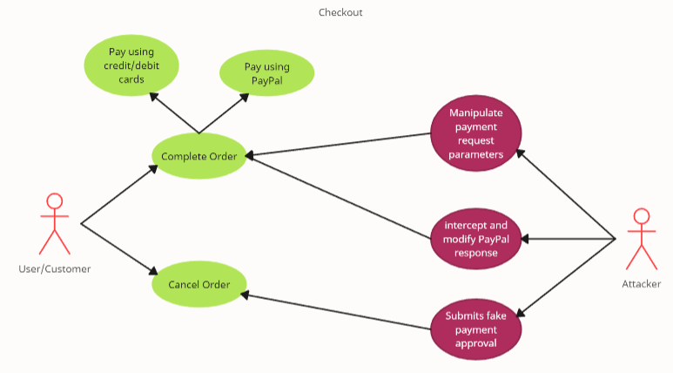

**Mitigation:**

To avoid unauthorised access and manipulation, implement proper input validation, secure communication (HTTPS), and check PayPal API answers.

### Data Labelling & Classification

|  |  |  |  |
| --- | --- | --- | --- |
| Data | Confidentiality | Integrity | Availability |
| Payment Details | Restricted | High | Critical |
| Order Details | Confidential | High | Critical |

### Subject/Object Matrix

|  |  |  |  |
| --- | --- | --- | --- |
|  | Payment Details | Order Details | User Data |
| Guest | N/A | N/A | N/A |
| User | Edit | Edit | N/A |
| Admin | Edit | Edit | Edit |

## Secure Software Design

### Feature Related Security Design

**Least Privilege:**  
Only after adding products to their cart, can users access the checkout page. They can configure their payment details bit not their order details.

**Separation of Duties:**

The checkout process is independent of other features, ensuring that problems in other aspects of the program do not compromise the payment process's security.

**Defense in Depth:**

User authentication and session management protect user access to the checkout. Furthermore, to ensure that errors messages do not divulge sensitive information, error handling and exception management are implemented.

**Open Design:**

The checkout code is designed to securely manage user payments without exposing critical data. PayPal credentials, for example, are safely kept and retrieved only when necessary.

**Psychological Acceptability:**

PayPal's CSS handles the button design, while the website design is simplistic.

### Attack Surface Evaluation

**Entry Points:**

* Users navigating to the checkout page.
* Interaction with the PayPal API to process payments.

**Exit Points:**

* Order creation.
* Order completion.
* Order cancellation.

**Attack Tree:**

* Impersonate legitimate users.
* Exploit vulnerabilities in the PayPal integration.
* Manipulate order details during payment processing.

**STRIDE:**

|  |  |
| --- | --- |
| Attacks | Identified Threats |
| * Impersonate legitimate users | * Session Hijacking |
| * Exploit vulnerabilities in PayPal integration * Modify order details * Change destination account * Manipulate shipping address | * SQL Injection * XSS |
| * Falsely indicate payment completion | * Cookie Replay |

### Threat Modelling

**Using P x I ranking method:**

|  |  |  |  |  |  |  |  |  |
| --- | --- | --- | --- | --- | --- | --- | --- | --- |
|  | Probability of Occurrence (P) | | | Impact (I) | | P | I | Risk |
| Threat | R | E | DI | D | A | (R+E+DI) | (D + A) | P x I |
| SQL Injection | 3 | 2 | 2 | 3 | 3 | 7 | 6 | 42 |
| XSS | 3 | 3 | 3 | 3 | 3 | 9 | 6 | 54 |
| Cookie Replay | 2 | 2 | 2 | 3 | 1 | 6 | 4 | 24 |
| Session Hijack | 2 | 2 | 3 | 2 | 1 | 7 | 3 | 21 |

**Document and Validate:**

|  |  |
| --- | --- |
| Threat (P x I rank) | Controls |
| XSS (54) | Encode output; Validate request; Validate input; Disallow script tags; Disable active scripting |
| SQL Injection (42) | Use parameterized queries; Validate input; Do not allow dynamic construction of SQL |
| Cookie Replay (24) | Cookieless authentication; Encrypt cookies to avoid tampering |
| Session Hijacking (21) | Use random and non-sequential Session Identifiers; Abandon session explicitly; auto logout on browser shutdown |

## Secure Software Coding

### Feature Related Defensive Coding Practices

**Input Validation:**

This is done on PayPal side.

**Sanitization:**

This is done on PayPal side.

**Error Handling and Exception Management:**

Throughout the checkout's implementation, I used numerous if-else lines to ensure that if there is an error or exception, the else statement would prevent the display of verbose error messages as well as handle the exception.

**Session Management:**

The cart and any user input that may include sensitive information will be cleared when the order is completed, or the user logs out. Only user inputs will be cleared if the order is cancelled.

### Secure Software Processes

#### Versioning

When we wanted to save the current state of the file, we zipped it up and sent it to our chatgroup with the proper naming convention to separate the versions. In addition, we utilise GitHub to keep track of our versions by uploading the new code to a new branch each time.

#### Code Analysis

**Static code analysis:**

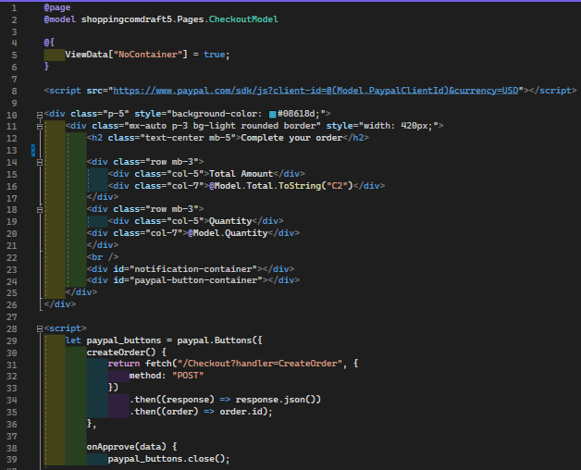

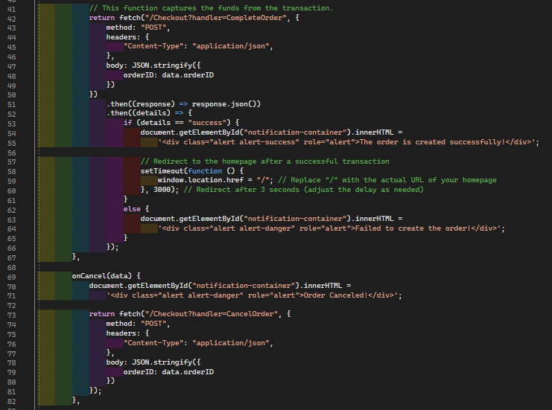

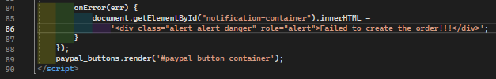

This creates the checkout index page

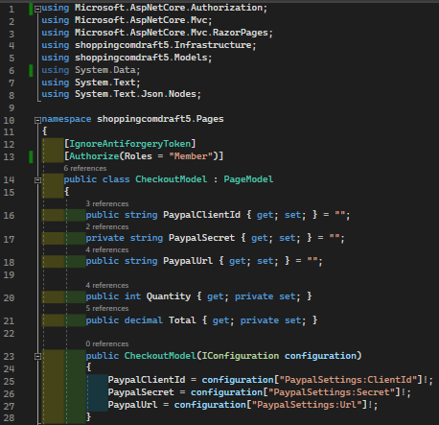

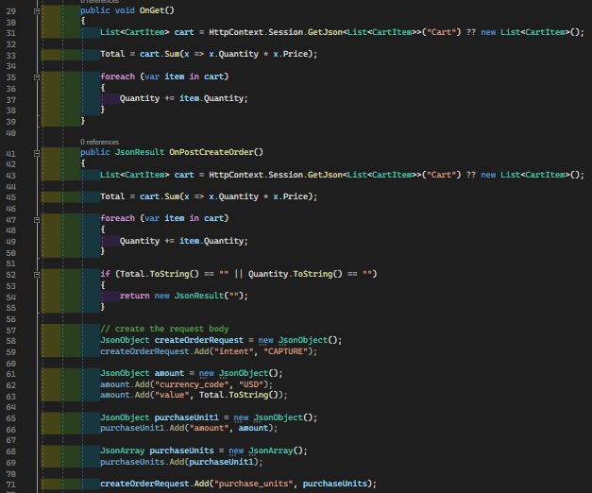

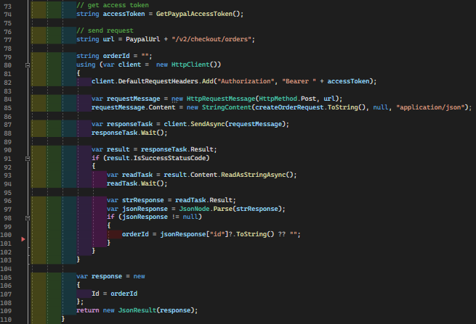

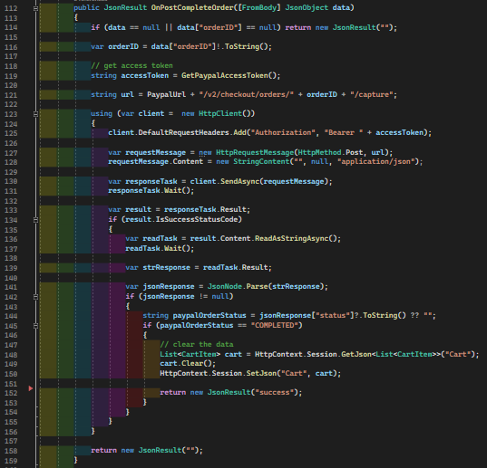

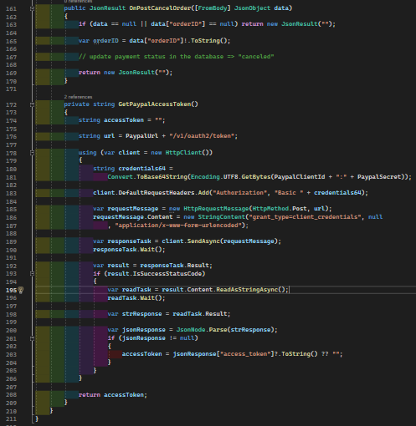

**Dynamic code analysis:**

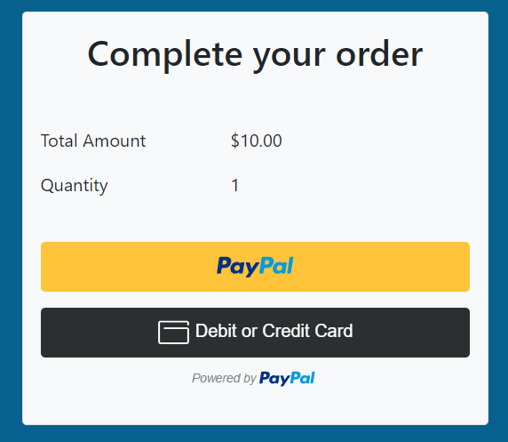

Accessing checkout page

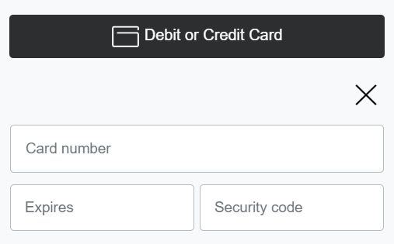

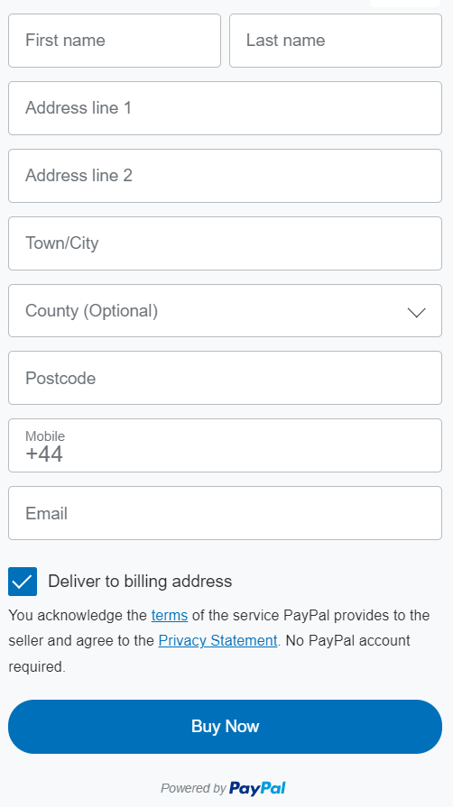

Using debit/credit cards

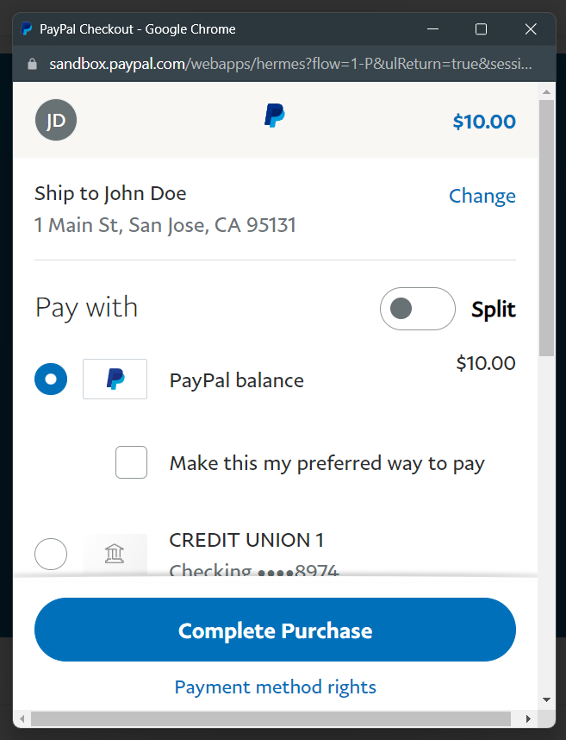

Using PayPal

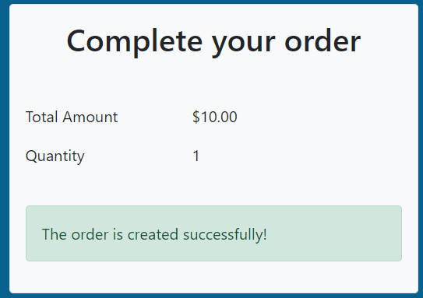

Order complete

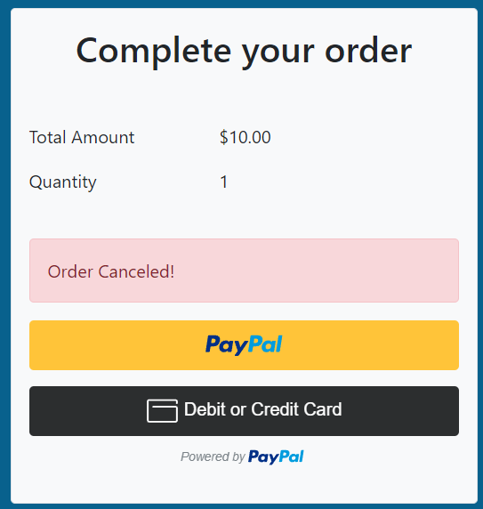

Order Cancelled

#### Code/Peer Review

My teammates double-checked my code for flaws and pen tested my features to see if there were any vulnerabilities that might be exploited.

## Secure Software Testing

### Test Strategy

During the secure software testing phase, our objective is to ensure that the Checkout functionality works correctly, securely, and meets the criteria. To validate the feature's behaviour, security, and robustness, we will use a combination of automated and manual testing methodologies.

### Test Plan

**Functional Testing:**

* Test order creation
* Test order completion
* Test order cancellation

**Security Testing:**

* Test XSS

### Test Cases

**Functional Testing:**

* Test order creation:
  + Steps:
    1. Add items to cart
    2. Proceed to checkout
  + Expected Result: An order should be created with item details.
* Test order completion:
  + Steps: Perform a mock payment using PayPal
  + Expected Result: Success order message should be shown.
* Test order cancellation:
  + Steps:
    1. Perform a mock payment using PayPal
    2. Stop the process midway through
  + Expected Result: Failed order message should be shown.

**Security Testing:**

* Test XSS
  + Steps: Attempt to insert a script tag into checkout-related input fields
  + Expected Result: The script tag should not be executed, and the input should be sanitised.

# Conclusion

In conclusion, in our journey developing Shopping.com, we have learnt many ways of securing web applications. Though it is not using the framework that is taught in the curriculum, we were still able to apply many of the concepts learnt in the module, and effectively secure our web application. Even though we implemented security features alongside product features, we did not sacrifice the usability of the product and were still able to create a moderately aesthetically pleasing interface for the user to interact with. This shows us that security can be applied in all applications, without sacrificing functionality. This has provided valuable experience for us, in developing web applications, and ensuring that they’re secure.

# Reference

Blender Up. (2022, June 24). *ASP.NET Core 6 .NET 6 Project - Shopping cart* [Video]. YouTube. https://www.youtube.com/watch?v=sX3g6hQZ8Lw

BoostMyTool. (2023, July 6). *How to Integrate PayPal Payments in ASP.NET Web Applications with Razor Pages | The Complete Guide* [Video]. YouTube. <https://www.youtube.com/watch?v=qLXDsoYOopU>

<https://learn.microsoft.com/en-us/aspnet/core/security/authentication/social/google-logins?view=aspnetcore-6.0>

<https://www.youtube.com/watch?v=tdNoArSjIyY&ab_channel=AlaeddinAlhamoud>